1. Include password eyes in add user account password and confirm password

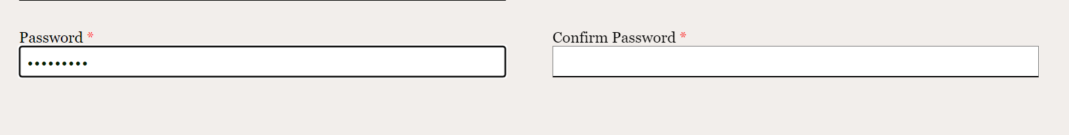  like dat na eyes

1. Fix degree for graduate school

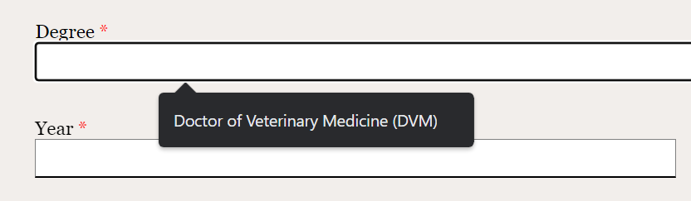

1. CONFIRMATION ONLY !!!!! d b yan editable

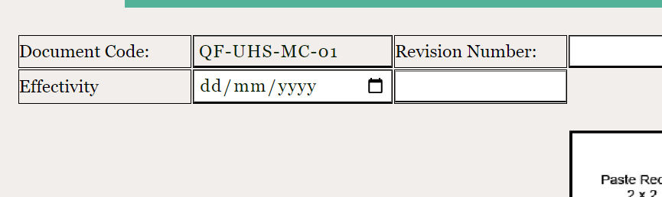

1. Go back button not working



1. Fix CSS (border line or make the buttons smaller )

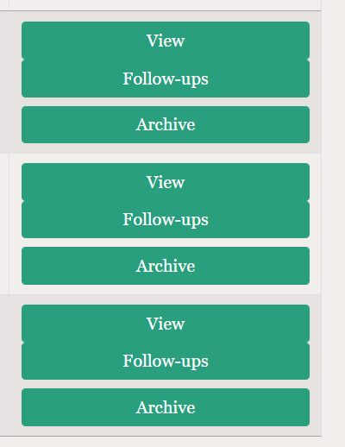

1. Once empty new medical certificate is made, it redirects to this page

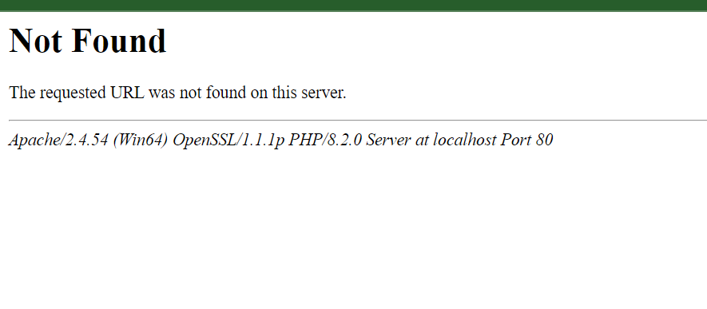

1. **SUGGESTION FOR ARCHIVED RECORDS**

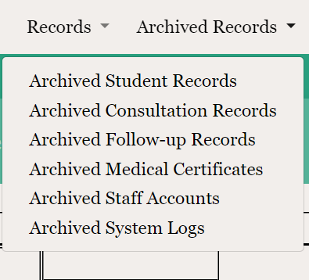

\**Remove Archived Consultation Record, Archived Follow-up Record, Archived Medical Certificate in the Archived Records. Only Archived Student Records would be left since when archiving a student record, all records would be archived at once. Then when Archived Student Records is clicked, there would also be a button for View All and a table like student summary would show. Therefore, there would be three columns in the individual archived student summary containing student record, consultation record and medical certificate.* ***SUGGESTION ONLY***

*MESSAGE IF AVAILBLE PROGRAMMERS MAY SUGGESTION SANA AKO FOR THE FOLLOW UP….