Run Postgres on Docker
- Download Docker
- Open command prompt and run docker pull postgres
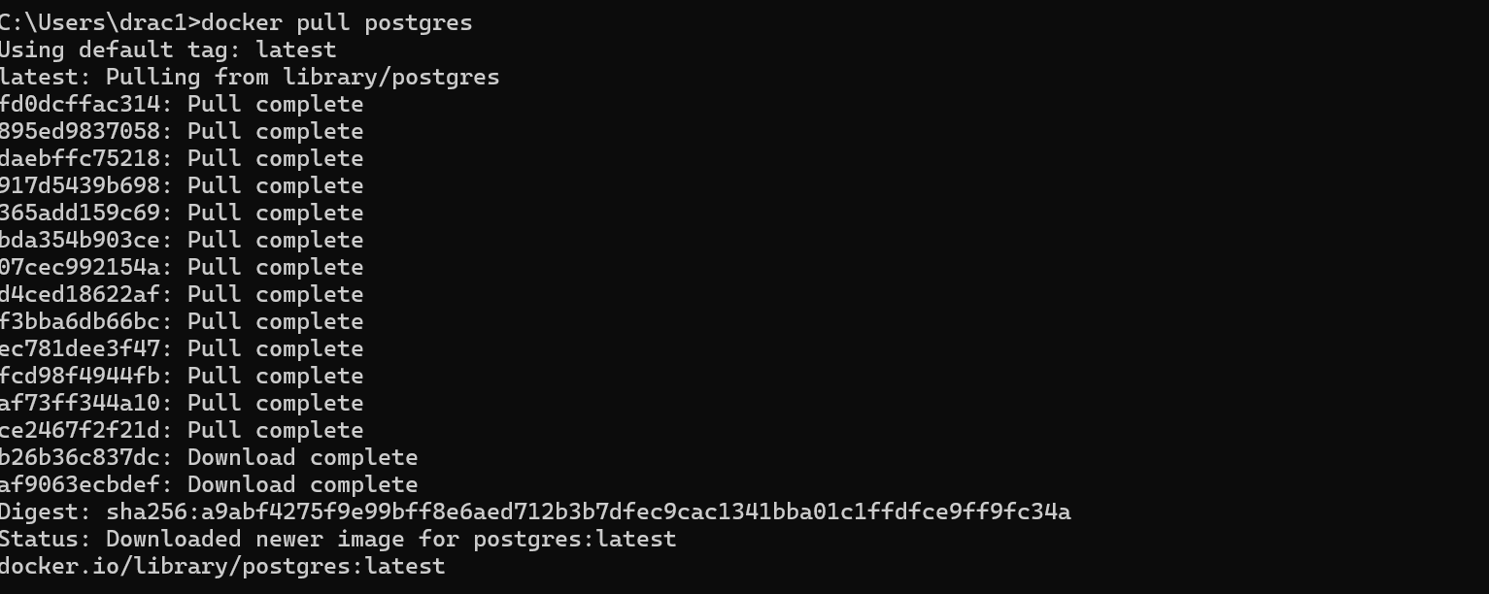

- Create a docker-compose file with following content:
version: "3.9"

services:
db:
image: postgres:latest
container_name: my-postgres
restart: always
environment:
POSTGRES_USER: drac1661
POSTGRES_PASSWORD: Drac1661@
POSTGRES_DB: udm_dev
POSTGRES_INITDB_ARGS: "--data-checksums --timezone=Asia/Kolkata"
ports:
- "5432:5432"
volumes:
- pgdata:/var/lib/postgresql

volumes:
Pgdata:

- In command prompt run :docker-compose up -d same directory wher you made the docer-compose.yml file
docker-compose up -d

5 Open Db evaer and click on New data base connection

Fill the detail as shown in screenshots:
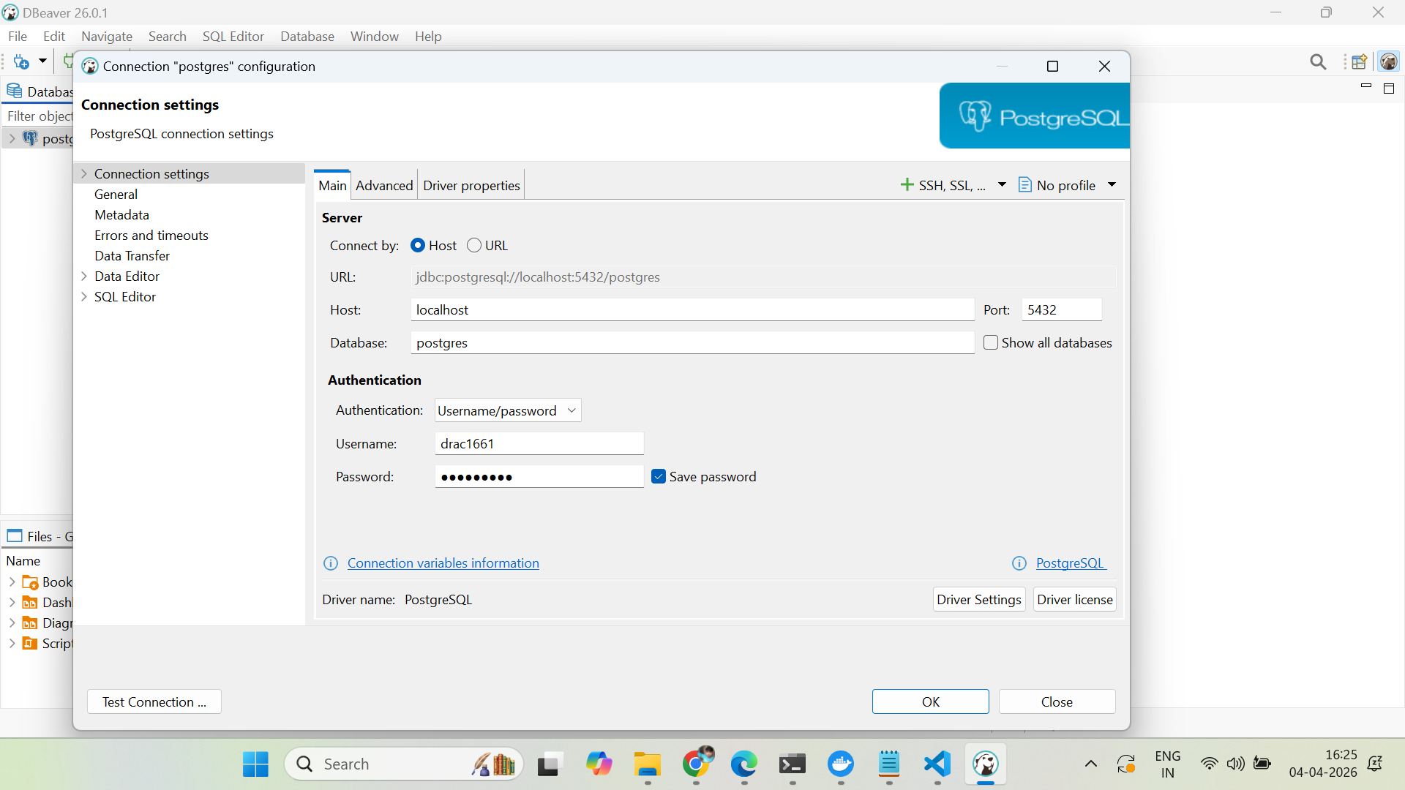
Click on ADvanced:
And click on replace legacy timezone:
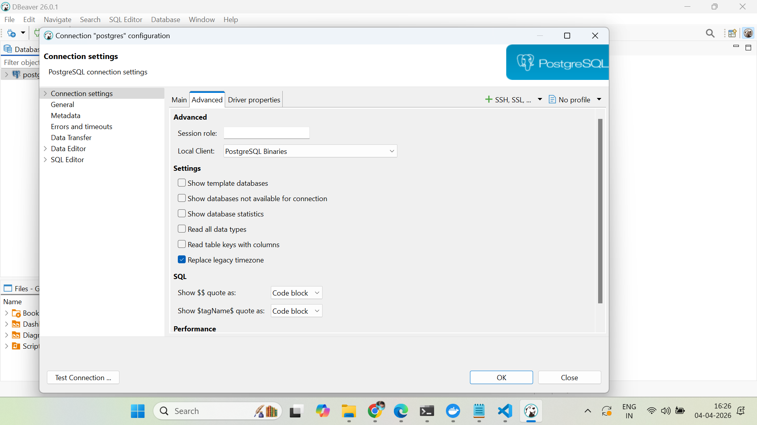

Click main
Click on test connection
Click on finish

