PC-98 Disk Image Mounter
98Bridge
User Manual

Version 1.0
March 2026
Licensed under the MIT License

Table of contents
Table of contents 2
Overview 3
The main window 3
Image management buttons 4
Mounting an image 4
The plugin system 4
Core plugins vs. user plugins 4
Folder structure 5
Plugin Manager 5
Installing a plugin 6
Disabling and enabling plugins 6
Removing a plugin 6
Reloading plugins 6
Configuration file 6
Writing your own plugin 7

Note: Right-click and select “Update Field” to refresh page numbers after opening.

Overview
98Bridge (PC-98 Disk Image Mounter) lets you browse, extract, and mount disk images from the NEC PC-98 platform. It supports floppy images (D88, HDM, FDI) and hard disk images (HDI, NHD) through a plugin-based architecture that can be extended with new formats at any time.
Key features:
- Browse FAT12/FAT16 filesystems with a built-in file tree
- Mount images as drive letters (Windows) or directories (Linux)
- Built-in hex viewer for sector-level inspection
- Write changes back into disk images
- Extensible plugin system for new image formats and filesystems

The main window
When you launch 98Bridge, you see the main window with the mount controls at the top, the disk image list on the left, and a tabbed content area on the right.
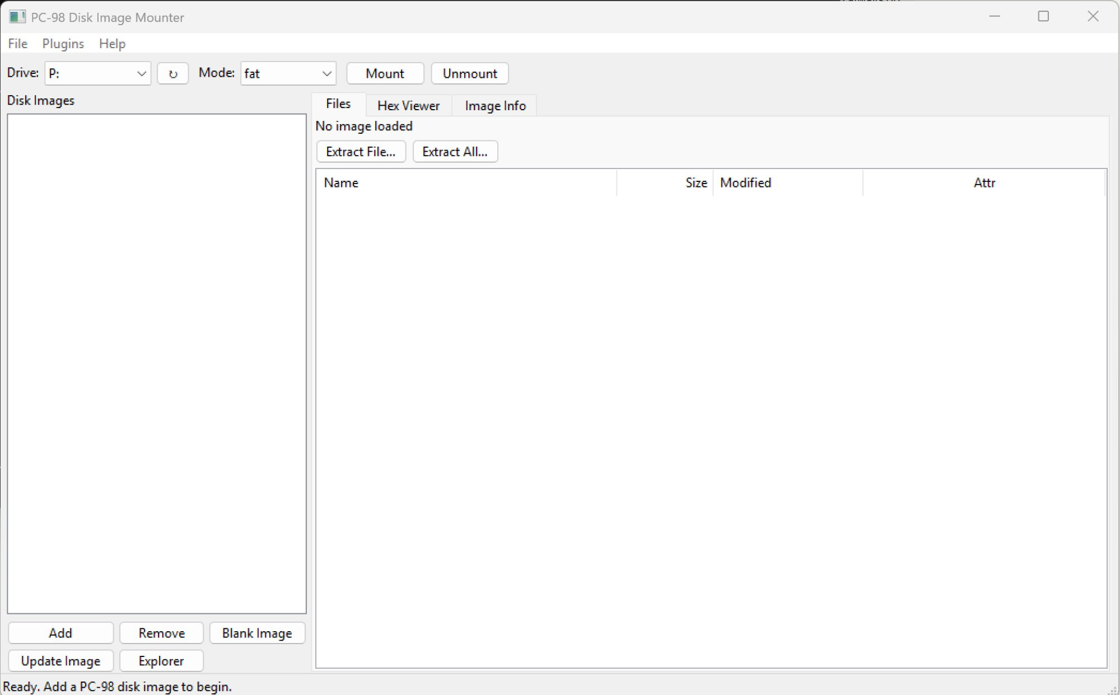
Figure 1: The main 98Bridge window

Image management buttons
At the bottom of the image list, five buttons provide quick access to common operations:
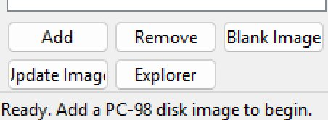
Figure 2: Image management buttons
- Add — Open one or more disk image files. Supports all formats registered by plugins.
- Remove — Remove the selected image from the list (does not delete the file).
- Blank Image — Create a new empty disk image with a chosen geometry and format.
- Update Image — Write changes from the mounted directory back into the original disk image.
- Explorer — Open the mounted directory in your system’s file manager.

Mounting an image
To mount a disk image:
- Click Add and select a disk image file.
- Choose a drive letter (Windows) or slot name (Linux) from the Drive/Slot dropdown.
- Select a mount mode: fat (browse files), flat (raw image as one file), or sectors (each sector as a file).
- Click Mount.

The plugin system
98Bridge uses a plugin architecture for all image format support, partition detection, and filesystem parsing. Even the built-in PC-98 formats are loaded as plugins, making the system fully modular.

Core plugins vs. user plugins
There are two categories of plugins:
- Core plugins live in the plugins/core/ folder. These are essential for the program to function and cannot be removed or disabled from the interface. They appear grayed out in the Plugin Manager with a “(core)” label.
- User plugins live in the plugins/ folder. These can be freely installed, removed, enabled, or disabled at any time.
98Bridge ships with these core plugins:
- pc98_formats — Registers all built-in image formats (D88, FDI, HDI, HDM, Raw) and partition detectors (MBR, PC-98 IPL).
- fat_filesystem — Registers the FAT12/FAT16 filesystem parser.
And one user plugin as an example:
- nhd_format — Adds support for NHD (T98-Next) hard disk images used by Neko Project II.

Folder structure
Plugins are stored alongside the main program:
plugins/ core/ pc98_formats.py fat_filesystem.py nhd_format.py README.md
Any .py file placed directly in the plugins/ folder is treated as a user plugin and loaded automatically at startup. Files in plugins/core/ are loaded first and marked as protected.

Plugin Manager
Open the Plugin Manager from the menu: Plugins → Plugin Manager (or press Ctrl+P).
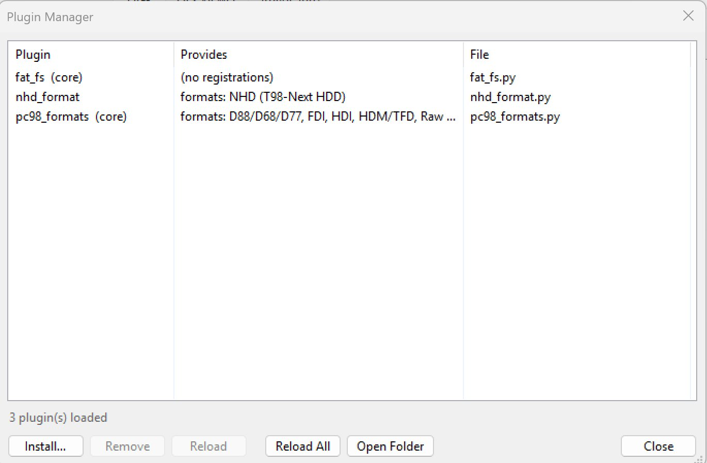
Figure 3: The Plugin Manager showing core and user plugins
The Plugin Manager lists all discovered plugins. Core plugins appear at the top in gray. Each row shows the plugin name, what it provides (formats, detectors, filesystem probers), and its filename.

Installing a plugin
- Click Install… in the Plugin Manager.
- Select a .py plugin file from your computer.
- The plugin is copied into the plugins/ folder and loaded immediately. It will also load automatically on future launches.
You can also install plugins manually by copying a .py file into the plugins/ folder and restarting the program (or clicking Reload All).

Disabling and enabling plugins
Select a user plugin in the list and click Disable. The plugin is unloaded and its state is saved in 98Bridge.config. Disabled plugins appear grayed out with “(disabled)” next to their name. Click Enable to reload a disabled plugin.
Note: Core plugins cannot be disabled. The Disable button is grayed out when a core plugin is selected.

Removing a plugin
Select a user plugin and click Remove. This unloads the plugin and permanently deletes its file from disk. You will be asked to confirm before the file is deleted. Core plugins cannot be removed.

Reloading plugins
- Reload — Unloads and re-imports the selected plugin from disk. Useful after editing a plugin file.
- Reload All — Unloads every plugin and rescans the plugins/ directory. Respects disabled states saved in 98Bridge.config.

Configuration file
Plugin state is saved in 98Bridge.config, a JSON file stored next to the main program. It is created automatically when you first disable a plugin.
Example:
{ "disabled_plugins": ["nhd_format"] }
You can edit this file by hand if needed. Delete it to reset all plugins to their default (enabled) state.

Writing your own plugin
A plugin is a single .py file that imports from the 98Bridge modules and calls registration functions. Here is a minimal example that adds support for a fictional .xyz image format:
from disk_image import DiskImage
from registry import register_image_format

class XYZImage(DiskImage):
def _parse(self):
self._sector_size = 512
self._total_sectors = len(self._data) // 512
self._label = "XYZ Image"

def read_sector(self, lba):
off = lba * 512
return bytes(self._data[off:off + 512])

def write_sector(self, lba, data):
off = lba * 512
self._data[off:off + 512] = data[:512]

register_image_format(
extensions=['.xyz'],
opener=XYZImage,
label='XYZ Images',
priority=10,
)
Save this as a .py file and either:
- Drop it into the plugins/ folder and restart, or
- Use Plugins → Install Plugin… from the menu.
Plugins can register three types of components:

- Image formats — register_image_format()
- Partition detectors — register_partition_detector()
- Filesystem probers — register_filesystem_prober()
See plugins/nhd_format.py for a complete real-world example, and plugins/README.md for additional documentation.

