Flashcard for Chinese characters / Image Flashcard Player 1.1
Installation and user Guide
Jonathan Luo

Flashcard4cn 1.1 combines latest flashcard for Chinese characters and Image Flashcard Player into one application.
Installation Guide
This installation guide is for Windows users.
- For Windows 8, suggest to install Classic Shell first, http://www.classicshell.net/

- Check which JRE is installed
At Windows Start menu, enter “cmd” and hit Enter to open a command line window
Type
java -version <enter>
If you see something like below, JRE is installed on your system
java version "1.7.0_71"
Java(TM) SE Runtime Environment (build 1.7.0_71-b14)
Java HotSpot(TM) 64-Bit Server VM (build 24.71-b01, mixed mode)
If you see something like above, you can skip step 3) below

- Install Java JRE 7 if you haven't done so, go to http://www.oracle.com/technetwork/java/javase/downloads/index.html
Click JRE Download, pick JRE 7 or higher for Windows
Typical JRE installation folder is
C:\Program Files (x86)\Java\jre7\bin for 32-bits
Or
C:\Program Files\Java\jre7\bin for 64-bits
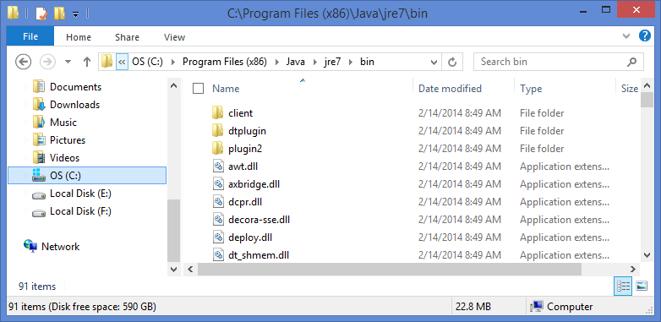

- At Start menu, in the search box, enter “Edit the system environment variables”, press Enter
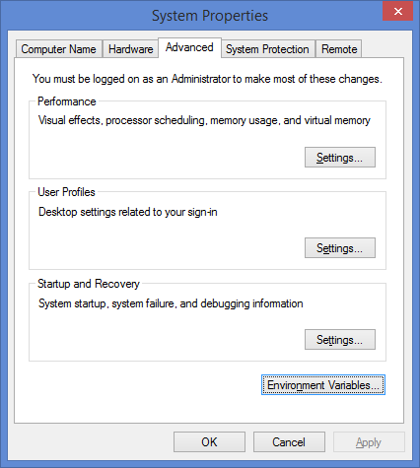
Click Advanced tab
Click Environment Variables
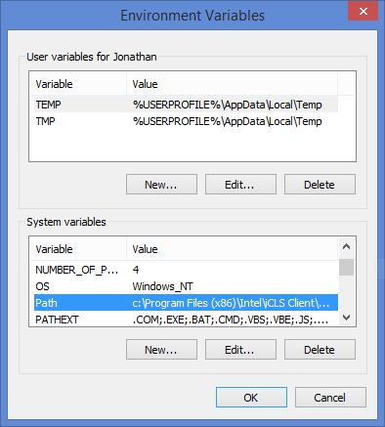
At System variables, select Path, click Edit…

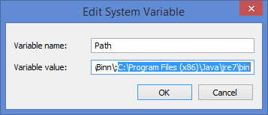
Enter your JRE installation path, for example, C:\Program Files (x86)\Java\jre7\bin, at the end, click OK.

- Download flashcard4cn-bin-1.1.zip from http://sourceforge.net/projects/flashcard4cn/files/flashcard4cn/1.1/
Unzip flashcard4cn-bin-1.1.zip into a folder of your choice.
- Open Explorer, switch to the folder, click startup.bat to start up flashcard4cn application.

Image Flashcard Player User Guide
Configure Image Flashcard Player
Start flashcard4cn application by click startup.bat, Click Tools >> Configure Image Flash Card…
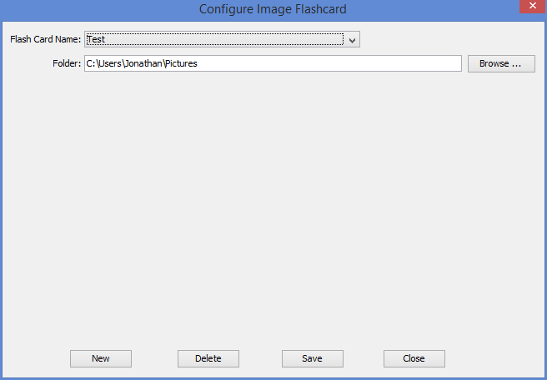
Click New
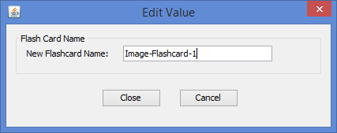
Enter New Flashcard Name, e.g. Image-Flashcard-1, click Close
Click Browse…, select a folder which contains your image flashcards.
Click Save.

Play Image Flashcards
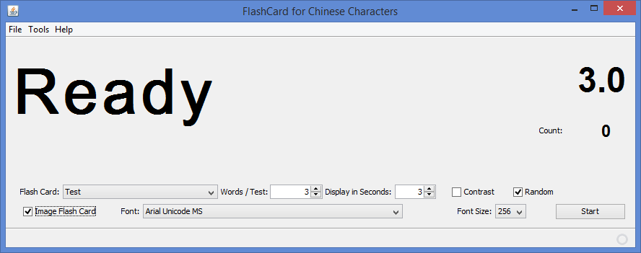
Click Image Flash Card check box, select desired flashcard from Flash Card drop down box.
Select Words/Test and Display in Seconds, and click Start
Image Flashcard Player automatically starts displaying image flashcards.

