Hunter Dale

Module 1.2 Assignment

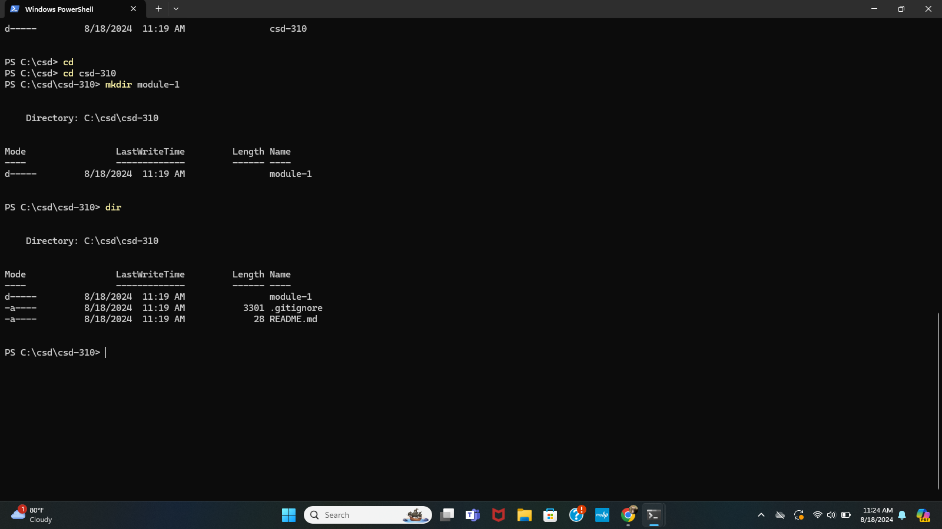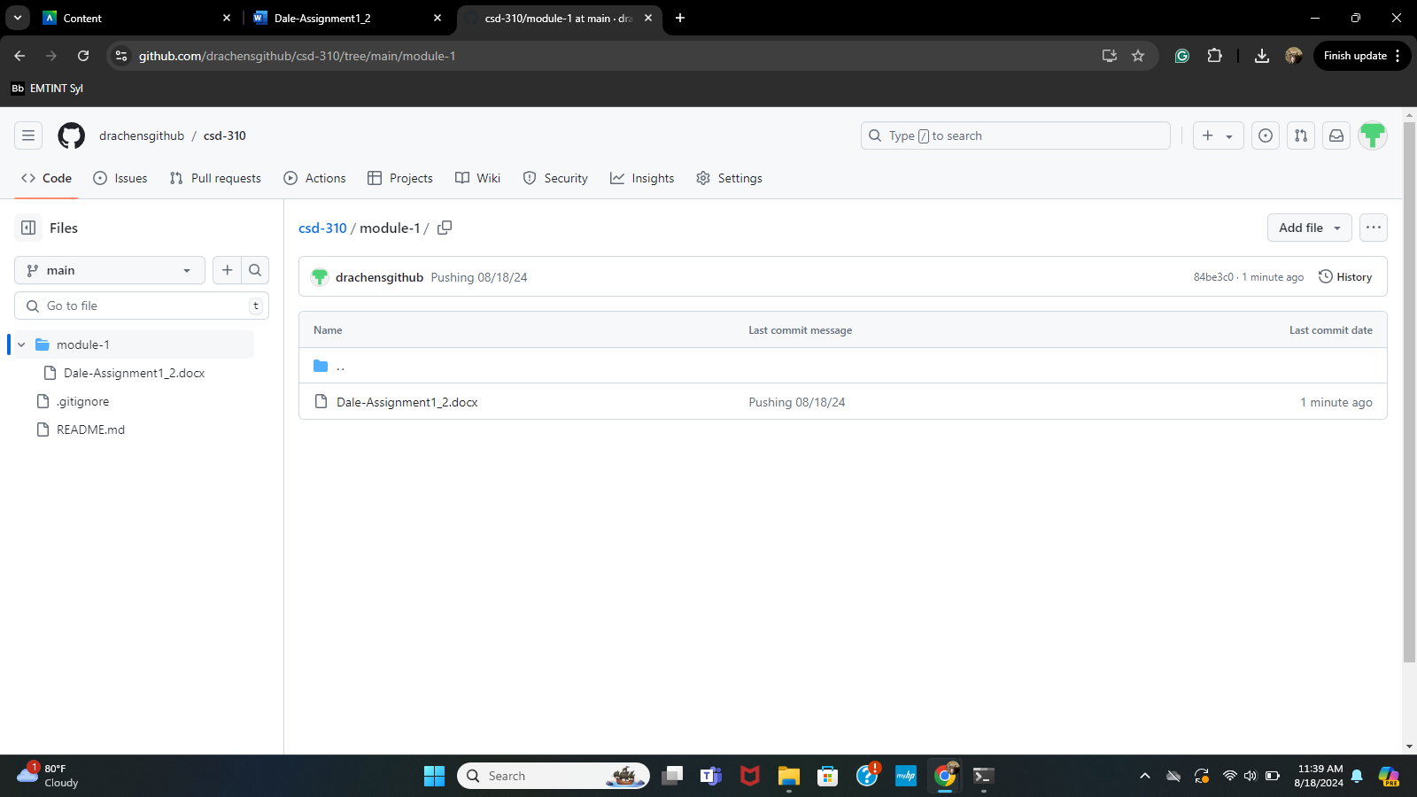<https://github.com/drachensgithub/csd-310>

Link to Repository Above