Hunter Dale

Assignment 2.3

8/25/24

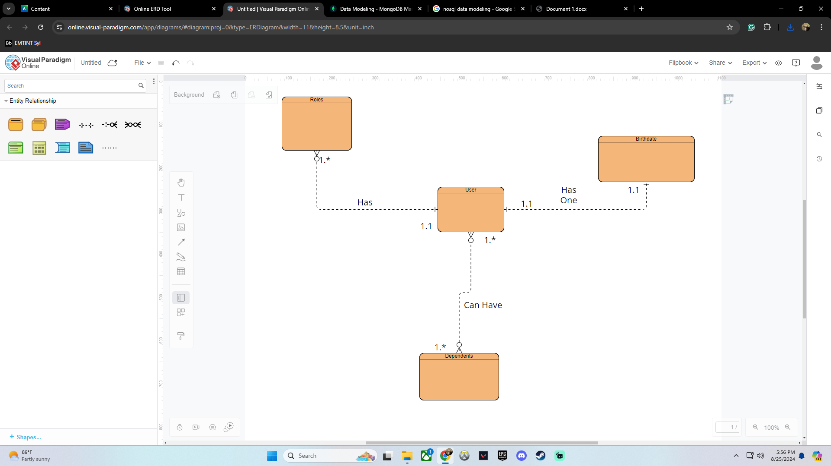NoSQL Data Structure

{

“user_firstname”: “Hunter”,

“user_lastname” : “Dale”,

“user_birthdate” : “3.23.04”,

“roles” : [

{

“job_type” : “Manager”,

},

{

“job_type” : “Shift_Lead”,

}

]

{

“dependents”: [

{

“type” : “Son”,

},

{

“type”: “Son2”,

},

{

“type”: “Daughter”,

}

]

}