Hunter Dale Assignment 5.2 9/8/24

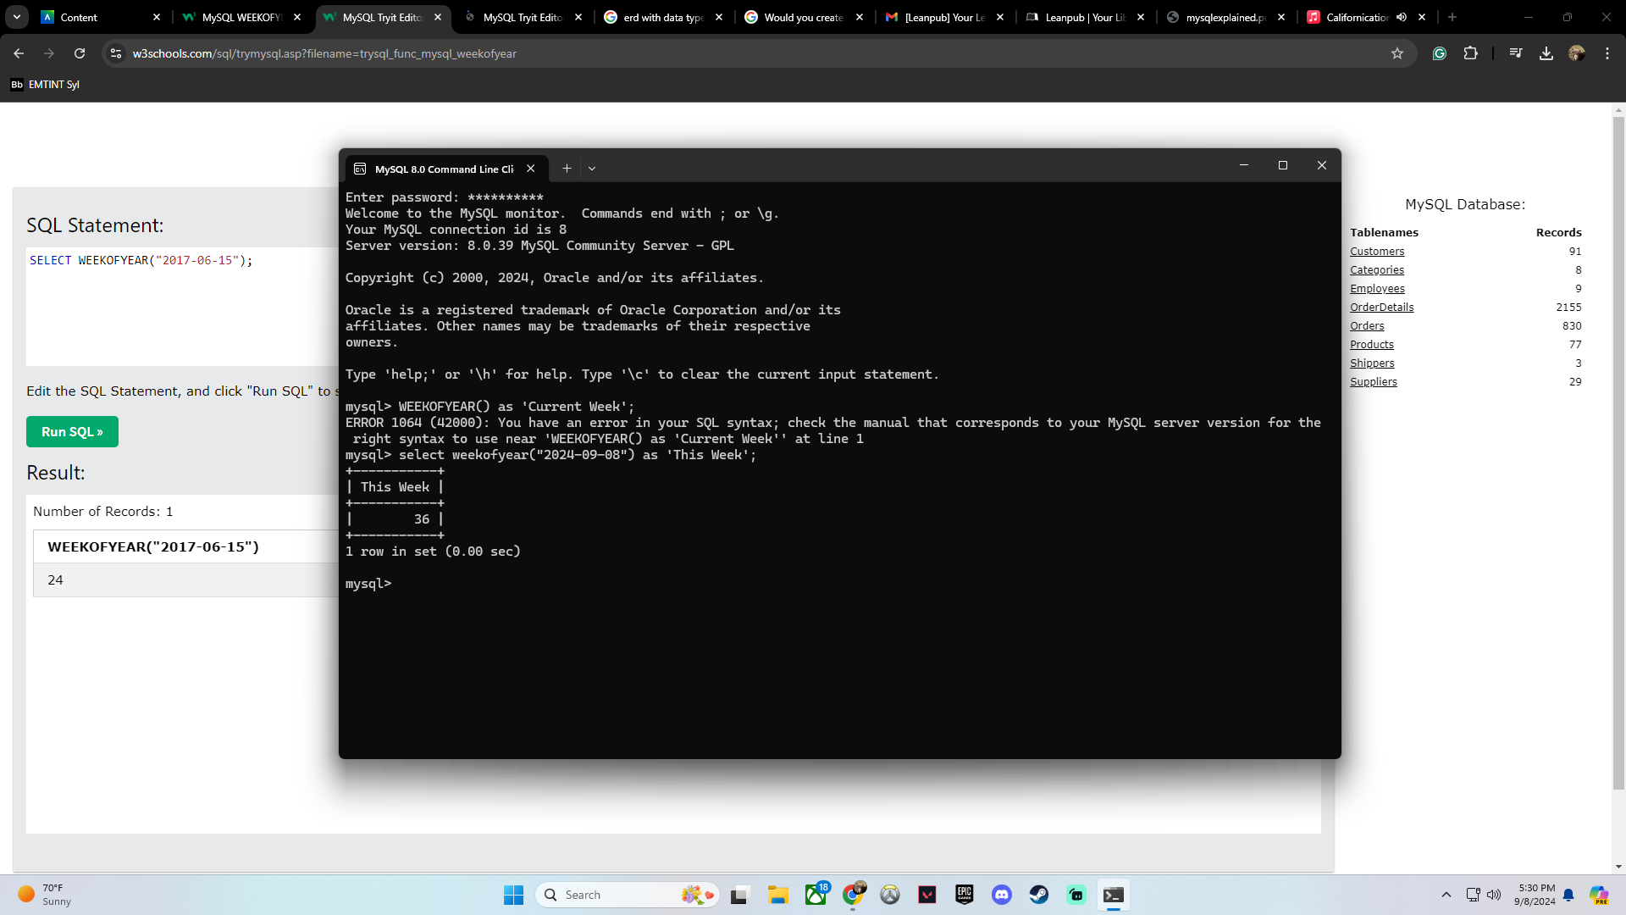This function is called ”WEEKOFYEAR”

The syntax is usually SELECT WEEKOFYEAR(YYYY-MM-DD); though I made sure to add the title as “This Week” so it makes sense. I would think this would be used to find what week a certain date was to compare sales or some other type of annual value!

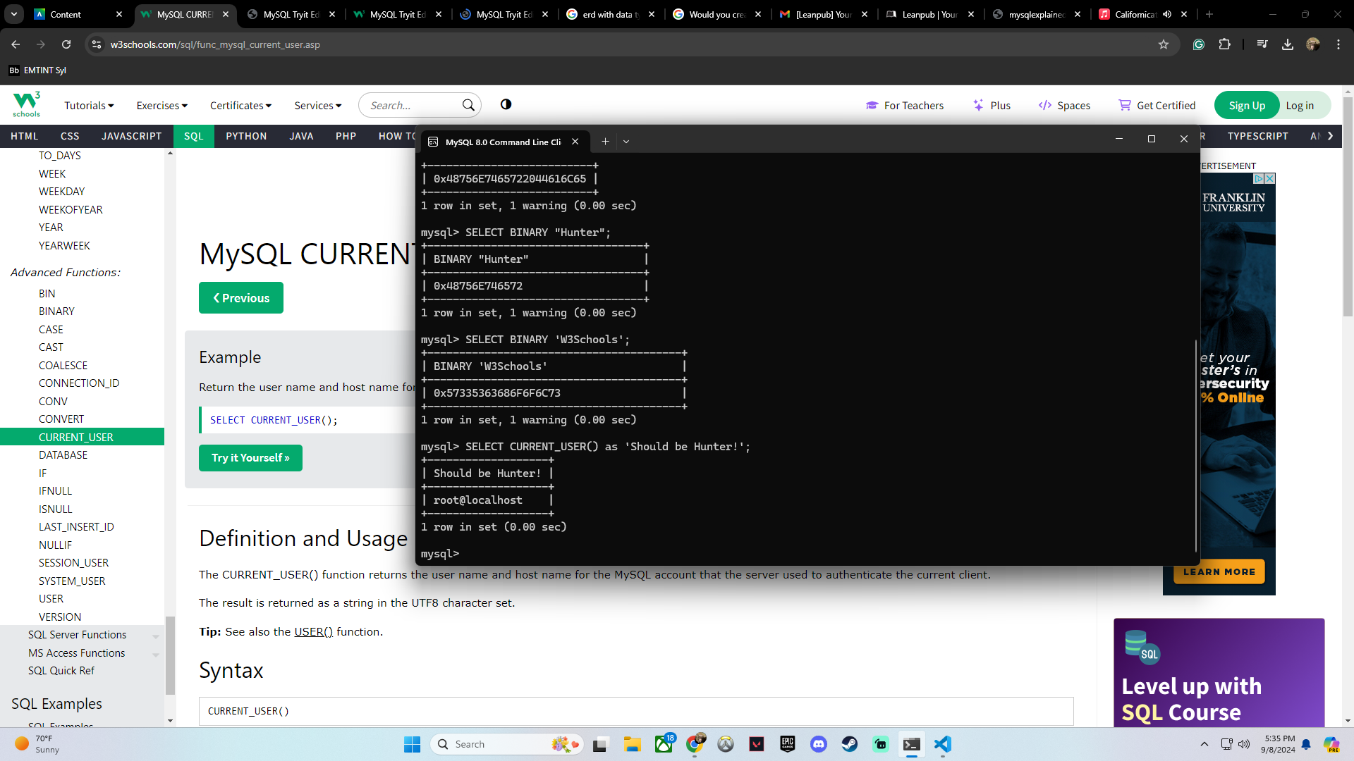This function is called” CURRENT_USER”

The syntax is usually SELECT CURRENT_USER (); but I added what I thought was going to spit out as the title and I was completely wrong. It shot out root@localhost which is just the main user! You would probably use this function to make sure you are on the right user so you are not accessing things you should not be. It could also tell you which user is online at the moment just in case that person should not be on the current user.

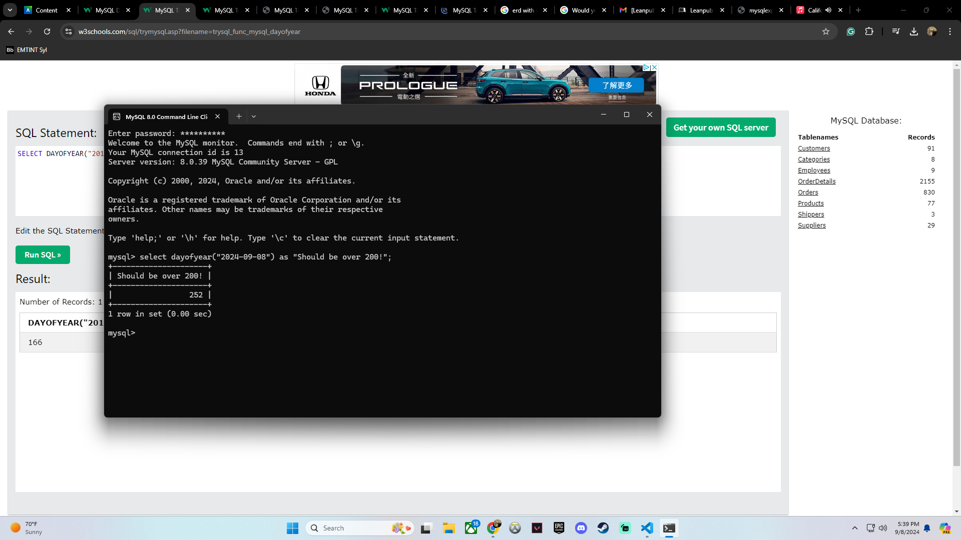This function is called ”DAYOFYEAR”

The usual syntax is SELECT DAY OF YEAR(YYYY-MM-DD); but I added how big I thought the number might be! I would think you would use this function to do something similar to the current week, but instead of weekly sales, you would be looking at specific day sales!