Hunter Dale

CSD-380

4/20/25

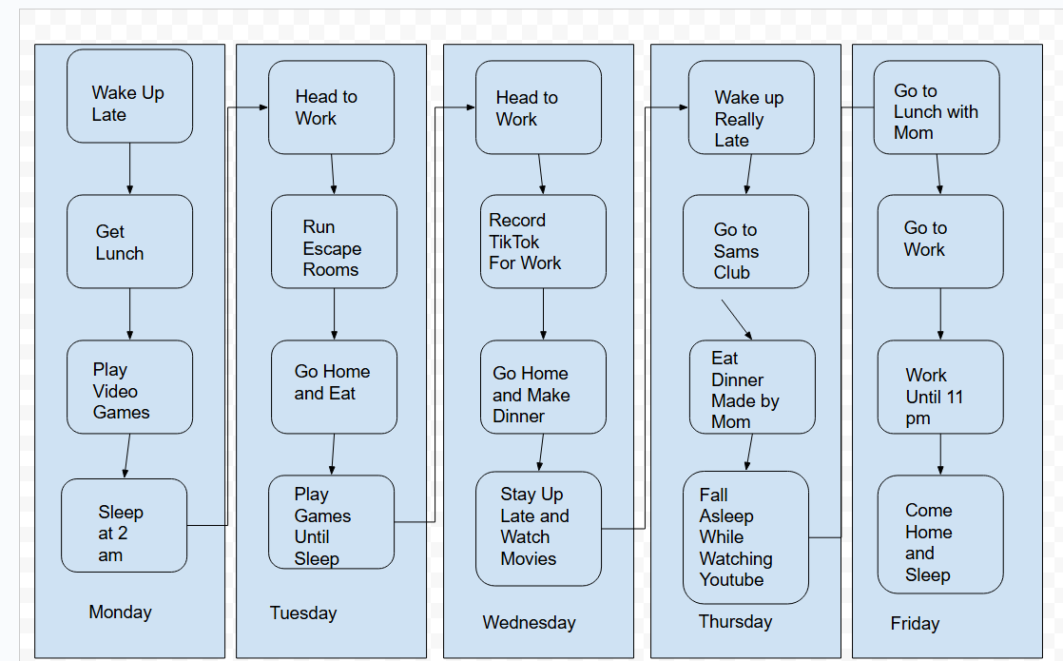

|  |  |
| --- | --- |
| Monday | Half-Day (12.5 Hours |
| Tuesday | Full Day (16 hours) |
| Wednesday | Full Day (17 hours) |
| Thursday | Half-Day (13 Hours) |
| Friday | Full Day (18 hours) |

Estimated Time Cycle (5 days)

|  |
| --- |
| I would say that I could optimize this but honestly on days I have to work I am busy or sleeping until I have to head to work. I have a very good personal life to work life balance and I have made it an important point to keep it that way.  The best thing I can say about better flow would be to on my way home to pick up food or make dinner myself so my mom does not have to work so much after she worked all day. |