Lundi, 25 November 2019,

# Monnaies Numériques

# 

Computer Science & Engineering

9329020182

Raphael STIEFFATRE

1. Installing and creating a truffle project :

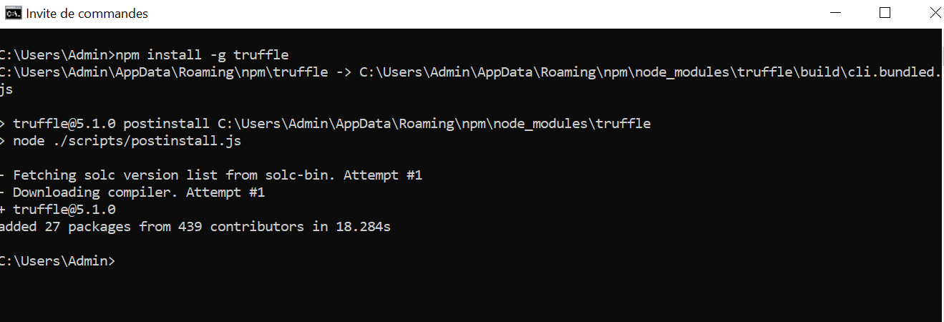

1. ERC20 token contract :

ERC20 : implementation of OpenZepelin

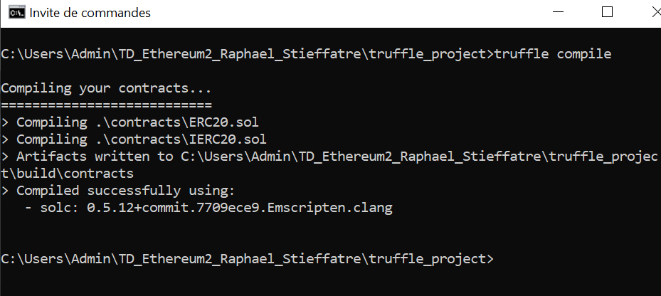

1. 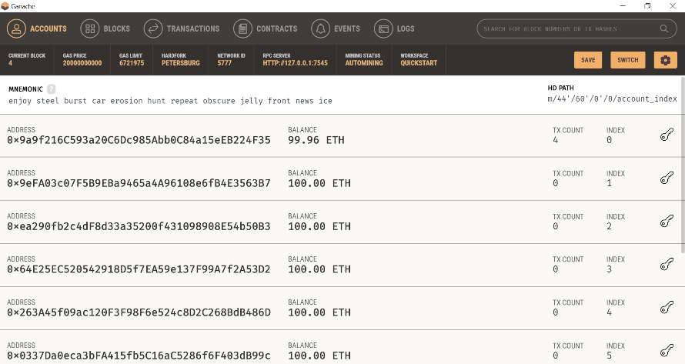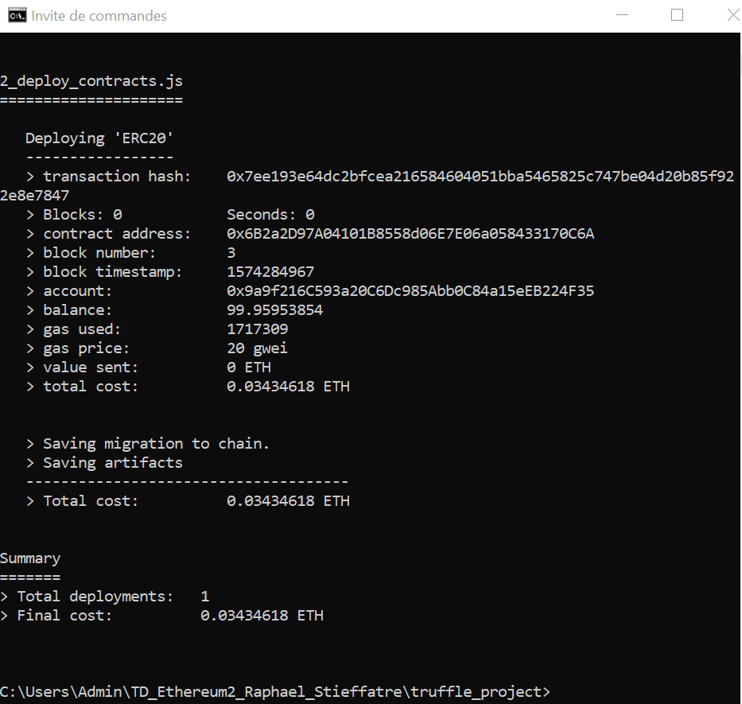Migration to Ganache :
2. Whitelisting : use of the modifier onlyWhitelisted of Openzeppelin WhitelistedRole contract :

