GoPMgr

Reporting and Extensions

STATUS  Proposed design |  | OWNER  GoPMgr maintainer |  | LAST UPDATED  November 13 2026

Authors | GoPMgr engineering documentation
Reviewers | Independent source review completed; owner decisions remain open
Related docs | ADR 014 and ADR 015 with their requirement registers
Scope | Trustworthy reports and controlled extension boundaries for local project data

1. Abstract
Integrate reporting integrity and secure extensions into the existing Go-first architecture. Preserve all reporting capabilities, authoritative source facts, exact calculations and offline operation. Reports share consistent snapshots and typed results; optional extensions remain outside the host trust boundary.
This proposed detailed design retains 120 explicit reporting requirements, eight expanded catalog families and 31 extension identifiers. Workstream direction, implementation authorization and qualification are separate. Existing ADR 010 and ADR 011 decisions continue to control.

2. Goals and Non-Goals
Goals | Non-goals
Preserve the full reporting and lifecycle catalog | No reduction to a small set of similar templates
Make calculations and issued evidence reproducible | No invented facts, histories or certainty
Keep core reports offline and host-native | No mandatory Wasm, marketplace or network service
Isolate optional execution and protect project data | No runtime, schema or public SDK adoption by this document

3. Background and Problem Statement
The reviewed baseline is main ac20cbe. Existing reports, exports, audit and document versions are useful foundations. Financial reports already use a read transaction; combined report preflight and resolution use separate reads. Immutable issued revisions and recovery remain target work.
PS 02 rules and App.AuditSchedule exist; the findings UI remains open. KRN 01 and KRN 02 constrain affected schedule, EVM and baseline claims. Reporting must neither alter kernel semantics incidentally nor represent a template as a qualified calculation.

4. Proposed Architecture

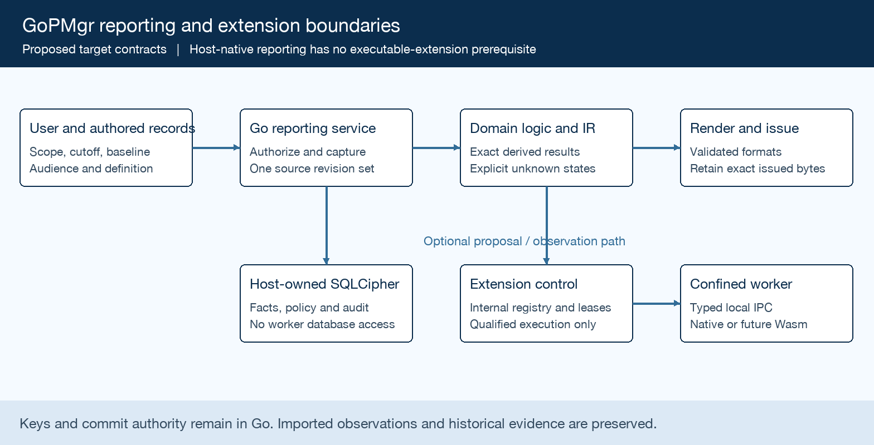
Figure 1. Host reporting path and separately qualified extension execution.

Core components

Component | Responsibility | Primary storage | Failure behavior
Go host | Authorization, domain calculations and commit authority | Encrypted project records | Reject unauthorized or stale changes
Snapshot and IR | Consistent source vector and typed derived results | Versioned inputs and policies | Block incomplete required claims
Render and issue | Accessible formats, exact bytes and recovery | Private issue package | Incomplete output is never issued
Extension control | Internal registry, admission and leases | Host-owned policy | No signature-implied permissions
Isolated runner | Qualified native or Wasm execution | Bounded job data only | Cancel, contain and account for cleanup

5. Request Lifecycle
- Select a versioned report definition, project scope, period, baseline, audience and output format.
- Authorize project and field access; validate input, applicability, completeness and destination before disclosure.
- Freeze project revisions and policy versions. For portfolios, record a per-project observation vector.
- Calculate in host domain services, then compile one typed ReportIR with source lineage and explicit metric states.
- For an approved issue, bind approval to exact revision and stage complete private artifacts before committing issuance.
- Bound generation and optional worker work; cancellation and failed cleanup must not expose an incomplete issue.
- Verify output hashes and record the outcome. Retain original issued bytes; restatements create successor issues.

6. API and Data Contracts

Primary data contract

Field | Type | Required | Description
definition | ID and version | Yes | Pins schema, calculations and output semantics
source_vector | Project revisions | Yes | Names captured records, cutoffs and coverage
metric_state | Typed value and state | Yes | Six states per ADR 014 ARCH14; coverage separate
policy | Versioned references | Yes | Audience, financial, calendar and approval policy
issue_identity | ID and digest | For issue | Binds approved revision to retained output bytes
execution_lease | Scoped handle | For extension | Binds operation, artifact, principal and epoch
evidence | Refs and outcomes | Yes | Per-format, platform and workload qualification

Contract guarantees

- Validation, calculation, preview and export must use the same frozen input and policy versions.
- Bind operations to principal incarnation, project, revision and receipt; reject replay and stale authority.
- Capture definition, calculation, calendar, financial basis, locale and artifact identities for reproduction.
- ReportIR is a derived view. Project records and preserved imported observations retain their authority.
Canonical requirements and dependency contracts are maintained in the repository at
docs/design/reporting-extension and docs/testing/reporting-extension-assurance.md.

7. Consistency, Idempotency, and Replay

Single-project snapshots use a read transaction or a verified immutable revision set. Portfolios expose independent observation times and coverage rather than claiming an atomic global snapshot. Required writes and recovery contracts remain subject to format and audit decisions.
Scenario | Expected behavior | Reasoning
Repeated issue request | Use the authorized operation receipt | Prevent duplicate material issuance
Required manifest write fails | Return failure; keep unissued staging recoverable | A PDF alone is not a committed issue
Timeout or worker failure | Cancel within qualified budgets; retain unhealthy accounting if cleanup fails | Protect ordinary host work and acknowledged edits
Policy or source changes | Use the frozen snapshot; revalidate lease at commit | Prevent mixed revisions and stale authorization

8. Security and Privacy Considerations

- Host-only authentication, encryption keys, persistence, scheduling and commit authority; default-deny scoped extension leases.
- Authorize each source, filter and audience; redact outputs and manifests. Log reason codes and digests without sensitive payloads.
- Keep signing and project keys in the host. Render PDF content, apply PDF/A metadata, then apply PAdES as the final mutation.
- Reject executable templates, unsafe paths, hostile archives and implicit network access. EXT profile E2 needs both guest and OS confinement.
- Retain original issue bytes and audit history. Approval, archive, withdrawal, retention and disposition need explicit policy and authority.

9. Operational Readiness
Signal | SLO or alert | Owner | Launch gate
Semantic agreement | Independent oracle for each claimed output | Domain owner | Required
Resource use | Measured profile; targets need approval | Maintainer | Required
Unauthorized effects | No disclosure or mutation outside granted scope | Security reviewer | Required
Source coverage | Reconcile selected, excluded and unknown records | Report owner | Required
Issue recovery | Retrieve exact bytes; reject partial issuance | Independent reviewer | Required
Rollout constraint: qualification is per requirement, format, platform, profile and workload. No release by date or green build alone.

10. Alternatives Considered

Alternative | Why it was considered | Why it was not selected
Renderer-owned calculations | Convenient template customization | Creates conflicting facts and weakens traceability
In-process native plugins | Low call overhead | Shares host privileges and failure scope
Wasm adoption now | Future untrusted extensibility | Requires separate runtime and confinement evidence
One global portfolio snapshot | Simple executive narrative | Independent encrypted files have no global transaction

11. Open Questions
- Approve persistent format, audit, retention and exact-revision approval policies before dependent writes.
- Resolve financial recognition, reserves, FX, shared identity and material coverage rules before dependent report claims.
- Measure hardware, latency and whole-pipeline resource budgets; preserve 50k editable and 100k stress objectives.
- Qualify the runtime, ABI, package trust and supported installed platforms before community execution or SDK release.

12. Decision and Next Steps
Start with RILD 0 definitions and source traceability, then truthful findings and consistent snapshots. Deliver host-native reports with incremental accessibility. Persistent issuance, connected data and executable extensions follow only their applicable decisions and qualification gates.
Milestone | Deliverable | Exit criteria
RILD 0 and 1 | Definitions, requirement crosswalk and truthful findings | Owners, decisions and independent oracles identified
RILD 2a and 4 | Snapshots, typed results and core reports | Same-source parity and applicable Q gates pass
RILD 2b, 3 and 5 | Governed issues and dependent domain expansion | Format, audit, retention and migration gates pass
RILD 6 and 7; EXT gates | Incremental UX and separately qualified execution | Installed evidence, adversarial review and owner acceptance

Proposed target contracts do not establish implementation authority or runtime qualification. RILD evidence levels and EXT execution profiles use separate namespaces.

