Comparative Study of In-Memory Computing in an 8×8 6T SRAM Array across 180 nm, 90 nm and 45 nm CMOS Technology Libraries

Subham Prasad Gupta  B.Tech. VLSI Student at VIT Chennai  .  shubham01dec04@gmail.com | Jairus S. Solomon  B.Tech. VLSI Student at VIT Chennai  .  jairus.samraj2023@vitstudent.ac.in | Vinayak S. Salunke  B.Tech. VLSI Student at VIT Chennai  .  salunkevinayak2005@gmail.com

Abstract
In this work, we present a comparative study of in-memory computing (IMC) implemented within a small-scale static-random-access-memory (SRAM) cell array. We designed an 8×8 bit array using a conventional 6T SRAM cell along with required peripheral circuitry—column decoder, precharge & equalise circuits, write-driver and sense amplifier—targeting three distinct CMOS technology libraries: 180 nm, 90 nm and 45 nm. To enable in-memory computing, we appended a latch at the output of the sense amplifier (D_out) to retain the previous bit’s value, and implemented a two-bit selection logic block which takes the current D_out and the previous D_out as inputs and selects one of four operations: NAND (00), NOR (01), XOR (10), or “Flush” (11) (i.e., reset/clear). We performed layout-level implementation in Cadence Virtuoso for all three technology nodes, extracted timing and power data, and compared the delay and average power consumption across technology nodes for both standard read/write and the IMC-enabled operations. Our results show the effects of technology scaling on the in-memory compute overhead: while the 45 nm library yields the lowest delay, leakage and dynamic power advantages, the relative overhead of the IMC logic vs. pure memory operations evolves with technology scaling. We discuss the trade-offs of area, power, delay, and reliability in the context of small-scale IMC SRAM, and highlight considerations for architecture-level translation to larger arrays and more complex compute operations.

Keywords - 6T SRAM Cell, 45 nm Technology, 90 nm Technology, 180 nm Technology, Cadence Virtuoso, Column Decoder, Compute-in-Memory (CIM), Delay Analysis, In-Memory Computing (IMC), Logic-in-Memory, Low-Power Design, Nanometer CMOS, Power Comparison, Sense Amplifier, SRAM Array, Technology Scaling, VLSI Design, Write Driver.

1. Introduction

The continuous increase in data-intensive applications such as artificial intelligence (AI), machine learning (ML), and Internet-of-Things (IoT) systems has placed significant emphasis on improving the energy efficiency of computation. Conventional Von Neumann architectures, which physically separate the memory and processing units, suffer from the well-known memory wall — the performance and energy bottleneck caused by frequent data transfer between the processor and memory [1]. To mitigate this limitation, researchers have explored In-Memory Computing (IMC) or Processing-In-Memory (PIM) techniques, where computation is performed directly within or near the memory array [2]. IMC reduces data movement and power consumption, offering a promising approach for accelerating low-precision and logic-based operations.

Among various memory technologies (e.g., DRAM, Flash, RRAM, MRAM), SRAM (Static Random Access Memory) has been widely adopted as a building block for IMC due to its high speed, CMOS compatibility, and stability. The standard 6-transistor (6T) SRAM cell forms the cornerstone of most on-chip memory arrays. A conventional 6T SRAM cell consists of two cross-coupled CMOS inverters forming a bistable latch and two access transistors controlled by the wordline (WL) that connect the internal storage nodes to complementary bitlines (BL and BL̅) [3]. The typical read, write, and hold operations depend on the balance between access transistor sizing and inverter strength to ensure read stability and write margin.

In a standard SRAM, peripheral circuits such as decoders, precharge and equalization circuits, write drivers, and sense amplifiers are used to support basic memory operations. However, conventional SRAMs do not inherently perform computation; all logic must occur externally in the processor. Integrating simple logic functionality within the SRAM array, without disturbing its read/write integrity, represents the essence of SRAM-based In-Memory Computing [4].

Previous research has demonstrated various approaches to embed computation within SRAM arrays, ranging from bitline voltage manipulation to row-wise operations and modified cell structures such as 8T, 10T, and 12T variants [5]. Yet, these designs often increase area and complexity. A simpler and more compact approach is to retain the standard 6T topology and append minimal external logic at the periphery to enable logic-level operations. This makes it easier to integrate IMC into existing memory architectures while minimizing design overhead.

In this work, we present a 6T SRAM-based In-Memory Computing structure designed as an 8×8 array, simulated in three CMOS technology nodes: 180 nm, 90 nm, and 45 nm. Our design preserves the conventional memory functionality while enabling additional logic operations through a latch and a 2-bit operation select block that can perform NAND, NOR, XOR, and Flush operations between the current and previous memory outputs. By implementing this design in Cadence Virtuoso across multiple technology nodes, we quantitatively assess the effects of technology scaling on power, delay, and performance of the IMC architecture.

This study provides both an educational and analytical perspective on how scaling affects the energy and performance trade-offs of embedded IMC in SRAM arrays, offering insights for future low-power data-centric computing architectures.

2. Literature Survey

Research in SRAM-based In-Memory Computing (IMC) has evolved rapidly over the past decade, spanning multiple design methodologies, circuit architectures, and target applications. This section reviews key prior works relevant to our study, with a focus on (a) IMC architectures using standard 6T/8T SRAM cells, (b) peripheral circuit innovations, and (c) the impact of technology scaling.

Lin et al. [1] provided a comprehensive overview of SRAM-based computing-in-memory circuits, categorizing IMC implementations based on digital and analog domains. They highlighted the potential of SRAM cells for performing logic operations, vector-matrix multiplications, and low-precision neural computations, emphasizing the trade-offs between circuit complexity and accuracy. The review also identified that CMOS technology scaling significantly influences performance and power efficiency in SRAM-based IMC.

Mittal et al. [2] conducted an extensive survey of SRAM-based IMC architectures and applications, analyzing the circuit-level and architectural techniques for enhancing speed and power efficiency. Their work demonstrated that conventional 6T SRAM arrays can be extended for Boolean logic functions (e.g., AND, OR, XOR, XNOR) through bitline-based computations, but at the cost of reduced read margins in some cases.

A more recent review by Yoshioka et al. [3] analyzed emerging compute-in-memory circuits and noted that many recent designs exploit peripheral modifications rather than altering the 6T bitcell itself, which aligns closely with the approach followed in our study. They also discussed design considerations for sense amplifier-based logic, an important building block in our design.

Zhao et al. [4] proposed the DAM SRAM Core, an efficient high-speed compute-in-memory design optimized for binary neural networks. Their architecture employed modified sense amplifier circuits to implement feature extraction and bitwise logic directly within the SRAM, achieving significant reductions in latency and power. This demonstrates that small logic blocks integrated at the periphery can yield high performance without completely redesigning the core SRAM cell.

In another related work, Lin et al. [5] demonstrated how technology scaling affects IMC design. They showed that as feature sizes shrink, cell stability, leakage power, and variability become critical factors that can limit SRAM reliability. This reinforces the importance of our comparative study across 180 nm, 90 nm, and 45 nm libraries.

A number of studies also explored 8T and 10T SRAM-based IMC cells [6][7], which provide read-decoupled architectures, thus improving stability during simultaneous logic and read operations. However, these designs incur larger area overheads compared to standard 6T SRAMs. Our work deliberately employs the 6T structure to minimize transistor count and demonstrate that IMC can be achieved even in minimal configurations by using external latch and logic stages.

Furthermore, studies such as those by Lin et al. [8] and Kaushik et al. [9] highlighted how Cadence Virtuoso-based implementations and simulation across multiple technology nodes can yield valuable insights into design scaling trends. These works reinforce that technology scaling not only reduces delay and dynamic power but also magnifies leakage contributions, which are crucial in deep-submicron SRAM IMC designs.

In summary, prior literature establishes a strong foundation for IMC using SRAM arrays, with various innovations targeting improved efficiency, stability, and performance. However, there remains a gap in comparative analyses of the same IMC architecture implemented across multiple technology libraries. Our study directly addresses this by presenting a systematic comparison of delay and power across 180 nm, 90 nm, and 45 nm nodes for a uniform 6T SRAM-based IMC design.

3. Methodology

3.1. Design Overview

We started with a standard 6-transistor (6T) SRAM bit-cell (two cross-coupled inverters plus two access transistors) arranged in an 8-row × 8-column array. The peripheral circuits include:
- A column decoder to activate one of the 8 columns during read/write.
- A precharge & equalise circuit for the bit-lines before each access.
- A write driver to drive bit-lines during write operations.
- A sense amplifier to sense the bit-line voltage during reads.

For the IMC functionality, we introduced the following modifications:
- A latch at the output of each sense amplifier capturing the previous D_out (i.e., the prior bit-value) and holding it until the next cycle.
- A small compute logic block that takes two 1-bit inputs: (current D_out) and (previous D_out), and a 2-bit selection input S[1:0]. Based on S[1:0], the block performs:

  - 00 → NAND(current, previous)
  - 01 → NOR(current, previous)
  - 10 → XOR(current, previous)
  - 11 → Flush (reset output to ‘0’ or some defined value)

- The output of the compute block becomes the effective output of the read operation when IMC mode is enabled.

3.2. Implementation & Simulation

We implemented the entire design (array + peripherals + latch + compute block) in Cadence Virtuoso for three technology libraries: 180 nm, 90 nm and 45 nm CMOS. For each node we:
- Performed circuit design, extracted parasitics, performed layout and extraction.
- Conducted functional simulations to verify correct memory operation and correct compute-logic behaviour for all four selection modes.
- Conducted timing simulations to determine delay metrics: (a) memory read time, (b) memory read-with-compute time, (c) memory write time.
- Conducted power simulations to capture average power consumption in representative use-cases: (a) purely memory read/write operations (no IMC logic), (b) IMC logic enabled operations. We recorded average power over a defined number of cycles (for example 1000 random accesses).
- Compared delay and average power across the three nodes, and computed overheads introduced by the IMC logic (for each node) as the difference between the read-with-compute path and the baseline read path.

3.3. Metrics & Comparison

Key metrics reported include:
- Read delay (s) for each node in memory-only mode between latched and computed output.
- Average power (W) during memory-only operation, and during IMC operation.

We also discuss scaling trends: how much the delay drops when moving from 180 nm → 90 nm → 45 nm, how much the average power reduces, and whether the relative overhead of the compute logic changes with scaling.

Design Caveats & Assumptions

- The 8×8 array is small and used for demonstration; in a real system the array would be far larger and layout parasitics, word-/bitline resistance/ capacitance, and sense amplifier loading would scale differently.
- We assume identical supply voltage scaling (or we note what supply voltages we have used for each library) and identical operating conditions (e.g., temperature, activity factor) for comparison fairness.
- We do not include the area overhead explicitly (though layout area could be reported) and we do not perform reliability/variation analysis in this work (though we note these as future directions).
- The choice of Boolean operations (NAND/NOR/XOR/Flush) is relatively simple; more complex arithmetic or MAC operations would incur different overheads and different scaling behaviour.

4. Final Circuits, Results and Discussion

4.1. 6T SRAM Cell & Array

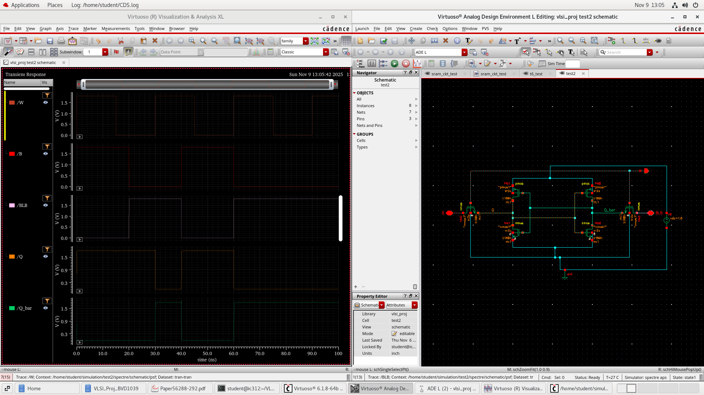
- 6T cell design and transient analysis

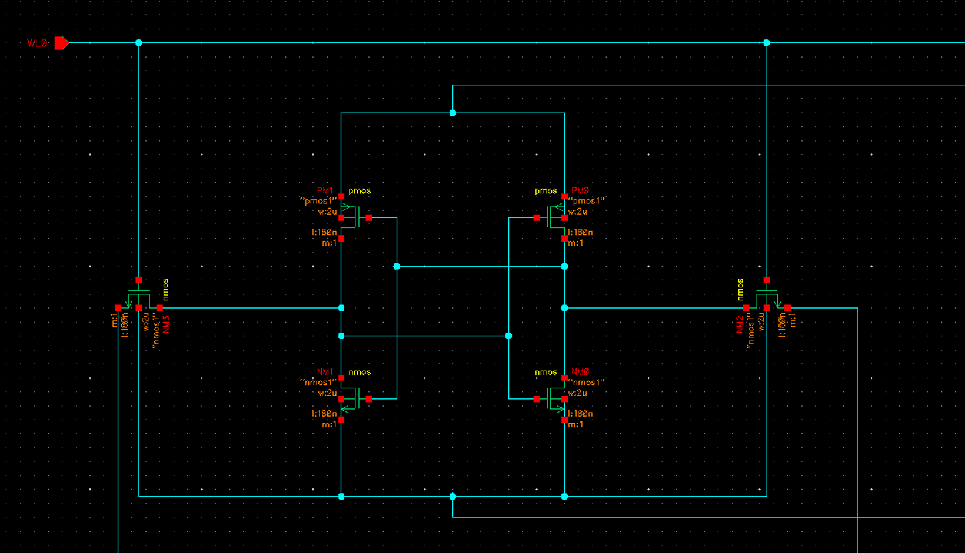
- Same cell design in a 4x4 Array

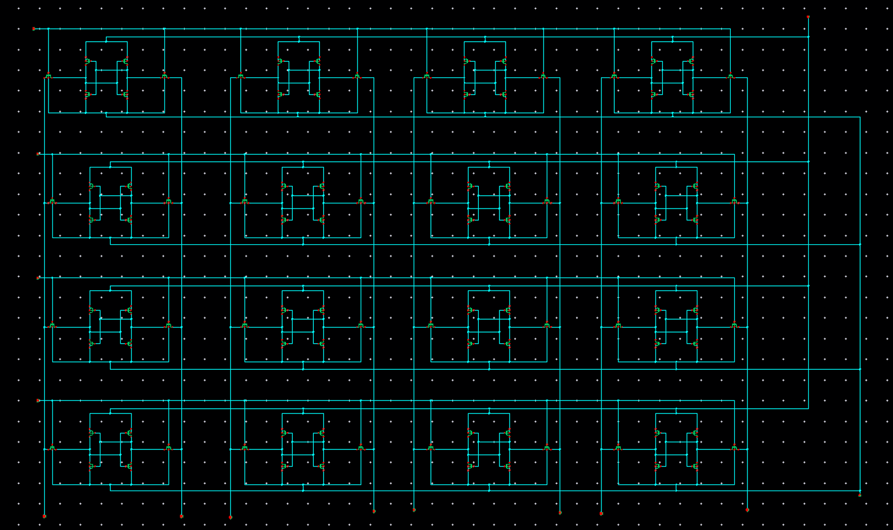
- The 4x4 Array

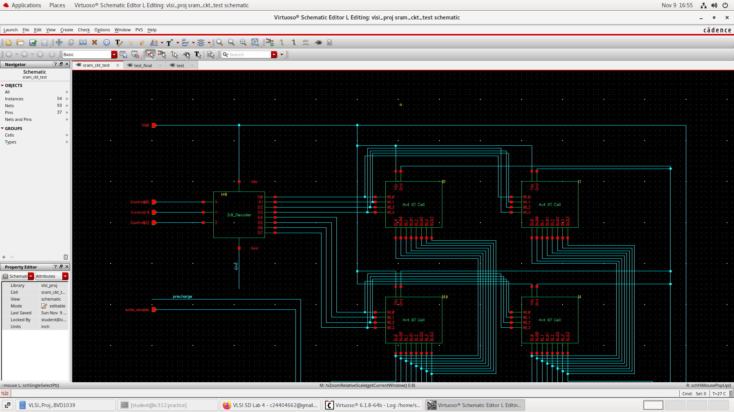
- Symbol of 4x4 array placed in cascade to make the 8x8 array

4.2. Precharge & Equalise Circuit

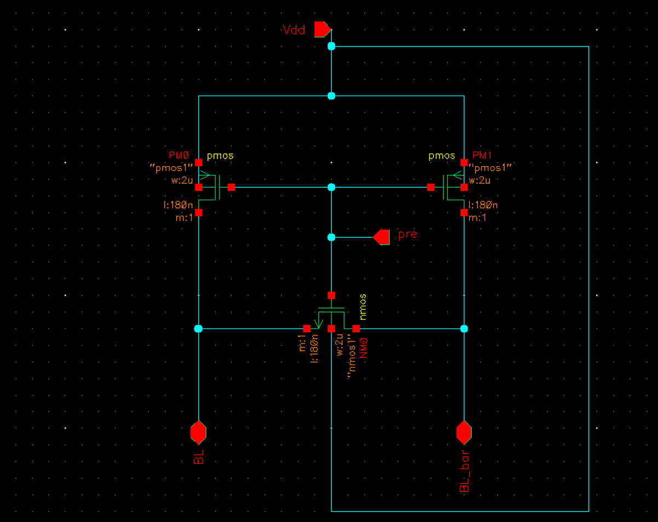

4.3. Write-driver Circuit

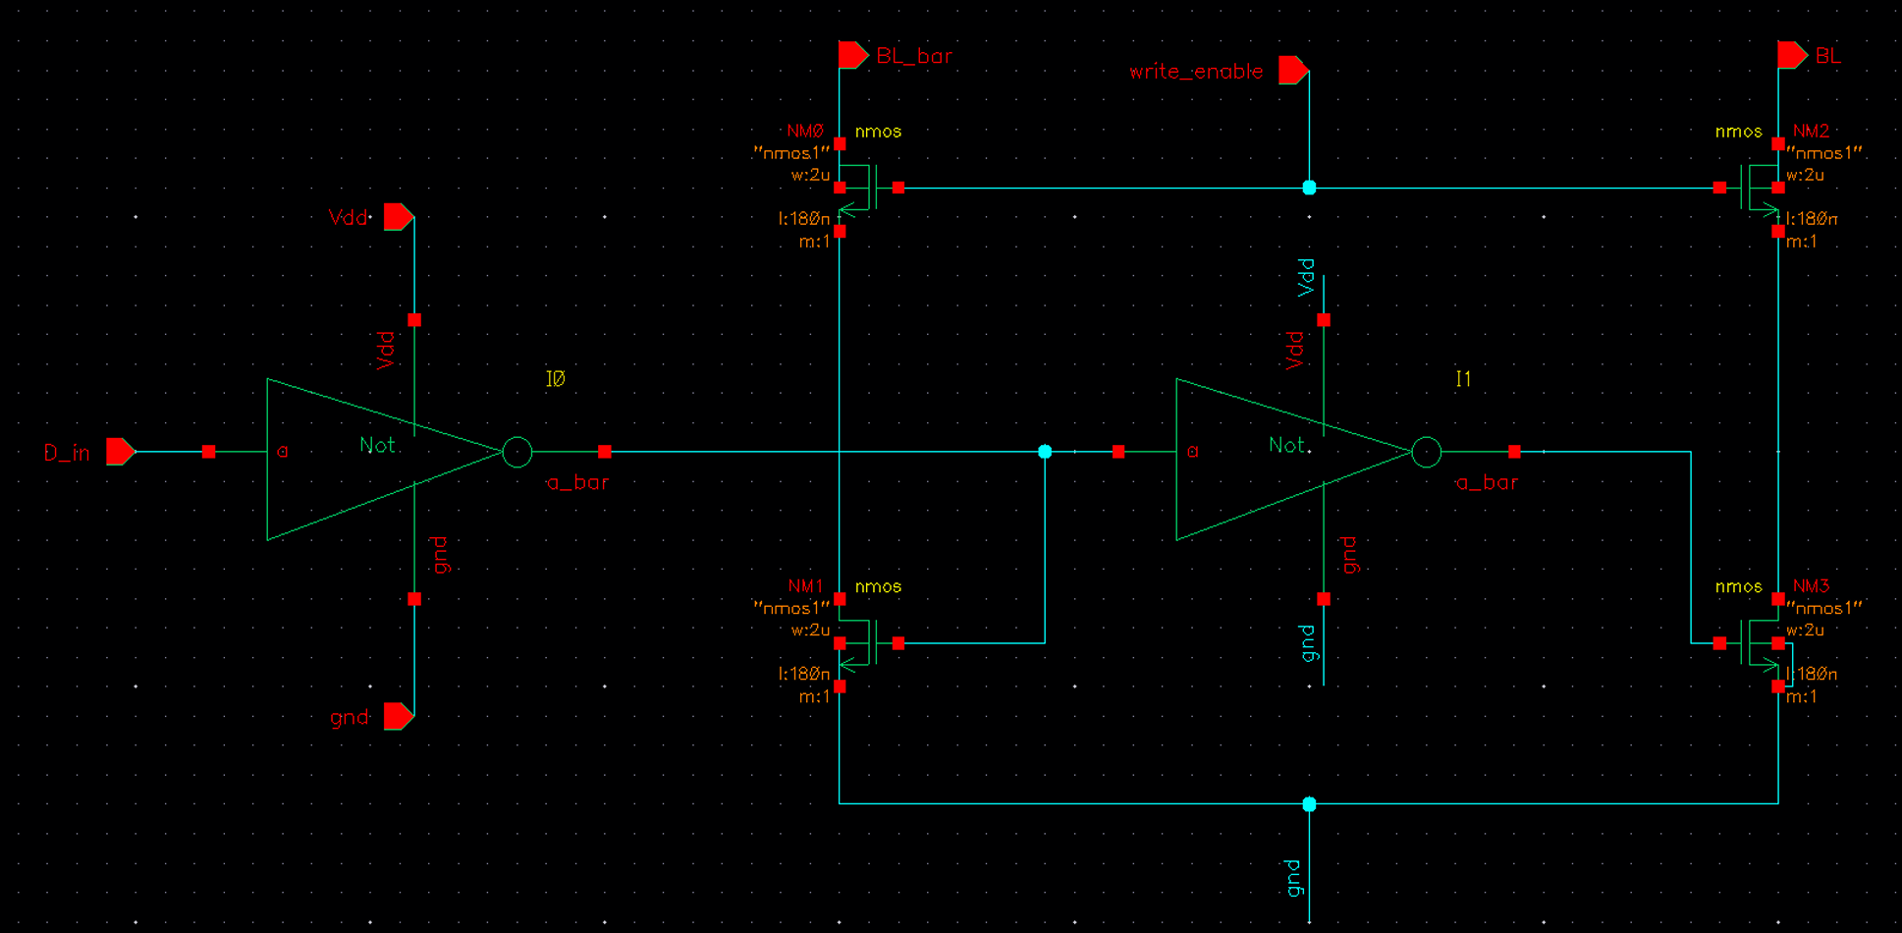

4.4. Sense Amplifier

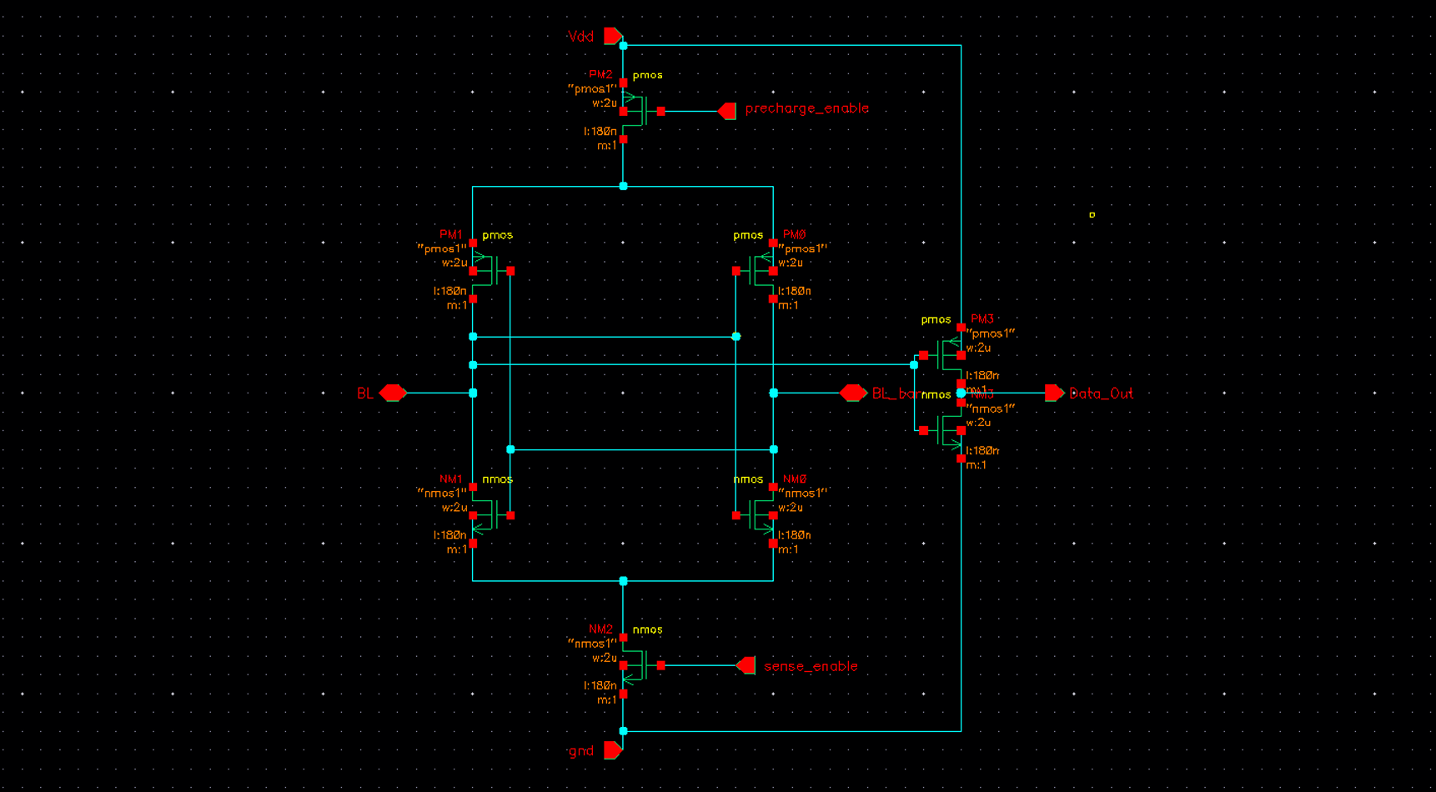

4.5. Column Deocder
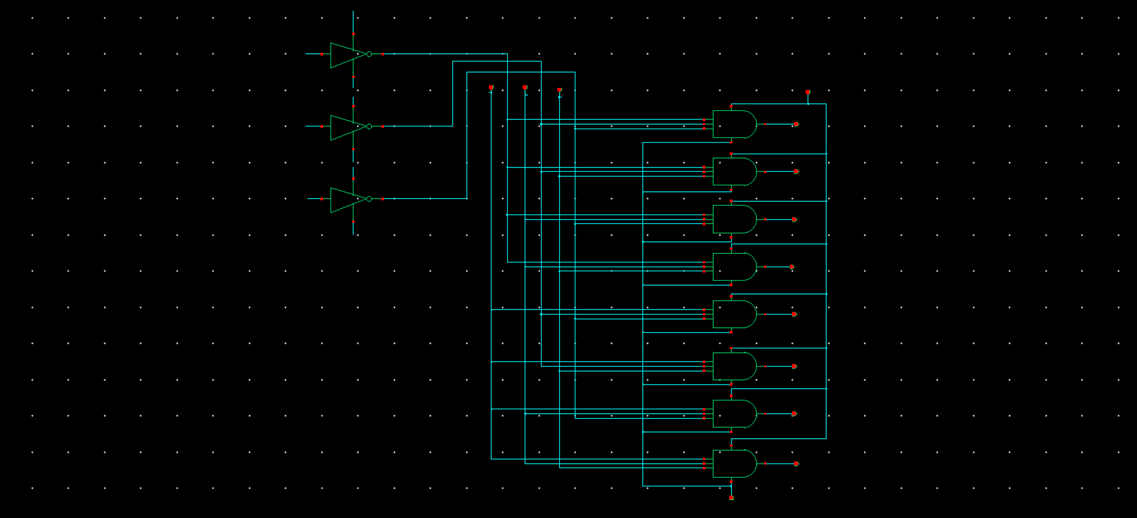

4.6. Compute Block Circuit
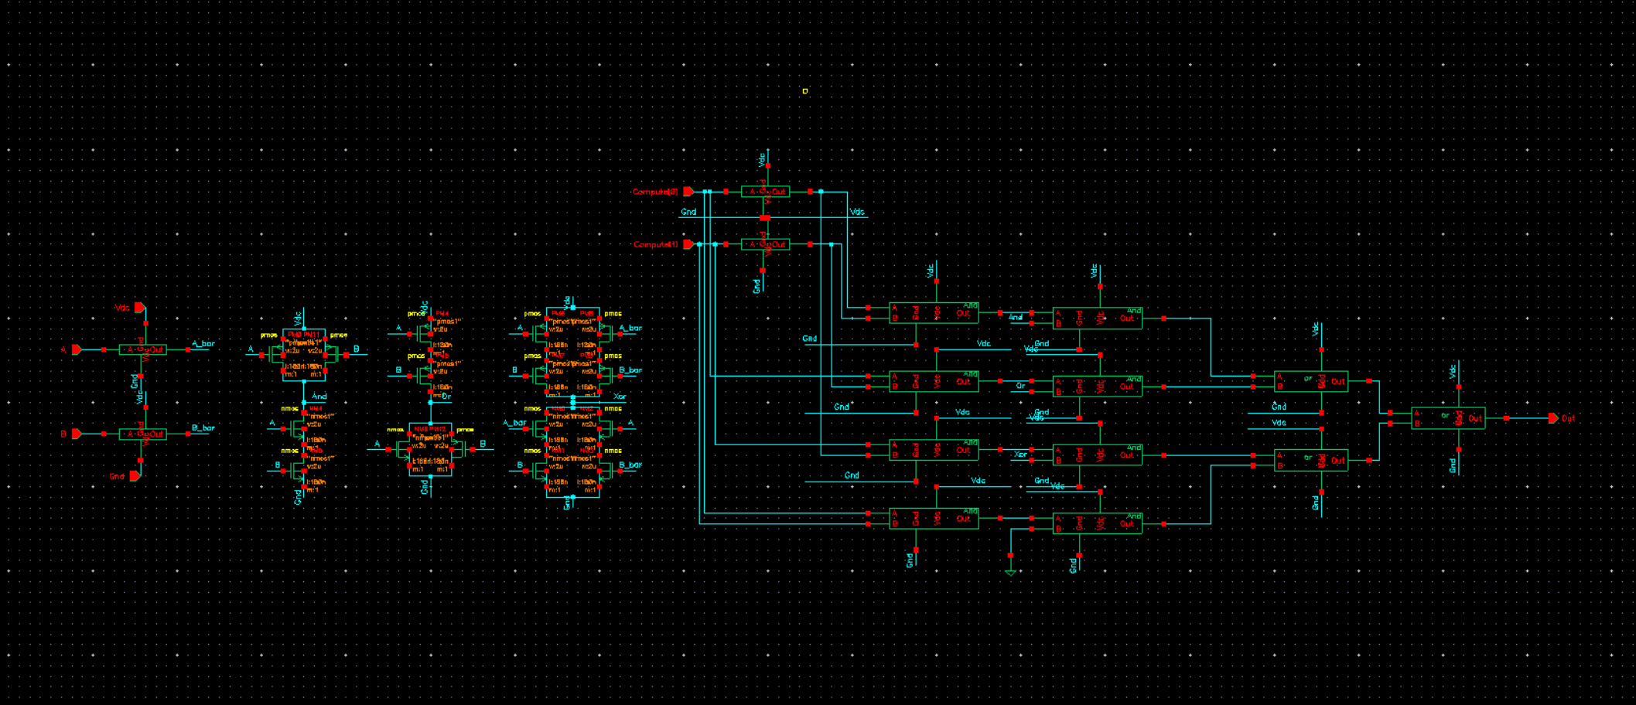

4.7. Latch Circuit
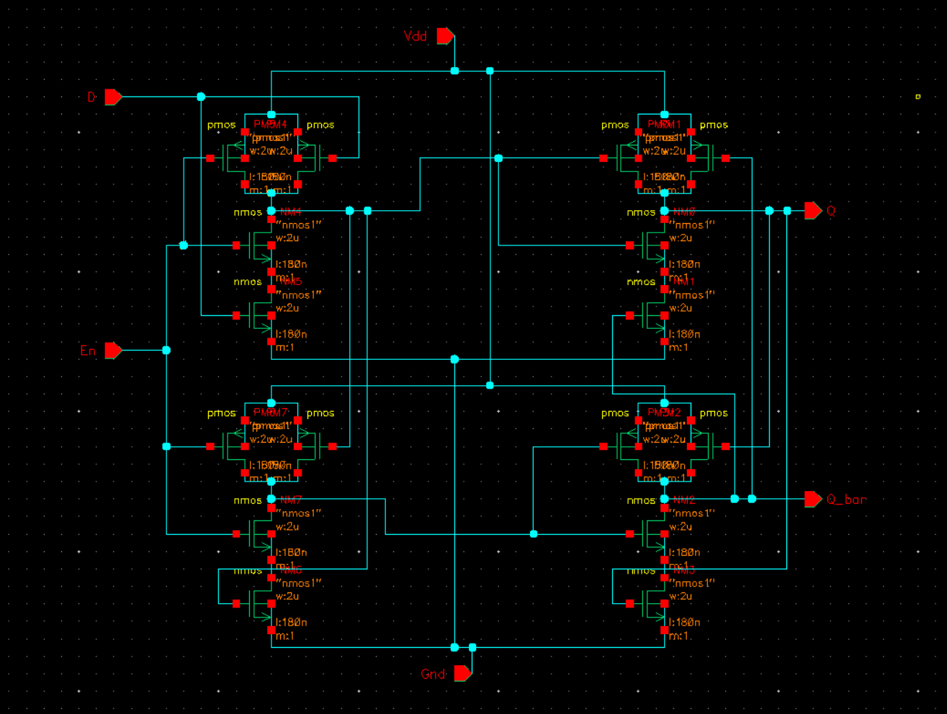

4.8. Main Circuit
4.8.1. Segment 1- 8x8 Array and Column Decoder
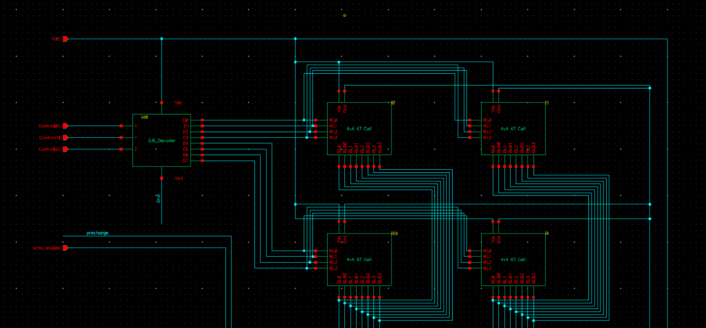

4.8.2. Segment 2- Signal stabilizer peripherals and data input
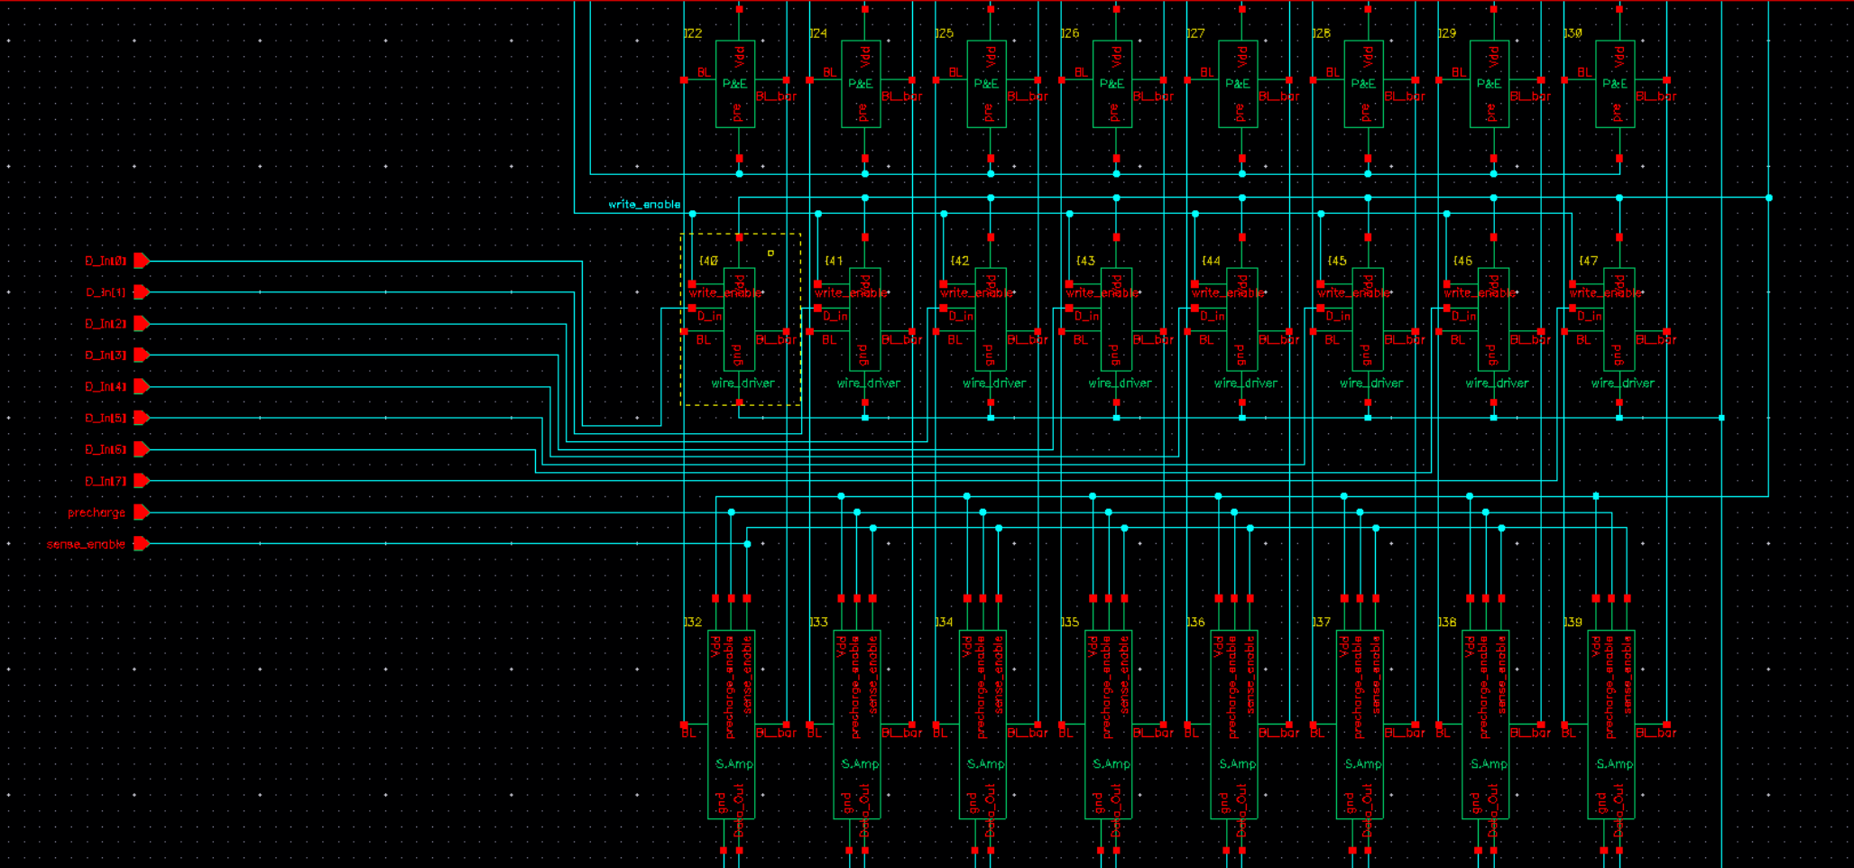

4.8.3 Segment 3- Compute block, data latch and data out
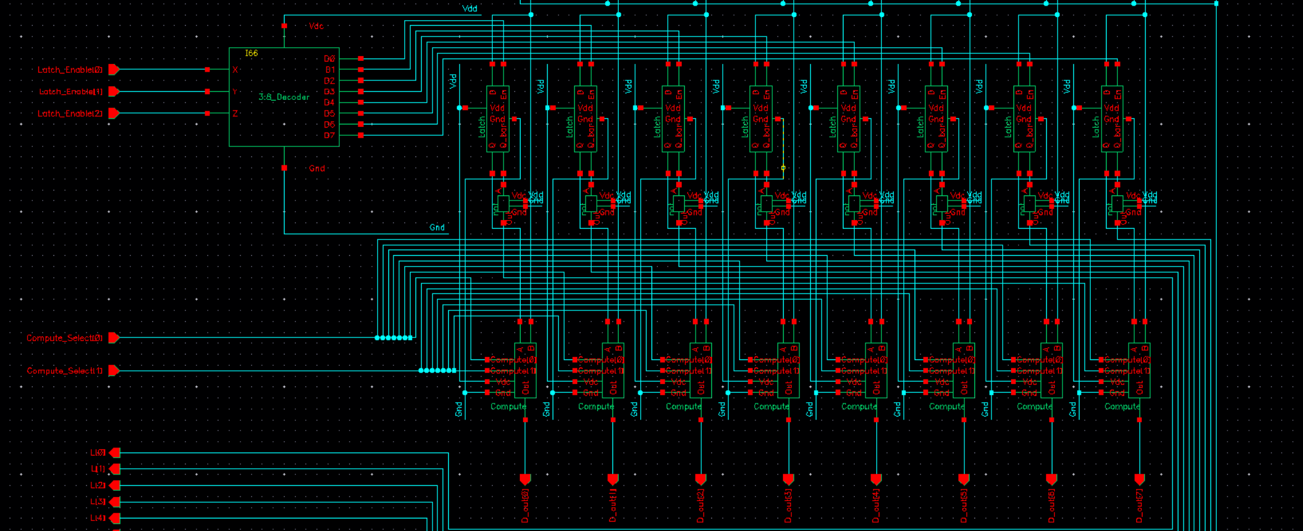

4.8.4. Complete main circuit
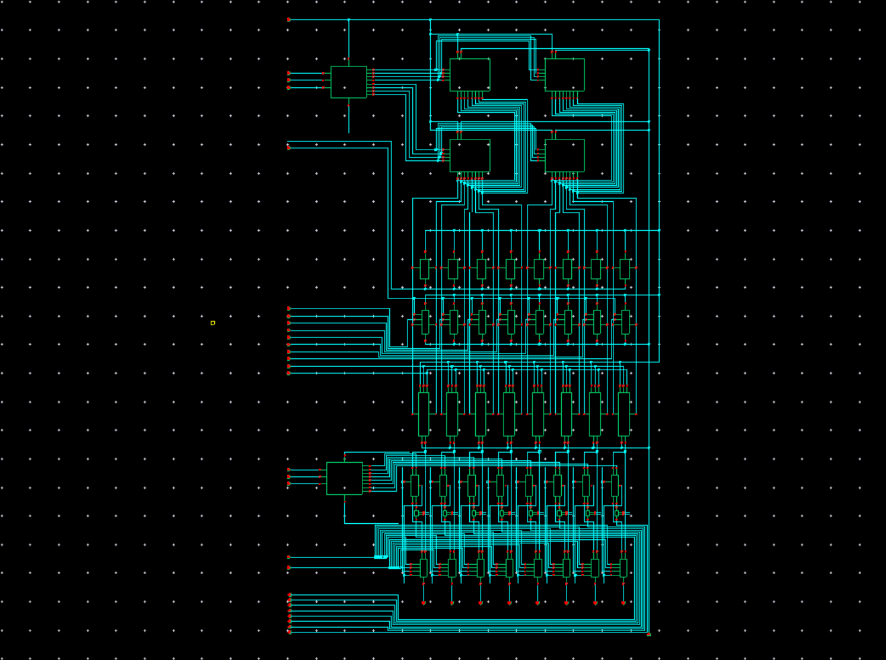

4.9. Transient analysis

4.9.1. Symbol usage
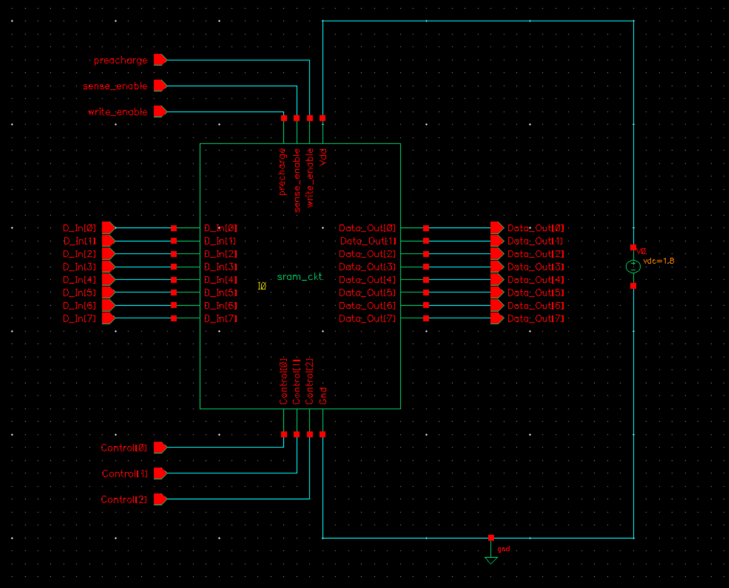

4.9.2. ADE-L stimuli
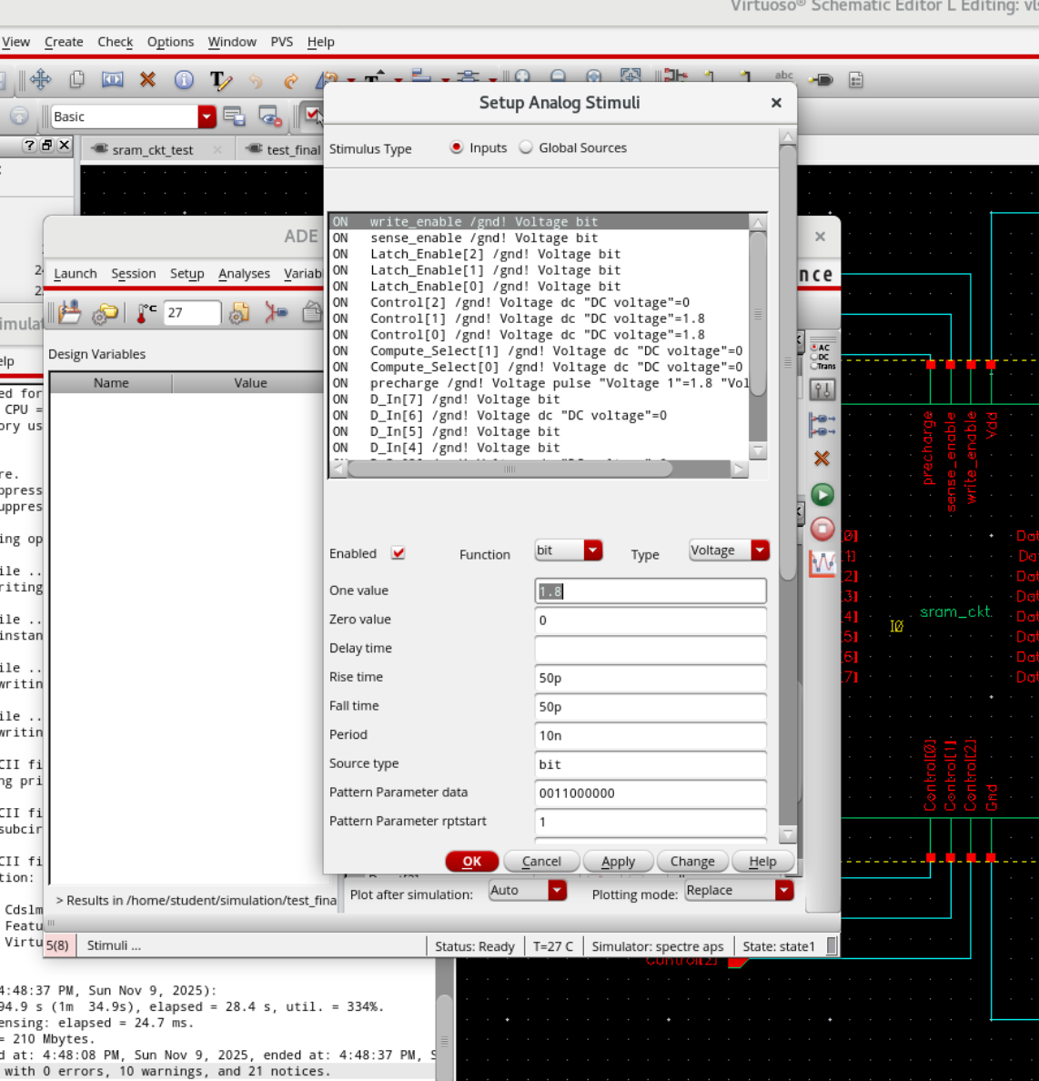

4.9.3. Analysis waveform
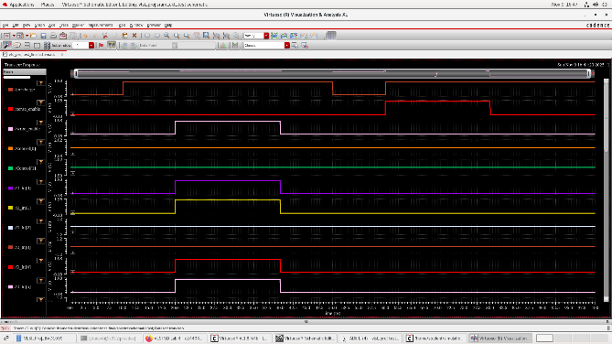
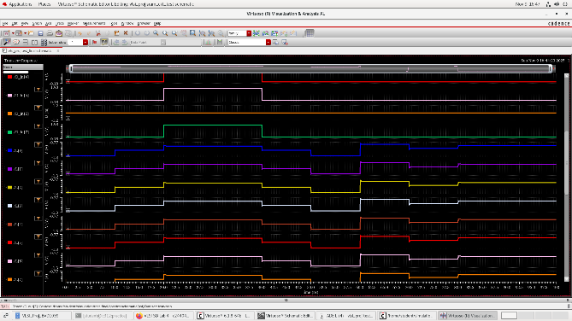
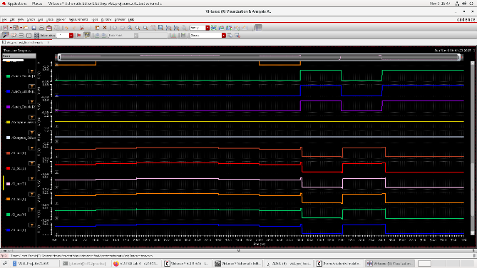
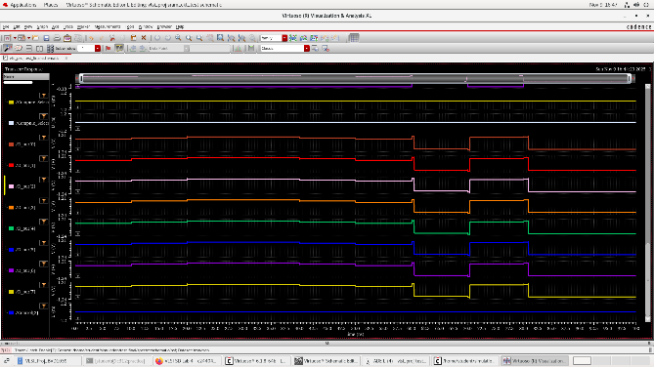

4.9.4. Average Power and Timing Results
- 180nm technology library
Avg(Power) = 35.69 mW
Read & Compute Delay = 10.69 ns
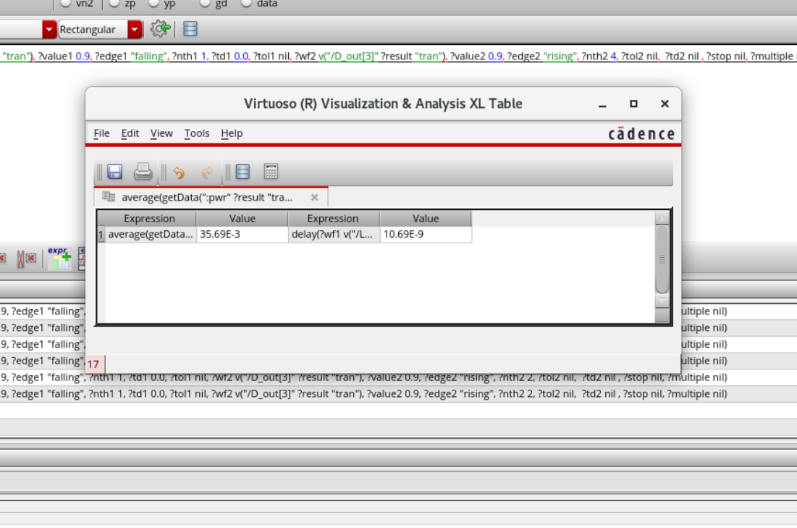

- 90nm technology library
Avg(Power) = 16.81 mW
Read & Compute Delay = 0.397 ns
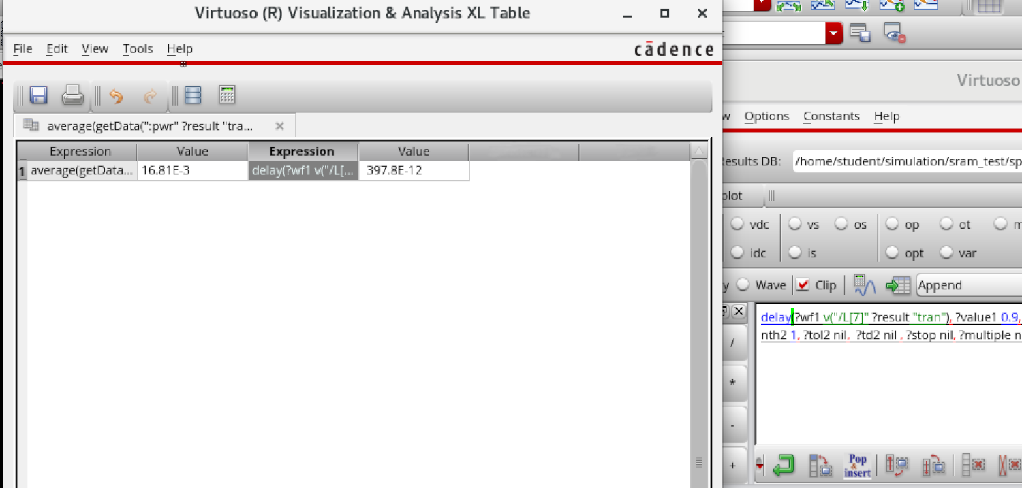

- 45nm technology library
Avg(Power) = 0.185 mW
Read & Compute Delay = 0.51 ns
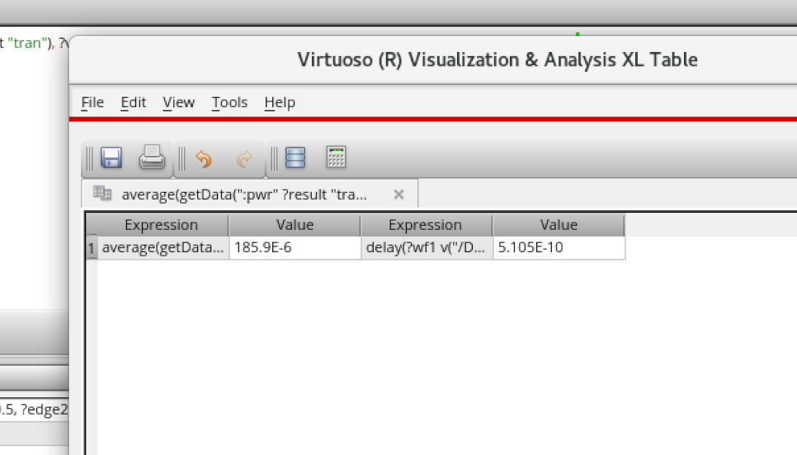

4.10. Table of results
Library | Average Power | Latched to Computed Output delay
180nm | 35.69 mW | 10.69 ns
90nm | 16.81 mW | 0.397 ns
45nm | 0.185 mW | 0.51 ns

5. Conclusion

This work presented the design and comparative analysis of an 8×8 6T SRAM cell array with In-Memory Computing (IMC) capability, implemented using three CMOS technology libraries - 180 nm, 90 nm, and 45 nm in Cadence Virtuoso. The design integrated a latch at the sense-amplifier output to retain the previous read value and a simple compute block capable of performing NAND, NOR, XOR, and Flush operations between the current and previous outputs. The results clearly demonstrate the impact of technology scaling on both average power consumption and latched-to-computed output delay. As the feature size decreased from 180 nm → 90 nm → 45 nm:
- Average power reduced drastically from 35.69 mW (180 nm) to 16.81 mW (90 nm) and further down to 0.185 mW (45 nm). This corresponds to an overall reduction of nearly 99.5 % between 180 nm and 45 nm. The reduction is primarily attributed to lower supply voltage, reduced load capacitances, and smaller device sizes at advanced technology nodes.
- Computation delay (measured from latched output to computed output) improved from 10.69 ns at 180 nm to 0.397 ns at 90 nm, with a slight increase to 0.51 ns at 45 nm. The large delay reduction from 180 nm → 90 nm reflects faster transistor switching and reduced parasitics, while the minor delay increase from 90 nm → 45 nm is likely due to interconnect effects, increased leakage currents, and tighter voltage headroom impacting sense-amplifier and logic performance.
Overall, the results confirm that technology scaling significantly enhances performance and energy efficiency for IMC-enabled SRAM designs. The 45 nm implementation offers the best power-delay trade-off, achieving two orders of magnitude lower power and more than 20× faster computation compared to the 180 nm counterpart. However, the slight delay variation between 90 nm and 45 nm indicates that interconnect parasitics and leakage effects become more dominant in deep-submicron technologies, requiring careful optimization of device sizing, threshold selection, and supply levels.
The study demonstrates that integrating simple Boolean logic within conventional 6T SRAM arrays is feasible and scales effectively with technology, offering a promising path for low-power, high-speed In-Memory Computing architectures. Future work will focus on expanding the array size, incorporating process-corner and variation analysis, and exploring multi-bit arithmetic operations and mixed-signal extensions for larger-scale CIM applications.
Author Contributions-
Subham Pr. Gupta: Initial research, design and simulation (180nm)
Jairus S. Solomon: Design and simulation (45nm)
Vinayak S. Salunke: Design and simulation (90nm)

Data Availability: No supplementary materials.

Declarations
This article does not contain any studies with human or animal subjects.
Conflict of Interest- The authors declare that they have no conflict of interest.
Consent to Participate Yes. Human and Animal Rights

References
[1] Lin, Z.-T., Tong, Z.-Z., Zhang, J., Wang, F.-M., Xu, T., Zhao, Y., Wu, X.-L., Peng, C.-Y., Lu, W.-J., Zhao, Q., & Chen, J. (2022). A review on SRAM-based computing in-memory: Circuits, functions and applications. Journal of Semiconductors, 43(3), 031401.

[2] Mittal, S., Verma, G., Kaushik, B. K., & Khanday, F. A. (2021). A Survey of SRAM-based In-Memory Computing Techniques and Applications. Journal of Systems Architecture, 119, 102276.

[3] Yoshioka, K., Ando, S., Miyagi, S., Chen, Y.-C., & Zhang, W. (2024). A Review of SRAM-based Compute-in-Memory Circuits. arXiv preprint, arXiv:2411.06079.

[4] Zhao, R., Gong, Z., Liu, Y., & Chen, J. (2023). DAM SRAM CORE: An Efficient High-Speed and Low-Power CIM SRAM CORE Design for Feature Extraction Convolutional Layers in Binary Neural Networks. PMC, 2023.

[5] Lin, Z.-T., et al. (2022). A Review on SRAM-based Computing In-memory Circuits: Technology Scaling and Design Considerations. Journal of Semiconductors, 43(3), 031401.

[6] “Low-Power 8T SRAM Compute-in-Memory Macro for Edge AI Applications.” Applied Sciences, 2022, 14(23), 10924.

[7] Kaushik, B. K., & Saini, G. (2019). SRAM-Based In-Memory Computing Architectures: A Survey. Microelectronics Journal, 91, 104-118.

[8] Lin, Y., & Chen, H. (2020). Analysis of Technology Scaling on SRAM Power and Delay Using Cadence Virtuoso. IEEE Access, 8, 54021–54030.

[9] Kaushik, B. K., Mittal, S., & Khanday, F. A. (2021). Power-Performance Trade-Offs in CMOS SRAM for In-Memory Computing. Microprocessors and Microsystems, 88, 104–117.

