Home Security System

**Software Requirements Specification**

Version 1.3

Team 2 :

Nguyễn Văn Tấn Đạt

Ngô Văn Tiến

Lưu Đình Hải Châu

Nguyễn Hoài Vinh

Nguyễn Quốc Hoàng

Danang, Sep 2016

**TABLE OF CONTENTS**

[**TABLE OF CONTENTS** 2](#_Toc461738928)

[1. DOCUMENT HISTORY 3](#_Toc461738929)

[2. REFERENCE DOCUMENTS 3](#_Toc461738930)

[3. DISTRIBUTION LIST AND APPROVALS 3](#_Toc461738931)

[4. INTRODUCTION 3](#_Toc461738932)

[4.1 Purpose 3](#_Toc461738933)

[4.2 In Scope 3](#_Toc461738934)

[5. ACTORS 4](#_Toc461738935)

[6. OVERVIEW 4](#_Toc461738936)

[6.1 System overview 4](#_Toc461738937)

[6.2 Requirements and Requirement Use cases 4](#_Toc461738938)

[6.3 System Pages Flow 11](#_Toc461738939)

[7. APPENDIX 11](#_Toc461738940)

# DOCUMENT HISTORY

|  |  |  |
| --- | --- | --- |
| **Date** | **Summary of Changes** | **Version** |
| 2/9/2016 | Create SRS document | 1.0 |
| 15/9/2016 | Fix usecases and screenshot | 1.1 |
| 19/09/2016 | Fix use cases and update 2.5.6 | 1.2 |
| 25/10/2016 | Change screens | 1.3 |

# REFERENCE DOCUMENTS

|  |  |
| --- | --- |
| **Document Name** | **Description** |
|  |  |
|  |  |
|  |  |
|  |  |
|  |  |
|  |  |
|  |  |

# DISTRIBUTION LIST AND APPROVALS

|  |  |
| --- | --- |
| **Name** | **Title** |
| Nguyễn Văn Tấn Đạt | * Design usecase * Design screen |
| Ngô Văn Tiến | * Specify Usecase |
| Lưu Đình Hải Châu | * Fix typos * Update technology and data variations list |
| Trương Văn Quốc Hoàng | * Fix typos * Update use cases and reference between use cases |
|  |  |
|  |  |
|  |  |
|  |  |
|  |  |

# INTRODUCTION

## Purpose

Build an app to monitor a room or a small house with only a camera. Camera can swing, detect object, and capture object..

## In Scope

# ACTORS

|  |  |
| --- | --- |
| **Actorr** | **Description** |
| Normal User | Has the right to Control camera, View records, View images |

# OVERVIEW

## System overview

* View stream of a camera
* Camera can automatically swing, detect object and capture images in Auto mode
* User can switch mode to Manual mode, to control Camera, capture images
* User can also view captured images and delete images

## Requirements and Requirement Use cases

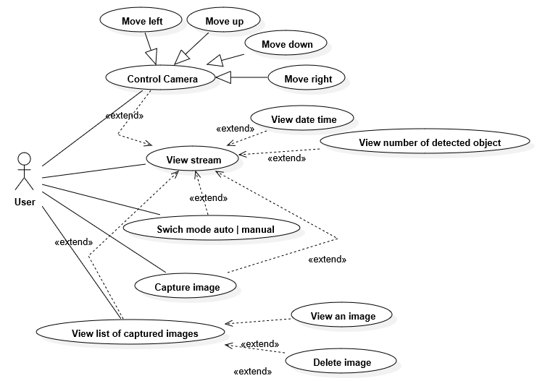

**6.2.1. View stream**

|  |  |
| --- | --- |
| **Use Case** | View stream |
| **Actors** | User |
| **Priority** | High |
| **Pre-condition** | The user opens the app and have wifi connected |
| **Post-condition** | Stream will be playing |
| **Main success scenario** | Stream video is connected |
| **Special requirements** |  |
| **Technology and Data Variations List** |  |
| **Screenshot** | E:\Documents\9thSemester\ThietKeHeThongNhung\Screenshot_2016-10-28-23-15-26.png |
| **Frequency of Occurrence** |  |
| **Open issues** |  |

**6.2.2. Control Camera**

|  |  |
| --- | --- |
| **Use Case** | Control Camera |
| **Actors** | User |
| **Priority** | High |
| **Pre-condition** | The users click on the button on top right of stream |
| **Post-condition** | Show controls and some use cases which user can use |
| **Main success scenario** | User can control the camera or capture or switch mode, and also view date time, and number detected objects |
| **Special requirements** |  |
| **Technology and Data Variations List** |  |
| **Screenshot** | E:\Documents\9thSemester\ThietKeHeThongNhung\Screenshot_2016-10-28-23-15-26.png  E:\Documents\9thSemester\ThietKeHeThongNhung\Screenshot_2016-10-28-23-14-44.png |
| **Frequency of Occurrence** |  |
| **Open issues** |  |

**6.2.3. View date time and number of detected objects**

|  |  |
| --- | --- |
| **Use Case** | View date time and number of detected objects |
| **Actors** | User |
| **Priority** | High |
| **Pre-condition** | The users click on the button on top right of stream |
| **Post-condition** |  |
| **Main success scenario** | User can view time and number detected objects |
| **Special requirements** |  |
| **Technology and Data Variations List** |  |
| **Screenshot** |  |
| **Frequency of Occurrence** |  |
| **Open issues** |  |

**6.2.4. Switch mode Auto | Manual**

|  |  |
| --- | --- |
| **Use Case** | Switch mode Auto | Manual |
| **Actors** | User |
| **Priority** | High |
| **Pre-condition** | The users click on the button on top right of stream to show Controls |
| **Post-condition** | Auto mode: Camera auto move to monitor the house and capture image if objects are detected.  Manual mode: User move the camera by hand |
| **Main success scenario** | User can switch between Auto mode and Manual mode |
| **Special requirements** |  |
| **Technology and Data Variations List** |  |
| **Screenshot** | E:\Documents\9thSemester\ThietKeHeThongNhung\Screenshot_2016-10-28-23-14-44.png |
| **Frequency of Occurrence** |  |
| **Open issues** |  |

**6.2.5. Capture images**

|  |  |
| --- | --- |
| **Use Case** | Capture images |
| **Actors** | User |
| **Priority** | High |
| **Pre-condition** | The users click on the button on top right of stream to show Controls |
| **Post-condition** |  |
| **Main success scenario** | User press button Capture 🡪 image will be saved. |
| **Special requirements** |  |
| **Technology and Data Variations List** |  |
| **Screenshot** | E:\Documents\9thSemester\ThietKeHeThongNhung\Screenshot_2016-10-28-23-14-44.png |
| **Frequency of Occurrence** |  |
| **Open issues** |  |

**6.2.6. View list of captured images**

|  |  |
| --- | --- |
| **Use Case** | View list of captured images |
| **Actors** | User |
| **Priority** | High |
| **Pre-condition** | 1. Click on the top right button  2. Click View images |
| **Post-condition** | The list of images will be shown sorted by date |
| **Main success scenario** | Show the list of saved images |
| **Special requirements** |  |
| **Technology and Data Variations List** |  |
| **Screenshot** |  |
| **Frequency of Occurrence** |  |
| **Open issues** |  |

**6.2.7. View an image**

|  |  |
| --- | --- |
| **Use Case** | View an image |
| **Actors** | User |
| **Priority** | High |
| **Pre-condition** | Click on an image |
| **Post-condition** |  |
| **Main success scenario** | The images will be shown at full screen |
| **Special requirements** |  |
| **Technology and Data Variations List** |  |
| **Screenshot** |  |
| **Frequency of Occurrence** |  |
| **Open issues** |  |

**6.2.8. Delete images**

|  |  |
| --- | --- |
| **Use Case** | Delete images |
| **Actors** | User |
| **Priority** | High |
| **Pre-condition** | 1. View list of captured images  2. Press and hold a image |
| **Post-condition** |  |
| **Main success scenario** | The button delete will show up on top left of image  User can click to delete a image |
| **Special requirements** |  |
| **Technology and Data Variations List** |  |
| **Screenshot** |  |
| **Frequency of Occurrence** |  |
| **Open issues** |  |

## System Pages Flow

# APPENDIX