Home Security System

**Software Requirements Specification**

Version 1.0

Nhóm 2 :

Nguyễn Văn Tấn Đạt

Ngô Văn Tiến

Lưu Đình Hải Châu

Nguyễn Hoài Vinh

Trương Văn Quốc Hoàng

Danang, Sep 2016

**TABLE OF CONTENTS**

**TABLE OF CONTENTS**

1. DOCUMENT HISTORY

2. REFERENCE DOCUMENTS

3. DISTRIBUTION LIST AND APPROVALS

4. INTRODUCTION

4.1 Purpose

4.2 In Scope

5. ACTORS

6. OVERVIEW

6.1 System overview

6.2 Requirements and Requirement Use cases

6.3 System Pages Flow

7. APPENDIX

# DOCUMENT HISTORY

|  |  |  |
| --- | --- | --- |
| **Date** | **Summary of Changes** | **Version** |
| 2/9/2016 | Create SRS document | 1.0 |
| 15/9/2016 | Fix use cases and screenshot | 1.1 |
| 19/09/2016 | Fix use cases and update 2.5.6 | 1.2 |

# REFERENCE DOCUMENTS

|  |  |
| --- | --- |
| **Document Name** | **Description** |
|  |  |
|  |  |
|  |  |
|  |  |
|  |  |
|  |  |
|  |  |

# DISTRIBUTION LIST AND APPROVALS

|  |  |
| --- | --- |
| **Name** | **Title** |
| Nguyễn Văn Tấn Đạt | * Design use case * Design screen |
| Ngô Văn Tiến | * Specify use case * Support use case |
| Lưu Đình Hải Châu | * Fix typos * Update technology and data variations list |
| Nguyễn Hoài Vinh |  |
| Trương Văn Quốc Hoàng | * Fix typos * Update use cases and reference between use cases |
|  |  |
|  |  |
|  |  |
|  |  |

# INTRODUCTION

## Purpose

Build an app to monitor a room or a small house with only one camera. Camera can swing, detect object, and capture object.

## In Scope

# ACTORS

|  |  |
| --- | --- |
| **Actor** | **Description** |
| Normal User | Has the right to Control camera, View records, View images |

# OVERVIEW

## System overview

* View stream of a camera
* Camera can automatically swing, detect object and capture images in Auto mode
* User can switch mode to Manual mode, to control Camera, capture images
* User can also view captured images and delete images

## Requirements and Requirement Use cases

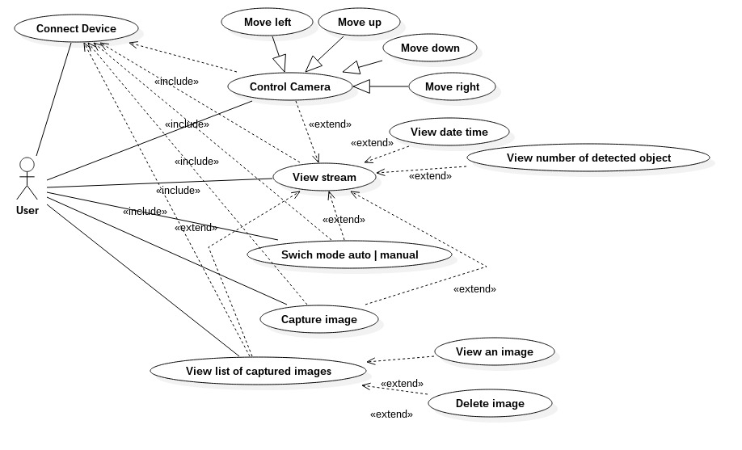

**6.2.1. Choose Device**

|  |  |
| --- | --- |
| **Use Case** | Choose Device |
| **Actors** | User |
| **Priority** | High |
| **Pre-condition** | * App is opened. * Wifi is turned on |
| **Post-condition** | Successfully connect to a camera |
| **Main success scenario** | Camera is connected |
| **Special requirements** | * Click on the icon on the screen of the app. * App show list of devices (camera) * User choose one camera in list to connect. |
| **Technology and Data Variations List** | Wifi |
| **Screenshot** |  |
| **Frequency of Occurrence** |  |
| **Open issues** |  |

**6.2.2. View stream**

|  |  |
| --- | --- |
| **Use Case** | View stream |
| **Actors** | User |
| **Priority** | High |
| **Pre-condition** | * App is opened * Camera is connected |
| **Post-condition** | Stream will be playing |
| **Main success scenario** | Stream video is connected |
| **Special requirements** | * App will display current footage of the camera. * There is a hidden menu bar to the right to select the optional tasks |
| **Technology and Data Variations List** | - Flask framework for streaming server |
| **Screenshot** |  |
| **Frequency of Occurrence** |  |
| **Open issues** |  |

**6.2.3. Control Camera**

|  |  |
| --- | --- |
| **Use Case** | Control Camera |
| **Actors** | User |
| **Priority** | High |
| **Pre-condition** | * App is opened * Camera is connected * User clicked on the button on top right of the application |
| **Post-condition** | User a control camera, application through the buttons |
| **Main success scenario** | User can control the camera or capture or switch mode, and also view date time, and number detected objects |
| **Special requirements** | * Press the menu top right corner to move to the main screen work. * The screen includes navigation bar, select mode, the camera controls and buttons, switch tasks and current parameters * Auto mode: see **6.2.5** * Joystick can control the camera with 4 directions: up-down-left-right * Capture button: see **6.2.6** * View image: see **6.2.7** * The biggest rectangle show video stream from camera * The smaller rectangle below display information of object inside the image being captured, more detail in **6.2.4** |
| **Technology and Data Variations List** | * Use 2 servos to control camera move up/down, left/right: 1 for X-axis, 1 for Y-axis * Use raspberry pi to control servos, raspberry act as middleware role between server and camera controller * Control camera actions (Auto mode, Capture image actions) by sending request to server |
| **Screenshot** |  |
| **Frequency of Occurrence** |  |
| **Open issues** |  |

**6.2.4. View date time and number of detected objects**

|  |  |
| --- | --- |
| **Use Case** | View date time and number of detected objects |
| **Actors** | User |
| **Priority** | High |
| **Pre-condition** | * App is opened * Camera is connected * User click on the button on top right of application |
| **Post-condition** | User can see information of the captured images |
| **Main success scenario** | User can view time and number detected objects |
| **Special requirements** | * When camera automatically capture image, or user press capture button, it will trigger this functionality * Application will try to detect object from the captured image and display. * Display format: each line for each image including: date and time and number of object detected. * Can be scroll if there are many lines |
| **Technology and Data Variations List** | - OpenCV for video capture, image capture and face detection |
| **Screenshot** |  |
| **Frequency of Occurrence** |  |
| **Open issues** |  |

**6.2.5. Switch mode Auto | Manual**

|  |  |
| --- | --- |
| **Use Case** | Switch mode Auto | Manual |
| **Actors** | User |
| **Priority** | High |
| **Pre-condition** | * App is opened * Camera is connected * Users click on the button on top right of stream to show controls |
| **Post-condition** | Auto mode: Camera automatically move to monitor the house and capture image if objects are detected.  Manual mode: User move the camera through application |
| **Main success scenario** | User can switch between Auto mode and Manual mode |
| **Special requirements** | * User click on toggle button with label Auto mode. * If auto mode is on: camera will automatically swing and capture image depend on the object * Maximum 3 pictures is captured within 5 minnutes * If auto mode is off: camera will receive the signal from application to swing or capture images |
| **Technology and Data Variations List** | * See **6.2.3** |
| **Screenshot** |  |
| **Frequency of Occurrence** |  |
| **Open issues** |  |

**6.2.6. Capture images**

|  |  |
| --- | --- |
| **Use Case** | Capture images |
| **Actors** | User |
| **Priority** | High |
| **Pre-condition** | * App is opened * Camera is connected * User click on the button on top right of stream to show controls |
| **Post-condition** |  |
| **Main success scenario** | User press button Capture → image will be saved. |
| **Special requirements** | Watch the entire video function was over and saved in memory. It helps to better manage and can review the video effect. |
| **Technology and Data Variations List** | * See **6.2.3** |
| **Screenshot** |  |
| **Frequency of Occurrence** |  |
| **Open issues** |  |

**6.2.7. View list of captured images**

|  |  |
| --- | --- |
| **Use Case** | View list of captured images |
| **Actors** | User |
| **Priority** | High |
| **Pre-condition** | * App is opened * Camera is connected * User click on the button on top right of stream to show controls * User click on View Images button |
| **Post-condition** | The list of images will be shown sorted by date |
| **Main success scenario** | Show the list of saved images |
| **Special requirements** | Show both videos and images that have been captured |
| **Technology and Data Variations List** |  |
| **Screenshot** |  |
| **Frequency of Occurrence** |  |
| **Open issues** |  |

**6.2.8. View an image**

|  |  |
| --- | --- |
| **Use Case** | View an image |
| **Actors** | User |
| **Priority** | High |
| **Pre-condition** | * App is opened * Camera is connected * User click on the button on top right of stream to show controls * User click on View Images button * User click on a specific image |
| **Post-condition** |  |
| **Main success scenario** | The images will be shown at full screen |
| **Special requirements** | * Show image with a small rectangle surround the face of object * There are 2 arrow button to go next, or previous image * Bottom of screen: show date time, and number of object detected in the current image |
| **Technology and Data Variations List** |  |
| **Screenshot** |  |
| **Frequency of Occurrence** |  |
| **Open issues** |  |

**6.2.9. Delete images**

|  |  |
| --- | --- |
| **Use Case** | Delete images |
| **Actors** | User |
| **Priority** | High |
| **Pre-condition** | 1. View list of captured images  2. Press and hold an image |
| **Post-condition** |  |
| **Main success scenario** | The button delete will show up on top left of image  User can click to delete an image |
| **Special requirements** | When click on x button, that image will be deleted |
| **Technology and Data Variations List** |  |
| **Screenshot** |  |
| **Frequency of Occurrence** |  |
| **Open issues** |  |

## System Pages Flow

# APPENDIX