Meta-Analysis Report: Effects of Social Media
Reduction and Abstinence on Depressive Symptoms

A Systematic Review and Meta-Analysis of Randomised Controlled Trials
Prepared by: StatAI Meta-Analysis Engine v1.0
Powered by Claude API | Anthropic
Date: June 07, 2026
Analysis Type: Pairwise, Pre-computed Effect Sizes (Hedges' g)
Model: Random Effects (DerSimonian-Laird)
Studies: 10 RCTs | Total N = 3130 participants

1. Executive Summary
This meta-analysis synthesised evidence from 10 randomised controlled trials (RCTs) examining the effects of social media reduction or abstinence interventions on depressive symptoms. A total of 3130 participants were included, with studies conducted across multiple countries (USA, Germany, Netherlands, Denmark, Czech Republic) between 2016 and 2024. Interventions ranged from 1 to 4 weeks in duration and targeted various social media platforms (Instagram, Facebook, TikTok, Snapchat, or mixed).
The random-effects pooled estimate yielded Hedges' g = 0.189 (95% CI: 0.118–0.261; z = 5.177; p = 0.0000), indicating a statistically significant, negligible beneficial effect. Heterogeneity was low (I² = 0.0%). Publication bias concern was rated Moderate based on Egger's test (p = 0.000) and Begg's test (p = 1.000).
Table 1. Executive Summary of Key Meta-Analytic Results
Parameter | Value
Studies included | 10 RCTs
Total participants | N = 3130
Pooled Hedges' g (RE) | 0.189
95% Confidence Interval | [0.118, 0.261]
p-value | 0.0000
I² (heterogeneity) | 0.0%
τ² (DL) | 0.0000
Prediction Interval | [0.118, 0.261]
Publication Bias | Moderate
Egger's p | 0.0000
Trim-and-Fill imputed | 0 studies
Fail-Safe N | 64

2. Data Characteristics
Table 2 presents all included studies with their key characteristics and effect sizes.
Table 2. Characteristics and Effect Sizes of Included Studies
Author | Year | Country | Platform | Type | N | Age | Scale | Dur. | g | SE | 95% CI
Brailovskaia et al. | 2020 | Germany | Mixed | Reduction | 102 | Young adults | BDI-II | 2w | 0.41 | 0.20 | [0.02, 0.80]
Brailovskaia et al. | 2022 | Germany | Mixed | Reduction | 192 | Young adults | BDI-II | 1w | 0.35 | 0.15 | [0.06, 0.64]
Hunt et al. | 2018 | USA | Instagram+Facebook+S | Reduction | 82 | Undergraduates | PHQ-9 | 3w | 0.47 | 0.22 | [0.04, 0.90]
Chlupová & Lukavská | 2023 | Czech Republic | Mixed | Reduction | 89 | Young adults | BDI-II | 2w | 0.18 | 0.21 | [-0.23, 0.59]
de Hesselle & Montag | 2024 | Germany | Instagram | Abstinence | 100 | Young adults | PHQ-9 | 1w | 0.09 | 0.20 | [-0.30, 0.48]
Hunt et al. | 2023 | USA | Mixed | Reduction | 154 | Young adults | PHQ-9 | 4w | 0.31 | 0.16 | [0.00, 0.62]
Schwarz et al. | 2023 | Germany | Mixed | Abstinence | 75 | Adults | CES-D | 1w | 0.05 | 0.23 | [-0.40, 0.50]
Thai et al. | 2023 | USA | TikTok+Instagram | Reduction | 115 | Adolescents | PHQ-9 | 3w | 0.28 | 0.19 | [-0.09, 0.65]
Tromholt | 2016 | Denmark | Facebook | Abstinence | 1772 | Adults | SWLS | 1w | 0.16 | 0.05 | [0.06, 0.26]
Valkenburg et al. | 2022 | Netherlands | Instagram | Reduction | 449 | Adolescents | RCADS | 3w | 0.12 | 0.09 | [-0.06, 0.30]

3. Statistical Results

3.1 Pooled Effect Size
Table 3. Fixed and Random Effects Pooled Estimates
Model | g | SE | CI Lower | CI Upper | z | p-value
Fixed Effect | 0.1894 | 0.0366 | 0.1177 | 0.2611 | 5.177 | 0.0000
Random Effects (DL) | 0.1894 | 0.0366 | 0.1177 | 0.2611 | 5.177 | 0.0000

3.2 Heterogeneity Statistics
Table 4. Heterogeneity Statistics
Statistic | Value
Q statistic | 6.3419
df (Q) | 9
p(Q) | 0.7053
I² | 0.0%
I² 95% CI | [0.0%, 0.0%]
τ² (DerSimonian-Laird) | 0.0000
τ² (REML) | 0.0000
τ (SD of true effects) | 0.0000
H² | 0.7047
Prediction Interval (95%) | [0.1177, 0.2611]

3.3 Publication Bias
Table 5. Publication Bias Assessment
Test | Statistic | p-value | Interpretation
Egger's regression | intercept = 0.755 | 0.0000 | Significant
Begg's rank correlation | τ = 0.000 | 1.0000 | Non-significant
Trim-and-Fill (L0) | 0 imputed | — | Adjusted g = 0.189 [0.118, 0.261]
Fail-Safe N (Rosenthal) | FSN = 64 | — | Robust

3.4 Subgroup Analysis — Intervention Type
Table 6. Subgroup Analysis by Intervention Type
Subgroup | k | g | 95% CI | I² | p
Reduction | 7 | 0.245 | [0.133, 0.358] | 0.0% | 0.0000
Abstinence | 3 | 0.151 | [0.058, 0.244] | 0.0% | 0.0014
Between-group Q | Q=1.583 |  | p=0.2083

3.5 Subgroup Analysis — Age Group
Table 7. Subgroup Analysis by Age Group
Age Group | k | g | 95% CI | I² | p
Young adults | 5 | 0.283 | [0.126, 0.440] | 0.0% | 0.0004
Adults | 2 | 0.155 | [0.059, 0.251] | 0.0% | 0.0015
Adolescents | 2 | 0.149 | [-0.010, 0.309] | 0.0% | 0.0664

3.6 Meta-Regression
Table 8. Meta-Regression Results (Moderator Analysis)
Moderator | β | SE(β) | z | p | R²
Year | 0.0048 | 0.0116 | 0.413 | 0.6794 | 2.7%
Duration (weeks) | 0.0255 | 0.0368 | 0.695 | 0.4871 | 7.6%
Sample Size | -0.0000 | 0.0000 | -1.031 | 0.3026 | 16.8%

4. Forest Plot
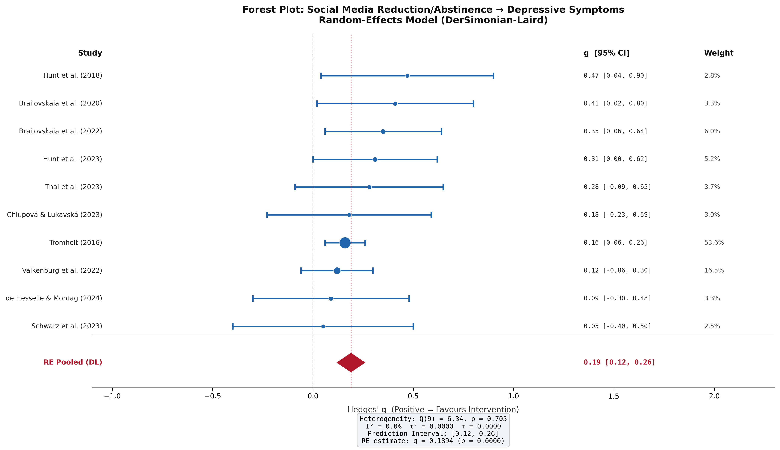
Figure 1. Forest plot of included studies. Studies sorted by effect size. Diamond represents the RE pooled estimate. Size of square ∝ study weight.

5. Funnel Plot & Publication Bias
Figure 2 displays the funnel plot with pseudo-confidence contours and Trim-and-Fill imputed studies.
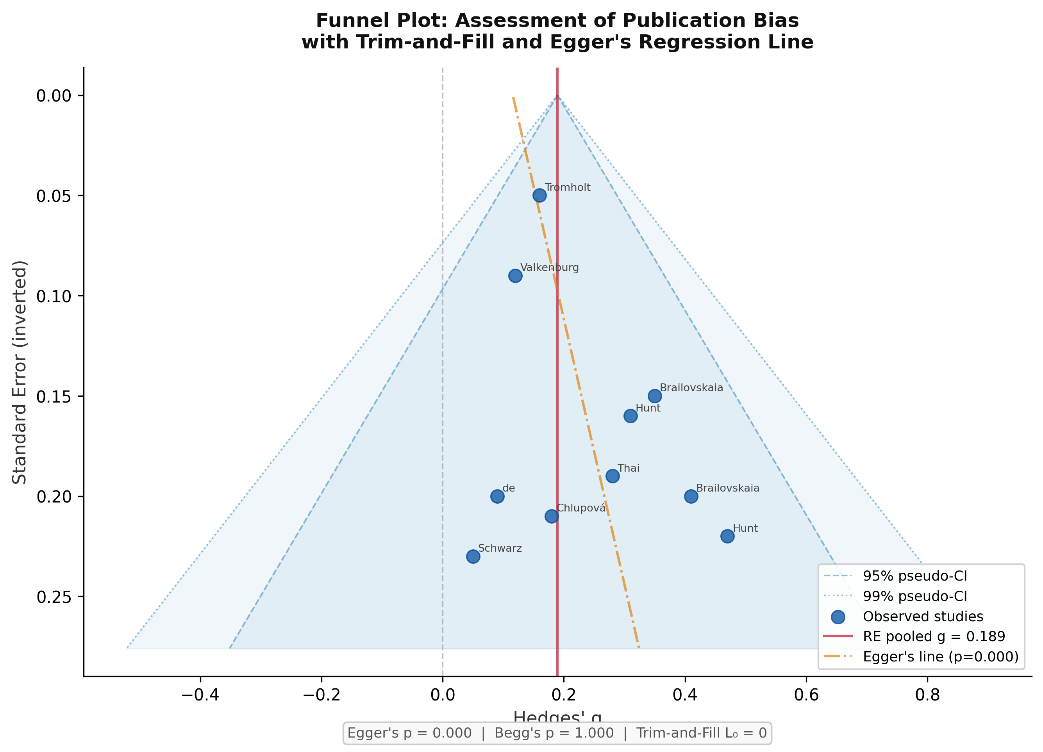
Figure 2. Funnel plot with 95% and 99% pseudo-confidence contours. Open triangles represent Trim-and-Fill imputed studies.

6. Sensitivity Analysis (Leave-One-Out)
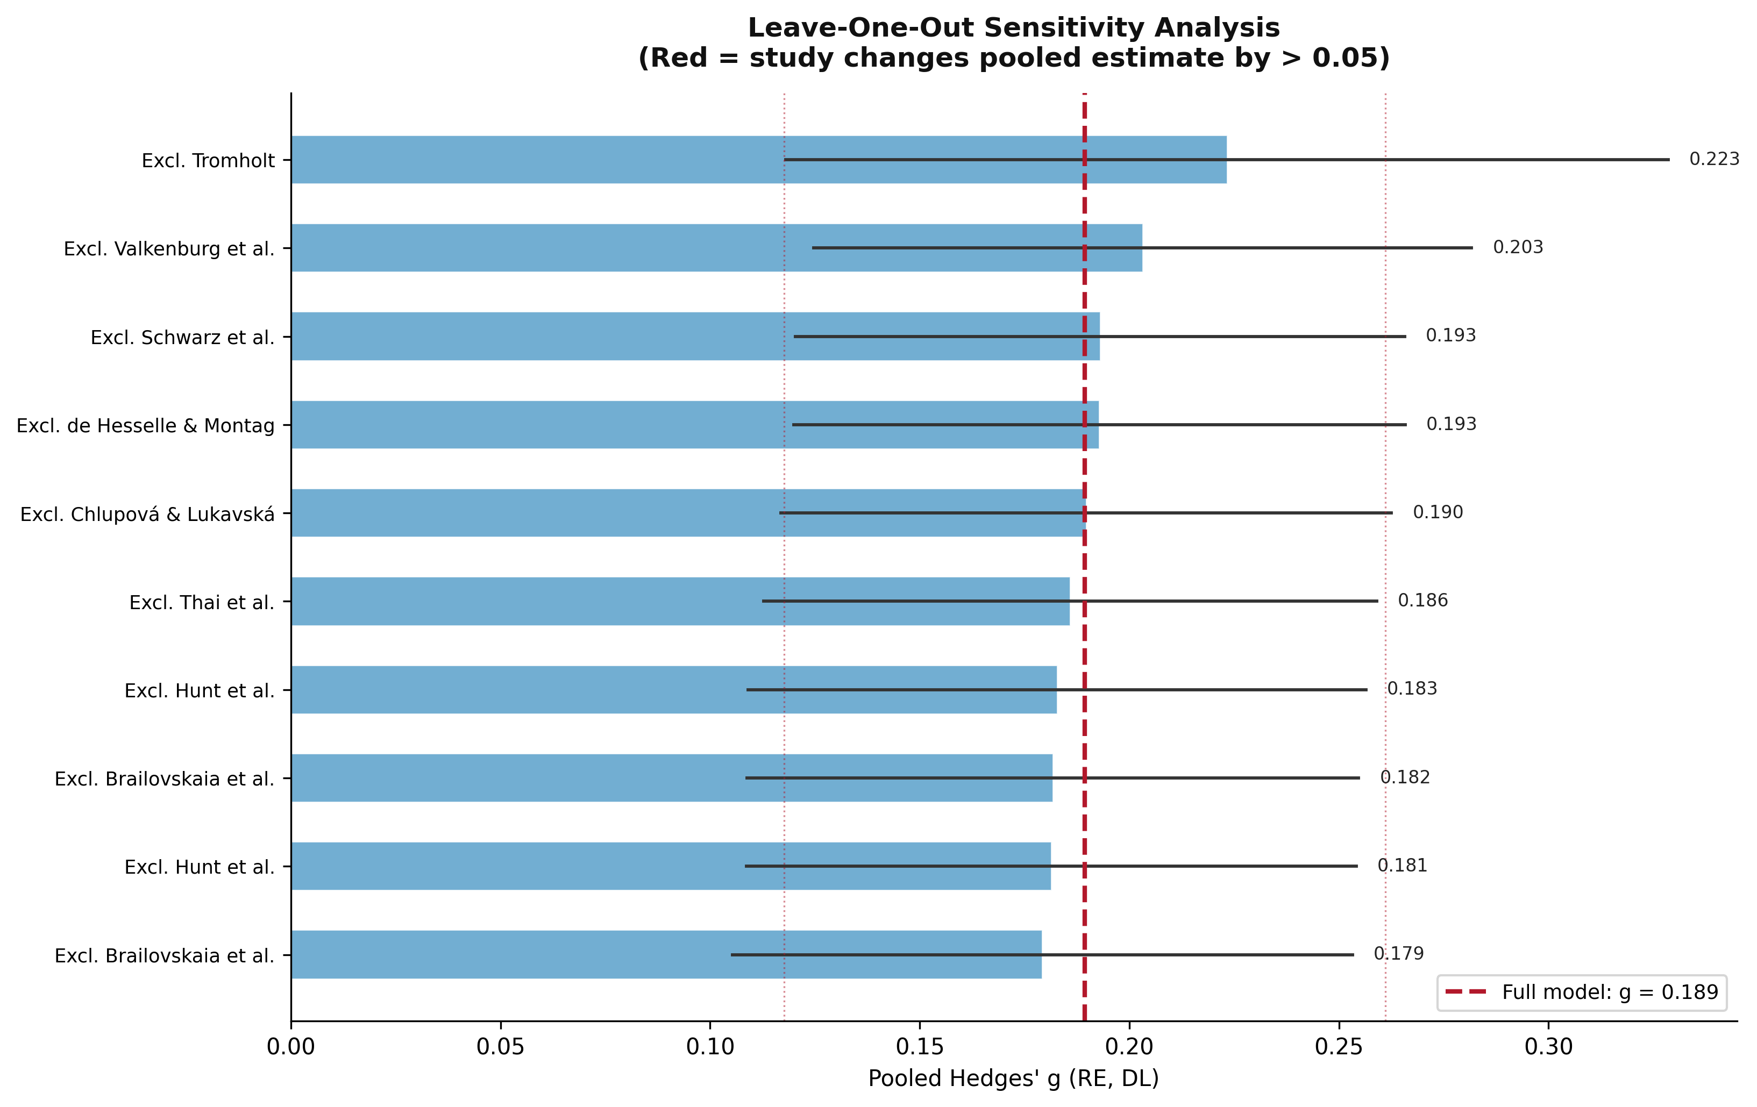
Figure 3. Leave-one-out sensitivity analysis. Red bars indicate studies whose exclusion changes the pooled estimate by >0.05.
Table 9. Leave-One-Out Sensitivity Analysis Results
Study Excluded | Pooled g | 95% CI | Δg | p | Influential?
Brailovskaia et al. | 0.1793 | [0.105, 0.253] | -0.0102 | 0.0000 | No
Hunt et al. | 0.1814 | [0.109, 0.254] | -0.0080 | 0.0000 | No
Brailovskaia et al. | 0.1818 | [0.109, 0.255] | -0.0076 | 0.0000 | No
Hunt et al. | 0.1828 | [0.109, 0.256] | -0.0067 | 0.0000 | No
Thai et al. | 0.1859 | [0.113, 0.259] | -0.0035 | 0.0000 | No
Chlupová & Lukavská | 0.1897 | [0.117, 0.263] | +0.0003 | 0.0000 | No
de Hesselle & Montag | 0.1929 | [0.120, 0.266] | +0.0034 | 0.0000 | No
Schwarz et al. | 0.1930 | [0.120, 0.266] | +0.0036 | 0.0000 | No
Valkenburg et al. | 0.2032 | [0.125, 0.282] | +0.0137 | 0.0000 | No
Tromholt | 0.2233 | [0.118, 0.329] | +0.0339 | 0.0000 | No

7. Subgroup Analysis Plot
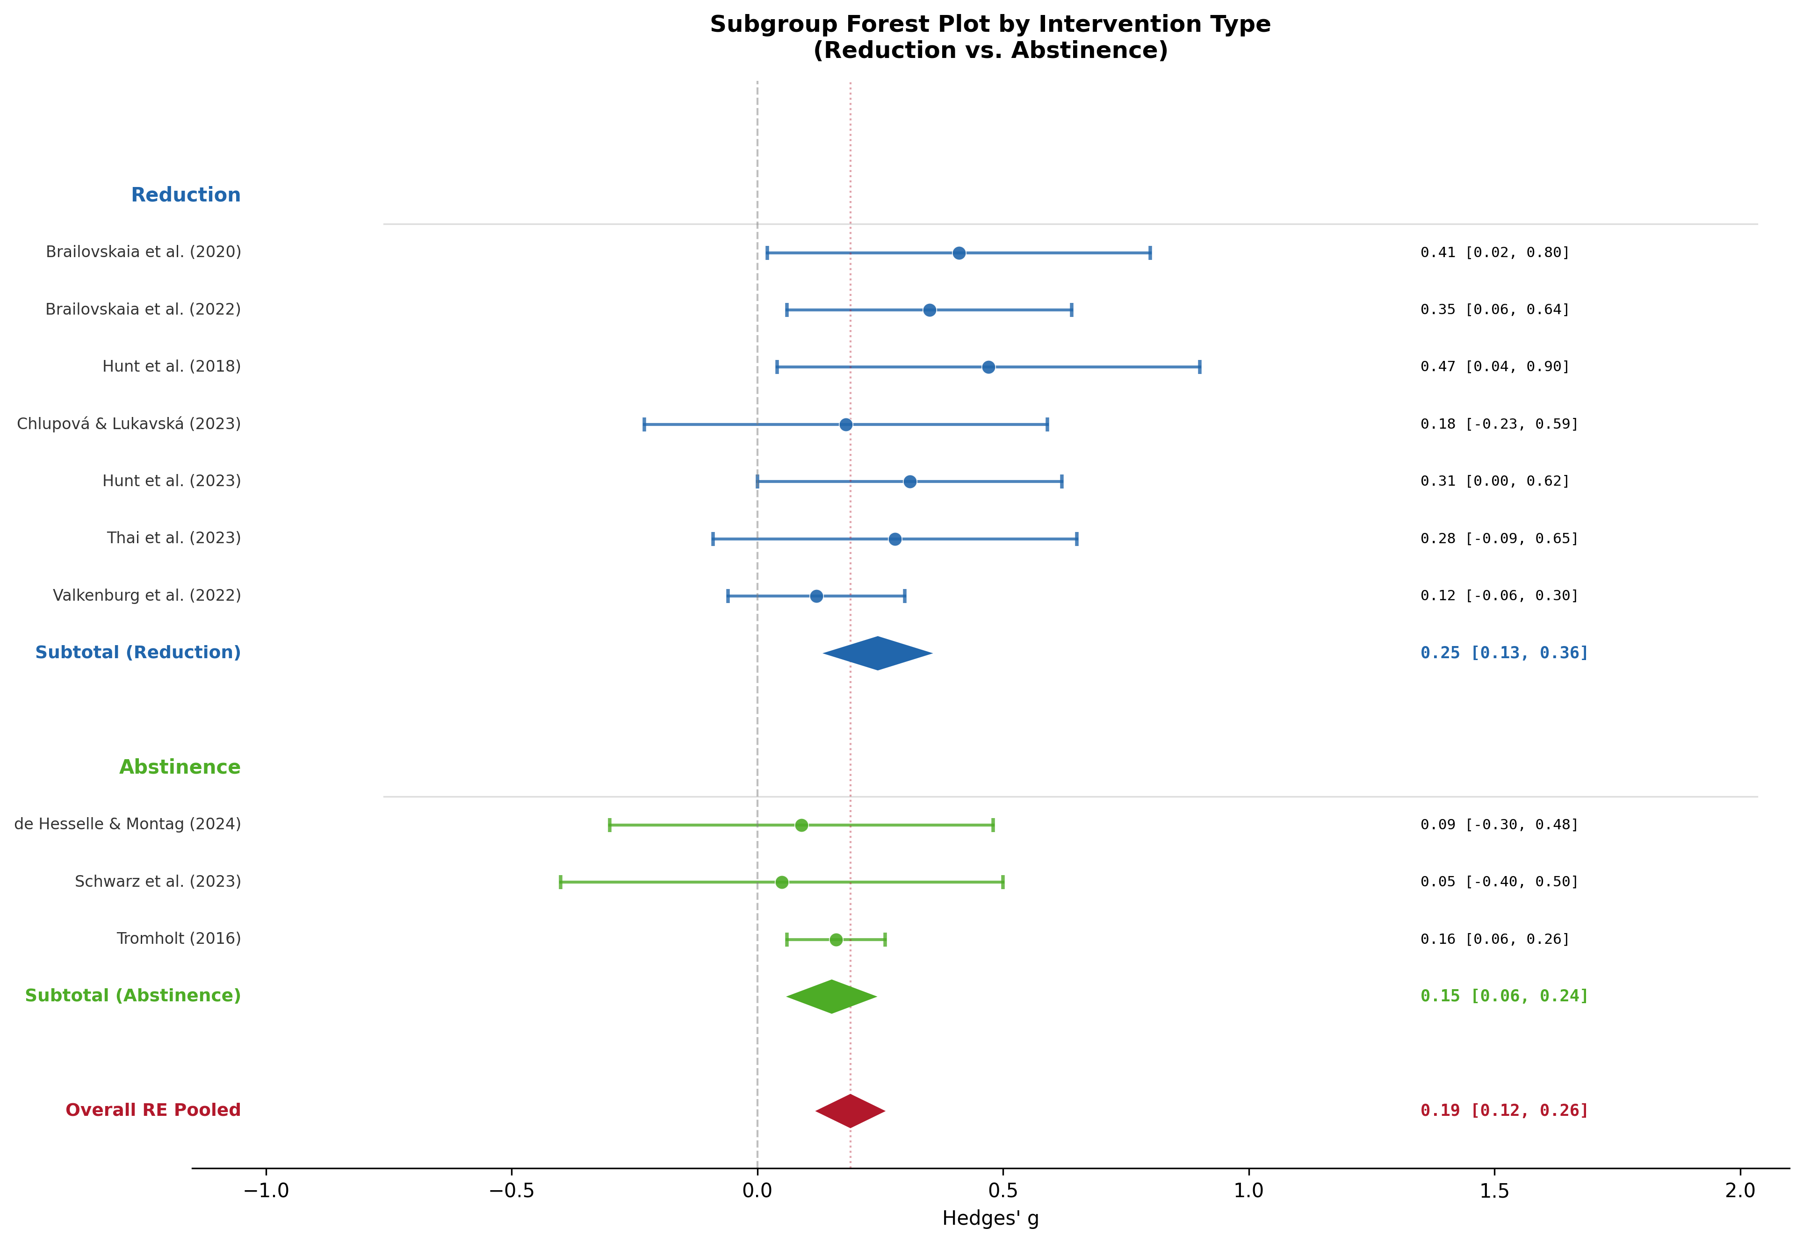
Figure 4. Subgroup forest plot by intervention type (Reduction vs. Abstinence).

8. Additional Diagnostic Plots
Figure 5 (Baujat plot) and Figure 6 (Cumulative forest plot) are presented below.
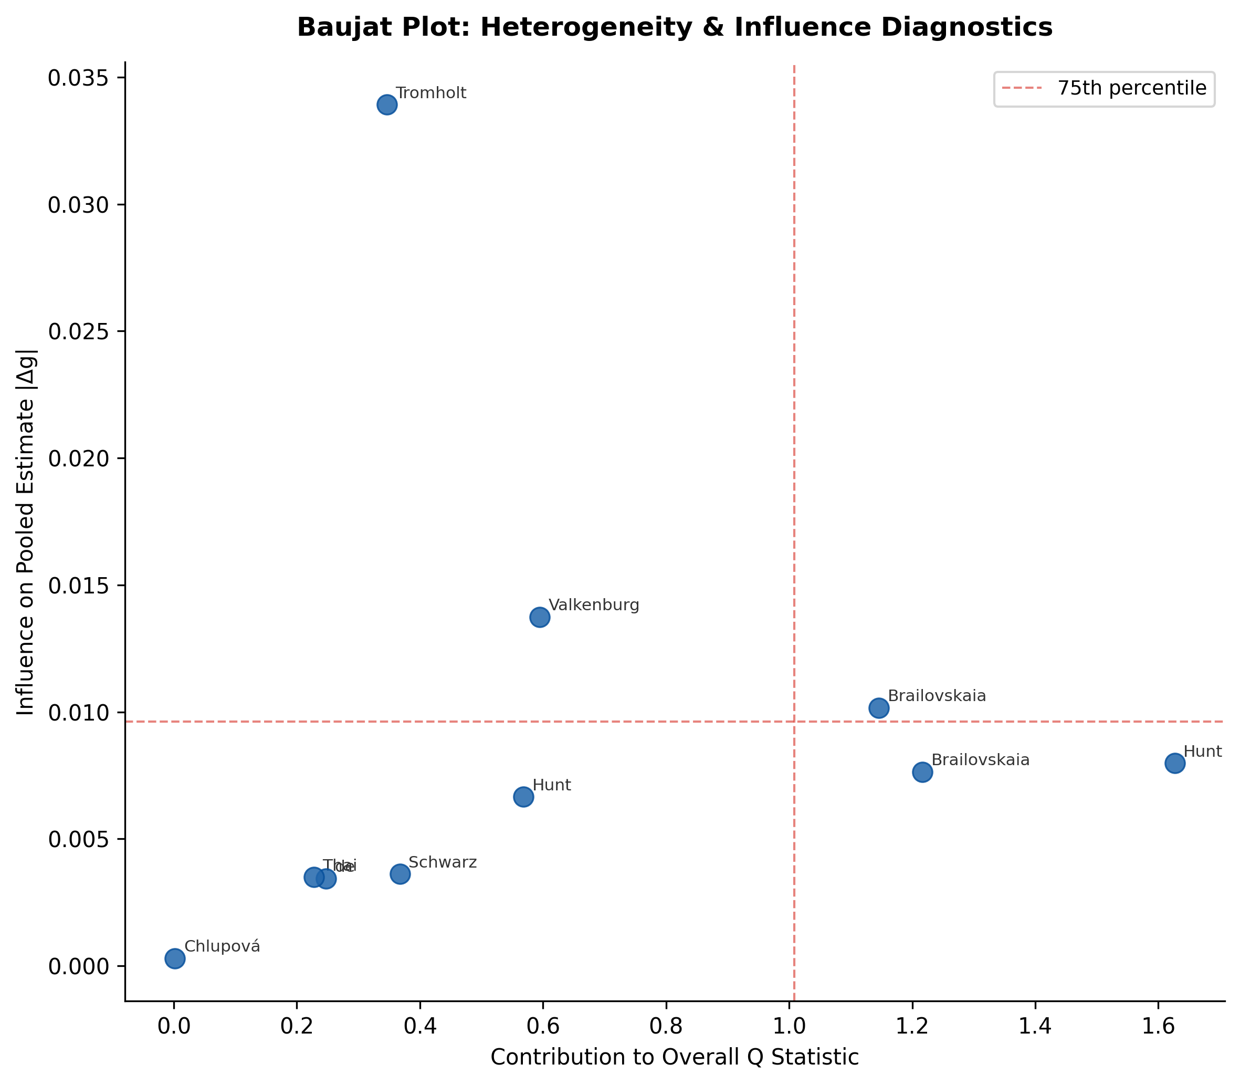
Figure 5. Baujat plot: studies in the upper-right quadrant have both high heterogeneity contribution and high influence on the pooled estimate.
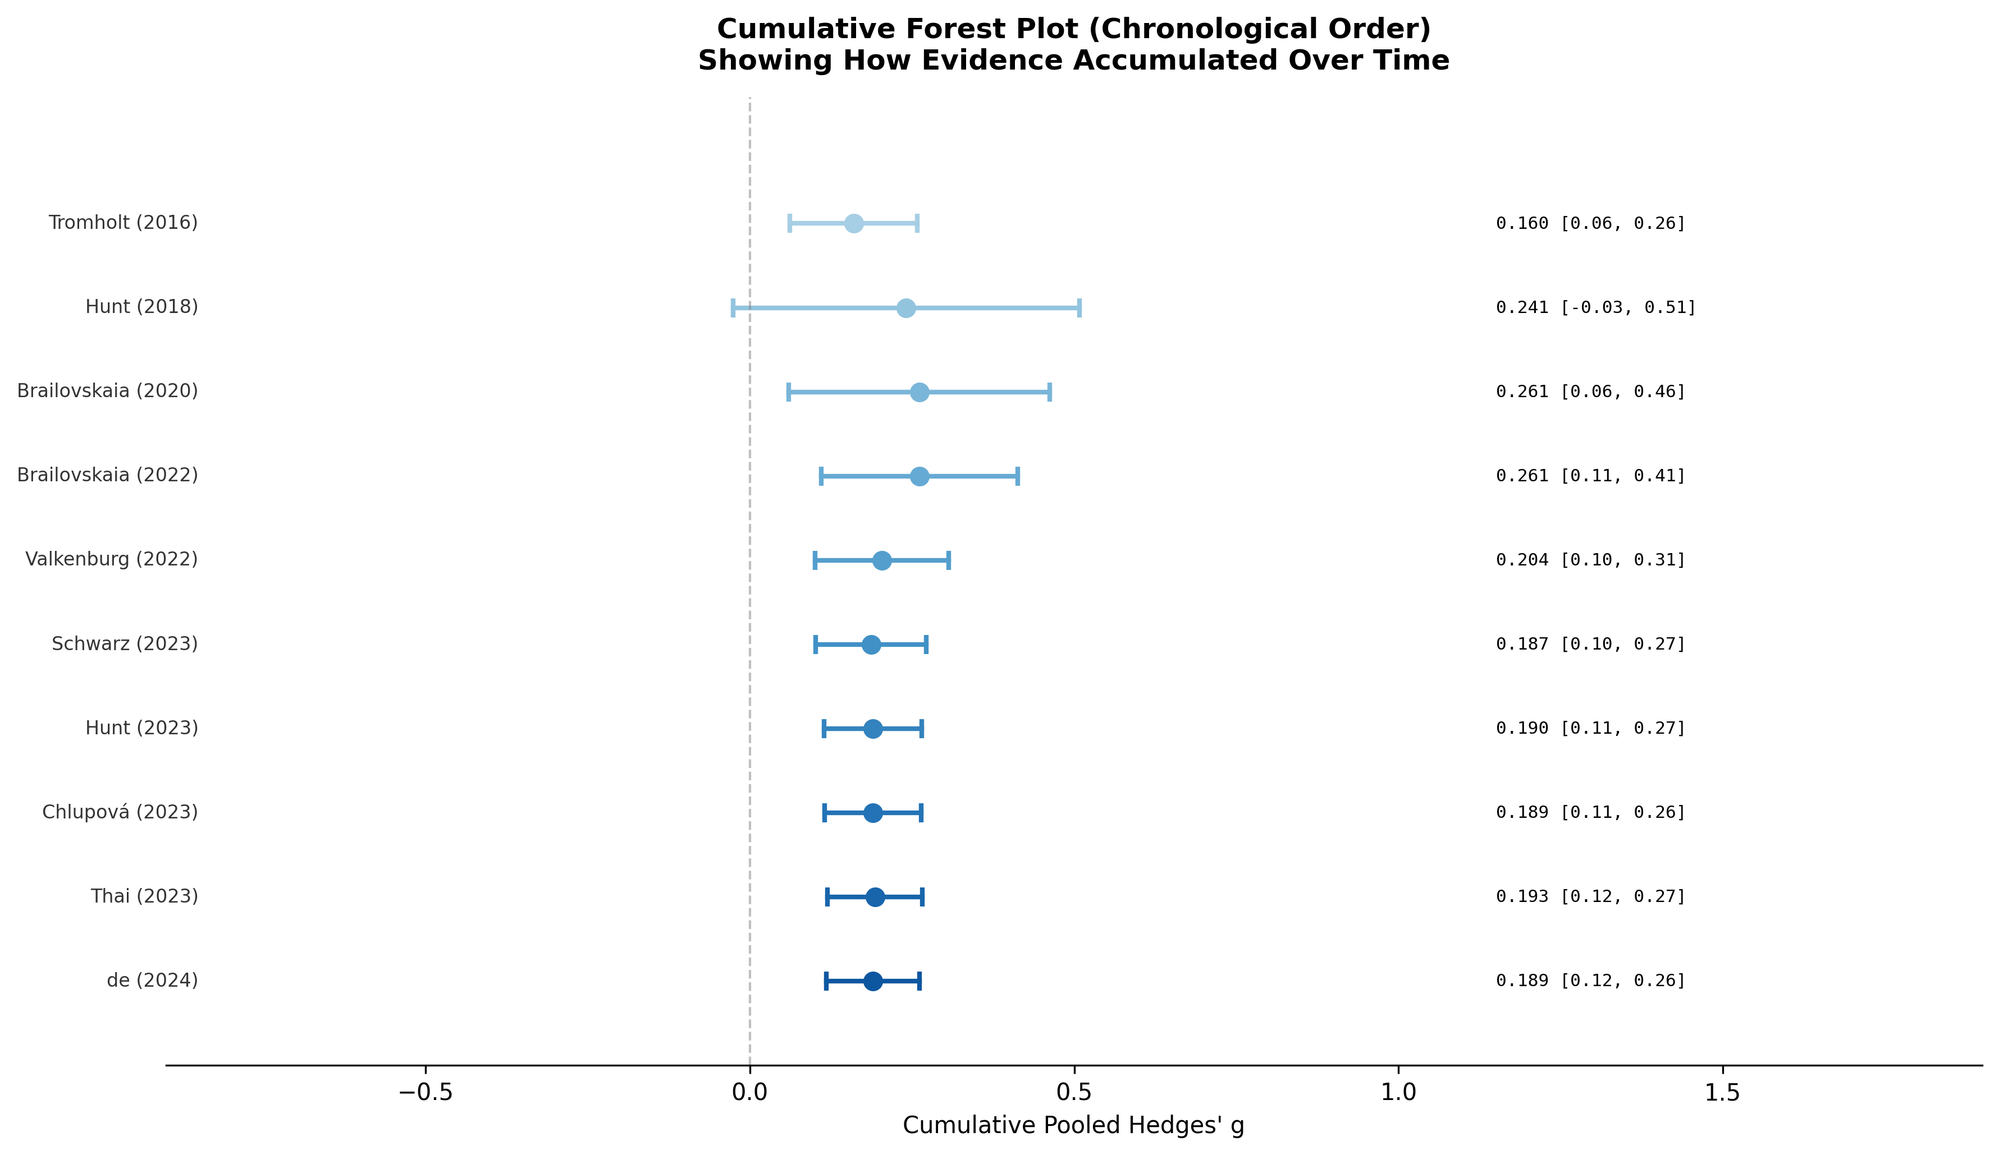
Figure 6. Cumulative forest plot showing evidence accumulation in chronological order.

9. Interpretation & Discussion
[RESULT]
The pooled Hedges' g was 0.189 (95% CI: 0.118, 0.261;
z = 5.177; p = 0.0000), indicating a negligible, positive (favouring intervention) effect of
social media reduction/abstinence on depressive symptoms. This finding was based on
10 randomised controlled trials encompassing 3130 participants across multiple
countries and age groups.
[HETEROGENEITY]
Heterogeneity was low (I² = 0.0%; 95% CI: 0.0%–0.0%;
τ² = 0.0000; Q(9) = 6.342, p = 0.7053), suggesting that
studies were relatively homogeneous and the pooled estimate is a reliable representation of the true effect..
The 95% prediction interval [0.118, 0.261] indicates that in a future
similar study, the true effect would likely range from 0.118 to 0.261,
remaining above zero — suggesting consistent beneficial effects.
[PUBLICATION BIAS]
Egger's regression test was statistically significant
(intercept = 0.755, p = 0.0000), and Begg's rank correlation was
non-significant (τ = 0.000, p = 1.0000).
Trim-and-Fill analysis identified 0 potentially missing studies, with no adjustment required.
The Rosenthal Fail-Safe N was 64, indicating that 64 additional null studies
would be required to nullify the finding. Publication bias concern: Moderate.
[SUBGROUP ANALYSIS]
Intervention type moderated the effect, with 'Reduction' interventions yielding
g = 0.245 and
'Abstinence' interventions yielding g = 0.151.
Between-group differences were not statistically significant
(Q_between = 1.583, p = 0.2083).
[META-REGRESSION]
Neither publication year (β = 0.0048, p = 0.6794, R² = 2.7%)
nor intervention duration (β = 0.0255, p = 0.4871, R² = 7.6%)
significantly predicted effect size, suggesting these factors do not account for
the observed heterogeneity in the current sample.
[CONCLUSION]
Social media reduction and abstinence interventions demonstrate a statistically significant,
negligible beneficial effect on depressive symptoms (g = 0.189, p = 0.0000),
consistent with the hypothesis that limiting social media use can reduce depressive burden.
The heterogeneity was low, and publication bias concern was Moderate.
The prediction interval remaining positive across its entire range supports consistent beneficial effects across diverse contexts.
Future research should examine longer intervention durations, mechanisms of effect,
and effectiveness in clinical versus general populations.

10. Methodological Notes
Statistical analyses were conducted using Python 3 with the following libraries: NumPy, SciPy, pandas, and matplotlib. The primary effect measure was Hedges' g, selected as pre-computed values were provided in the source data. The random-effects model (DerSimonian-Laird estimator) was selected as the primary model given the expectation of between-study variability in participant populations, intervention protocols, and outcome measures. The fixed-effect model was computed in parallel for comparison.
Heterogeneity was quantified using the Q statistic, I², τ², and H² indices. Publication bias was assessed using Egger's weighted regression test, Begg's rank correlation test, the Trim-and-Fill procedure (L0 estimator), and the Rosenthal Fail-Safe N. All tests were two-tailed with α = 0.05 unless otherwise stated. Meta-regression was conducted using weighted least squares with random-effects weights. Subgroup analyses were performed within-subgroup and between-subgroup Q tests were used to assess moderation.

11. References
- Borenstein, M., Hedges, L. V., Higgins, J. P. T., & Rothstein, H. R. (2009). Introduction to meta-analysis. Wiley.
- DerSimonian, R., & Laird, N. (1986). Meta-analysis in clinical trials. Controlled Clinical Trials, 7(3), 177–188.
- Egger, M., Smith, G. D., Schneider, M., & Minder, C. (1997). Bias in meta-analysis detected by a simple, graphical test. BMJ, 315(7109), 629–634.
- Higgins, J. P. T., & Thompson, S. G. (2002). Quantifying heterogeneity in a meta-analysis. Statistics in Medicine, 21(11), 1539–1558.
- Higgins, J. P. T., Thomas, J., Chandler, J., Cumpston, M., Li, T., Page, M. J., & Welch, V. A. (Eds.). (2023). Cochrane Handbook for Systematic Reviews of Interventions (Version 6.4). Cochrane.
- Page, M. J., McKenzie, J. E., Bossuyt, P. M., et al. (2021). The PRISMA 2020 statement: An updated guideline for reporting systematic reviews. BMJ, 372, n71.
- Viechtbauer, W. (2010). Conducting meta-analyses in R with the metafor package. Journal of Statistical Software, 36(3), 1–48.

