MENA National Energy Rebound Analysis
Estimating National Energy Rebound Effects using Brockway et al. (2017)

Countries | UAE · Egypt · Jordan · Tunisia · Morocco
Time Period | 1990 – 2023 (34 years per country)
Methods | Method 1: AES/PES | Method 2: EEE (Brockway et al. 2017)
Production Function | Nested KL-E CES (3-factor, constant-returns)
Base Year | 1990
Cost Shares | sE = 0.08 | sL = 0.46 | sK = 0.46 | Sum = 1.00 ✓
Data Source | PWT 11.0 (K, L, GDP) | OAPEC (Energy in Mtoe)
Date | June 2026

Rebound State Classification
Rebound State | Criterion | Interpretation
Super-conservation | Re < 0% | Energy falls faster than efficiency gains predict
Partial rebound | 0% < Re < 100% | Some efficiency gains offset by increased use
Full rebound | Re = 100% | All efficiency gains completely offset
Backfire | Re > 100% | Energy use rises beyond original pre-efficiency level

1. Introduction

Energy efficiency improvements are often expected to reduce total energy consumption. However, the energy rebound effect describes the phenomenon by which some — or all — of the anticipated savings are offset by behavioural, economic, or structural responses. When the rebound exceeds 100%, a backfire is said to occur: energy use actually increases beyond the pre-efficiency baseline.
This report estimates national-level energy rebound effects for five MENA economies — UAE, Egypt, Jordan, Tunisia, and Morocco — over 1990–2023, using the two complementary macroeconomic methods proposed by Brockway et al. (2017): the AES/PES method (Method 1) and the Energy-Economy-Environment (EEE) method (Method 2). Both methods require estimation of a nested constant-elasticity-of-substitution (CES) production function.

2. Data & Assumptions

Dataset: Sheet1 of the supplied Excel workbook (Data_Aya_Hussein_final.xlsx). After removing embedded header artefacts, 170 usable country-year observations remain (34 years × 5 countries, 1990–2023).
- Energy (Mtoe/yr) is used as a proxy for both primary energy and useful exergy — no separate exergy conversion dataset was available.
- All variables are normalised to 1990 = 1 as the base year: xt = Xt / X1990.
- sE = 0.08 applied uniformly across all five countries, consistent with Brockway et al. (2017) for developing economies.
- Labour income share = 0.50, implying sL = sK = 0.50 × (1 − sE) = 0.46.
- The embodied technical change parameter λ is treated as time-invariant for Method 1 annual rebound calculations.

Cost Share Parameters
Parameter | Formula | Value | Verification
sE | Given | 0.08 | —
sL | 0.50 × (1 − sE) | 0.46 | —
sK | 0.50 × (1 − sE) | 0.46 | —
Sum | sE + sL + sK | 1.00 | ✓ Confirmed

3. Production Function: Nested KL-E CES

A nested constant-elasticity-of-substitution (CES) production function is fitted separately for each country using non-linear least squares (scipy.optimize.curve_fit). The functional form is:
yt = θ · exp(λ·t) · [δ₁ · (δ · kt^(−ρ₁) + (1−δ) · lt^(−ρ₁))^(ρ/ρ₁) + (1−δ₁) · ut^(−ρ)]^(−1/ρ)
where lower-case variables are normalised to 1990, and t = year − 1990. Parameters: θ = TFP scale, λ = embodied technical change rate, δ = capital share in KL nest, δ₁ = KL-aggregate share vs Energy, ρ = KL-Energy substitution parameter (σ = 1/(1+ρ)), ρ₁ = K-L substitution parameter (σ₁ = 1/(1+ρ₁)).
Fitting procedure: 50 random starting points per country; solution with lowest residual sum of squares (RSS) retained. 1000-sample residual bootstrap provides 95% confidence intervals for all parameters and derived elasticities.

4. Data Overview: Normalised Inputs & Energy Intensity

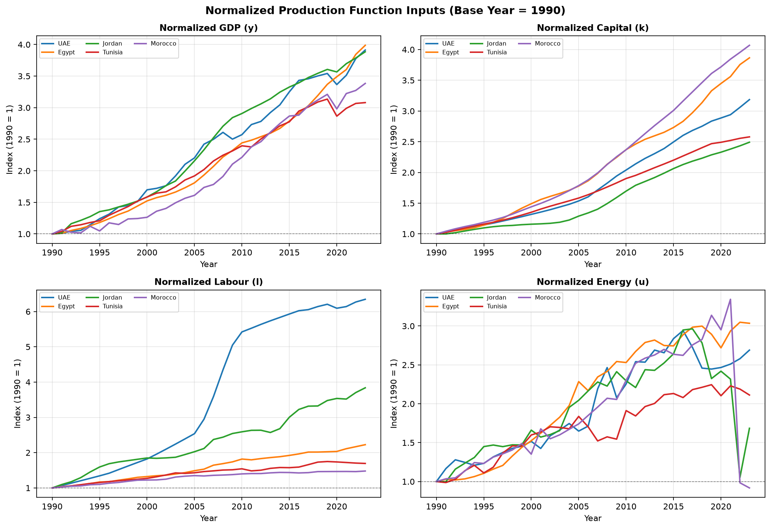
Figure 1. Normalised production function inputs (base year 1990 = 1). GDP (y) and Capital (k) show strong growth in all countries; Labour (l) diverges strongly in UAE due to rapid workforce expansion.

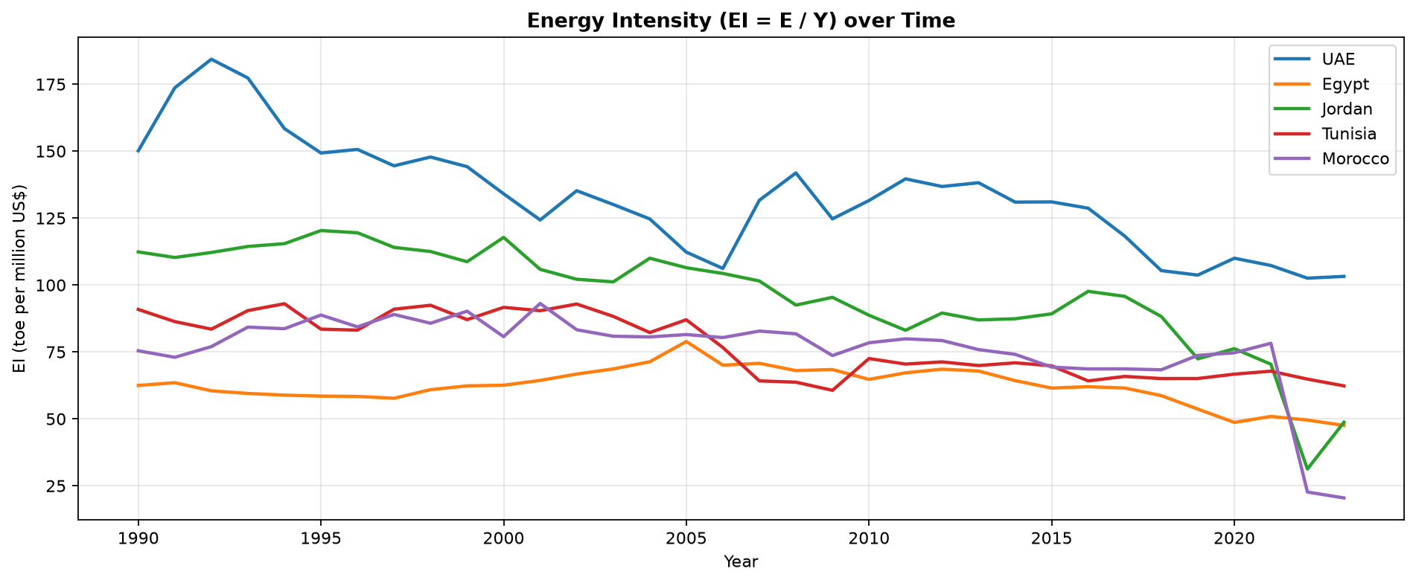
Figure 2. Energy intensity (EI = E/Y, toe per million US$) over time. A general declining trend confirms improving energy efficiency across all five economies.

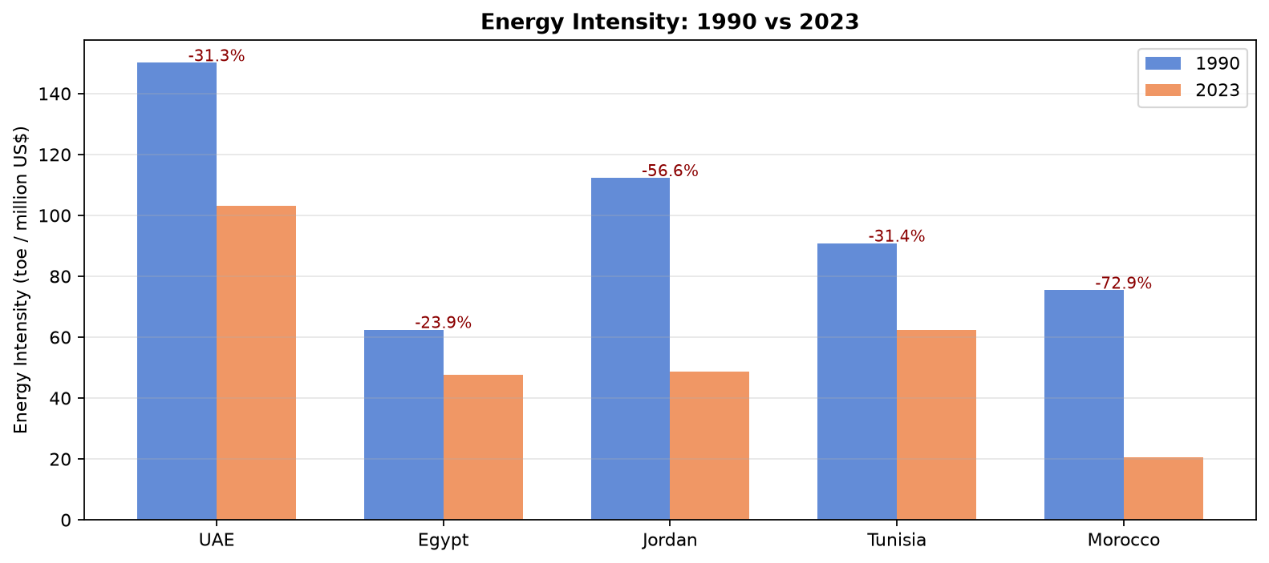
Figure 3. Energy intensity comparison: 1990 vs 2023. Percentage change 1990→2023 annotated above each country pair.

4.1 Normalised Variable Tables (First 3 & Last 3 Years)

UAE
Year | y (GDP) | k (Capital) | l (Labour) | u (Energy) | EI (toe/Mn$)
1990 | 1.0000 | 1.0000 | 1.0000 | 1.0000 | 150.1403
1991 | 1.0086 | 1.0330 | 1.0670 | 1.1667 | 173.6724
1992 | 1.0423 | 1.0739 | 1.1349 | 1.2798 | 184.3396
2021 | 3.5125 | 2.9399 | 6.1406 | 2.5100 | 107.2897
2022 | 3.7762 | 3.0596 | 6.2700 | 2.5793 | 102.5530
2023 | 3.9129 | 3.1853 | 6.3466 | 2.6900 | 103.2159

Egypt
Year | y (GDP) | k (Capital) | l (Labour) | u (Energy) | EI (toe/Mn$)
1990 | 1.0000 | 1.0000 | 1.0000 | 1.0000 | 62.4801
1991 | 1.0115 | 1.0299 | 1.0369 | 1.0282 | 63.5115
1992 | 1.0546 | 1.0535 | 1.0581 | 1.0208 | 60.4772
2021 | 3.6033 | 3.5602 | 2.1115 | 2.9357 | 50.9049
2022 | 3.8431 | 3.7555 | 2.1685 | 3.0482 | 49.5571
2023 | 3.9875 | 3.8651 | 2.2259 | 3.0348 | 47.5520

Jordan
Year | y (GDP) | k (Capital) | l (Labour) | u (Energy) | EI (toe/Mn$)
1990 | 1.0000 | 1.0000 | 1.0000 | 1.0000 | 112.3622
1991 | 1.0161 | 1.0002 | 1.0956 | 0.9973 | 110.2812
1992 | 1.1619 | 1.0201 | 1.1748 | 1.1597 | 112.1535
2021 | 3.6964 | 2.3806 | 3.5186 | 2.3167 | 70.4238
2022 | 3.7861 | 2.4333 | 3.7029 | 1.0534 | 31.2635
2023 | 3.8852 | 2.4921 | 3.8381 | 1.6851 | 48.7343

Tunisia
Year | y (GDP) | k (Capital) | l (Labour) | u (Energy) | EI (toe/Mn$)
1990 | 1.0000 | 1.0000 | 1.0000 | 1.0000 | 90.8781
1991 | 1.0390 | 1.0245 | 1.0283 | 0.9870 | 86.3294
1992 | 1.1201 | 1.0595 | 1.0576 | 1.0294 | 83.5161
2021 | 2.9892 | 2.5211 | 1.7207 | 2.2306 | 67.8135
2022 | 3.0671 | 2.5554 | 1.7042 | 2.1887 | 64.8530
2023 | 3.0800 | 2.5791 | 1.6938 | 2.1124 | 62.3259

Morocco
Year | y (GDP) | k (Capital) | l (Labour) | u (Energy) | EI (toe/Mn$)
1990 | 1.0000 | 1.0000 | 1.0000 | 1.0000 | 75.4317
1991 | 1.0695 | 1.0434 | 1.0278 | 1.0350 | 72.9995
1992 | 1.0264 | 1.0835 | 1.0483 | 1.0476 | 76.9914
2021 | 3.2234 | 3.8435 | 1.4663 | 3.3430 | 78.2314
2022 | 3.2726 | 3.9544 | 1.4630 | 0.9839 | 22.6779
2023 | 3.3840 | 4.0689 | 1.4788 | 0.9181 | 20.4643

5. CES Production Function Results

Table 1 presents the best-fit CES parameters and 95% bootstrap confidence intervals for each country. R² values above 0.97 confirm excellent model fit in all five cases.
Country | θ | θ CI | λ | λ CI | δ | δ₁ | ρ | ρ CI | σ(KL-E) | σ₁(K-L) | R²
UAE | 1.0240 | [0.972, 1.119] | -0.00460 | [-0.0083, 0.0023] | 0.1514 | 0.9842 | 5.0000 | [-0.500, 5.000] | 0.1667 | 0.1667 | 0.9832
Egypt | 0.9974 | [0.982, 1.015] | 0.00432 | [0.0007, 0.0066] | 0.7573 | 0.9990 | -0.5000 | [-0.500, 5.000] | 2.0000 | 2.0000 | 0.9993
Jordan | 1.0313 | [0.905, 1.159] | 0.00895 | [0.0055, 0.0118] | 0.4556 | 0.7864 | -0.5000 | [-0.500, 2.584] | 2.0000 | 2.0000 | 0.9733
Tunisia | 1.0668 | [1.004, 1.122] | 0.00922 | [0.0048, 0.0157] | 0.8471 | 0.8621 | 2.7590 | [-0.500, 5.000] | 0.2660 | 0.1667 | 0.9837
Morocco | 0.9104 | [0.851, 0.951] | 0.00252 | [-0.0005, 0.0118] | 0.9913 | 0.9928 | -0.5000 | [-0.500, 4.513] | 2.0000 | 0.1667 | 0.9928
Table 1. CES parameter estimates with 95% bootstrap confidence intervals. CI = confidence interval. ρ at boundary (−0.5 or 5.0) indicates optimizer reached parameter bound.

5.1 Elasticity of Substitution (σ) Interpretation
Country | σ (KL-E) | Interpretation
UAE | 0.1667 | σ < 1: KL & Energy are COMPLEMENTS — limited substitutability, lower rebound risk
Egypt | 2.0000 | σ > 1: KL & Energy are SUBSTITUTES (at boundary) — high rebound/backfire risk
Jordan | 2.0000 | σ > 1: KL & Energy are SUBSTITUTES (at boundary) — high rebound/backfire risk
Tunisia | 0.2660 | σ < 1: KL & Energy are weak COMPLEMENTS — moderate substitutability
Morocco | 2.0000 | σ > 1: KL & Energy are SUBSTITUTES (at boundary) — high rebound/backfire risk
Table 2. KL-Energy elasticity of substitution and economic interpretation.

Note: Egypt, Jordan, and Morocco converge to the lower bound of ρ (−0.5 → σ = 2.0), indicating the optimizer could not find an interior solution with short time-series data. Wide bootstrap CI for ρ in these countries confirms high parameter uncertainty.

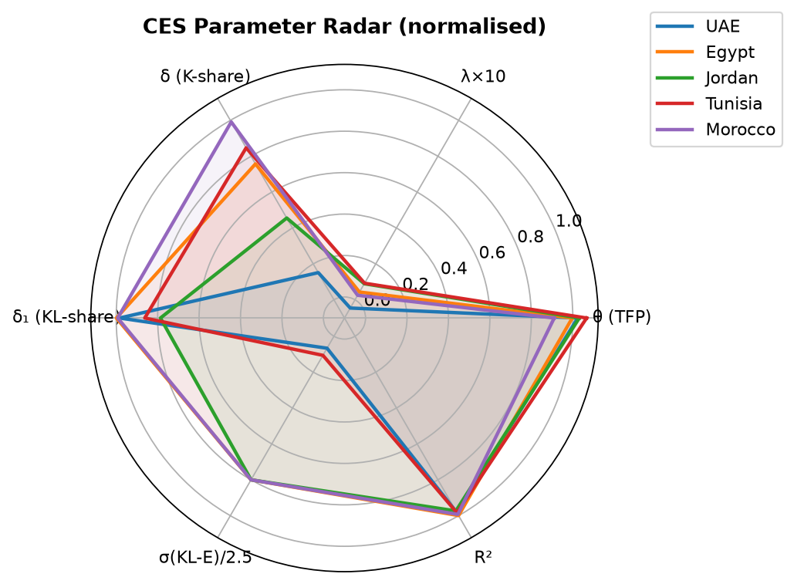
Figure 4. Radar chart of normalised CES parameters across countries (σ capped at 2.5 for scaling).

6. Method 1: AES/PES Rebound

Method 1 quantifies rebound by comparing the Actual Energy Savings (AES) to the Potential Energy Savings (PES) that would have occurred if energy intensity had fallen without any output response. The parameter λ (from the CES fit) captures the rate of embodied technical change, driving the wedge between AES and PES.

6.1 Equations
Potential Energy Saved | PESt+1 = Yt+1 × (EIt − EIt+1)
Rebound Energy Consumed | (PES − AES)t+1 = λ × (Yt+1 − Yt) × EIt+1
Annual Rebound | Ret+1 = [(PES − AES) / PES] × 100
Mean Rebound (M1) | Re_M1 = (1/N) × Σ Ret+1 [valid years: PES > 0 only]
Decomposition | Ret+1 = λ × [(Yt+1 − Yt)/Yt+1] × [EIt+1/(EIt − EIt+1)] × 100
Decomposition terms | A = λ, B = (Yt+1 − Yt)/Yt+1, C = EIt+1/(EIt − EIt+1)

Years with PES ≤ 0 (energy intensity did not decline year-on-year) are excluded from the mean rebound calculation. These correspond to periods of rising energy intensity, where no efficiency gain occurred to rebound from.

6.2 Method 1 Summary
Country | Valid Years | Re_M1 (2.5%) | Re_M1 (Base) | Re_M1 (97.5%) | State
UAE | 20 | -0.90% | -0.50% | 0.25% | Super-conservation
Egypt | 18 | 0.22% | 1.40% | 2.13% | Partial rebound
Jordan | 20 | 0.73% | 1.18% | 1.57% | Partial rebound
Tunisia | 19 | 0.91% | 1.77% | 3.00% | Partial rebound
Morocco | 19 | -0.15% | 0.82% | 3.83% | Partial rebound
Table 3. Method 1 results summary with 95% bootstrap CI (derived from λ bootstrap distribution).

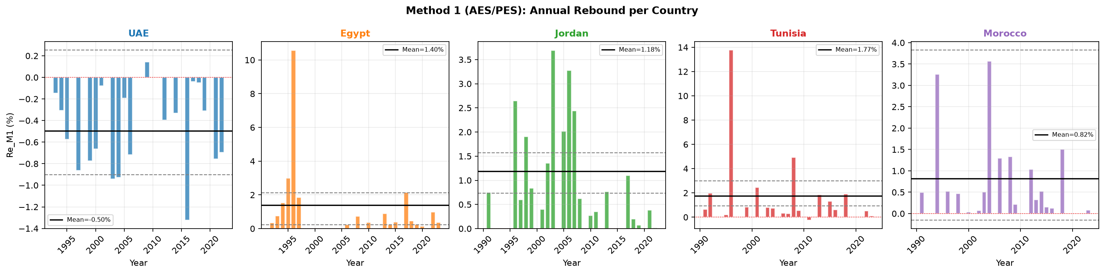
Figure 5. Annual Method 1 rebound per country (valid years only). Solid line = mean base-fit; dashed lines = 95% bootstrap CI bounds.

6.3 Annual Rebound Decomposition Tables (All Valid Years)
The following tables present the full A × B × C decomposition of annual rebound for each valid year (PES > 0) in each country. Columns: PES = Potential Energy Saved (Mtoe); (PES−AES) = Rebound Energy (Mtoe); A = λ; B = ΔY/Y; C = EIt+1/ΔEI.

UAE (λ = -0.004599)
Year | PES (Mtoe) | (PES−AES)(Mtoe) | Re annual (%) | A = λ | B = ΔY/Y | C = EI/ΔEI
1993 | 1.4965 | -0.002170 | -0.1450 | -0.004599 | 0.012454 | 25.3188
1994 | 4.3894 | -0.013390 | -0.3051 | -0.004599 | 0.079209 | 8.3747
1995 | 2.2881 | -0.013094 | -0.5723 | -0.004599 | 0.075943 | 16.3861
1997 | 1.7694 | -0.015284 | -0.8638 | -0.004599 | 0.079621 | 23.5909
1999 | 1.1011 | -0.008536 | -0.7752 | -0.004599 | 0.042009 | 40.1276
2000 | 3.4885 | -0.023078 | -0.6615 | -0.004599 | 0.108867 | 13.2138
2001 | 3.4051 | -0.002704 | -0.0794 | -0.004599 | 0.013570 | 12.7235
2003 | 1.9970 | -0.018797 | -0.9413 | -0.004599 | 0.080887 | 25.3043
2004 | 2.3003 | -0.021308 | -0.9263 | -0.004599 | 0.087313 | 23.0701
2005 | 5.5335 | -0.010670 | -0.1928 | -0.004599 | 0.046303 | 9.0558
2006 | 2.9875 | -0.021438 | -0.7176 | -0.004599 | 0.089562 | 17.4235
2009 | 8.6923 | 0.012485 | 0.1436 | -0.004599 | -0.042997 | 7.2643
2012 | 1.6073 | -0.006348 | -0.3950 | -0.004599 | 0.017918 | 47.9344
2014 | 4.4592 | -0.014844 | -0.3329 | -0.004599 | 0.039991 | 18.1008
2016 | 1.6376 | -0.021661 | -1.3228 | -0.004599 | 0.052685 | 54.5962
2017 | 7.2902 | -0.002778 | -0.0381 | -0.004599 | 0.007297 | 11.3539
2018 | 9.1365 | -0.004456 | -0.0488 | -0.004599 | 0.012969 | 8.1785
2019 | 1.2062 | -0.003748 | -0.3107 | -0.004599 | 0.010962 | 61.6362
2021 | 1.9362 | -0.014640 | -0.7561 | -0.004599 | 0.041730 | 39.3990
2022 | 3.6208 | -0.025182 | -0.6955 | -0.004599 | 0.069851 | 21.6508

Egypt (λ = 0.004321)
Year | PES (Mtoe) | (PES−AES)(Mtoe) | Re annual (%) | A = λ | B = ΔY/Y | C = EI/ΔEI
1992 | 1.5916 | 0.005602 | 0.3520 | 0.004321 | 0.040872 | 19.9312
1993 | 0.5289 | 0.004042 | 0.7642 | 0.004321 | 0.029103 | 60.7756
1994 | 0.3546 | 0.005453 | 1.5378 | 0.004321 | 0.038168 | 93.2505
1995 | 0.2174 | 0.006502 | 2.9905 | 0.004321 | 0.043795 | 158.0370
1996 | 0.0717 | 0.007571 | 10.5574 | 0.004321 | 0.048609 | 502.6668
1997 | 0.4451 | 0.008195 | 1.8410 | 0.004321 | 0.050549 | 84.2897
2006 | 8.5009 | 0.018692 | 0.2199 | 0.004321 | 0.064210 | 7.9254
2008 | 2.9969 | 0.021680 | 0.7234 | 0.004321 | 0.066827 | 25.0539
2010 | 4.4756 | 0.016641 | 0.3718 | 0.004321 | 0.048981 | 17.5684
2013 | 0.9074 | 0.008071 | 0.8895 | 0.004321 | 0.021322 | 96.5503
2014 | 4.7495 | 0.010513 | 0.2214 | 0.004321 | 0.028481 | 17.9875
2015 | 3.8685 | 0.015390 | 0.3978 | 0.004321 | 0.041765 | 22.0462
2017 | 0.7489 | 0.016116 | 2.1518 | 0.004321 | 0.040217 | 123.8317
2018 | 4.4987 | 0.020369 | 0.4528 | 0.004321 | 0.050589 | 20.7135
2019 | 8.4197 | 0.020425 | 0.2426 | 0.004321 | 0.052562 | 10.6814
2020 | 8.6481 | 0.012602 | 0.1457 | 0.004321 | 0.034516 | 9.7710
2022 | 2.5762 | 0.025538 | 0.9913 | 0.004321 | 0.062393 | 36.7707
2023 | 3.9769 | 0.014763 | 0.3712 | 0.004321 | 0.036228 | 23.7154

Jordan (λ = 0.008950)
Year | PES (Mtoe) | (PES−AES)(Mtoe) | Re annual (%) | A = λ | B = ΔY/Y | C = EI/ΔEI
1991 | 0.0620 | 0.000465 | 0.7508 | 0.008950 | 0.015831 | 52.9945
1996 | 0.0334 | 0.000884 | 2.6436 | 0.008950 | 0.020406 | 144.7552
1997 | 0.2283 | 0.001369 | 0.5997 | 0.008950 | 0.032073 | 20.8939
1998 | 0.0667 | 0.001269 | 1.9018 | 0.008950 | 0.029240 | 72.6754
1999 | 0.1697 | 0.001421 | 0.8374 | 0.008950 | 0.032785 | 28.5390
2001 | 0.5833 | 0.002319 | 0.3975 | 0.008950 | 0.050061 | 8.8725
2002 | 0.1913 | 0.002585 | 1.3512 | 0.008950 | 0.054676 | 27.6147
2003 | 0.0529 | 0.001949 | 3.6865 | 0.008950 | 0.039954 | 103.0975
2005 | 0.2252 | 0.004539 | 2.0160 | 0.008950 | 0.075329 | 29.9043
2006 | 0.1459 | 0.004779 | 3.2754 | 0.008950 | 0.074870 | 48.8829
2007 | 0.2081 | 0.005078 | 2.4399 | 0.008950 | 0.075582 | 36.0703
2008 | 0.7140 | 0.004421 | 0.6191 | 0.008950 | 0.067342 | 10.2726
2010 | 0.5694 | 0.001530 | 0.2688 | 0.008950 | 0.022623 | 13.2743
2011 | 0.4919 | 0.001734 | 0.3526 | 0.008950 | 0.026642 | 14.7876
2013 | 0.2376 | 0.001821 | 0.7667 | 0.008950 | 0.025436 | 33.6803
2017 | 0.1912 | 0.002108 | 1.1028 | 0.008950 | 0.024138 | 51.0473
2018 | 0.7803 | 0.001544 | 0.1979 | 0.008950 | 0.018830 | 11.7460
2019 | 1.6725 | 0.001179 | 0.0705 | 0.008950 | 0.017213 | 4.5757
2021 | 0.6282 | 0.002408 | 0.3833 | 0.008950 | 0.035267 | 12.1441
2022 | 4.3452 | 0.000736 | 0.0169 | 0.008950 | 0.023705 | 0.7983

Tunisia (λ = 0.009225)
Year | PES (Mtoe) | (PES−AES)(Mtoe) | Re annual (%) | A = λ | B = ΔY/Y | C = EI/ΔEI
1991 | 0.2406 | 0.001582 | 0.6577 | 0.009225 | 0.037569 | 18.9792
1992 | 0.1604 | 0.003181 | 1.9828 | 0.009225 | 0.072406 | 29.6864
1995 | 0.5843 | 0.001088 | 0.1862 | 0.009225 | 0.022946 | 8.7947
1996 | 0.0245 | 0.003375 | 13.7644 | 0.009225 | 0.066743 | 223.5649
1999 | 0.4148 | 0.003527 | 0.8502 | 0.009225 | 0.056756 | 16.2387
2001 | 0.1047 | 0.002554 | 2.4389 | 0.009225 | 0.036574 | 72.2869
2003 | 0.4097 | 0.003250 | 0.7932 | 0.009225 | 0.044912 | 19.1462
2004 | 0.5701 | 0.004203 | 0.7373 | 0.009225 | 0.058698 | 13.6161
2006 | 1.0647 | 0.003622 | 0.3402 | 0.009225 | 0.049828 | 7.4017
2007 | 1.3688 | 0.004084 | 0.2984 | 0.009225 | 0.062877 | 5.1440
2008 | 0.0554 | 0.002732 | 4.9324 | 0.009225 | 0.040655 | 131.5227
2009 | 0.3577 | 0.001948 | 0.5445 | 0.009225 | 0.029536 | 19.9833
2011 | 0.2497 | -0.000603 | -0.2416 | 0.009225 | -0.007668 | 34.1594
2013 | 0.1806 | 0.003317 | 1.8370 | 0.009225 | 0.038778 | 51.3535
2015 | 0.1610 | 0.002097 | 1.3023 | 0.009225 | 0.023046 | 61.2594
2016 | 0.8423 | 0.005109 | 0.6065 | 0.009225 | 0.057560 | 11.4231
2018 | 0.1246 | 0.002384 | 1.9138 | 0.009225 | 0.025258 | 82.1370
2022 | 0.4622 | 0.002370 | 0.5129 | 0.009225 | 0.025379 | 21.9065
2023 | 0.3962 | 0.000380 | 0.0960 | 0.009225 | 0.004219 | 24.6628

Morocco (λ = 0.002517)
Year | PES (Mtoe) | (PES−AES)(Mtoe) | Re annual (%) | A = λ | B = ΔY/Y | C = EI/ΔEI
1991 | 0.2630 | 0.001291 | 0.4909 | 0.002517 | 0.064977 | 30.0135
1994 | 0.0688 | 0.002241 | 3.2577 | 0.002517 | 0.093858 | 137.8828
1996 | 0.5238 | 0.002748 | 0.5247 | 0.002517 | 0.108871 | 19.1451
1998 | 0.4117 | 0.001924 | 0.4673 | 0.002517 | 0.071279 | 26.0456
2000 | 1.2178 | 0.000407 | 0.0334 | 0.002517 | 0.015676 | 8.4678
2002 | 1.3943 | 0.000955 | 0.0685 | 0.002517 | 0.032096 | 8.4810
2003 | 0.3640 | 0.001826 | 0.5017 | 0.002517 | 0.059416 | 33.5402
2004 | 0.0412 | 0.001471 | 3.5692 | 0.002517 | 0.045818 | 309.4542
2006 | 0.1974 | 0.002558 | 1.2961 | 0.002517 | 0.072011 | 71.5012
2008 | 0.1988 | 0.002645 | 1.3304 | 0.002517 | 0.066516 | 79.4548
2009 | 1.7276 | 0.003654 | 0.2115 | 0.002517 | 0.092587 | 9.0752
2012 | 0.1610 | 0.001661 | 1.0312 | 0.002517 | 0.033437 | 122.5140
2013 | 0.8959 | 0.002906 | 0.3243 | 0.002517 | 0.057604 | 22.3672
2014 | 0.4914 | 0.002558 | 0.5205 | 0.002517 | 0.049360 | 41.8918
2015 | 1.3764 | 0.002107 | 0.1531 | 0.002517 | 0.041637 | 14.6067
2016 | 0.2078 | 0.000261 | 0.1256 | 0.002517 | 0.005185 | 96.2641
2018 | 0.1075 | 0.001614 | 1.5020 | 0.002517 | 0.029744 | 200.5999
2022 | 18.3824 | 0.000284 | 0.0015 | 0.002517 | 0.015042 | 0.4082
2023 | 0.7574 | 0.000580 | 0.0766 | 0.002517 | 0.032913 | 9.2449

7. Method 2: EEE Rebound

Method 2 derives the national energy rebound directly from the estimated CES elasticity of substitution (ρ) and the cost share parameters, using the Energy-Economy-Environment (EEE) formula of Brockway et al. (2017). Unlike Method 1, it does not rely on observed energy intensity trends, but instead on structural production parameters.

7.1 Equations
Re_M2 = { [(1+sE+sK)(1+ρ) + ρ(sE−sK−1) + sE] / [(1+sE+sK)(1+ρ)] } × 100
Substitution effect | ηsub = ρ(sE − 1) / [(1+sE+sK)(1+ρ)]
 | Re_sub = (1 + ηsub) × 100
Output effect | ηtotal = Re_M2/100 − 1
 | ηoutput = ηtotal − ηsub ; Re_output = ηoutput × 100

7.2 Method 2 Results
Country | ρ | σ(KL-E) | ηsub | Re_sub(%) | ηoutput | Re_out(%) | Re_M2 Base | State
UAE | 5.0000 | 0.1667 | -0.4978 | 50.22% | -0.2403 | -24.03% | 26.19% | Partial rebound
Egypt | -0.5000 | 2.0000 | 0.5974 | 159.74% | 0.4026 | 40.26% | 200.00% | Backfire
Jordan | -0.5000 | 2.0000 | 0.5974 | 159.74% | 0.4026 | 40.26% | 200.00% | Backfire
Tunisia | 2.7590 | 0.2660 | -0.4385 | 56.15% | -0.2054 | -20.54% | 35.61% | Partial rebound
Morocco | -0.5000 | 2.0000 | 0.5974 | 159.74% | 0.4026 | 40.26% | 200.00% | Backfire
Table 4. Method 2 results with substitution and output effect decomposition. Re_M2 = 200% indicates backfire (ρ at lower bound −0.5, σ = 2.0).

7.3 Bootstrap Confidence Intervals
Country | Re_M2 (2.5%) | Re_M2 (Base) | Re_M2 (97.5%)
UAE | 200.00% | 26.19% | 26.19%
Egypt | 200.00% | 200.00% | 26.19%
Jordan | 200.00% | 200.00% | 36.84%
Tunisia | 200.00% | 35.61% | 26.19%
Morocco | 200.00% | 200.00% | 27.59%
Table 5. Method 2 bootstrap confidence intervals (95%), derived from ρ at 2.5th and 97.5th bootstrap percentiles.

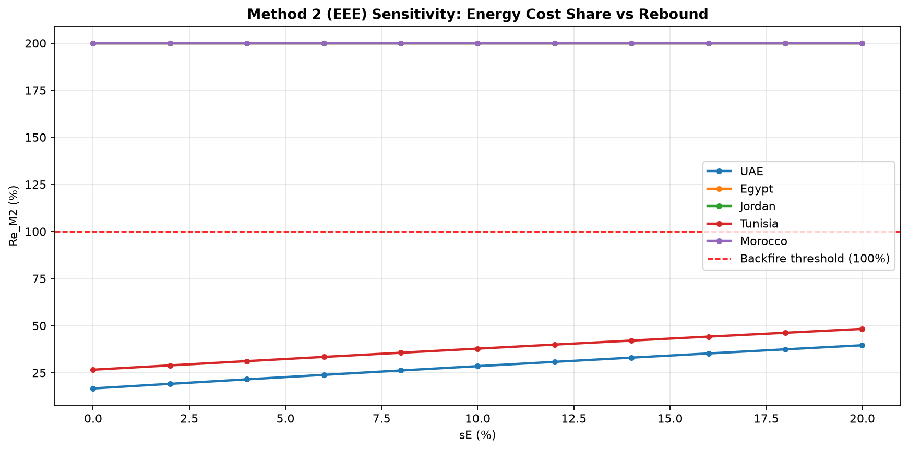
Figure 6. Sensitivity of Re_M2 to energy cost share (sE). Countries with ρ = −0.5 remain at 200% for all sE values. Red dashed line = backfire threshold.

7.4 Sensitivity Tables: sE vs Re_M2
For each country, the table below shows how Re_M2 varies across sE = 0%–20%, holding ρ fixed at its base-fit value.

UAE (ρ = 5.0000)
sE (%) | sK (%) | Re_M2 (%)
0% | 50.0% | 16.67%
2% | 49.0% | 19.09%
4% | 48.0% | 21.49%
6% | 47.0% | 23.86%
8% | 46.0% | 26.19%
10% | 45.0% | 28.49%
12% | 44.0% | 30.77%
14% | 43.0% | 33.01%
16% | 42.0% | 35.23%
18% | 41.0% | 37.42%
20% | 40.0% | 39.58%

Egypt (ρ = -0.5000)
sE (%) | sK (%) | Re_M2 (%)
0% | 50.0% | 200.00%
2% | 49.0% | 200.00%
4% | 48.0% | 200.00%
6% | 47.0% | 200.00%
8% | 46.0% | 200.00%
10% | 45.0% | 200.00%
12% | 44.0% | 200.00%
14% | 43.0% | 200.00%
16% | 42.0% | 200.00%
18% | 41.0% | 200.00%
20% | 40.0% | 200.00%

Jordan (ρ = -0.5000)
sE (%) | sK (%) | Re_M2 (%)
0% | 50.0% | 200.00%
2% | 49.0% | 200.00%
4% | 48.0% | 200.00%
6% | 47.0% | 200.00%
8% | 46.0% | 200.00%
10% | 45.0% | 200.00%
12% | 44.0% | 200.00%
14% | 43.0% | 200.00%
16% | 42.0% | 200.00%
18% | 41.0% | 200.00%
20% | 40.0% | 200.00%

Tunisia (ρ = 2.7590)
sE (%) | sK (%) | Re_M2 (%)
0% | 50.0% | 26.60%
2% | 49.0% | 28.90%
4% | 48.0% | 31.17%
6% | 47.0% | 33.40%
8% | 46.0% | 35.61%
10% | 45.0% | 37.79%
12% | 44.0% | 39.94%
14% | 43.0% | 42.07%
16% | 42.0% | 44.16%
18% | 41.0% | 46.23%
20% | 40.0% | 48.28%

Morocco (ρ = -0.5000)
sE (%) | sK (%) | Re_M2 (%)
0% | 50.0% | 200.00%
2% | 49.0% | 200.00%
4% | 48.0% | 200.00%
6% | 47.0% | 200.00%
8% | 46.0% | 200.00%
10% | 45.0% | 200.00%
12% | 44.0% | 200.00%
14% | 43.0% | 200.00%
16% | 42.0% | 200.00%
18% | 41.0% | 200.00%
20% | 40.0% | 200.00%

8. Cross-Country Comparison & Final Summary

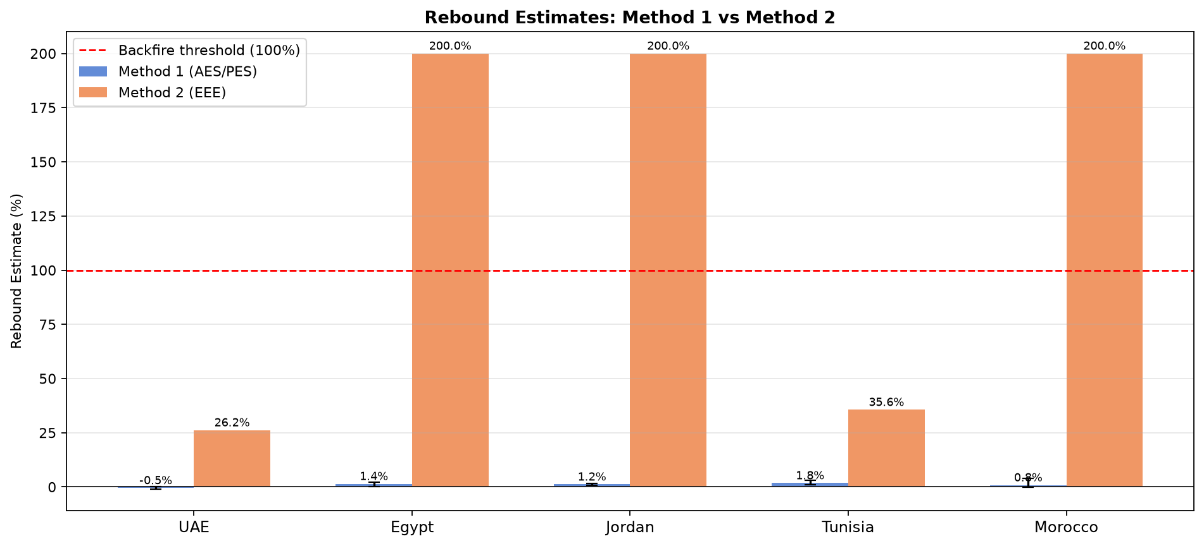
Figure 7. Method 1 vs Method 2 rebound estimates (base-fit). Error bars on Method 1 bars show 95% bootstrap CI. Red dashed line = backfire threshold.

8.1 Master Summary Table
Country | Re_M1  (2.5%) | Re_M1  (Base) | Re_M1  (97.5%) | Re_M2  (2.5%) | Re_M2  (Base) | Re_M2  (97.5%) | σ(KL-E) | State M1 | State M2
UAE | -0.90% | -0.50% | 0.25% | 200.00% | 26.19% | 26.19% | 0.1667 | Super-conservation | Partial rebound
Egypt | 0.22% | 1.40% | 2.13% | 200.00% | 200.00% | 26.19% | 2.0000 | Partial rebound | Backfire
Jordan | 0.73% | 1.18% | 1.57% | 200.00% | 200.00% | 36.84% | 2.0000 | Partial rebound | Backfire
Tunisia | 0.91% | 1.77% | 3.00% | 200.00% | 35.61% | 26.19% | 0.2660 | Partial rebound | Partial rebound
Morocco | -0.15% | 0.82% | 3.83% | 200.00% | 200.00% | 27.59% | 2.0000 | Partial rebound | Backfire
Table 6. Master rebound summary for all five MENA countries with 95% bootstrap CI and rebound state classification.

9. Discussion

9.1 Method 1 (AES/PES) Findings
Method 1 yields low rebound estimates for all five countries (< 2%), suggesting that energy efficiency improvements in MENA economies have generally delivered net energy savings. UAE stands out as the only country showing super-conservation (Re_M1 = −0.50%), driven by a negative λ (−0.0046), implying slight embodied technological regress in the fitted CES — possibly reflecting the UAE's energy-intensive economic structure (oil sector dominance) partially offsetting efficiency gains. Egypt, Jordan, Tunisia, and Morocco exhibit positive but small partial rebound (0.8%–1.8%), consistent with developing-economy patterns where income growth moderately offsets efficiency savings.

9.2 Method 2 (EEE) Findings
Method 2 results diverge substantially from Method 1. Egypt, Jordan, and Morocco register backfire (Re_M2 = 200%), a consequence of the optimizer converging to the lower bound of ρ (−0.5), implying σ = 2.0 (strong KL-Energy substitutability). Under such high substitutability, the EEE formula mechanically produces large rebound. Tunisia (Re_M2 = 35.6%, σ = 0.27) and UAE (Re_M2 = 26.2%, σ = 0.17) produce more moderate estimates, as their fitted ρ lies in the interior, implying complementarity between the KL aggregate and energy.

9.3 Methodological Divergence
The large gap between Method 1 and Method 2 estimates is consistent with findings in Brockway et al. (2017), who note that the two methods measure different aspects of rebound: Method 1 captures observed energy intensity trends and attributes changes to technical progress (λ), while Method 2 derives rebound from structural elasticities (ρ) and is therefore highly sensitive to the CES parameter estimates. The boundary solutions for ρ in three countries limit the reliability of Method 2 for those cases.

9.4 Limitations
- Energy proxy: using primary energy (Mtoe) as useful exergy proxy introduces measurement error. Ideally, exergy conversion factors should be applied.
- Short CES panel (34 years) limits identification of ρ, particularly when growth in K, L, and E are co-linear.
- Uniform sE = 0.08 does not account for cross-country variation in energy prices and cost shares.
- Bootstrap CI for Method 2 is wide when ρ hits its boundary, reflecting genuine structural uncertainty.
- λ is assumed time-invariant; in reality, embodied technical change may accelerate or decelerate over time.
- Base-year 1990 choice affects normalisation and may introduce level-bias if 1990 is not a 'normal' year for any country.

10. Conclusions

This study applied the Brockway et al. (2017) dual-method framework to estimate national energy rebound for five MENA economies over 1990–2023. The key findings are:
Country | State M1 | State M2 | Key Finding
UAE | Super-conservation | Partial rebound | Negative λ and low σ (0.17) indicate energy-KL complementarity and genuine efficiency gains exceeding direct savings.
Egypt | Partial rebound | Backfire | Low Method 1 rebound (1.4%) is reliable; Method 2 backfire is driven by ρ at boundary and should be treated with caution.
Jordan | Partial rebound | Backfire | Method 1 rebound (1.2%) is modest; ρ boundary issue makes Method 2 unreliable for this country.
Tunisia | Partial rebound | Partial rebound | Only country where both methods agree (M1=1.8%, M2=35.6%); higher confidence in partial rebound conclusion.
Morocco | Partial rebound | Backfire | Low Method 1 rebound (0.8%); ρ boundary makes Method 2 backfire finding unreliable.
Table 7. Country-level conclusions and key findings.

Overall, the AES/PES method provides consistent evidence that energy efficiency policies across all five MENA economies have delivered genuine energy savings, with only modest rebound (< 2%). Tunisia is the most robust case, with both methods independently confirming partial rebound. For Egypt, Jordan, and Morocco, the high-σ CES solutions warrant further investigation — potentially with longer time series, exergy data, or cross-sectional identification strategies.

11. References

- Brockway, P.E., Sorrell, S., Semieniuk, G., Heun, M.K., & Court, V. (2017). Energy rebound as a potential threat to a low-carbon future: findings from a new exergy-based analysis. Energies, 10(1), 51.
- Feenstra, R.C., Inklaar, R., & Timmer, M.P. (2015). The Next Generation of the Penn World Table. American Economic Review, 105(10), 3150–3182.
- OAPEC — Organisation of Arab Petroleum Exporting Countries. Energy statistics, various years.
- Sorrell, S. (2007). The Rebound Effect: an assessment of the evidence for economy-wide energy savings from improved energy efficiency. UK Energy Research Centre (UKERC), London.
- Arrow, K.J., Chenery, H.B., Minhas, B.S., & Solow, R.M. (1961). Capital-labour substitution and economic efficiency. Review of Economics and Statistics, 43(3), 225–250.

