Vol. 00 no. 00 2008
BIOINFORMATICS APPLICATIONS NOTE Pages 1–2
SBML2LATEX: Conversion of SBML ﬁles into human-readable reports
Andreas Dräger 1,∗, Hannes Planatscher1, Dieudonné MotsouWouamba1 ,
Adrian Schröder 1, Michael Hucka2, Lukas Endler3, Martin Golebiewski4 ,
Wolfgang Müller4, Andreas Zell1
1Centerfor BioinformaticsTübingen (ZBIT), University ofTübingen,Tübingen, Germany
2Beckman Institute BNMC, California Institute ofTechnology,Pasadena, United States 3European Bioinformatics Institute,WellcomeTrust Genome Campus, Hinxton, United Kingdom 4Scientiﬁc Databases and Visualization Group, EML Research gGmbH, Heidelberg, Germany
Received on XXXXX; revised on XXXXX; accepted on XXXXX
Associate Editor: XXXXXXX
ABSTRACT Summary: The XML-based Systems Biology Markup Language (SBML) has emerged asa standardfor storage, communication and interchangeof modelsin systems biology.Asa machine-readableformat XML is difﬁcultfor humans to read and understand. Many tools are available that visualize the reaction pathways stored in SBML ﬁles, but many components, e.g., unit declarations, complex kinetic equations, or links to MIRIAM resources, are often not made visible in these diagrams.Fora broader understandingof the models, supportin scientiﬁc writing and error detection, a human-readable report of the complete modelis needed.We present SBML2LATEX,aJavabased stand-aloneprogramtoﬁllthisgap.A convenientwebservice allows users to directly convert SBML to various formats, including DVI,LATEX, and PDF, and provides manysettingsfor customization. Availability: Source code, documentation, and a web service are freelyavailableat http://webservices.cs.uni-tuebingen.de/webservices. Contact: andreas.draeger@uni-tuebingen.de
1 INTRODUCTION
SBML (Hucka et al., 2003) has become the de facto standard format for storing models of biochemical systems. SBML allows for deﬁnitions of complex models of molecular interactions and cellular processes. Over one hundred software tools now support SBML, including manywith intuitive graphical interfaces. Manytools support visualizing and saving molecular interaction graphs (Funahashi et al.,2003),butimportantdetailssuchasunit deﬁnitions, kineticrate equations, user-deﬁned functions, events, model notes, or annotations whether in Systems Biology Ontology (SBO) (Le Novère et al., 2006a) or MIRIAM format (Le Novère et al., 2005) are usually not madeexplicitinthe graphical presentations.Todetect potential errors ortogainanoverviewofthe modelasa whole,itis necessaryto examine the full contentof the SBML ﬁle,but the unfriendlinessof XML to human readers makes this an inconvenient and difﬁcult task.
Toaddressthis problem,wehavedeveloped SBML2LATEX,atool that accepts SBML ﬁles as input and generates summaries of their
∗to whom correspondence should be addressed

contentsas reportsinLATEXsourcecode format.Forconvenienceof usage an online web service directly produces human-readable ﬁles in variuos formats. Several settings allow for customization of the output,e.g.,addinganextratitlepage insteadof headlines,orchoosing the paper size, orientation (portrait or landscape), font sizes and styles. SBML2LATEXcovers all constructs deﬁned in the latestspeciﬁcationofSBML(Level2Version4)andisableto typesetcomplex kinetic formulas. It computes the derived units for all SBML elements using libSBML (Bornstein et al., 2008) and shows warnings ifkineticequationscannotbeevaluatedtothe correctunits.Allinformation is presented in clearly arranged tables, reaction equations and plain text, simplifying the task of understanding and communicating the model as well as detecting and correcting errors.
This work extends the approach of the rate law generator SBML-squeezer (Dräger et al., 2008) to translate rate equations toLATEX summaries currentlyforSBMLuptoLevel2Version1that includes information relevant for generated rate laws: global parameters, species, and compartments. This earlierwork does not comprise the full functionality of SBML2LATEXbecause of its focus on rate equations.

2 TRANSLATION OF SBML
Besides the mandatory ﬁeld “id” (short identiﬁer), every SBML component may contain optional attributes foradetailed name, SBO term number, notes (XHTML formatted explanation to be displayed to humans) and annotation (machine readable extension for software tools). Most SBML components contain special additional ﬁelds speciﬁc to each component type, e. g., the unit of a parameter, species, or compartment. SBML2LATEXtranslates every optional ﬁeld if it exists and writes this information in the description of the respective component. The URNs in MIRIAM annotations are translated to hyperlinks to the actual URLs. However, software-speciﬁc annotations (such as graph layout extensions) are not translated. The headline of the model report contains the model’s name, or its “id” attribute value if the SBML ﬁle doesnotassignanametothemodel.Theﬁrst section presentsageneraloverview of the model, including the number of SBML components within the model, SBML level and version, and the model’s history. All ﬁve predeﬁned SBML unit deﬁnitions are madeexplicit, which simpliﬁes the error detection process. As SBML does not contain mandatory components, SBML2LATEX displaysthe sectionsaboutthefollowing componentsinthisorderonlyifthey

©Oxford University Press 2008.

A. Dräger et al.

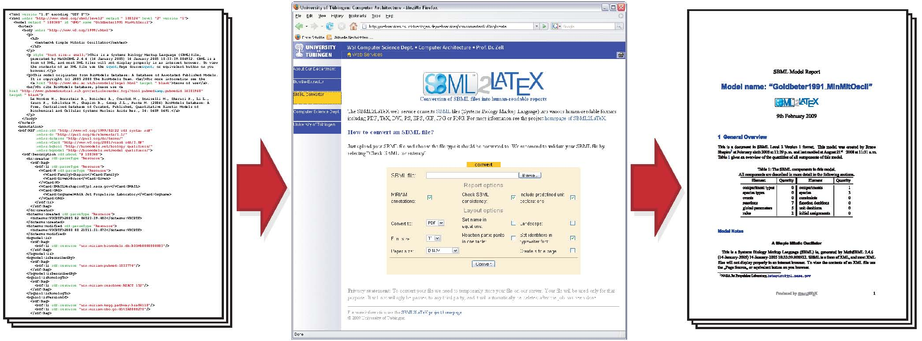
Fig. 1. Example workﬂow using the SBML2LATEXweb service and SBML ﬁleBIOMD0000000003.xml (available at http://www.ebi.ac.uk/biomodels). After upload of an SBML ﬁle, several options allowcustomizing the output: MIRIAM annotations, an SBML consistencycheck or predeﬁned unit declarations can be excluded, the desired ﬁle format can be selected; the paper size can be set to the US formats letter, legal or executive as well as to the European formats DIN A0-9 and the page orientation can be switched to landscape (especially important if the report contains fractions with very long denominators, where no automatic line break canbe inserted).Several other options inﬂuencethe layoutof the report, e.g., names canbe usedin equations insteadof identiﬁers, which canbe displayedin typewriter or roman font. When the user clicks on the “convert”button, the report ﬁleis generated and accessible fordownload.

are declared in the model: compartment types, compartments, species types, species, global parameters, initial assignments, function deﬁnitions, rules, events, constraints, and reactions. Each one of these sections in the report starts with a sentence that gives the number of components to be described and displays allavailable information about each respective component.For instance, section “Reactions” containsa table with all reaction equations and one subsection for each single reaction.For each reaction, its reactants, products, and modiﬁers are displayed in a table, followed by the formula of the kinetic law, its derived units, and a table of local parameters. For events, the trigger condition, the delay function, if one exists, and all assignments are given. If the model contains anyspecies, the last section shows the derived rate equations for the temporal changes of their amount. SBML2LATEX highlights kinetic equations whose units cannot be reduced to substance per time. Hyperlinks allow the user to jump to each referenced kinetic equation, event, or rule a species is involved in. If the model contains anySBO annotations, a glossary presents the SBO numbers together with terms and deﬁnitions. Finally,a consistencyreportofthe modelis includedattheend of the document.line break
SBML2LATEX is distributed under the GNU General Public License and completely written in Java™. It contains a modiﬁed version of HTML2LATEX(http://htmltolatex.sourceforge.net), and depends on an installation of libSBML.

3 CONCLUSION
SBML2LATEX facilitates the complicated and cumbersome model development processbyprovidingasimple methodto translatesuch models to human-readable reports. These reports support scientiﬁc writing because sophisticated formulas can be directly adopted and ease the error detection and model communication. The web service version provides a convenient way to create such reports in various formats and offers several options. If further customization becomes necessary, the source code and the binaries can be downloaded and used locally. SBML2LATEX has been integrated into the SABIO-RK database (Rojas et al., 2007) and can directly be accessed from the SBML homepage, http://sbml.org. The BioModels Database (Le Novère et al., 2006b) also relies on it to provide PDF versions of its models.
ACKNOWLEDGMENTS
The authors are grateful to Henning Schmidt, Detlev Bannasch, and Jochen Supper. Thisworkwas fundedby the German Federal Ministry of Education and Research (BMBF) in the National Genome Research Network (NGFN+) under Project Number 01GS08134 and HepatoSys under Project Number 0313080 L, and federal state Baden-Württembergin theTübinger Bioinformatik-Grid under Project Number 23-7532.24-4-18/1. Conﬂict of Interest: none declared.
REFERENCES
Bornstein, B. J. et al. (2008). LibSBML: an API Library for SBML. Bioinformatics, 24(6), 880–881. Dräger,A. et al. (2008). SBMLsqueezer:aCellDesigner plug-into generate kinetic rate equations for biochemical networks. BMC Systems Biology, 2(1), 39. Funahashi, A. et al. (2003). CellDesigner: a process diagram editor for gene-regulatory and biochemical networks. BioSilico, 1(5), 159–162.
Hucka, M. et al. (2003). The systems biology markup language (SBML):a medium for representation and exchange of biochemical network models. Bioinformatics, 19(4), 524–531.
Le Novère, N. et al. (2005). Minimum information requested in the annotation of biochemical models (MIRIAM). Nature Biotechnology, 23(12), 1509–1515.
Le Novère, N. et al. (2006a). Adding semantics in kinetics models of biochemical pathways.InC.KettnerandM.G.Hicks, editors, 2nd International ESCECWorkshop on Experimental StandardConditions on Enzyme Characterizations. Beilstein Institut, Rüdesheim, Germany, Rüdessheim/Rhein, Germany. ESEC.
Le Novère, N. et al. (2006b). BioModels Database: a free, centralized database of curated, published, quantitative kinetic models of biochemical and cellular systems. Nucleic Acids Research, 34, D689–D691.
Rojas, I. et al. (2007). Storing and Annotating of Kinetic Data. In Silico Biology, 7, 37–44.

