|  |
| --- |
| Central Connecticut State University |
| Process Description |
| SCRUM – Applying the Framework |
|  |
| **DeAlessio, Bryce T. (Student)** |
| **Bryce DeAlessio** |

|  |
| --- |
|  |

## Introduction

### Technical definition

Within the scope of Project Management of software products Scrum is an iterative and empirical “framework within which people can address complex adaptive problems, while productively and creatively delivering products of the highest possible value” (Schwaber & Sutherland). This framework sets forth a set of roles for the people involved in a software development project, a series of events that occur during the process and the artifacts that flow through those events to produce a potentially deliverable portion of the overall project. It uses a number of concepts borrowed from “Lean Manufacturing Principles” .

### Purpose and function

The purpose of Scrum is to provide a project management process that can handle incomplete and or rapidly changing customer requirements. Scrum is one of several project management systems geared toward software and systems development that arose (Beck & others, 2001) due to backlash against the traditional “Water Fall” method. The "Water Fall" method placed heavy emphasis on knowing all customer requirements before starting a project and delivering a product to a fixed contract. See figure 1.

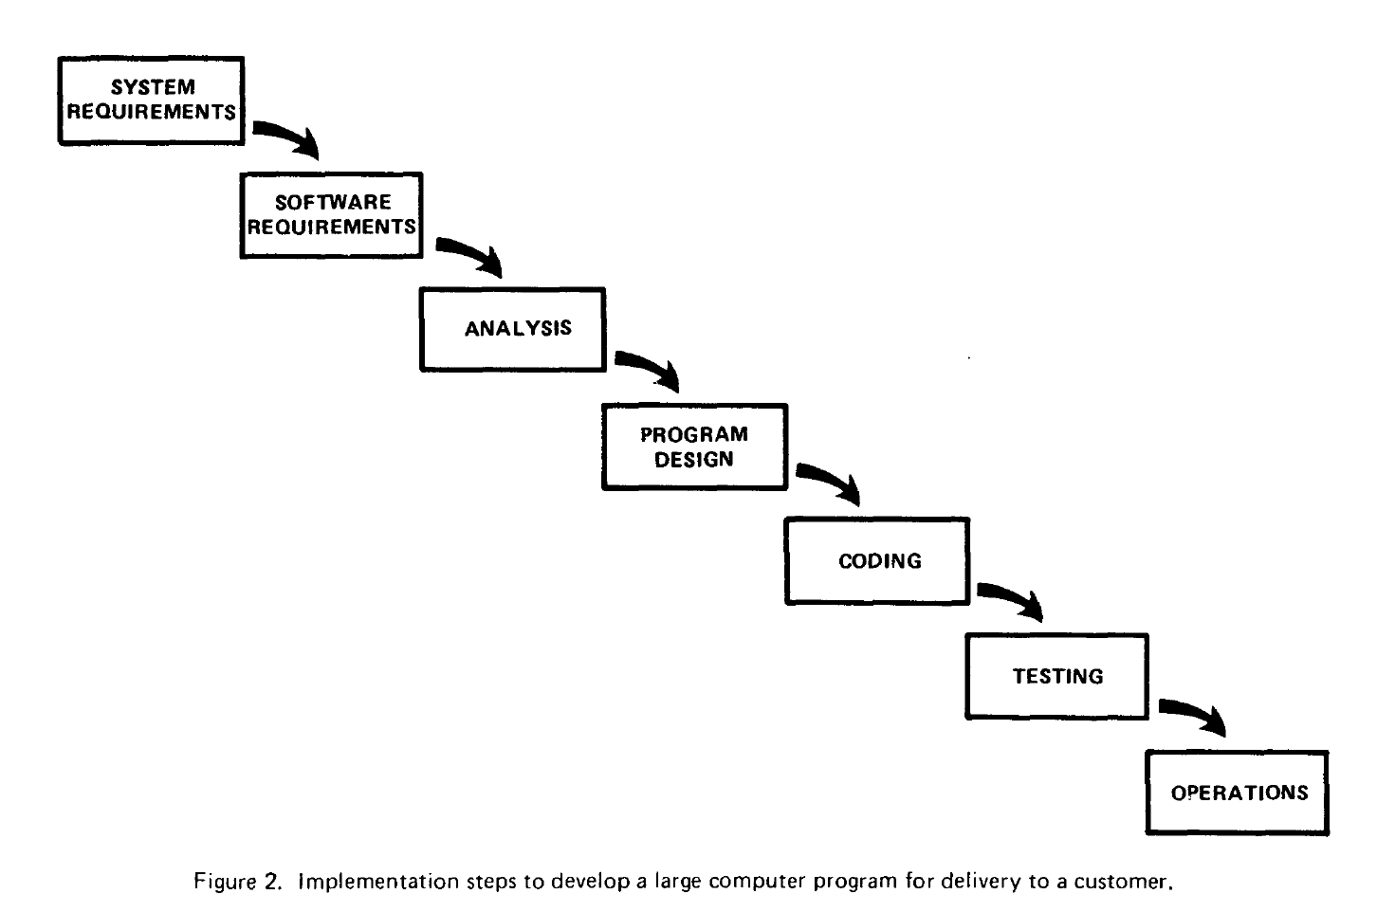Figure 1 | Traditional Waterfall Method (Royce)[1]

In contrast Scrum's emphasis is on maintaining close communication with the customer to handle changing requirements.

### Process Overview

At the start of a new Scrum project the Scrum team gathers initial customer requirements and Creates a Product Backlog. Within a Scrum team there are three roles, the Product Owner, the Scrum Manger and the developers (the people performing the actual work). With the initial team and product backlog in place an on-going series of events take place called Sprints which end only after the product is deemed done. Within each sprint a series of smaller events take place starting with the Sprint Planning Meeting, Then a daily Scrum meeting to track progress. At the end of the Sprint a Sprint Review meeting is held with both Scrum team and customers present. Finally a Sprint Retrospective meeting is held for the team to evaluate it's execution of the Sprint.

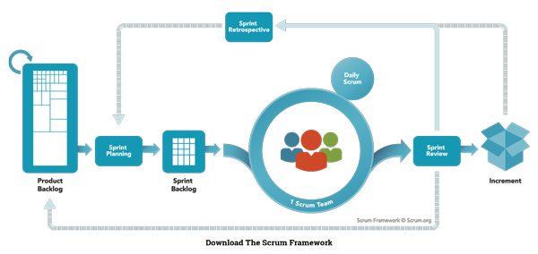  
Figure 2 | The Scrum Process [5]

#### Roles

lorem ipsum

### Gather Requirements

The Product Owner is the sole point of contact of the Scrum team with the customer. Thus the Product Owner takes responsibility for gathering product requirements from the customer for a requested product. The Product Owner works with the team to analyze the requirements and create a product Backlog which is a collection of features of the overall product to be worked on.

### Sprint

The Sprint is to be a two week to a month long time-boxed event. Each Sprint's Goal is to deliver a working subset of the final product to the customer. Sprint's continue in this iterative fashion until the team has reduced the Product Backlog items to zero and has reached it's definition of done.

### Sprint Planning Meeting

The Sprint Planning Meeting is where the team decides which Product Backlog Items (PBI) are going to be worked and how to turn them into finished features. The meeting is time-boxed to a maximum of 3 hours in length. During the meeting there are two main questions to be answered, "What can be done this Sprint?" and "How will the work get done"?[4] Question one is where the Team Decides which PBI's to include in the sprint. The second question, drives the team to split each PBI into smaller actionable steps that will bring the PBI to completion. These smaller steps generated by the team and the PBI's they belong too are called the Sprint Backlog. Producing the Sprint Backlog is the deliverable goal or artifact of this meeting.

### Daily Scrum

The Daily Scrum is a 15 minute meeting that happens at an agreed upon time every day. It's purpose is for the team to review their progress and raise any issues getting in their way. In the meeting everyone physically stands which is meant to encourage everyone to keep their contributions short & direct. Each person on the team should answer three questions; "What did you do the day before?", "What are you working on today?" and "Are you having any issues?"[4].

### Sprint Review

The Sprint Review is an event that occurs at the end of Sprint where the team demonstrates it's progress to the customer

### The Sprint Retrospective

lorem ipsum