|  |
| --- |
| Central Connecticut State University |
| Mechanism Description |
| General description of a Planetary Gear Box |
|  |
|  |
| **Bryce DeAlessio** |

|  |
| --- |
|  |

**Definition**

A planetary gear box is an assembly of gears that are arrayed around each other in a concentric pattern allowing a very high gear ratio and speed reduction in a compact configuration. The configuration allows the input and output shafts to lie on the same axis.

**Functional Overview**

The configuration of a planetary gear box consists of a central gear often called the sun gear. A set of planet gears which mesh with the sun-gear and orbit around the same axis of the sun gear. The planet gears are connected via bearings to a carrier that rotates on a common axis with the sun-gear. Finally a ring-gear with internal teeth meshes with the planet gears simultaneously. With a planetary gear box any one of the three main components (the sun-gear, carrier or ring gear) can be fixed while the most common configuration has the outer ring statically mounted with the input torque applied to the sun gear and output torque occurring on a shaft attached to the carrier.

Figure 1

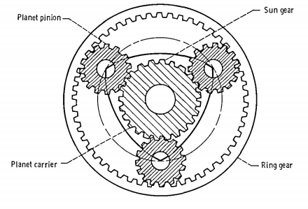

(Coy, Townsend, & Zaretsky "Gearing" 1985 54) - Figure 52 [2]

**Sun Gear**

The sun gear is the central gear about which the rest of rest of the gear-box assembly rotates. The sun gear can have either straight teeth or helical teeth. It is typically the driving member of the assembly which meshes with the planet gears.

**Planet Gears**

The planet gears orbit the sun gear and must have the same type of teeth as the sun gear. The number of teeth and resulting pitch diameter can be different. The more planet gears arrayed around the sun gear the more load the assembly can handle because the forces are distributed evenly.[1]

**Bearings**

The bearings connect the planet gears to the carrier. They provide a friction reducer upon which the planet gears rotate upon their individual axes.

**Carrier**

The Carrier is a single piece frame in which the planet gears are mounted together in a common diameter in an array around the central sun gear. The Carrier is the mounting point

**Ring Gear**

The ring gear is the largest gear in the assembly and it surrounds the entire assembly. It has Internal teeth that mesh with the external teeth of the planet gears.

**Conclusion**

Planetary Gear systems have a wide variety of use cases. Any where a large reduction in speed and increase in torque is required in a small space you will find them.

Citations

[1] The World of Planetary Gears Mar 1, 2000 Charles S. Kaim Associate Editor | Motion System Design - <http://machinedesign.com/motion-control/world-planetary-gears>

[2] Coy, John J., Dennis P. Townsend, and Erwin V. Zaretsky. <https://ntrs.nasa.gov/archive/nasa/casi.ntrs.nasa.gov/19860005142.pdf> . Cleveland, Ohio: Nasa Lewis Research Center, Dec. 1985. Pdf. NASA Reference Publication 1152