* [vedio] How to Get Started with Kaggle’s Titanic Competition | Kaggle, [How to Get Started with Kaggle’s Titanic Competition | Kaggle](https://www.youtube.com/watch?v=8yZMXCaFshs&feature=youtu.be)
  + EDA
    - How to improve



### 2.1 Age

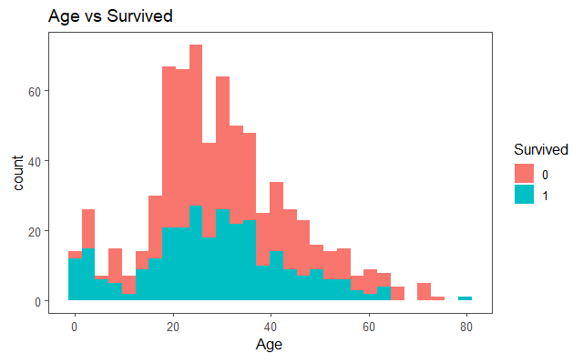

### 2.2 Sex Vs Survive

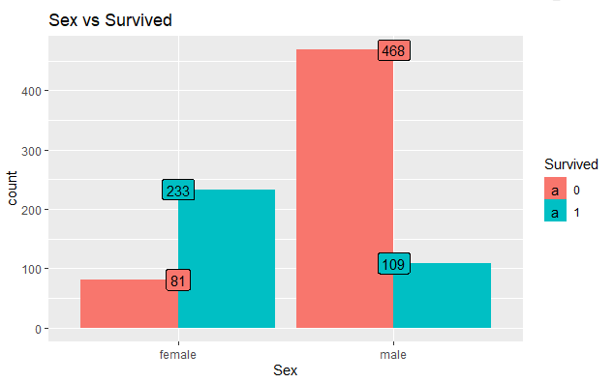

### 2.3 Age Vs Sex Vs Survived

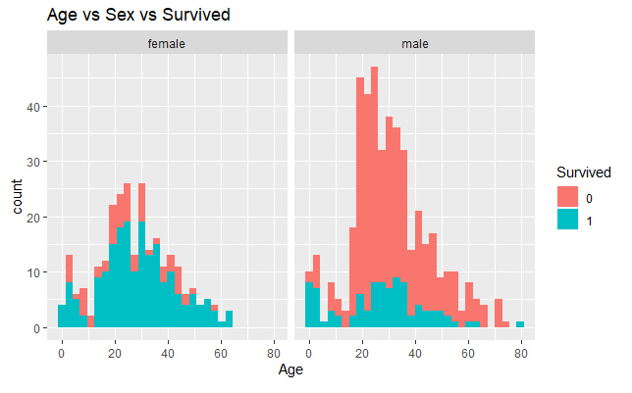

### 2.4. Pclass vs Sex

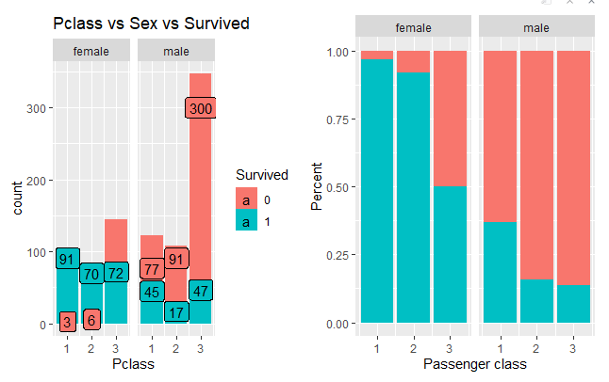

### 3.2 Title Vs Survived

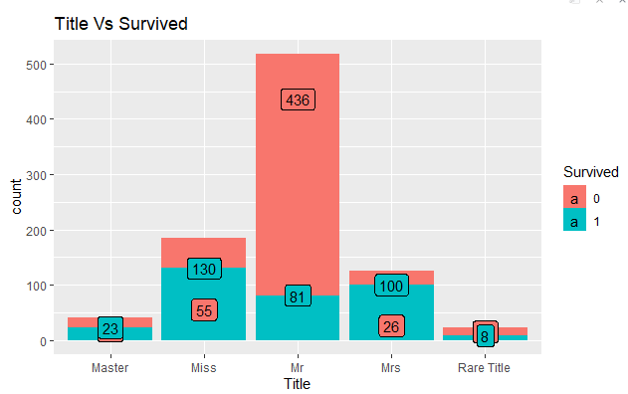

### 3.3 Family size Vs Survived

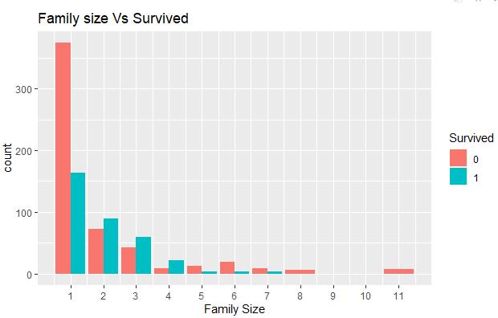

### 4.1 Redefined the Fsize to factor:

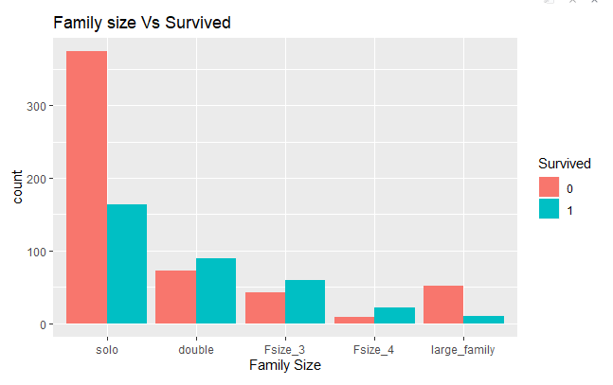

### 4.2 SLLR on Survived~Age

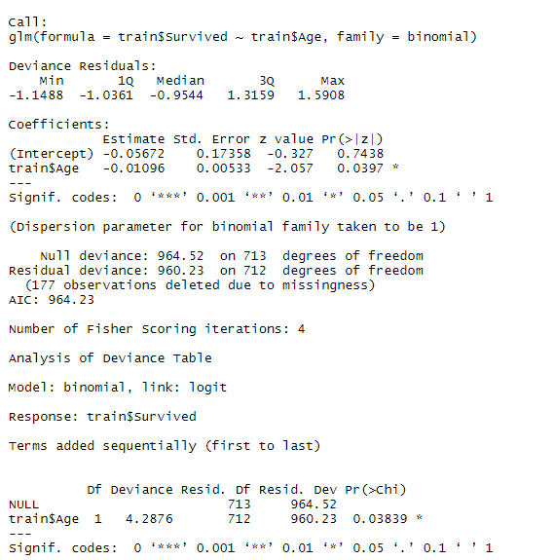

### 4.3 SLLR on Survived~Sex

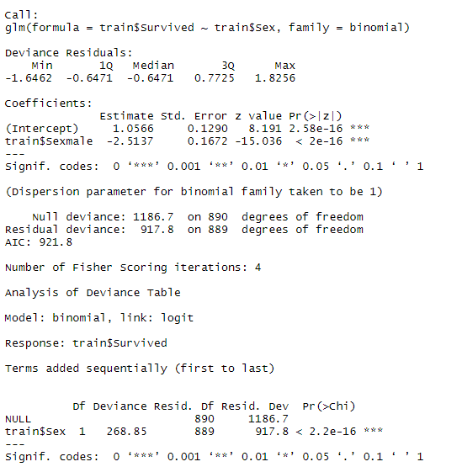

### 4.4 SLLR on Survived~Pclass

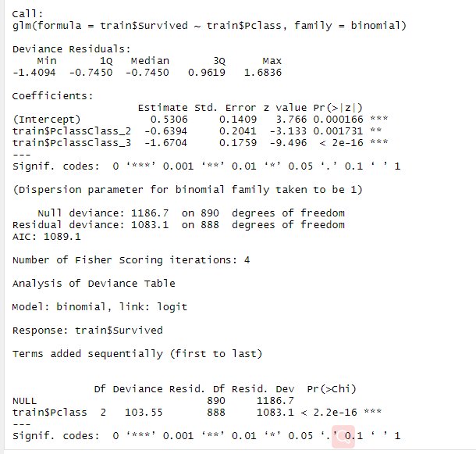

### 4.5 SLLR on Survived~Fsize

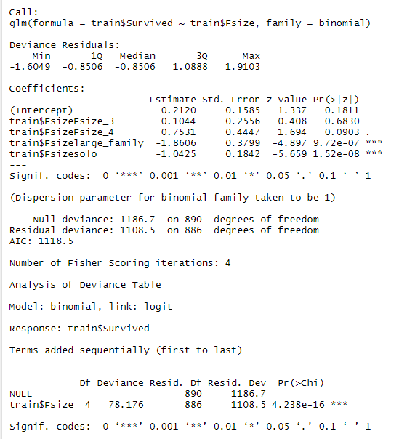

### 4.6 SLLR on Survived~Age + Sex + Pclass + Fsize

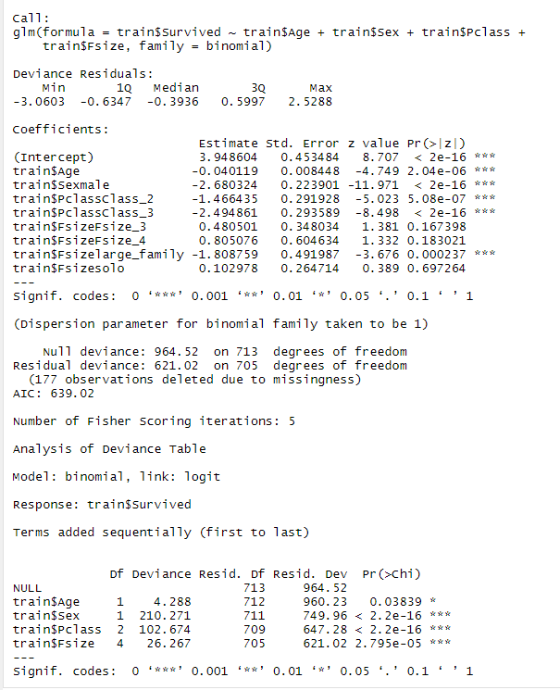

## 5. SLLP with interaction terms

