User Manual

for

Project Scribe

**Prepared by Cody Moniz and Ryan Viveiros**

**Naval Undersea Warfare Center**

**April 27, 2018**

**Table of Contents**

**Installation Guide** **3**

**Features and Usage** **3**

**Launch Screen** **3**

**Test Mode** **4**

**Test Steps** **4**

**CCLog** **7**

**Shift Entry** **9**

**Counts** **10**

**Executive Summary** **11**

**Edit Mode** **12**

**View Mode** **13**

# Installation Guide

This section will discuss the installation of TELAT on a new machine. TELAT will be provided on a CD as both a distributable .jar file, and as source code. The .jar file will be in a separate folder along with all files required to execute it. To install this distributable file:

1. Insert the CD into the intended machine’s disk drive
2. Open the CD to view its files and folders
3. Find and open the folder labeled TELAT_Distribution
4. Copy all items in this folder
5. Paste the items into a folder of your choosing. It is recommended that you create a new folder.
6. Execute the .jar file

# Features and Usage

This section will discuss TELATs features, tools, and menus. Each will be briefly introduced, and the usage of that feature will also be provided.

## Launch Screen

Upon launching TELAT, the user will be greeted by a title screen which can be seen in Figure 1.

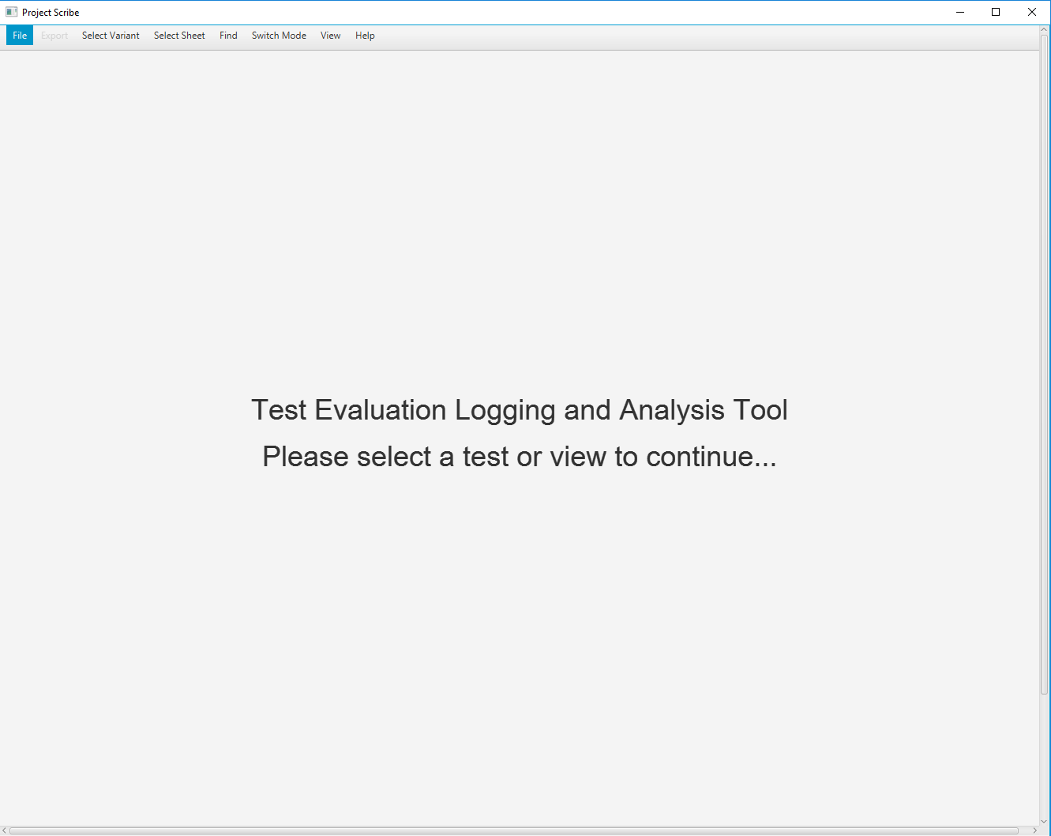

Figure 1. Launch Screen

This title screen will prompt the user to either select a test (SORT) file, or a view to continue. A test file can be imported using the “Load” option under “File”, or by pressing “control + L” on a Windows-based machine, as seen in Figure 2. Also, the user may select a view to continue from the title screen. It should be noted that views cannot provide information until a test is loaded.

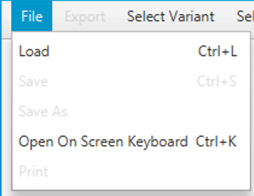

Figure 2. Loading in a File

## Test Mode

Test Mode is one of TELAT’s three main modes of operation. It consists of a checklist of steps, which are referred to internally as “Test Steps”, in addition to views. The views provided in TELAT are the CCLog, Counts, the Executive Summary, and Shift Entry. The usage of each of these views will be explained in-depth throughout this section.

## Test Steps

If the user chooses to load a SORT file at the title screen, they will automatically enter Test Steps. Once the Test Steps section is entered, the user will be prompted to select a variant, as seen in Figure 3.

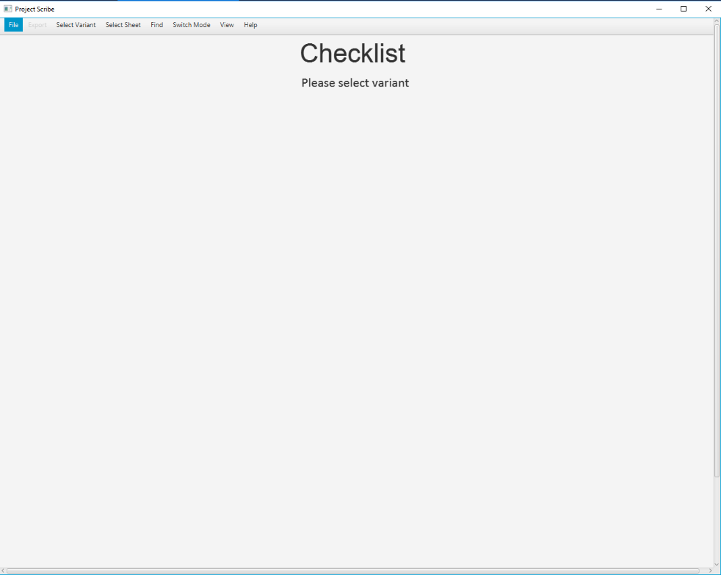

Figure 3. View of Test Steps Upon Launch

A list of variants can be found and selected under “Select Variant” in the menu bar, which is shown in Figure 4.

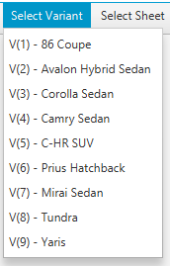

Figure 4. “Select Variant” Menu Item

Once the variant is selected, TELAT will display the test steps associated with that variant. The test steps can be evaluated as “passed”, “failed”, or “not tested” using a drop-down arrow located under the step. In addition, each step contains a comment field. Steps that were marked as either “failed” or “not tested” require a comment. This functionality can be seen in Figure 5.

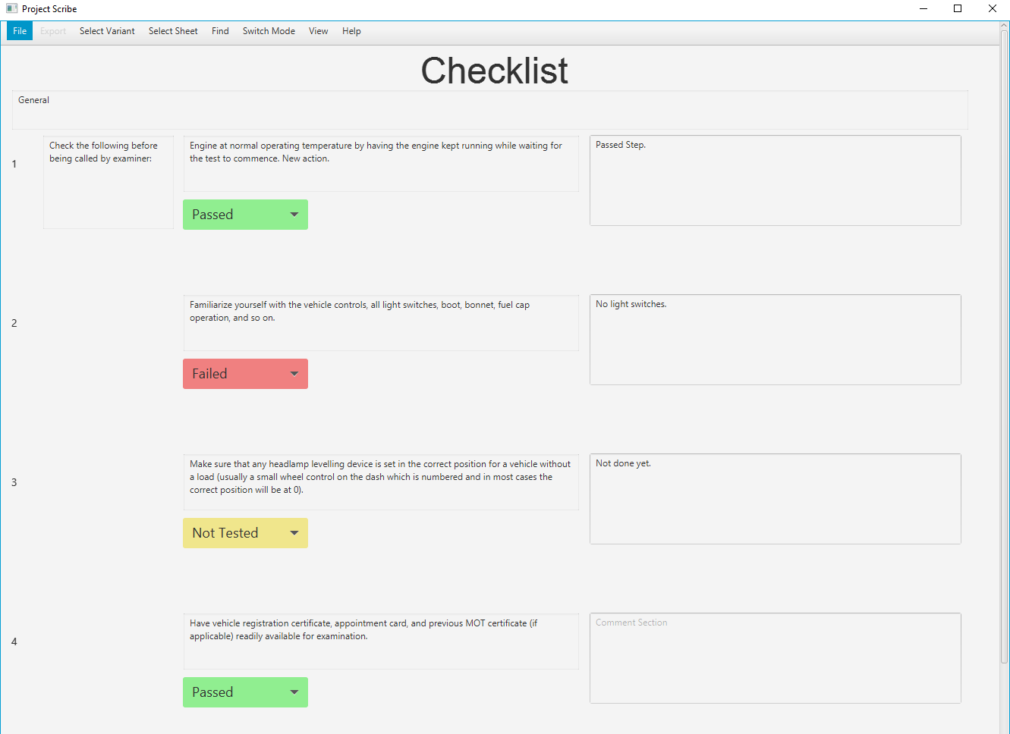

Figure 5. Test Steps

If a comment is not provided, TELAT will prevent the user from moving to other pages until the comment field is filled out, which can be seen in Figure 6.

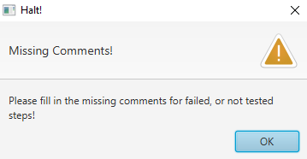

Figure 6. Missing Comment Alert

There are five steps per page, and the user can swap pages one, five, or ten pages at a time using the arrows at the bottom of the checklist. Each step is part of a Stage, Header, and Subheader. Stage can be switched using the “Select Sheet” menu item. Headers can be navigated through the “Find” menu item. These navigation options can be seen in Figure 7.

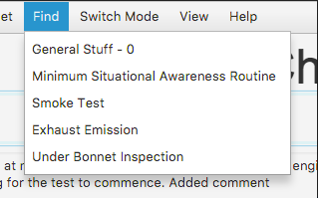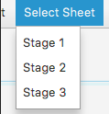

Figure 7. Navigating TELAT

Changes to the steps will automatically remain persistent within a use session, but will need to be saved to be available the next time TELAT is launched.

Other modes can be selected using the “Switch Mode” menu item. Likewise, switching views within Test Mode can be accomplished using “Switch View”. Figure 8 shows this functionality.

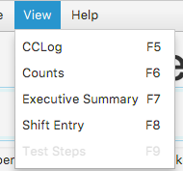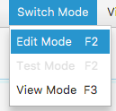

Figure 8. Swapping Modes and Views

## CCLog

CCLog provides TELAT with event logging. When CCLog is entered, a screen with two buttons will be displayed. This screen can be seen in Figure 9.

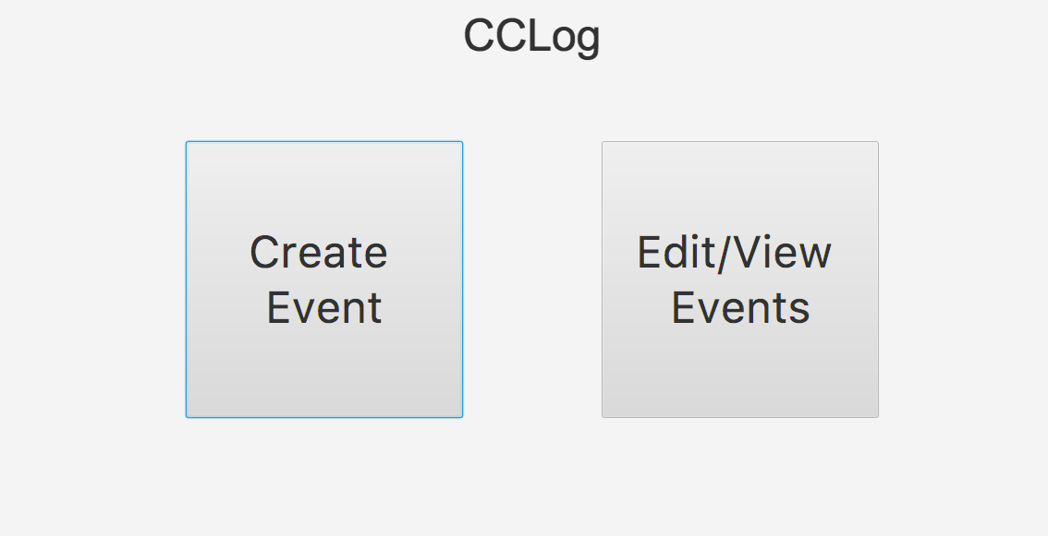

Figure 9. CCLog Main Screen

The first button will allow the user to create a new event, while the second button will allow the user to view a log of all created events. The event creation screen, which is accessed from the “Create Event” button, will automatically generate a timestamp for the user. After this, other information can be provided. The event creation screen will close automatically when the user saves the event. Event creation can be seen in Figure 10.

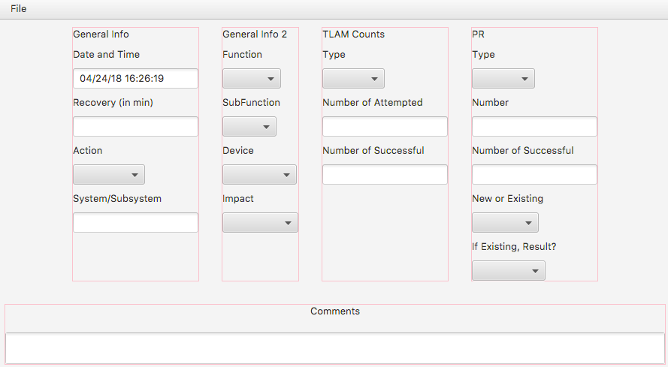

Figure 10. Event Creation

The event log can be accessed using the “Edit/View Events” button. The log displays two events per page, and the pages can be swapped one, five, or ten pages at a time. The events are listed from most recently created to least recently created. Finally, the user can edit events from the log. This log can be seen in Figure 11.

## 

Figure 11. Event Log

## Shift Entry

Shift Entry provides TELAT with personnel tracking. In the first three fields the test duration, shift length, and number of shifts are represented. The bottom part of the tool will allow the user to add a shift and add a start time, stop time, test director, and personnel for that shift. It is important to note that the user must select file and then click save for entries to be saved for your testing session. Successful saving will yield Figure 12. The saved information from shift entry will be found in the ADV_SORT file associated with the current selected test.

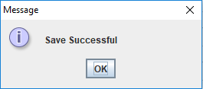

Figure 12. Successful Shift Entry Saving

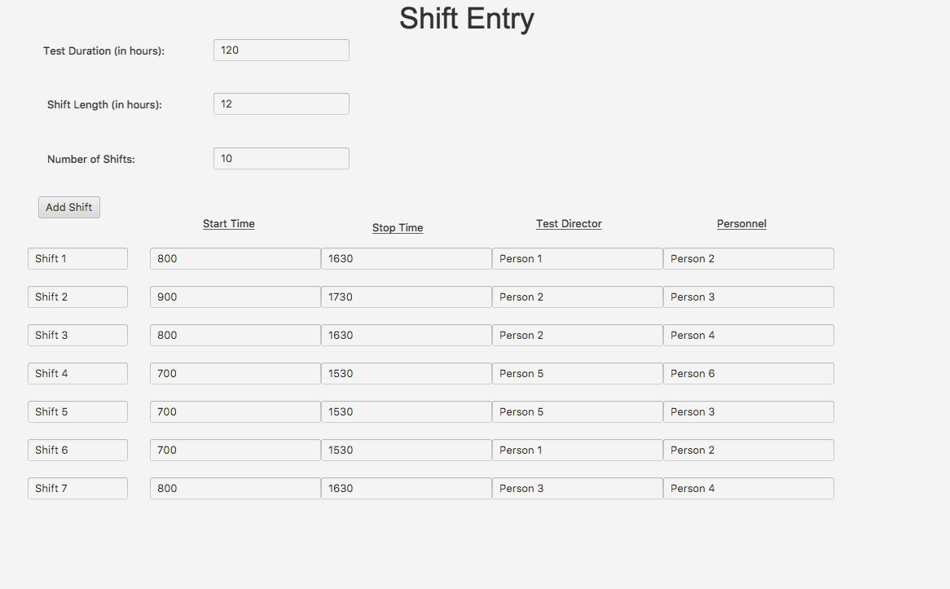

Figure 13. Shift Entry Page

## Counts

The Counts section automatically generates metrics about a test. The user can select which sheet they would like to see metrics about using the drop-down arrow located in the top left of the screen. Counts will generate the number of test steps, passed steps, failed steps, and not tested steps for that sheet. In addition, Counts will provide the same metrics for all sheets, regardless of which one was selected. Finally, metrics from the CCLog are reported at the bottom of the view, which can be seen in Figure 14.

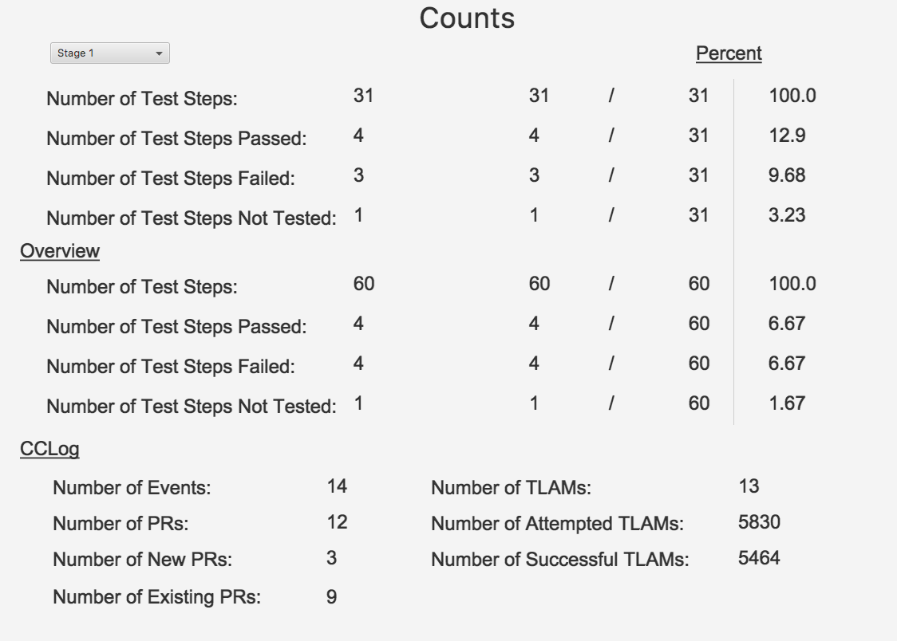

Figure 14. Counts

## Executive Summary

The Executive Summary view allows the user to define high-level, administrative details about a test. These details include the name of the test, the length of a shift for the test, its start and end date, as well as its location. Additionally, version information can be provided by the user in the appropriately labeled fields. There is a drop-down arrow that allows the user to specify whether there were any discrepancies at the start of the test. If “yes” is selected, a comment field will appear for the user to fill-in. Executive summary can be seen in Figure 15.

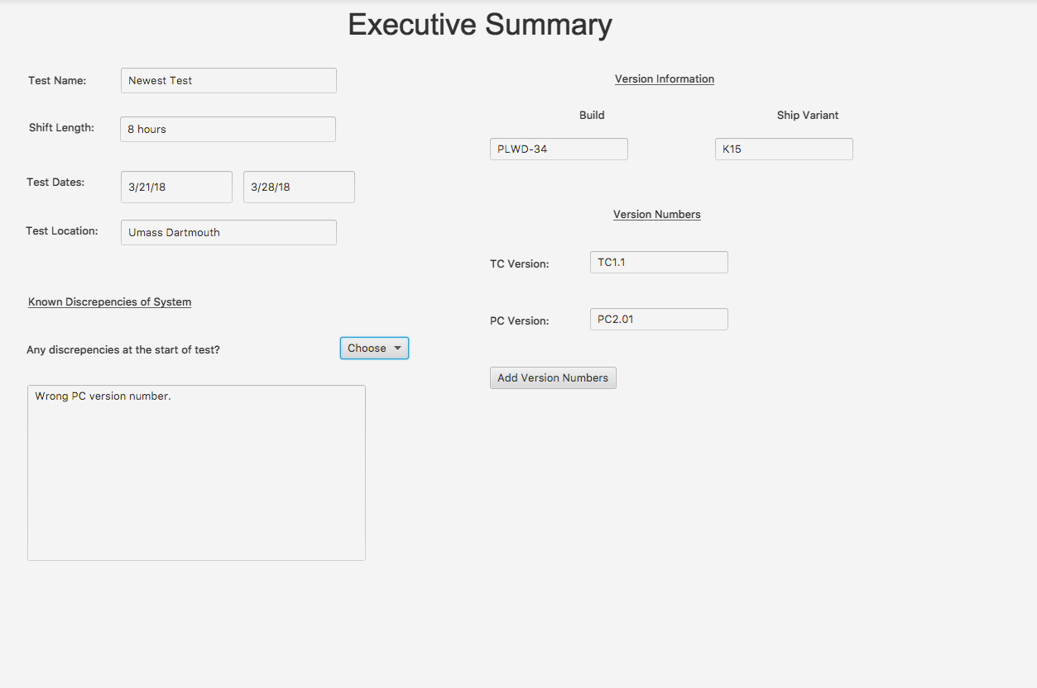

Figure 15. Executive Summary

## Edit Mode

Edit Mode allows the user to edit test steps and their associated data directly. Edit mode is protected by a password, which can be seen in Figure 16.

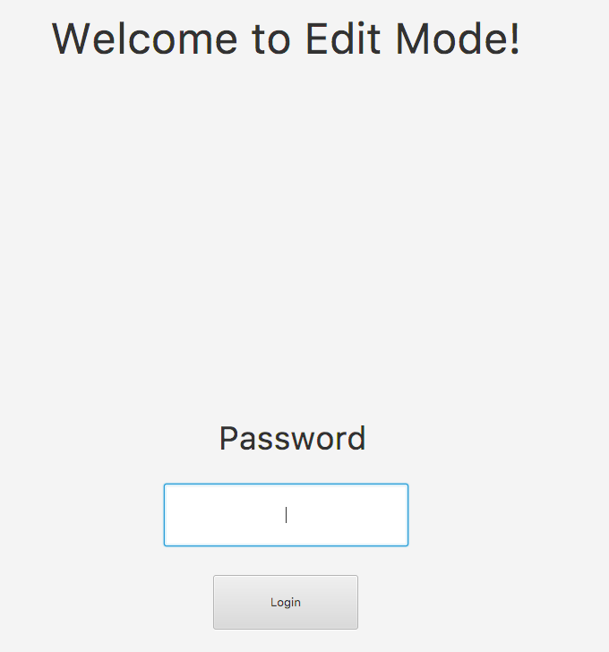

Figure 16. Edit Mode Password Lock

Once the password has been entered, the user may proceed into Edit Mode by clicking on the button labeled “Login”, or by pressing the enter key. If the entered password is incorrect, a red error message will appear, and the user may reattempt to enter the password. Once the password lock is cleared, the user enters Edit Mode. When Edit Mode is loaded the first time during a session, the user must load the file they wish to edit (note: the same file does not remain loaded due to technical limitations). Once the file is loaded, all headers, sub-headers, test steps, ID numbers, and variants are editable. Changes must be saved to be reflected outside of Edit Mode. Edit Mode can be seen in Figure 17.

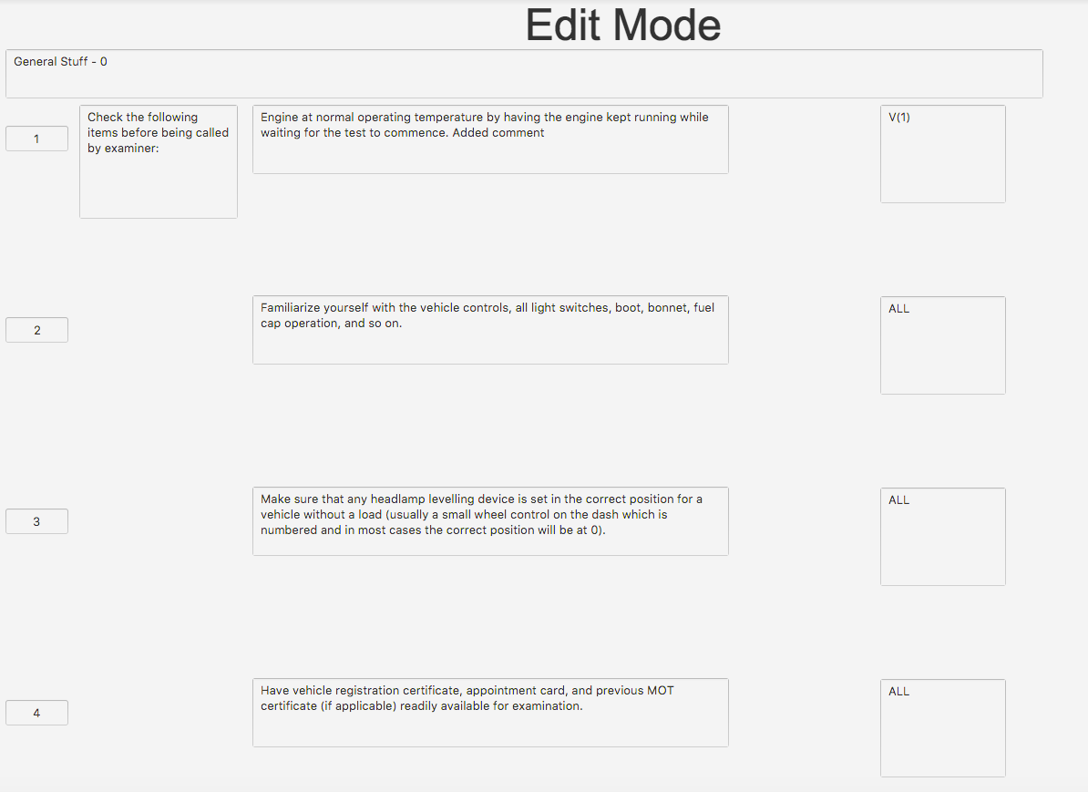

Figure 17. Edit Mode

## View Mode

View Mode provides a view-only perspective for TELAT. When the user is in View Mode, no changes can be made to Test Steps or Executive Summary.