A Major Project Proposal Report on

**NCIT Management System**

Submitted in partial Fulfillment on the Requirement for

the Degree of **Bachelor in Information Technology**

under Pokhara University

Submitted by:

**Shristi Awale, 15440**

**Sujan Maharjan, 15441**

**Sushant Maharjan, 15447**

**Dibas Paudel, 15416**

Date:

**03/08/2019**

**Department of Information Technology**

**NEPAL COLLEGE OF**

**INFORMATION TECHNOLOGY**

Balkumari, Lalitpur, Nepal

## **ABSTRACT**

*NCIT Management System is the web-based application designed for managing the inventory system. In this application, we will get the latest information about the material used and are being used by the college. This application will maintain all the materials and keep track of all the records into a database. The application will be maintained by the administrations based on departments and sections. The creation and management of accurate, up-to-date information regarding materials are critically important in the university as well as colleges. NCIT Management system will also deal with all kind of assets and inventory which are used on academic programs, college functions and extra curriculum conducted in the college. It will also have the detail of various products which are damaged and need to be repaired. It also facilitates us to explore all the activities happening in the college and products will be used in those programs. This system will be able to store the record of all the inventory actions conducted in the college and different reports can be generated as per the requirements and needs. This project is categorized as individual aspects for the sales and inventory management system. In this system, we are solving a different problem affecting to direct sales management and purchase management.*

*Keywords: Management System, Inventory, purchase & sales, archive.*

Contents

ABSTRACT 1

1. INTRODUCTION 1

1.1 PROBLEM STATEMENT 2

1.2 OBJECTIVES 2

1.3 SCOPE OF THE PROJECT 2

2. LITERATURE REVIEW 3

2.1 EXISTING SYSTEM 3

2.2 PROPOSED SYSTEM 3

3. METHODOLOGY 4

3.1 SOFTWARE DEVELOPMENT LIFECYCLE 4

3.2 TOOLS AND TECHNIQUE 4

4. TASK AND TIME SCHEDULE 5

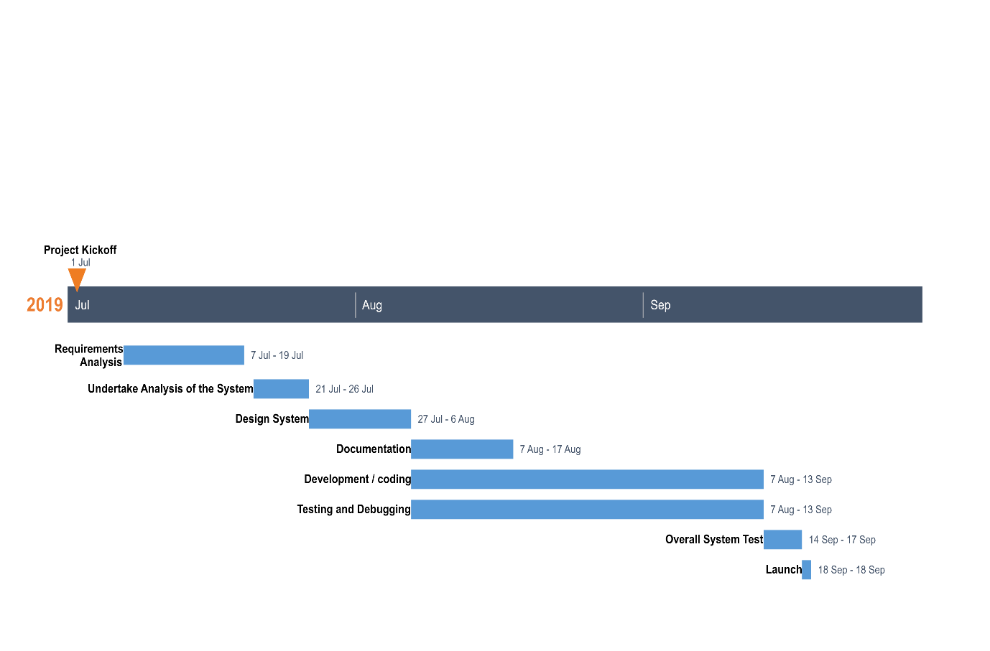 6

Bibliography 7

Acronyms 8

SRS 8

System Requirement Specifications 8

ERD 8

Entity Relationship Diagram 8

DFD 8

Data Flow Diagram 8

# INTRODUCTION

The design and implementation of an NCIT Management System is to replace the current paper records. College staff can directly access all aspects of a student’s academic progress through the online platform embedded in the college’s website. The system utilizes user authentication, displaying only information necessary for an individual’s duties. Additionally, each sub-system has authentication allowing authorized users to create or update information in that subsystem. All data is thoroughly reviewed and validated on the server before actual record alteration occurs. In addition to a staff user interface, the system plans for the student user interface, allowing users to access information and submit requests online thus reducing processing time. All data are stored securely on SQL servers managed by the college administrator and ensures the highest possible level of security. The system features a complex logging system to track all users’ access and ensure conformity to data access guidelines and is expected to increase the efficiency of the college’s record management thereby decreasing the work hours needed to access and deliver student records to users.

The project NCIT Management System will be a complete web-based application designed on Dot Net technology using Visual Studio Software. This project also helps to develop Inventory Management System Model software in which all the information regarding the stock of the organization will be presented. It will be an intranet-based application which has admin component to manage the inventory and maintenance of the inventory system.

This desktop application is based on the management of stock of an organization. The application contains a general organization profile, sales, details. Purchase details and the remaining stock that is presented in the organization. There is a provision of updating the inventory also. This application also provides the remaining balance of the stock as well as the details of the balance of the transaction.

Each new stock is created and entitled with the named and the entry date of that stock and it can also be updated any time when per the transaction or the sales is returned in case. Here the login page is created to protect the management of the stock of the organization to prevent it from the threads and misuse of the inventory.

## PROBLEM STATEMENT

In the existing system, the store manager manages all the inventories incoming and outgoing. The manager keeps all the purchase into a spreadsheet and passes it down to the accounting section for billing purpose. The departments can request for assets to the store manager and s/he will have to deliver it. There is no tracking of the assets transferred and received by the departments.  As there is no tracking, there are high chances of items being miss placed and miss used. Even in the college events, there is no proper inventory management. Only the budget is declared by the members and purchase within the budget limitation. Records of purchased and delivered items are not maintained, causing errors while billing. Even the savage values and depression rate are not evaluated.

## OBJECTIVES

The main objectives of this study are as follows:

* To provide an online platform for college inventory record management.
* To create and handle records for all the purchase, distributed transfer and sales activities.
* To store the inventory record online into a secure database instead of spreadsheet documents.

## SCOPE OF THE PROJECT

The scope of our project is as follows:

* Determination of economic order quantity
* Tracking of distribution of items
* Inventory evaluation and forecasting
* Future inventory price forecasting
* Formulation of policy for inventory usage
* Organization and distribution assets with safe handover.

# LITERATURE REVIEW

## EXISTING SYSTEM

* + 1. TanerArsan, EmrahAr ,EmrahBas_kan, and Zeki Bozkus have developed the “Inventory Management System” to replace the manual paper work based inventory records of the organization. In their project they have developed the frontend application which have an interface with the SQL database for retrieval and storage of data. The developed application has the ability to keep history, track, to give detailed reporting for each inventory with reduced human intervention.
    2. Jayson P. Bartolome and Winston Rey S. Aguirre have developed the “College Laboratory inventory system” for the engineering college. They have develop the Bar code for each component in the laboratory. The information of those components is stored in the database. Then they have installed the bar code scanner to know the information of each component. (Scrap Management in Sheet Metal Indstry, 2019)

## PROPOSED SYSTEM

This paper presents a method for storing information of students and staffs with the use of College Management System. This web-based application is also based on the management of stock of the college. This web-based application contains general college profile, sales, details (Purchase details and the remaining stock that are presented in the college). There is a provision of updating the inventory. Our system is proposed for the betterment of assets and inventory management in the college, keeping track of all the purchase, sales, transfers and depression values.

Hence we conclude that the present system would definitely help the user by saving time and effort by reducing the volume of errors and processing time. The efficiency of the work done will be improved and work satisfaction on the part of the faculty members after computerization would definitely be high.

# METHODOLOGY

## SOFTWARE DEVELOPMENT LIFECYCLE

The framework we followed in developing the project is in agile methodology, in which continuous iteration of development and testing throughout the software development lifecycle of the project.

.

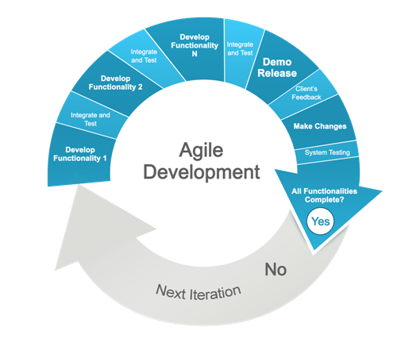

Fig: Agile Methodology

#### ANALYSIS PHASE

In this phase, analysis was done in order to find out the requirements of the system. The outcome of this phase is SRS.

We had a meeting with store manager of our college and we collect some information about ongoing inventory management system processes. We designed our SRS accordingly.

#### DESIGN PHASE

In this phase the SRS was modified into the system’s design. DFD, ER-Diagram, Use case Diagram were developed.

#### Use Case Diagram

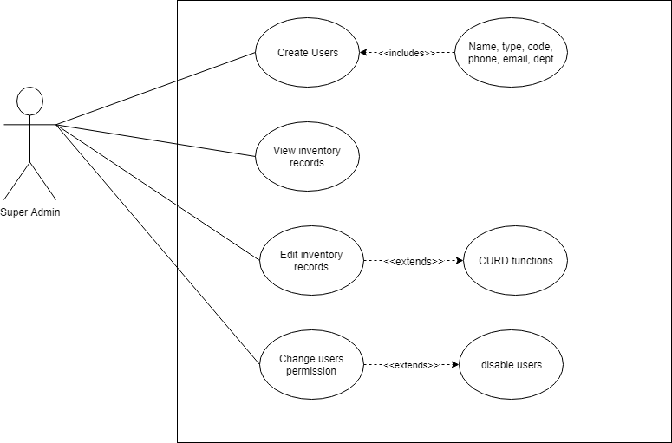

Fig: Use Case of Super Admin

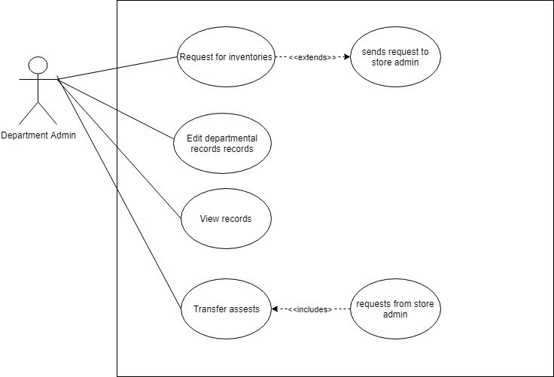

Fig: Use Case of Department Admin

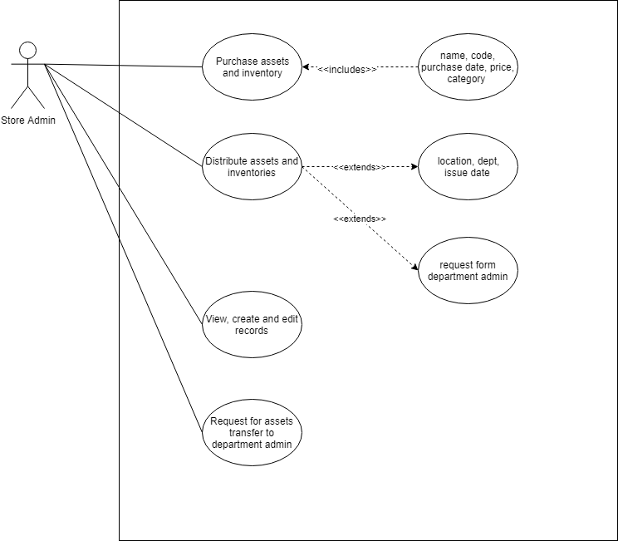

Fig: Use Case of Store Admin

#### CODING PHASE

In this phase coding was done according to the design and a working system was developed by the end of this process.

#### TEASING PHASE

In this phase, the system was tested. With each testing a list of changes to the system was developed and the changes were applied to the software until satisfying system was achieved.

## TOOLS AND TECHNIQUE

|  |  |
| --- | --- |
| TOOLS | PURPOSE |
| Visual Studio Enterprise 2019 | Text Editor |
| Draw.io | Design |
| HTML-5, CSS-3, JavaScript | Designing UI |
| Microsoft SQL Server Tool 2018 | Manage Server and Database |
| Web Browser | Application Testing |

Table 1: Tools to be used

# TASK AND TIME SCHEDULE

The project schedule has been designed as per requirements and constraints involved. This project is scheduled to be completed in about 60 days. Requirement analysis have been given more emphasis. Research and database management is to be done first and well documented. Debugging and Testing is to be done prior to the completion of the project.

|  |  |
| --- | --- |
| ***TASK*** | ***APPROX DURATION (in days)*** |
| Requirement Analysis and Specification | 10 |
| Undertake Analysis of the System | 5 |
| Design System | 7 |
| Documentation | 8 |
| Development / coding | 28 |
| Testing and Debugging | 28 |
| Overall System Test | 2 |
| Launch | 1 |

Table 2: Project Task and Schedule

## C:\Users\user\AppData\Local\Microsoft\Windows\INetCache\Content.Word\Project8thgranttchart.png

Fig: Gantt chart

# Bibliography

*Incremental Model -javapoint*. (2019, July 31). Retrieved from JavaPoint: https://www.javatpoint.com/software-engineering-incremental-model

*Scrap Management in Sheet Metal Indstry*. (2019, August 1). Retrieved from SlideShare: https://www.slideshare.net/KannanParamasivan/scrap-managemnt-in-sheet-metal-industry

**Acronyms**

|  |  |
| --- | --- |
| SRS | System Requirement Specifications |
| ERD | Entity Relationship Diagram |
| DFD | Data Flow Diagram |
|  |  |
|  |  |
|  |  |
|  |  |