UNIVERSITY OF MINDANAO
COLLEGE OF COMPUTING EDUCATION

IT6/L – FUNDAMENTALS OF DATABASE

[UNIVERSITY OF SAINT FREYA, STUDENT ENROLLMENT SYSTEM]
FINAL PROJECT TECHNICAL DOCUMENTATION
Submitted by:
Ryu Booc Sun
Jul Khair Umali
Submitted to:
Jhun Bart Macirin
IT6/L 3438
[Submission Date]

Chapter 1. Project Introduction

1.1 Project Title

University of Saint Freya, Student Enrollment System

1.2 Background of the Study / Existing Process
The process of enrollment is an essential part of every educational institution. It ensures that students are registered properly and assigned to their respective academic courses and programs. Universities handle a wide array of student information, this includes academic backgrounds, personal records and achievements, details of the program, offering for subjects and records of the enrollment themselves. The management of these records are important to maintain an organized academic operation while providing the students with a smooth enrollment experience.

Universities around the world continue to accommodate growing academic programs and the student population itself which in turn makes managing enrollment information become increasingly demanding. Traditional or poorly integrated recordkeeping processes may lead to difficulties in organizing student information, monitoring records of enrollment, maintaining accurate academic data, and retrieving back information when needed. These challenges highlight the importance of having a well-structured and centralized database that supports the institution's enrollment operations.

The University of Saint Freya is a hypothetical educational institution established as the setting of this project. Its proposed Student Enrollment Systems aims to provide an organized approach to managing student registration, academic programs, course offerings and enrollment records. The system shall utilize a relational database to keep and maintain consistency, accuracy, and proper relationships among the institution's administrative and academic information.

Through the development of this system, the project seeks to demonstrate how proper database design and implementation can support university enrollment operations. It will focus on identifying the institution's data requirements, establishing appropriate database relationships, applying normalization principles, and implementing the database to provide a reliable foundation for managing enrollment information.

1.2.1 Existing Process
Currently, the University of Saint Freya follows a traditional and manual enrollment process in which students are required to coordinate with the university’s administrative offices to complete their enrollment. The process consists of several stages, beginning with student registration and ending with the confirmation of the enrollment.
1. Student Registration → Students obtain and complete registration forms containing their personal and academic information.
2. Document Verification → The registrar’s office reviews the submitted documents and verifies the student’s information.
3. Academic Advising → Students coordinate with their respective academic departments regarding their eligible subjects and academic schedules.
4. Subject Enrollment → Enrollment personnel record the students’ selected subjects and relevant academic information.
5. Assessment and Payment → Students receive their enrollment assessment and settle the applicable fees.
6. Enrollment Confirmation → Administrative personnel verify the completion of enrollment requirements and confirm the student's enrollment status.

Although this process allows the university to manage student enrollment, relying on physical documents and separate digital records may result in redundant and repetitive data entry, delays in retrieving and receiving information and difficulties maintaining student and academic records.

The proposed Student Enrollment System aims to address these challenges by providing an online platform for managing student registration and academic records. By transitioning from physical documentation to an organized digital process, the system seeks to improve data entry accuracy, minimize redundant information, and simplify the maintenance and retrieval of student and academic records. Furthermore, centralizing these records within a relational database will help maintain data consistency and support more efficient enrollment operations.

1.3 Statement of the Problem
The existing enrollment process of the University of Saint Freya presents several challenges in managing student information and academic records. Reliance on physical documentation and separate recordkeeping procedures may result in redundant data entry, difficulties in retrieving information, and inconsistencies in maintaining student records. These challenges highlight the need for a more organized and centralized enrollment system.

Specifically, this project seeks to address the following problems:
→ How can student information and registration records be organized and maintained efficiently?
→ How can academic programs, subjects, instructors, and sections be properly managed within a centralized database?
→ How can redundant and inconsistent data be minimized through proper database design and normalization?
→ How can enrollment transactions and payment records be accurately recorded and monitored?
→ How can authorized university personnel efficiently retrieve and manage student and academic records?

1.4 General and Specific Objectives
To design and develop a Student Enrollment System for the University of Saint Freya that provides an organized and centralized platform for managing student records, academic programs, subject offerings, section assignments, enrollment transactions, and payment records through a relational database.

The project specifically aims to:
- To develop a structured database for managing university departments, academic programs, subjects, instructors, and student information.
- To organize subject offerings into sections with corresponding instructors, schedules, classrooms, academic terms, and enrollment capacities.
- To establish a systematic process for recording student enrollments in available class sections.
- To maintain student payment records, including payment amounts, dates, and corresponding payment methods.
- To establish appropriate relationships between database entities through primary keys, foreign keys, and constraints.
- To apply database normalization principles to minimize data redundancy and maintain data consistency.
- To implement and test the database using Laravel and a relational database management system.

1.5 Scope and Limitations
1.5.1 Scope
The proposed Student Enrollment System for the University of Saint Freya focuses on organizing and managing student information, academic records, enrollment transactions, and payment information through a centralized relational database. The system covers the management of departments, academic programs, subjects, instructors, students, class sections, enrollments, and payment records.
Furthermore, the database is designed to establish relationships between these entities to ensure organized data storage and efficient record management. It also includes the recording of class schedules, assigned instructors, enrollment capacities, student enrollment statuses, and payment transactions. The project will involve database design, implementation, and testing using Laravel and a relational database management system.
1.5.2 Limitations

The proposed Student Enrollment System is primarily focused on managing student information, academic records, enrollment transactions, and payment information. It does not cover other university operations such as grade management, attendance monitoring, examination records, library services, or other administrative functions outside the scope of enrollment management.
Furthermore, the system's payment functionality is limited to recording payment information and does not initially support direct integration with external banking institutions or online payment gateways. Advanced academic scheduling features, including automatic conflict detection and timetable optimization, are also not included in the initial implementation.
The project is developed specifically for the hypothetical University of Saint Freya and will focus on the requirements and database structure established for this academic project.

1.6 Intended Users and Benefits
1.6.1 Intended Users
The proposed Student Enrollment System is intended for individuals responsible for managing and participating in the enrollment operations of the University of Saint Freya. These include students, registrar personnel, academic department personnel, finance personnel, and system administrators. Each user is expected to interact with the system according to their respective responsibilities and access permissions.
- Students
- Registrar Personnel
- Academic Department Personnel
- Finance Personnel
- System Administrators
1.6.2 Benefits of the System
The implementation of the proposed Student Enrollment System is expected to provide several benefits to the University of Saint Freya and its intended users. Through a centralized database, the system aims to improve the organization, maintenance, and retrieval of student and academic records while reducing redundant data entry and inconsistencies.
- Benefits to Students
- Benefits to Registrar Personnel
- Benefits to Academic Department Personnel
- Benefits to Finance Personnel
- Benefits to the University Administration

Chapter 2. Requirements Analysis

2.1 Description of the Existing Process
The existing enrollment process of the University of Saint Freya follows a traditional, manually coordinated procedure consisting of six steps, beginning with student registration and concluding with enrollment confirmation. Throughout this process, students are required to coordinate with the university's administrative personnel and provide the necessary documents and personal information to complete their enrollment requirements.
→ 1. Student Registration
→ 2. Document Verification
→ 3. Academic Advising
→ 4. Subject Enrollment
→ 5. Assessment and Payment
→ 6. Enrollment Confirmation

2.2 Data Gathering Method and Findings
2.2.1 Data Gathering Methods
The initial requirements of the proposed Student Enrollment System were established through multiple data-gathering methods. These methods include research of related systems, document analysis, group discussions, and database design analysis. Each method contributed to identifying the necessary information, processes, and requirements for the proposed system.

The data-gathering process for the proposed system consists of the following procedures:
First Procedure: Identification of Information Requirements to help determine what information is necessary for university enrollment operations.
Second Procedure: Research of Related Systems which examine existing university enrollment systems to understand their common functions and processes.
Third Procedure: Analysis of Related Documents in order to review available examples of registration forms, academic records, and payment documentation.
Fourth Procedure: Group Discussion and Evaluation. This is to discuss the gathered information and determine which requirements are relevant to the University of Saint Freya.
Fifth Procedure: Database Requirements Identification so that the identified requirements will be translated into entities, attributes, relationships, and constraints.
2.2.2 Findings
● Student information must be systematically maintained.
● Academic programs and subjects must be properly organized.
● Sections must be associated with instructors and subjects.
● Enrollment records must connect students with their selected sections.
● Payment transactions must be properly recorded.

Based on the findings gathered through the identified methods, the proposed Student Enrollment System requires a structured and centralized database to support the management of student information, academic records, enrollment transactions, and payment information. These findings served as the basis for identifying the necessary database entities, attributes, and relationships that will be incorporated into the system's design and implementation.

2.3 Functional Requirements
ID | Functional Requirement | Description
FR-01 | Student Registration | The system shall allow student information to be recorded and stored.
FR-02 | Student Information Management | The system shall allow student records to be viewed and updated.
FR-03 | Department Management | The system shall allow department information to be maintained.
FR-04 | Academic Program Management | The system shall allow academic programs to be recorded and associated with departments.
FR-05 | Subject Management | The system shall allow subjects and their corresponding units to be managed.
FR-06 | Instructor Management | The system shall allow instructor information to be recorded and maintained.
FR-07 | Section Management | The system shall allow sections, schedules, assigned instructors, and maximum capacities to be managed.
FR-08 | Student Enrollment | The system shall allow students to enroll in available sections.
FR-09 | Enrollment Record Management | The system shall allow enrollment records and their statuses to be viewed and updated.
FR-10 | Payment Management | The system shall allow student payments to be recorded and maintained.
FR-11 | Payment Method Management | The system shall allow available payment methods to be managed.

2.4 Business Rules

ID | Business Rule
BR-01 | Each department must have a unique department code.
BR-02 | Each academic program must belong to an associated department.
BR-03 | Each subject may be associated with a department.
BR-04 | Each instructor may be associated with a department.
BR-05 | Each student must have a unique student number.
BR-06 | Each student may be associated with an academic program.
BR-07 | Each section must correspond to an existing subject and may be assigned an existing instructor.
BR-08 | Each section must have a defined maximum enrollment capacity.
BR-09 | An enrollment record must reference an existing student and section.
BR-10 | A student's enrollment status must follow the system's predefined enrollment statuses.
BR-11 | Each payment must be associated with an existing student.
BR-12 | Each payment must use an existing payment method.
BR-13 | Each payment must have a recorded amount, school year, and semester.
BR-14 | Payment methods must have an availability status indicating whether they can be used.

Chapter 3. Database Design

3.1 Identified Entities and Attributes
The system has nine entities. Three describe the school's structure (departments, programs, subjects), two describe people (students, instructors), and four record activity (sections, enrollments, payments, payment methods). Primary keys are shown in bold with a key icon in the ERD and marked PK below; foreign keys are marked FK.

Table 3.1. Identified entities and attributes
Entity | Description | Attributes
departments | Academic departments of the institution | department_id (PK), department_code, department_name
programs | Degree programs offered by a department | program_id (PK), program_code, program_name, department_id (FK)
subjects | Courses that can be offered, owned by a department | subject_id (PK), subject_code, subject_name, units, department_id (FK)
instructors | Faculty members who handle sections | instructor_id (PK), first_name, middle_name, last_name, email, department_id (FK)
students | Students registered in a program | student_id (PK), student_no, first_name, middle_name, last_name, gender, email, contact_no, program_id (FK), year_level, status, date_registered
sections | A class offering of one subject for a school year and semester | section_id (PK), section_code, subject_id (FK), instructor_id (FK), school_year, semester, schedule_day, start_time, end_time, room, max_capacity
enrollments | A student's enrollment in one section | enrollment_id (PK), student_id (FK), section_id (FK), enrollment_datetime, status
payments | A payment made by a student for a school year and semester | payment_id (PK), student_id (FK), school_year, semester, amount, payment_method_id (FK), payment_datetime
payment_methods | Accepted ways of paying (e.g., cash, GCash, bank transfer) | payment_method_id (PK), method_name, method_available

3.2 Entity-Relationship Diagram (ERD)
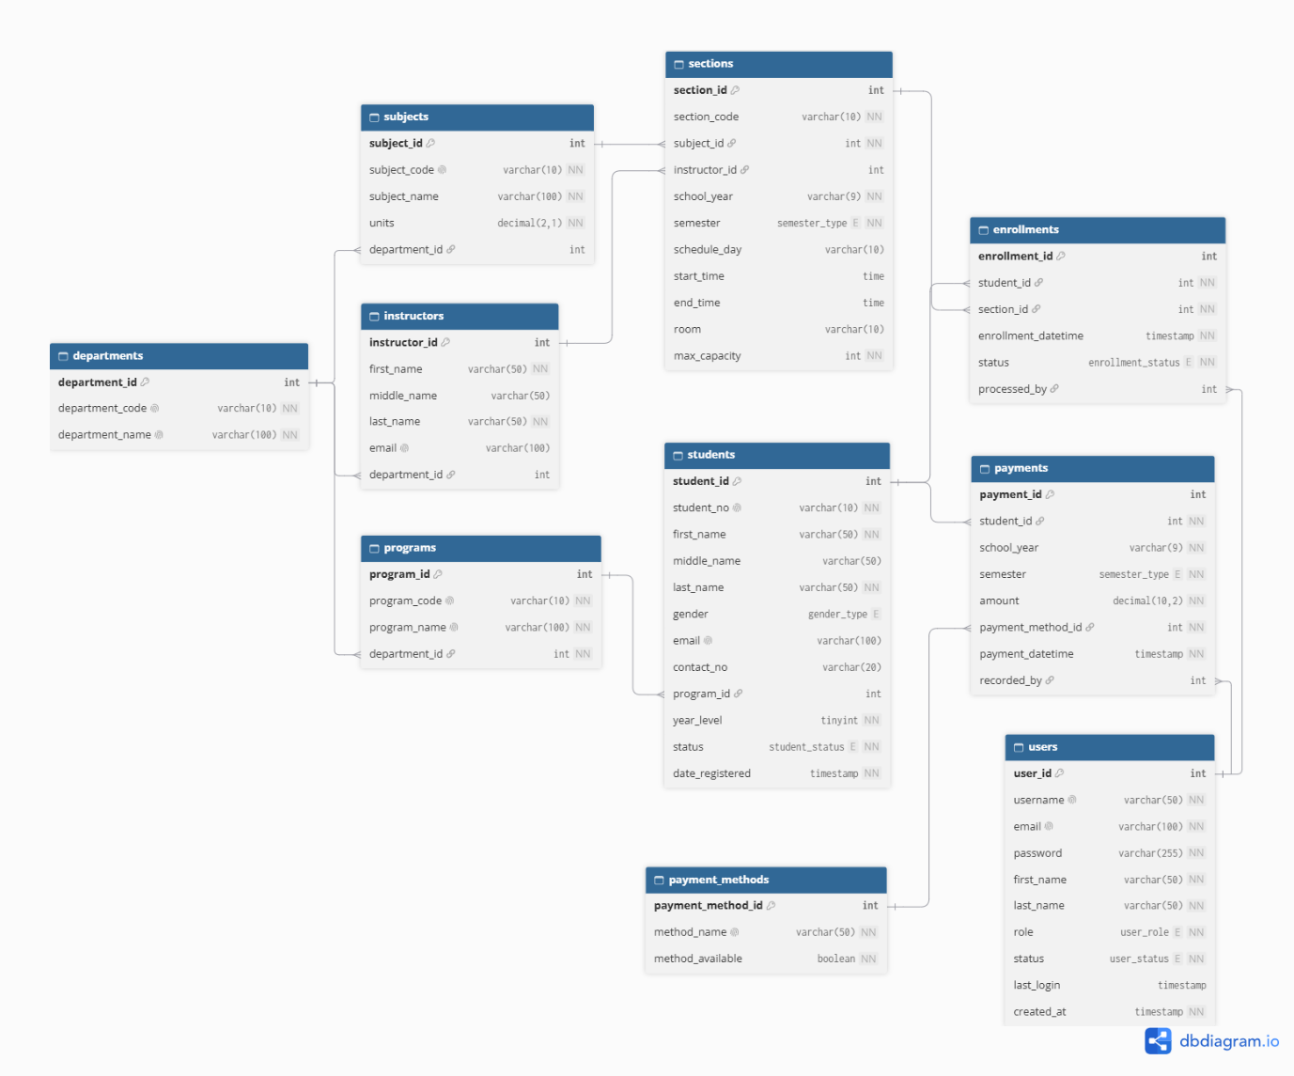
Figure 3.1. Entity-Relationship Diagram of the system

3.3 Relational Schema
Each relation is written as TABLE(attributes). Primary keys are in bold, and foreign keys are in italics followed by the table they reference.
- departments(department_id, department_code, department_name)
- programs(program_id, program_code, program_name, department_id → departments)
- subjects(subject_id, subject_code, subject_name, units, department_id → departments)
- instructors(instructor_id, first_name, middle_name, last_name, email, department_id → departments)
- students(student_id, student_no, first_name, middle_name, last_name, gender, email, contact_no, program_id → programs, year_level, status, date_registered)
- sections(section_id, section_code, subject_id → subjects, instructor_id → instructors, school_year, semester, schedule_day, start_time, end_time, room, max_capacity)
- enrollments(enrollment_id, student_id → students, section_id → sections, enrollment_datetime, status)
- payment_methods(payment_method_id, method_name, method_available)
- payments(payment_id, student_id → students, school_year, semester, amount, payment_method_id → payment_methods, payment_datetime)

3.4 Database Normalization (1NF, 2NF, 3NF)
The database was normalized from a single unnormalized student record into nine tables in Third Normal Form (3NF). The starting point is the information currently written on one student's enrollment and payment form.

3.4.1 Unnormalized Form (UNF)
STUDENT_RECORD(student_no, student_name, gender, email, contact_no, program_code, program_name, department_code, department_name, year_level, status, date_registered, {subject_code, subject_name, units, subject_department, section_code, school_year, semester, schedule, room, max_capacity, instructor_name, instructor_email, instructor_department, enrollment_datetime, enrollment_status}, {payment_datetime, school_year, semester, amount, payment_method, method_available})
Problems in UNF:

The subjects a student takes and the payments a student makes are repeating groups (shown in braces).

student_name, instructor_name and schedule (e.g., "MWF 8:00–9:00") are not atomic.

Program, department, subject and instructor details are repeated in every student's record.

3.4.2 First Normal Form (1NF)
A table is in 1NF when every field holds one atomic value and there are no repeating groups. To reach 1NF:

Names were split into first_name, middle_name and last_name.

schedule was split into schedule_day, start_time and end_time.

Each repeating group was moved to its own row, giving two relations:

STUDENT_ENROLLMENT(student_no, section_code, school_year, semester, first_name, middle_name, last_name, gender, email, contact_no, program_code, program_name, department_code, department_name, year_level, status, date_registered, subject_code, subject_name, units, subject_department, schedule_day, start_time, end_time, room, max_capacity, instructor_first_name, instructor_last_name, instructor_email, instructor_department, enrollment_datetime, enrollment_status). Primary key: (student_no, section_code, school_year, semester).

STUDENT_PAYMENT(student_no, payment_datetime, first_name, last_name, school_year, semester, amount, method_name, method_available). Primary key: (student_no, payment_datetime).

3.4.3 Second Normal Form (2NF)
A table is in 2NF when it is in 1NF and no attribute depends on only part of a composite key. In STUDENT_ENROLLMENT, student details depend only on student_no, and section details depend only on (section_code, school_year, semester). In STUDENT_PAYMENT, the student's name depends only on student_no. Removing these partial dependencies gives:

STUDENT(student_no, first_name, middle_name, last_name, gender, email, contact_no, program_code, program_name, department_code, department_name, year_level, status, date_registered). Primary key: student_no.

SECTION(section_code, school_year, semester, subject_code, subject_name, units, subject_department, instructor_first_name, instructor_last_name, instructor_email, instructor_department, schedule_day, start_time, end_time, room, max_capacity). Primary key: (section_code, school_year, semester).

ENROLLMENT(student_no, section_code, school_year, semester, enrollment_datetime, status). Primary key: (student_no, section_code, school_year, semester).

PAYMENT(student_no, payment_datetime, school_year, semester, amount, method_name, method_available). Primary key: (student_no, payment_datetime).

3.4.4 Third Normal Form (3NF)
A table is in 3NF when it is in 2NF and no non-key attribute depends on another non-key attribute (no transitive dependency). The remaining transitive dependencies were:

In STUDENT: program_code → program_name, department_code, and department_code → department_name.

In SECTION: subject_code → subject_name, units, subject_department, and instructor_email → instructor names and department.

In PAYMENT: method_name → method_available.
Each determinant was moved into its own table. A surrogate key (an auto-increment integer ID) was then added to every table, and the natural keys (student_no, program_code, subject_code, and so on) were kept as UNIQUE columns. The final 3NF tables are:
Table 3.2. Final tables in Third Normal Form
3NF table | Primary key | Came from
departments | department_id | STUDENT, SECTION
programs | program_id | STUDENT
students | student_id | STUDENT
subjects | subject_id | SECTION
instructors | instructor_id | SECTION
sections | section_id | SECTION
enrollments | enrollment_id | ENROLLMENT
payment_methods | payment_method_id | PAYMENT
payments | payment_id | PAYMENT
No department_id is stored in students, because a student's department is already found through programs. This avoids a transitive dependency and keeps the department in one place.

3.5 Data Dictionary
The data dictionary lists every field of the nine tables with its data type, key, nullability and constraints. All primary keys are INT AUTO_INCREMENT. NN means NOT NULL.
Table 3.3. Data dictionary of the departments table
Field | Data type | Key | Null | Constraints / Default | Description
department_id | INT | PK | NN | AUTO_INCREMENT | Unique ID of the department
department_code | VARCHAR(10) |  | NN | UNIQUE | Short code, e.g., CCE
department_name | VARCHAR(100) |  | NN | UNIQUE | Full name of the department
Table 3.4. Data dictionary of the programs table
Field | Data type | Key | Null | Constraints / Default | Description
program_id | INT | PK | NN | AUTO_INCREMENT | Unique ID of the program
program_code | VARCHAR(10) |  | NN | UNIQUE | Short code, e.g., BSIT
program_name | VARCHAR(100) |  | NN | UNIQUE | Full name of the program
department_id | INT | FK | NN | References departments | Department that offers the program
Table 3.5. Data dictionary of the subjects table
Field | Data type | Key | Null | Constraints / Default | Description
subject_id | INT | PK | NN | AUTO_INCREMENT | Unique ID of the subject
subject_code | VARCHAR(10) |  | NN | UNIQUE | Subject code, e.g., IT6
subject_name | VARCHAR(100) |  | NN |  | Descriptive title of the subject
units | DECIMAL(2,1) |  | NN | CHECK (units > 0) | Number of units, e.g., 3.0
department_id | INT | FK | Null | References departments | Department that handles the subject
Table 3.6. Data dictionary of the instructors table
Field | Data type | Key | Null | Constraints / Default | Description
instructor_id | INT | PK | NN | AUTO_INCREMENT | Unique ID of the instructor
first_name | VARCHAR(50) |  | NN |  | Instructor's first name
middle_name | VARCHAR(50) |  | Null |  | Instructor's middle name
last_name | VARCHAR(50) |  | NN |  | Instructor's last name
email | VARCHAR(100) |  | Null | UNIQUE | Instructor's email address
department_id | INT | FK | Null | References departments | Department the instructor belongs to
Table 3.7. Data dictionary of the students table
Field | Data type | Key | Null | Constraints / Default | Description
student_id | INT | PK | NN | AUTO_INCREMENT | Unique ID of the student
student_no | VARCHAR(10) |  | NN | UNIQUE | School-issued student number, e.g., 2025-0001
first_name | VARCHAR(50) |  | NN |  | Student's first name
middle_name | VARCHAR(50) |  | Null |  | Student's middle name
last_name | VARCHAR(50) |  | NN |  | Student's last name
gender | ENUM |  | Null | 'Male', 'Female', 'Other' | Student's gender
email | VARCHAR(100) |  | Null | UNIQUE | Student's email address
contact_no | VARCHAR(20) |  | Null |  | Mobile or phone number
program_id | INT | FK | Null | References programs | Program the student is taking
year_level | TINYINT |  | NN | CHECK (1–5) | Current year level
status | ENUM |  | NN | 'Active', 'Inactive', 'Graduated', 'Dropped'; default 'Active' | Current student status
date_registered | TIMESTAMP |  | NN | DEFAULT CURRENT_TIMESTAMP | Date and time the record was created
Table 3.8. Data dictionary of the sections table
Field | Data type | Key | Null | Constraints / Default | Description
section_id | INT | PK | NN | AUTO_INCREMENT | Unique ID of the section
section_code | VARCHAR(10) |  | NN | UNIQUE with school_year and semester | Section code, e.g., IT6-A
subject_id | INT | FK | NN | References subjects | Subject offered in the section
instructor_id | INT | FK | Null | References instructors | Instructor assigned to the section
school_year | VARCHAR(9) |  | NN |  | School year, e.g., 2026-2027
semester | ENUM |  | NN | '1st', '2nd', 'Summer' | Semester of the offering
schedule_day | VARCHAR(10) |  | Null |  | Class days, e.g., MWF
start_time | TIME |  | Null |  | Class start time
end_time | TIME |  | Null | CHECK (end_time > start_time) | Class end time
room | VARCHAR(10) |  | Null |  | Room, e.g., R301
max_capacity | INT |  | NN | CHECK (> 0); default 40 | Maximum number of students
Table 3.9. Data dictionary of the enrollments table
Field | Data type | Key | Null | Constraints / Default | Description
enrollment_id | INT | PK | NN | AUTO_INCREMENT | Unique ID of the enrollment
student_id | INT | FK | NN | References students; UNIQUE with section_id | Enrolled student
section_id | INT | FK | NN | References sections | Section the student enrolled in
enrollment_datetime | TIMESTAMP |  | NN | DEFAULT CURRENT_TIMESTAMP | Date and time of enrollment
status | ENUM |  | NN | 'Enrolled', 'Dropped', 'Completed'; default 'Enrolled' | Status of the enrollment
Table 3.10. Data dictionary of the payment_methods table
Field | Data type | Key | Null | Constraints / Default | Description
payment_method_id | INT | PK | NN | AUTO_INCREMENT | Unique ID of the payment method
method_name | VARCHAR(50) |  | NN | UNIQUE | Name, e.g., Cash, GCash
method_available | BOOLEAN |  | NN | DEFAULT TRUE | Whether the method is currently accepted
Table 3.11. Data dictionary of the payments table
Field | Data type | Key | Null | Constraints / Default | Description
payment_id | INT | PK | NN | AUTO_INCREMENT | Unique ID of the payment
student_id | INT | FK | NN | References students | Student who paid
school_year | VARCHAR(9) |  | NN |  | School year the payment is for
semester | ENUM |  | NN | '1st', '2nd', 'Summer' | Semester the payment is for
amount | DECIMAL(10,2) |  | NN | CHECK (amount > 0) | Amount paid in pesos
payment_method_id | INT | FK | NN | References payment_methods | Method used to pay
payment_datetime | TIMESTAMP |  | NN | DEFAULT CURRENT_TIMESTAMP | Date and time of payment

3.6 Primary Keys, Foreign Keys, and Constraints
Every table has an INT AUTO_INCREMENT primary key, ten foreign keys enforce the relationships, and UNIQUE, CHECK, DEFAULT and ENUM constraints protect the data entered.

3.6.1 Primary Keys
Table 3.12. Primary keys of each table
Table | Primary key
departments | department_id
programs | program_id
subjects | subject_id
instructors | instructor_id
students | student_id
sections | section_id
enrollments | enrollment_id
payment_methods | payment_method_id
payments | payment_id

3.6.2 Foreign Keys
ON UPDATE CASCADE is used for all foreign keys, so a changed parent ID is updated in the child rows. ON DELETE RESTRICT blocks deleting a parent that still has records (for example, a student with payments). ON DELETE SET NULL is used only where the link is optional.
Table 3.13. Foreign key constraints
Constraint name | Child table (column) | Parent table (column) | On delete
fk_programs_dept | programs (department_id) | departments (department_id) | RESTRICT
fk_subjects_dept | subjects (department_id) | departments (department_id) | SET NULL
fk_instructors_dept | instructors (department_id) | departments (department_id) | SET NULL
fk_students_program | students (program_id) | programs (program_id) | SET NULL
fk_sections_subject | sections (subject_id) | subjects (subject_id) | RESTRICT
fk_sections_instructor | sections (instructor_id) | instructors (instructor_id) | SET NULL
fk_enrollments_student | enrollments (student_id) | students (student_id) | RESTRICT
fk_enrollments_section | enrollments (section_id) | sections (section_id) | RESTRICT
fk_payments_student | payments (student_id) | students (student_id) | RESTRICT
fk_payments_method | payments (payment_method_id) | payment_methods (payment_method_id) | RESTRICT

3.6.3 Other Constraints
Table 3.14. Other constraints
Type | Table | Rule | Purpose
UNIQUE | departments | department_code; department_name | No duplicate departments
UNIQUE | programs | program_code; program_name | No duplicate programs
UNIQUE | subjects | subject_code | No duplicate subject codes
UNIQUE | instructors | email | One account per email
UNIQUE | students | student_no; email | No duplicate student numbers or emails
UNIQUE | sections | (section_code, school_year, semester) | A section code is used once per term
UNIQUE | enrollments | (student_id, section_id) | A student cannot enroll twice in the same section
UNIQUE | payment_methods | method_name | No duplicate methods
CHECK | subjects | units > 0 | Units must be positive
CHECK | students | year_level BETWEEN 1 AND 5 | Valid year level only
CHECK | sections | max_capacity > 0 | Capacity must be positive
CHECK | sections | end_time > start_time | Class must end after it starts
CHECK | payments | amount > 0 | No zero or negative payments
ENUM | students | gender, status | Only listed values are accepted
ENUM | sections, payments | semester | '1st', '2nd' or 'Summer' only
ENUM | enrollments | status | 'Enrolled', 'Dropped' or 'Completed' only
DEFAULT | students, enrollments, payments | CURRENT_TIMESTAMP | Date and time are filled in automatically
DEFAULT | payment_methods | method_available = TRUE | New methods are available by default
The ENUM values, the composite UNIQUE keys, the CHECK rules and the ON DELETE actions above are defined in the SQL script. The ERD in Figure 3.1 shows only the tables, columns, keys and relationships.

3.7 Initial SQL Database Implementation
The database, named enrollment_db, was created in MariaDB 10.11 using the script below. It builds all nine tables with their keys and constraints and loads 42 initial sample records. The same script is submitted as enrollment_db.sql and can be imported in phpMyAdmin (Import tab) or run with mysql -u root -p < enrollment_db.sql.

Chapter 4. System Development and Database Integration

4.1 Development Tools and Technologies
The Student Enrollment System (SES) is implemented as a server-rendered web application using PHP 8.3, Laravel 13.17, Eloquent ORM, Blade templates, and MariaDB 10.11. Composer manages PHP packages, while Vite and npm compile the application styles and JavaScript. The project is developed and tested in Visual Studio Code with the Laravel Artisan command line.
The repository was initially supplied as a Laravel Livewire/Fortify starter. Its existing Fortify authentication and Blade-based views were retained rather than replacing the starter with Breeze; this keeps the installed two-factor authentication and passkey support compatible with the application. Registration, login, authorization, and account approval are customized for the SES workflow.
4.2 System Architecture
SES follows the Model-View-Controller pattern. Eloquent models represent Department, Program, Subject, Instructor, Student, Section, Enrollment, PaymentMethod, Payment, and the authenticated User. Controllers accept HTTP requests, validate input, delegate enrollment and payment transactions to services, and return Blade views or redirects. Named routes in routes/web.php group pages behind authentication, email verification, active-account, and administrator middleware.
The database contains nine academic and transaction tables in addition to Laravel?s users and framework tables. Foreign keys connect programs, subjects, instructors, students, sections, enrollments, payment methods, and payments. User-to-enrollment and user-to-payment relationships record which authenticated operator processed each transaction. Administrators maintain academic setup and account access; active operators manage students and day-to-day enrollment and payment workflows.
4.3 Database Connection Implementation
Database settings are read from the Laravel environment configuration (DB_CONNECTION, DB_HOST, DB_PORT, DB_DATABASE, DB_USERNAME, and DB_PASSWORD); credentials are not embedded in controllers or committed source files. Laravel migrations create the schema, foreign keys, unique keys, indexes, numeric checks, six reporting views, andon MySQL/MariaDB the integrity triggers, stored functions, and stored procedures. The application does not execute the supplied SQL script, whose destructive database setup statements make it unsuitable for importing into an existing database.
The production database target is MariaDB 10.11 or MySQL 8. For safe automated validation, the PHPUnit configuration uses an isolated in-memory SQLite database. Application behavior and schema migrations have been exercised in that test environment; MariaDB-specific triggers and stored routines still require execution against a configured MariaDB/MySQL instance before production deployment.
4.4 CRUD Operations Implementation
Administrators can create, list, inspect, edit, and delete departments, programs, subjects, instructors, sections, and payment methods. Authenticated operators can perform the same student-record operations. Reusable catalog controllers and Blade list, detail, and form views provide common search, pagination, validation messages, and confirmation prompts. Deletion is refused when another record references the selected master or student record, preserving referential integrity.
Enrollment processing is separate from master-data CRUD. Operators enroll an active student into a section, drop an active enrollment, or atomically drop and add a section in the same academic term. Payments are append-only audit records and are not edited or deleted through the interface. Each payment records the student, school year, semester, positive amount, available payment method, timestamp, and processing user.
4.5 Advanced SQL Implementation
The schema enforces primary and foreign keys, unique student numbers and catalog codes, constrained status/semester values, positive course units, capacity, and payment amounts, as well as indexes for term, status, and student lookups. The views v_student_details, v_section_availability, v_enrollment_details, v_payment_history, v_student_term_summary, and v_user_accounts provide joined and aggregated reporting datasets.
MariaDB/MySQL routines include fn_available_slots, fn_total_units, fn_total_paid, sp_enroll_student, sp_drop_add, and sp_record_payment. Triggers reject enrollment by inactive students and capacity overruns, prevent section capacity from being reduced below its current enrollment, reject payments using unavailable methods or without a current-term enrollment, and prevent attempts to remove or demote the last active administrator. At the application layer, Laravel DB transactions make enrollment, drop/add, and payment changes atomic; row locks serialize capacity and payment checks where supported. Reports also use Eloquent joins/relationships, scoped filters, and aggregate sums.
4.6 Application Interface and Screenshots
The authentication interface provides email-or-username login, password reset, two-factor and passkey options inherited from the starter, registration, and logout. New registrations are stored as Pending Operators and cannot sign in until an administrator activates them. The administrator dashboard summarizes students, active students, sections, enrollments, payment totals, and pending accounts.
Figures 4.1?4.5 are screenshots captured from the running application using an isolated SQLite preview database with synthetic demo records. They demonstrate the rendered user interface and do not contain production or personal data.
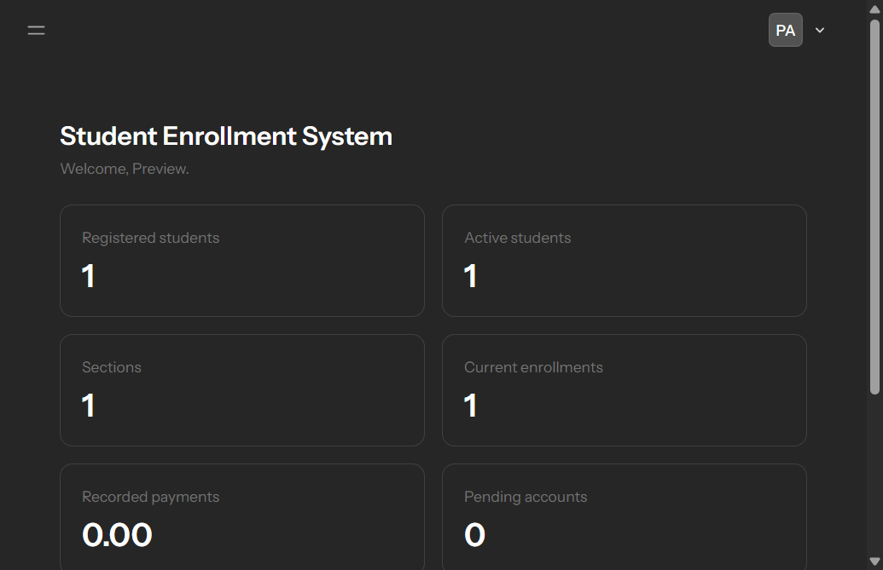
Figure 4.1. SES administrator dashboard with enrollment summary.
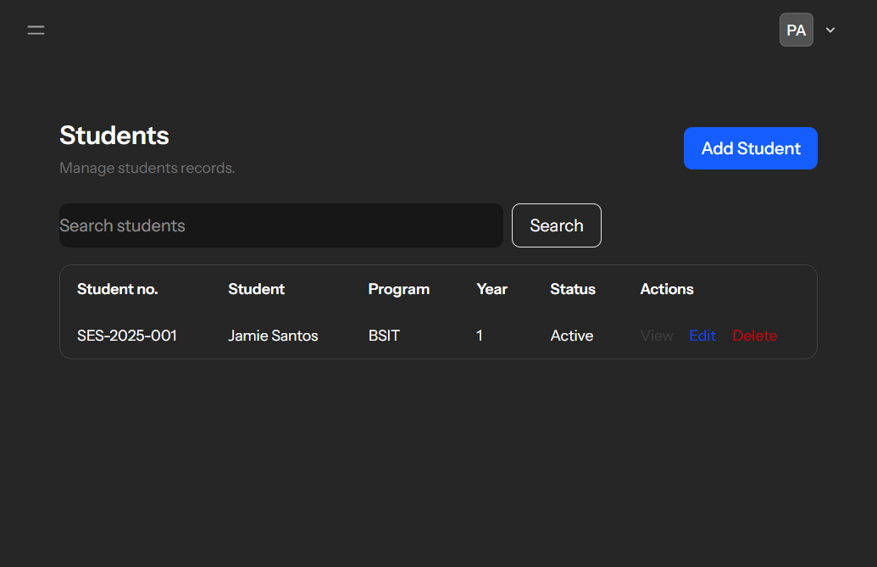
Figure 4.2. Student records list and search.
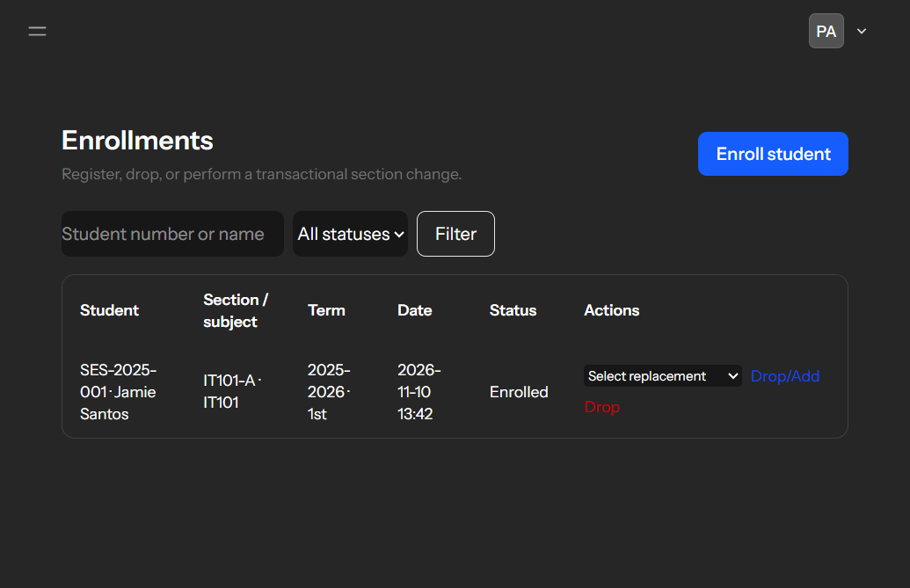
Figure 4.3. Enrollment list and drop/add controls.
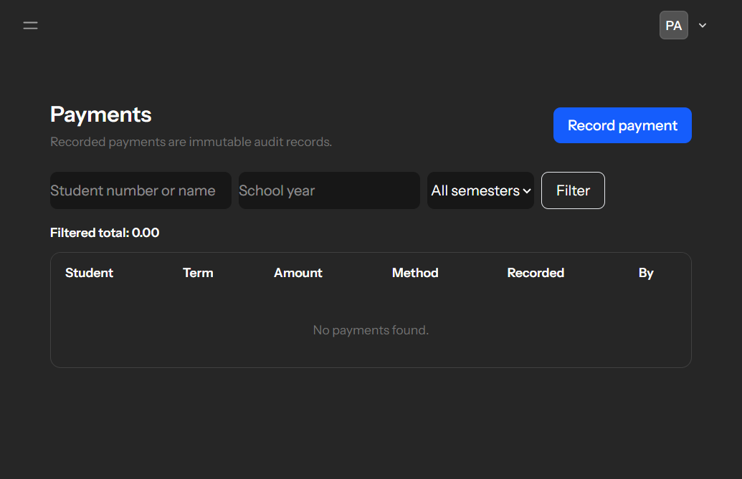
Figure 4.4. Payment history and term filters.
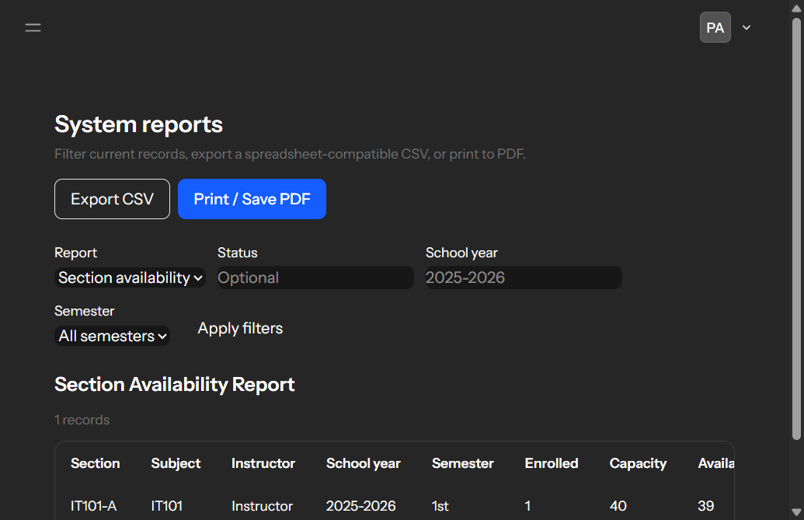
Figure 4.5. Section availability report and export controls.
4.7 Input Validation and Error Handling
All write operations use server-side Laravel validation in addition to browser-level form constraints. Rules cover required and bounded text, unique identifiers, valid email addresses, foreign-key existence, allowed status and semester values, year level 1?5, positive course units, section capacity and schedule ordering, and positive numeric payment amounts. Rejected requests return field-specific errors and preserve submitted values for correction.
Authentication is rate-limited and accepts either an email address or username. Only active accounts can authenticate; pending registrations require explicit administrator approval. Authenticated routes require verified email and active status, and administrator routes return HTTP 403 to operators. CSRF protection is enabled by Laravel’s web middleware. Transaction failures roll back all changes, referenced-record deletes are blocked, and the application reports validation or authorization errors rather than silently accepting incomplete operations.

