Jimmy Goad

CS-330

Project 1 Sample Picture

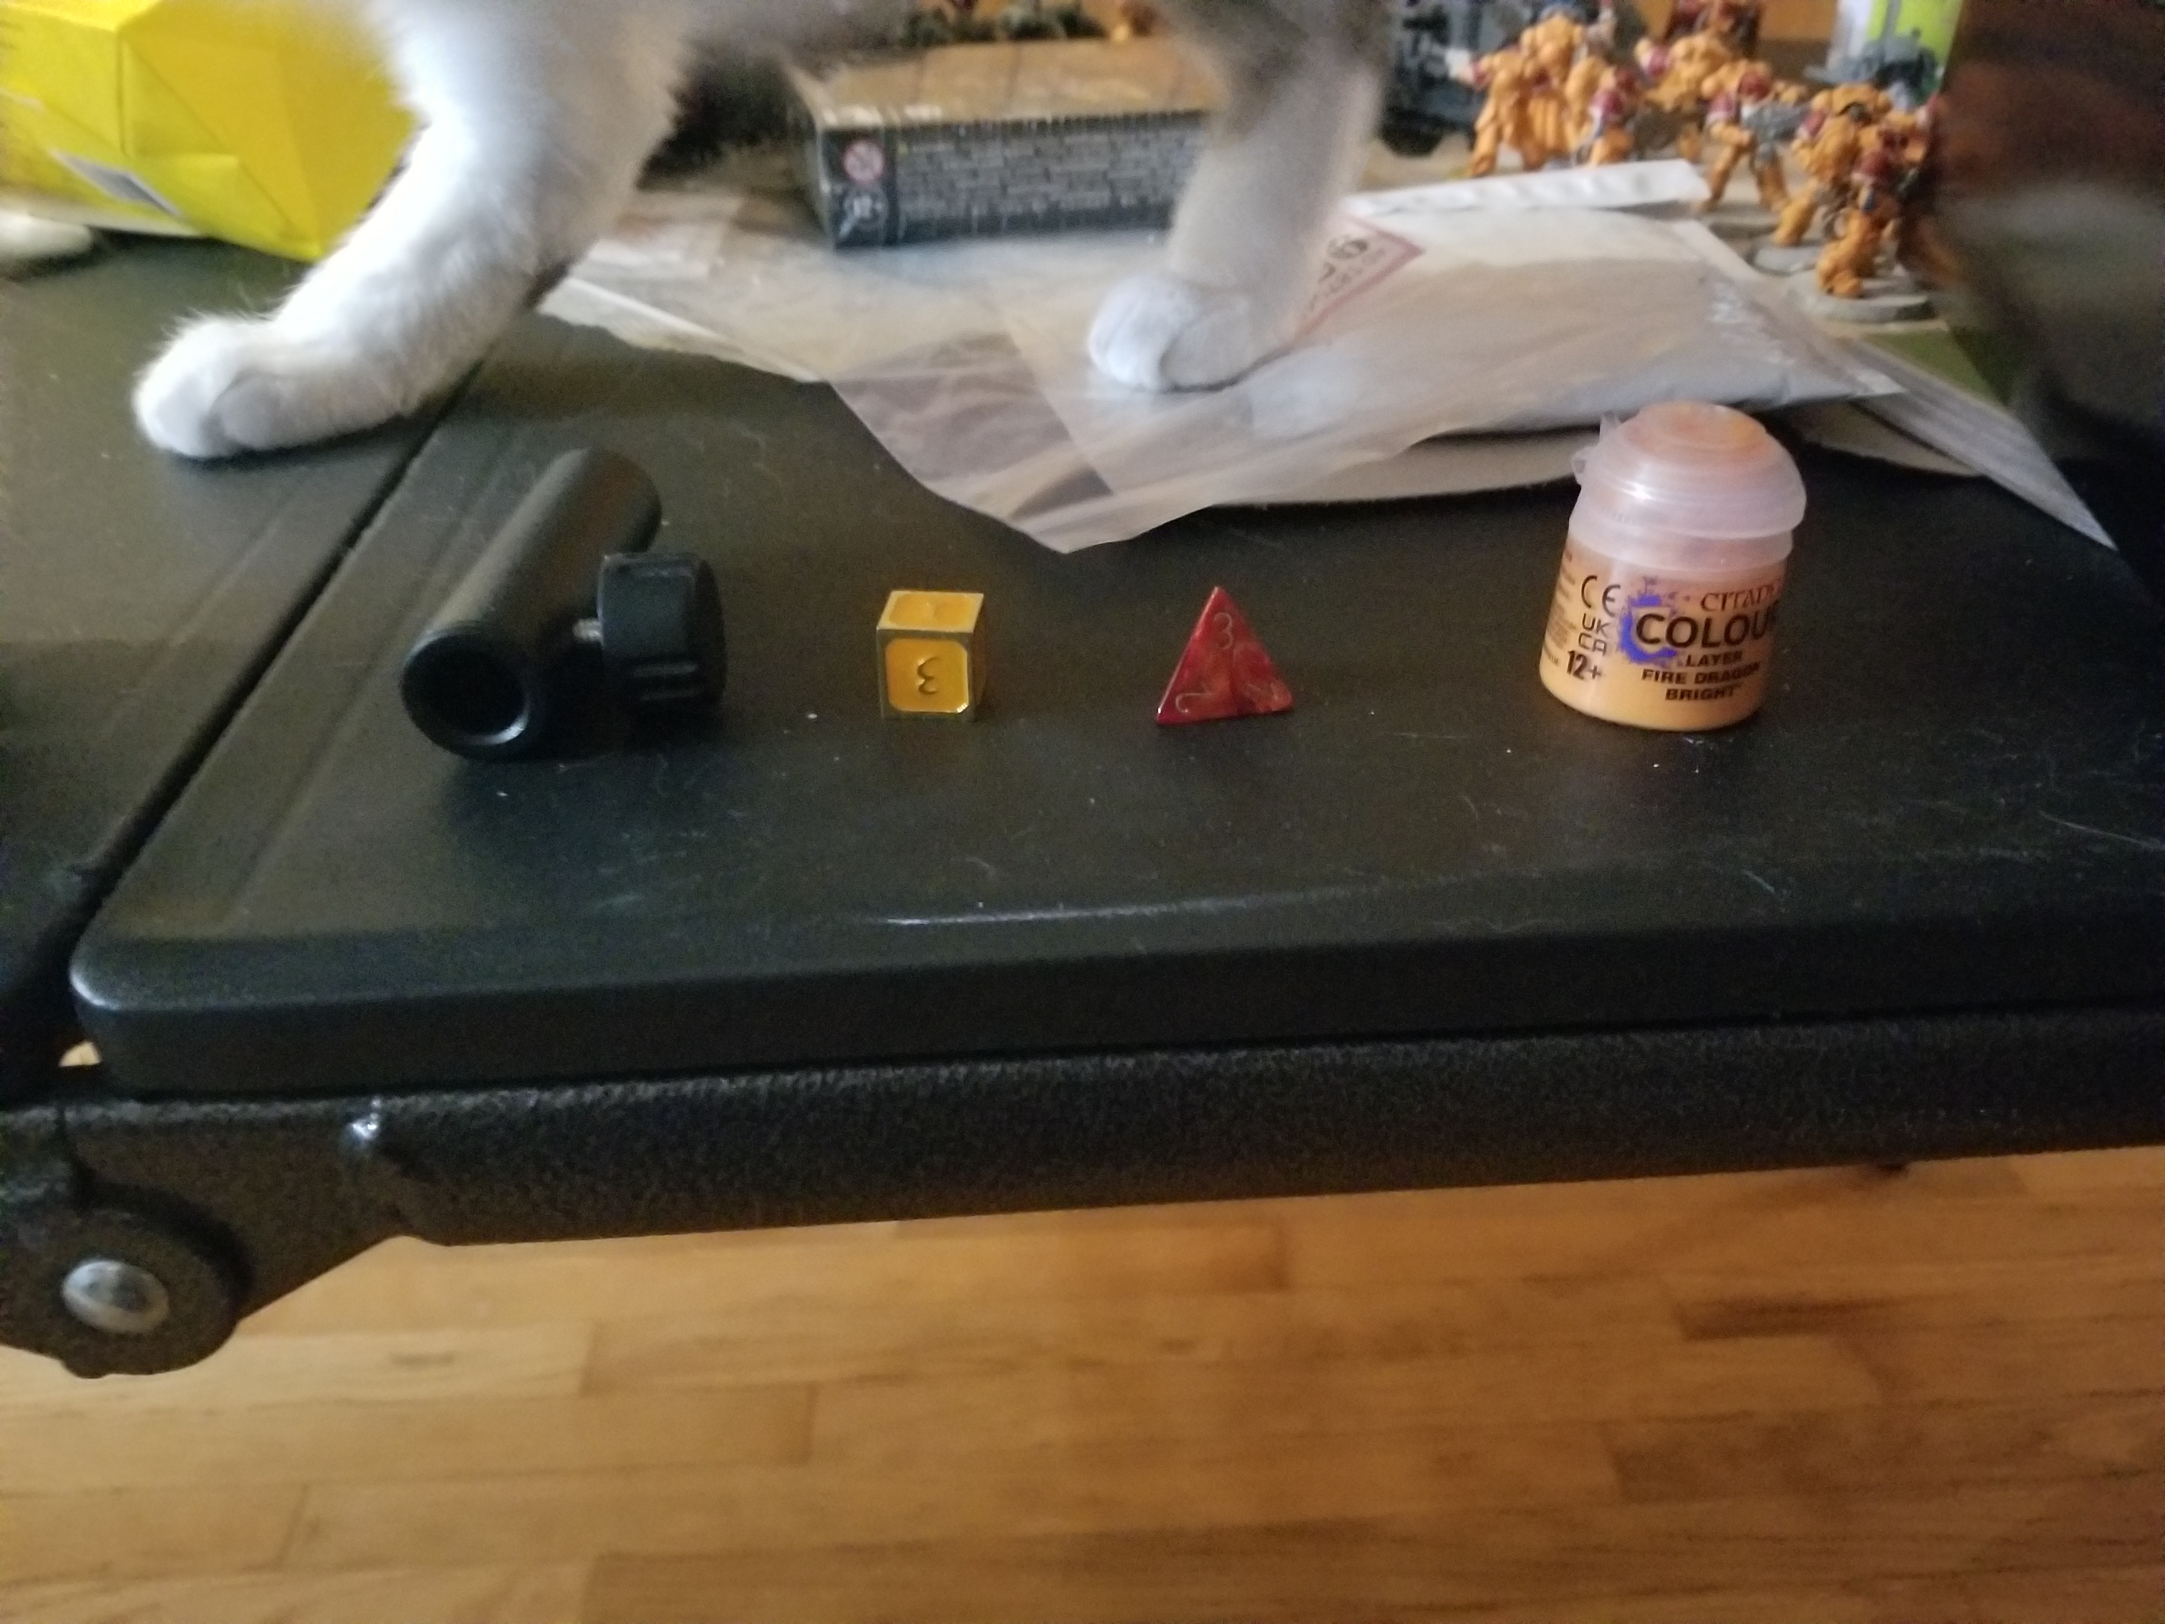
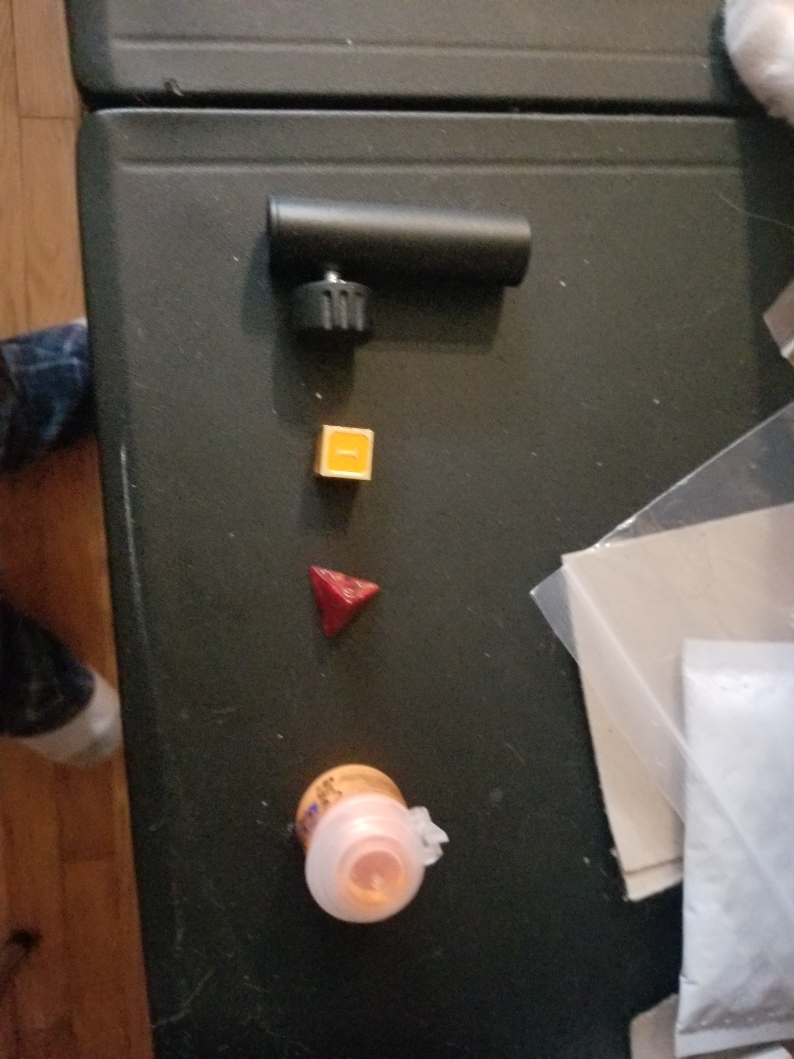

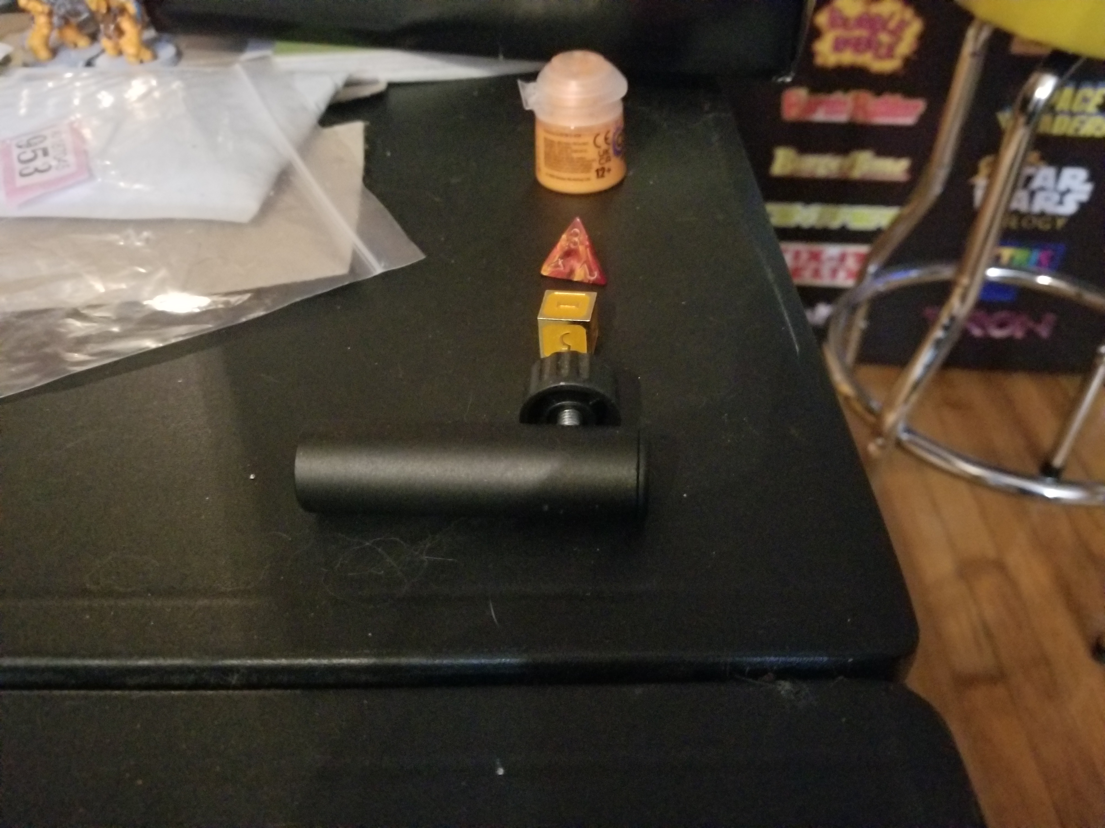

For my picture I have two dice, a mic attachment, and a paint cup. For the dice I can simply use a pyramid and a cube to represent them. The mic attachment can be constructed by making a cylinder for the tube and then a tourus added to it for the dial. The paint vat can be constructed with a tapered cylinder or a cylinder with a torus on top. The table will be my plane and ill put all the objects on top of it to simulate the scene. I feel these objects will be good to start cause the dice will be simple enough just being simple shapes themselves. The other two may be a little complicated making me do some more work to combine mutiple objects onto the plane expanding my knowledge with practice.

