Jimmy Goad

CS-340

Project 2

Animal Shelter
This application should allow someone to search through the AAC database by animal type. After animal selection the application will also give a map location for the requested animals.

Motivation
The program was to expand my knowledge of user interface construction using mongodb and jupyter.

Getting Started
1.To begin launch Mongo and import the csv file for the aac_shelter_outcomes.csv
2.Next go through and create simple and complex indexes to sort through the needed information in the document.
3.Next a admin account must be created
4.Next a user have to use python to run the program through jupyter
5.finally connect

Installation
Python and Jupyter notes will be needed to run the files and MongoDB will be need to get the information form the database.

Logo
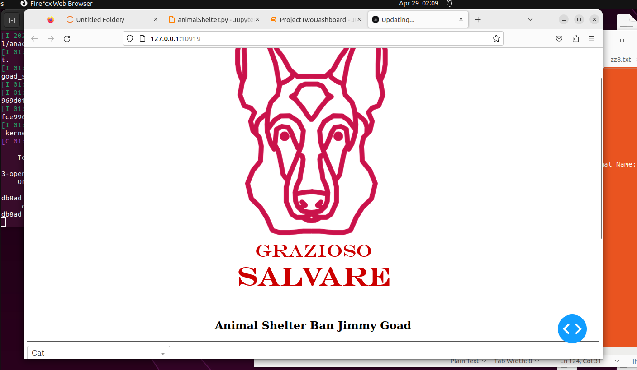

Filters
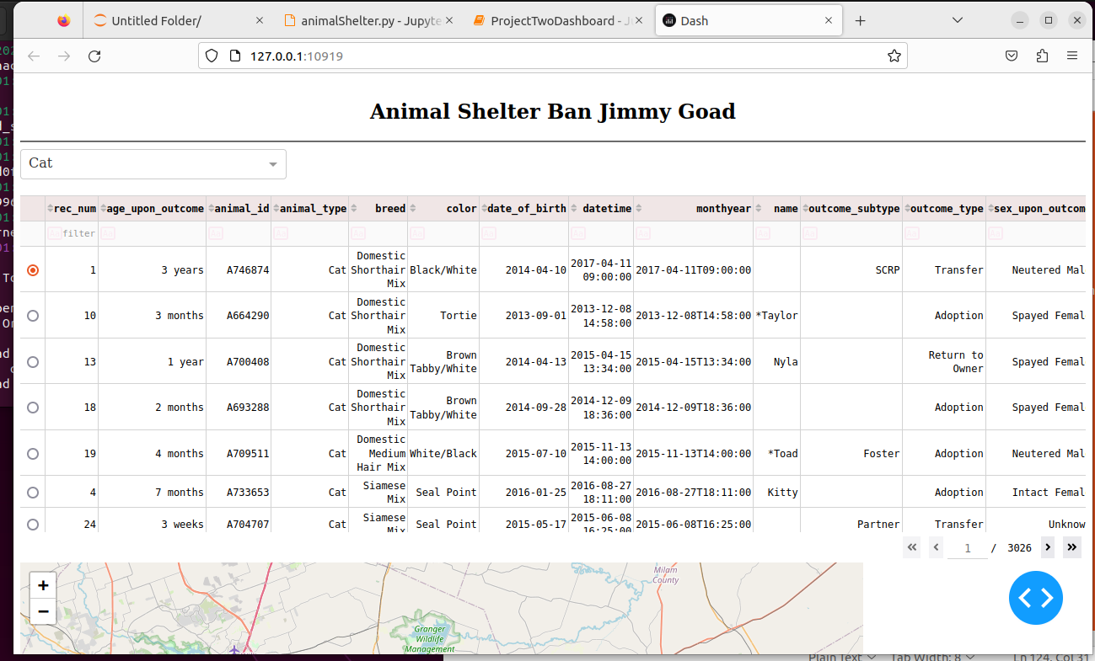

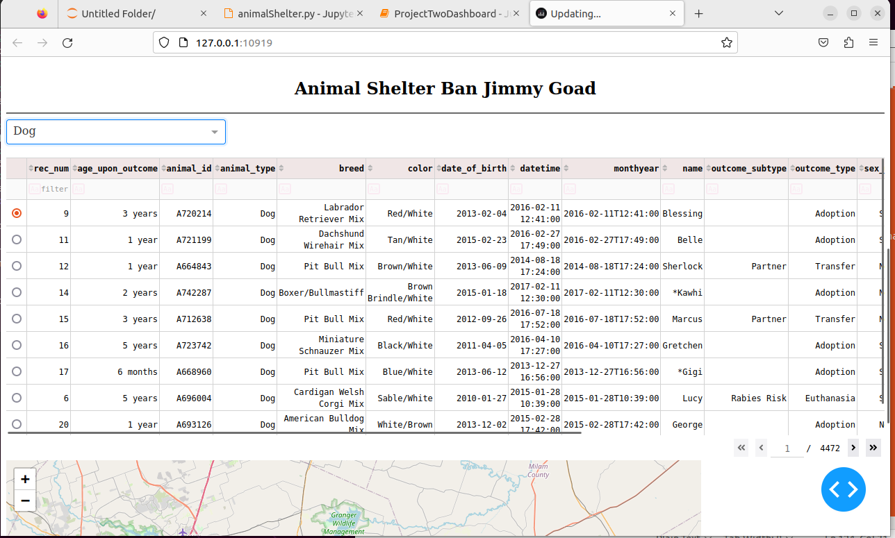
Geo Location
