**MEGHALI PHUKAN**

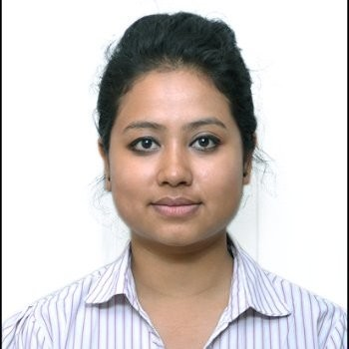 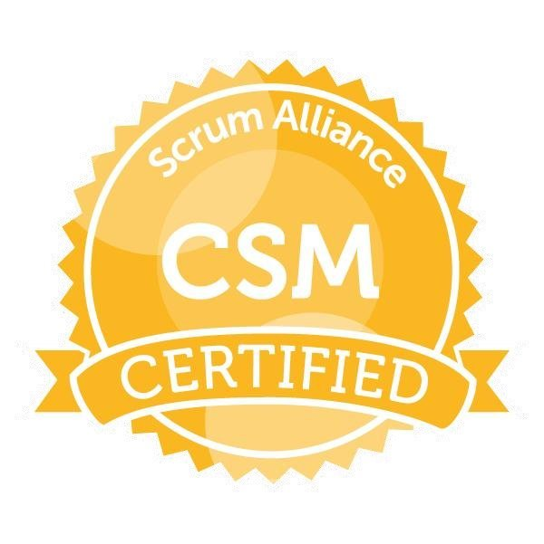 

**Contact:**+44-7796296337 Email: [meghali.phukan@outlook.com](mailto:meghali.phukan@outlook.com)

**Professional Summary**

* Certified Scrum Master and ISTQB Certified professional with 6 years of rich and relevant experience in testing of web based and client server applications and 0.6 years of experience in development and maintenance of Java application.
* Have rich experience in Utilities, Banking & Capital Markets and Insurance.
* DevOps Trained in Jenkins, Jenkins pipeline, Docker using AWS.

**Skills**

* Good knowledge and experience in Agile Methodology.
* Experience in functional testing, regression testing, smoke testing, GUI testing, and web-services testing.
* Familiar with Test strategy, Test Plan and Traceability Matrices.
* Strong knowledge of all phases of SDLC and Strong working knowledge of Software testing life cycle(STLC).
* Knowledge of Bug life cycle.
* Rich hands on experience in creating test scripts and execution plans.
* Experienced in Designing Test Cases, Verifying and Validating and version control.
* Good experience in coordinating testing effort, responsible for test deliverables, status reporting to management, issue escalations.
* Analyzing bugs and interacting with development team members in fixing the defects.
* Possess good analytical, problem solving & leadership skills. Has strong ability to learn new technologies in short span and implement independently, hardworking, motivated and goal oriented.
* Knowledge of Automation Testing Tool: Selenium webdriver, SoapUI, Quick Testing professional.

**Technical Skills**

* **Test Case Writing Tools:** TFS (basics), HP ALM, Microsoft Azure DevOps
* **Database:** Oracle
* **Programming Languages:** JavaScript, CoreJava, J2EE
* **Software Methodologies/ Concepts/Frameworks**: SCRUM, Agile, OOPS
* **S/W Applications:** MS Office (Word, Excel, Power point), Rally, Crucible
* **Operating System:** Windows XP, Windows 7, Linux,Windows 8.1,Windows 10
* **Tools:** Putty, WINSCP,Weblogic, ANT, Jenkins, Jenkins pipeline, Docker,IBM Websphere

**Trainings, Certification and Awards**

* **CSM (Certified Scrum Master)** training and certification completed with 97%.
* **ISTQB Certified Tester Foundation Level** completed with 82.5% .
* Completed **manual testing training** organized by MPHASIS for a duration of 5 months.
* Completed **ETL training** organized by LTI for a duration of 1 month.
* Received **APEX AWARD** in appreciation for my work from Mphasis.
* Completed Insurance Domain(basics) training from LTI.
* Completed 2 months of DevOps training in Jenkins,Jenkins Pipeline and Docker using AWS.

**Professional Experience**

**Project # 5**

AMT-Sybex

**Product** : Geofield

**Position** : Test Lead

**Duration** : April 2019 till present

**Project Description**:

Geofield is a powerful mobile spatial solution designed for field-based work management that is optimised for tablets, smartphones and portable computers running Windows, iOS and Android. Designed for disconnected use, Geofield provides a map-based, task centric and supportive environment for the field technician. Through the use of digital workflows, data from multiple sources that is required for a particular task is presented to the user.Tested the client and server of Geofield which involved functional testing, SOAPUI testing and performance testing. Also, had an exposure to Oracle and sqlite databases for backend data validation.

**Responsibilities**:

* Review customer specifications.
* Support and provide input to Proposal and Estimation processes.
* Provide high/low level accurate test effort estimations.
* Creation of Test Plans to clearly define the test approach that will be taken for allocated projects.
* Management, reporting and tracking of test levels.
* Support the Technical Delivery Lead in scheduling and planning of test activity including responsible for the testing phase of the delivery plan.
* Managing the daily workload of Test Analysts and giving direction on projects.
* Defect management and metric reporting – Communicating defect metrics and details internally and to client upon request.
* Management of test activities, including the tracking of tasks and production of accurate and timely reporting.
* Point of contact for the Client in relation to testing and release activity.
* Communicating all test issues effectively and executing procedures in order to arrive at the appropriate fix.
* Actively involved in the sprint planning sessions with the product owner to help in prioritising product backlog items into respective 2 week sprints.
* Create and maintenance of test metrics dashboards in Azure DevOps which includes widgets for burn down, sprint velocity, etc
* Effectively involving in the sprint retrospective sessions and own actions items and deliver.
* Influencing the project stakeholders in a pragmatic manner towards delivery of solution from test perspective.
* Working along with the offshore test team in Bangalore and helping them to resolve their issues effectively.
* Time-boxing daily stand-up calls to exactly 15 mins and ensuring that technical discussions happen offline. Raising a flag wherever needed if time exceeds.
* Keeping on top of the offshore test team to track their daily progress and blockers.
* Liaising with the Development Lead and Product owner to resolve issues effectively.
* Dealing with changes that come in and go out of the project to ensure that no hindrance is created with the existing planned delivery. Changes are incorporated into sprints based on priority, capacity and need.
* Handling and managing and provide support for tests for UAT and SIT phases of testing.

**Project # 4**

**Client :** Travelers

**Position :** Test Engineer/Test Lead

**Duration :** Aug 2016 till Nov 2018

**Project Description:**

Manual testing through mainframe host and automation test execution through SoapUI and on Travelers legacy and UI applications. Various service groups and mainframe datasets were tested effectively to deliver Insurance solutions to the client. This was a personal insurance application called HOMES and Homeowners which dealt in property insurance.

**Responsibilities**:

* Automation test suite preparation and execution. Helped the client save 50% of manual effort through automated test case execution through Selenium.
* Perform Smoke testing, Functional Testing and Regression testing using data driven test execution method.
* Perform database queries to validate test data.
* Keyword driven test execution using SoapUI.
* Web service testing through SoapUI.
* Attending Scrum call/standup meeting with onsite counterparts. Actively volunteered to run the standup in the absence of scrum master.
* Attending defect triage and defect status meetings.
* Preparing Test Data’s for the test cases. Automated this activity as well using QTP which speeded up the release cycles and gave more time to analyze and fix any underlying issues after builds.
* Giving mandatory information of a defect in HP ALM to developers in order to fix it.
* Worked on DBT(define, build and test)model testing in SAFe Agile framework and performed regression testing from mainframe host screens and UI.
* Track Bug Report to its closure.
* Planning knowledge transfer sessions for team members and developers to share product knowledge.
* Sharing product knowledge to employees of another vendor organization during transition phase in the project.
* Participating in retrospectives and planning sessions in Agile projects.
* Raising reviews in crucible tool for test cases and test results.
* Followed process in HP ALM to upload test cases, test results and map the test cases to requirements.
* Performed batch testing in mainframe host.
* Performed MQ testing in mainframe host.
* Took up the role of a defect prevention analyst(DPA) and helped to coordinate for any underlying leaked defects to the line managers and leads for various matrices.
* Participated in QA audit processes and helped achieve 97-98% results with all the processes and practices in place.
* Prepared the QA scorecard reports for the various teams which calculated efforts like test case execution percentage, efforts saved through automation, defect ratio,etc .
* Performed the role of offshore HOMES QA Lead and lead a team of 3 members. Helped in mentoring and coaching the team and allocate several tasks to team for efficient delivery in the project schedule.
* Attended walkthrough meetings with BA.

**Project # 3**

**Client :** First Republic Bank

**Position :** Middleware QA tester

**Duration :** June 2014 till Aug2016

**Project Description:**

Manual and automation test execution through SoapUI on FRB’s middleware. Various service groups were tested effectively to deliver banking solutions to the client.

**Responsibilities**:

* Automation test suite preparation and execution.
* Perform Smoke testing, Functional Testing and Regression testing using data driven test execution method.
* Perform database queries to validate test data.
* Keyword driven test execution using SoapUI.
* Attending Scrum call with onsite counterparts.
* Preparing Test Data’s for the test cases.
* Preparing Test Environment to execute the test cases.
* Giving mandatory information of a defect to developers in order to fix it.
* RTM (Requirement traceability matrix) preparation.
* Track Bug Report to its closure.
* Checking results in a database and editing XML configuration files in SoapUI.
* Planning knowledge transfer sessions for team members to share product knowledge.

**Project # 2**

**Client:**SKF

**Position:**QA Tester

**Duration:**Jan2014 to June 2014

**Project Description:** GAIA is similar to EAI (Enterprise Application Integration) which is used to integrate various applications in SKF Manufacturing. All message transfer are routed, enriched, encrypted and transferred securely through this interface application. It uses JCAPS 6 for Integration of different Enterprise Application.

**Responsibilities:**

* Preparing Test Scenarios.
* Defect Tracking.
* Giving mandatory information of a defect in QC to developers in order to fix it.
* Preparing Test Summary Reports and share with the Team.
* Test case and test data preparation.
* Smoke testing, Functionality Testing and Regression testing.
* Participating in retrospectives at end of each sprint.
* Practical experience of IBM WebSphere Application Server and running UNIX scripts to stop and start middleware applications.

**Project # 1**

**Client :**General Motors

**Position :**Software Development engineer in Test

**Duration :**Feb 2013 to Jan 2014

**Project Description:**Computer-Aided Testing (CAT) is the use of computers to facilitate the acquisition, processing, dissemination, and management of performance data. Like many other large corporations, CAT (computer aided testing) in GM has evolved to meet the needs of individual test labs. The growth process led to silos of software and hardware that in most case is unique to each test laboratory. Until recently, there has been little or no planning to store and reuse data in a systematic way. Lotus Notes, Microsoft Access, and Microsoft Excel were the predominant tools for managing performance data tools that are simple and easy to use, but lack the capability for sharing test results beyond a small, localized user community.

**Responsibilities**

* My role included understanding and analyzing business requirements and functionalities listed in SRD (Systems requirement document).
* Writing test cases based on understood requirements and execution of those test cases.
* Identify and report the issues/ bugs found in upgrades.
* Co-ordination with development team and retesting of fixed bugs until closure of the issues that rose.
* Provide QA sign off and deliver the executed test cases with detailed test data to client.
* Perform regression testing during upgrades.
* Perform sanity testing for small patches to the system.
* Apart from regular testing activities train new team members about project details and concepts. Scheduled a cross-functional KT session with members of the development team.
* Assists business users with UAT (user acceptance testing) and analyze test results.
* Performed build and deployment activity using ANT and Web Logic.

**PERSONAL DETAILS**

**Name** : Meghali Phukan

**Gender**  : Female

**Father's Name** : Tarun Kumar Phukan

**Date of Birth** : April 15,1989

**Marital Status**    : Married

**Address**      : 88E Forrest Street,Airdrie ML6 7AG

**Nationality** : Indian