|  |  |
| --- | --- |
| Chathura  Adikari |  |

|  |  |  |
| --- | --- | --- |
| <13, Wrigsham Street, Coventry, CV3 5FU> |  |  |
| <07432046118> |  |  |
| <chathura003@gmail.com> |  |  |
| <https://www.linkedin.com/in/chathura-adikari> |  |  |
|  |  |  |

IT professional with 9 + years of experience in Technical Support, Deployment, Operations, Maintenance and DevOps. Onsite working/training experience with clients in countries such as USA, UK and India. Certified in AWS/ANSIBLE/Red Hat Sys Admin and ITIL.

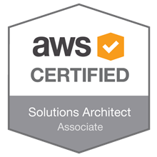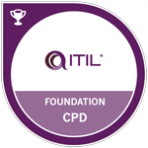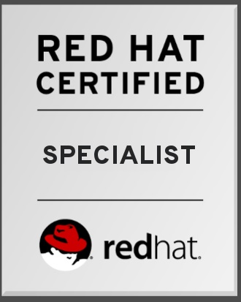

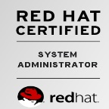

# Skills

|  |  |
| --- | --- |
| * **AWS** : EC2, Elastic Beanstalk, S3, ElasticCache, ELB, CloudWatch, IAM, SES, Route 53, RDS, VPC (subnets, routing tables, security groups, NAT/Internet Gateways, VPC Peering ), CloudFormation, AWS CLI, Terraform * **Automation**: Bash/Shell scripting, Puppet, Kubernetes, Docker, Ansible, Jenkins, Git/bitbucket * **App/Web**: Apache, Jboss, Tomcat * **DB**: Oracle/MySQL * **Administration**: DNS, NFS, FTP, LVM, VPN, Jboss/Tomcat, WebLogic, HA Clustering (CMAN,Pacemaker), Jboss Fuse, Zookeeper, ActiveMQ, Bitbucket, Maven, REST API | * **OS**: RHEL 6/ 7 , Windows * **Others**: ​Nagios, Zendesk, Jira, Bugzilla, Wireshark, Confluence, Postman * **Methodologies:** Agile development methodologies. Working knowledge of Sprints and Scrum/Kanban |

### *In Reverse chronological order*

### FEB 2019 – present

## Infrastructure Engineer / Obillex Limited

* Design, develop and maintain continuous Integration and Deployment pipeline using Jenkins, Bitbucket, Maven, Jfrog Artifactory and AWS.
* Designed and implemented new procedures for infrastructure migration using Ansible playbooks.
* Identify tasks which should be automated and write tools to automate them.
* Manage AWS services for all the projects including configuration and deployment of all required infrastructure, administrative tasks, and budgeting.
* Introduce new technologies and tools to the company to help build up an agile development environment.
* Analyze and troubleshoot deployment/application issues in a timely manner.
* Collaborate with a wide variety of internal teams including business development, network operations, development teams to ensure environments meet their requirements and conformed to industry-standard best practices
* Create and Implement standards and best practices across organization.

### AUG 2015 – Jan 2019

## Technical Support Lead (DevOps) / Persistent Systems

* Management and execution of on-going service operation tasks (performance monitoring, Testing, Debugging, log analysis, troubleshooting, provisioning, platform extensibility, migration, etc)
* Designed and implemented new procedures for infrastructure migration using Ansible playbooks.
* Identify tasks which should be automated and write tools to automate them.
* Developing CI/CD roadmap and implementing to the project
* Play a significant role in establishing operational processes for a fast-growing distributed cloud platform.
* Improve deployment process within AWS (ex: automated deployment).
* Monitor, analyze, and report performance statistics for cloud hosted environments.
* Managing 30+ servers in a distributed and highly available critical infrastructure
* AWS services administration: IAM, VPC, Route 53, EC2, S3, Elastic Beanstalk, RDS, CloudWatch, CloudFormation,etc.
* Built and deployed Docker containers to break up monolithic app into microservices, improving developer workflow, increasing scalability.
* Automate deployment of applications, system configurations, and security settings in AWS cloud based environment while implementing integrations, updates, and fixes.

### Nov 2009 – aug 2015

## Senior Tech: Support Engineer / Intel Corporation

* Management and execution of on-going service operation tasks (performance monitoring, log analysis, troubleshooting, provisioning, platform extensibility, migration, etc)
* Deploy product releases, hot fixes and service packs
* Identify tasks which should be automated and write tools to automate them.
* Design and build automation frameworks for the deployment, management, and monitoring of web-based business service.
* Taking ownership of technical issues and working with various teams to resolve the issue.
* Analyze and resolve problems according to priorities and time frames laid out in the Service Level Agreements
* Apply training and logic to assist clients in remote and onsite troubleshooting and problem resolution
* Client account management from a technical perspective.
* Ensure compliance with departmental policies (i.e. Change management, IT security standards, release management, incident management)

### JUN 2008 – Nov 2009

## Application Support Engineer / JIT Holdings (PVT) LTD.

* Server Administration (Sun Solaris 8,9, Windows, Oracle 8i & 9i, BEA WebLogic 8.1)
* Rapid troubleshooting of issues
* Managing the billing server application (mediation).
* On-site technical support for customers
* Detail Analysis & Diagnosis
* Testing of patches released, upon receipt of maintenance or patch releases
* Backing up and restoring the database
* Utilize Issue Tracking system to gather information, log problems, analyze results, track issues and resolutions

# Education

## B.Sc Special (Hons) in Information Technology / Sri Lanka Institute of Information Technology (SLIIT), Sri Lanka

## Specialization: Computer Systems and Networking

# Certifications

AWS Certified Solution Architect – Associate 2018

ITIL® Foundation Certificate in IT Service Management 2018

Red Hat Certified System Administrator 2018

Red Hat Certified Specialist in Ansible Automation 2018

Red Hat Certified Specialist in OpenShift Administration (Dockers/Kubernetes) (Currently on going)

# Salient Projects

## IoT Solution on Amazon Web Services / Internet of Things (IoT)

**Description**: Develop custom services on an IoT platform (Concert IoT) running on AWS to alert and resolve remote device’s (thing’s) maintenance issues to achieve business or technical insights.

**Role**: Technical Support Lead

Responsibilities: Provide Maintenance and Operational Support to the client in order to resolve day to day issues.

**Tools and Technologies:** AWS Services, Docker, Jenkins, Ansible, BitBucket

## API Monetization Platform for Telco Service Providers

**Description**: Developed telco application which provides the service exposure, creation and orchestration capability including API’s exposed to partners, APIs exposed to support systems and APIs exposed to internal application components

**Responsibilities**: Client account Management along with Diagnosing, Reproducing, Deploying and Fixing customer issues.

**Tools and Technologies**: Linux, Solaris, Oracle/SQL, Bash Script, Tomcat, Apache, RedHat Clustering, puppet

## Digital Services Hub for Telco Service Providers

**Description**: Developed a solution which can be used to provide payment, settlement and merchandising capabilities, such as the ability to offer free trials, sign users up for subscriptions and cross-sell products.

**Role**: Senior Technical Support Engineer

**Responsibilities**: Responsible for ensuring availability and performance of the system by taking ownership of technical issues and working with various teams to resolve the issues.

**Tools and Technologies**: Linux, Solaris, Tomcat, WebLogic, Oracle, PL/SQL, Bash Scripting