Kunal Rana
56 Hunter Road, Leicester, LE4 5GH
M: 07752652748 | E: kunalrana@hotmail.co.uk

Profile
A passionate, determined and reliable individual who is keen to learn and gain new skills by seeking to maximise self-potential, and enhance core skills. Someone who works towards the criterion which meets the Service Level Agreements and appreciates the results of achieving them. A proactive person with high standards of quality who is a strong team player with sound interpersonal skills and understands the importance and value of customer service delivery.

Skills

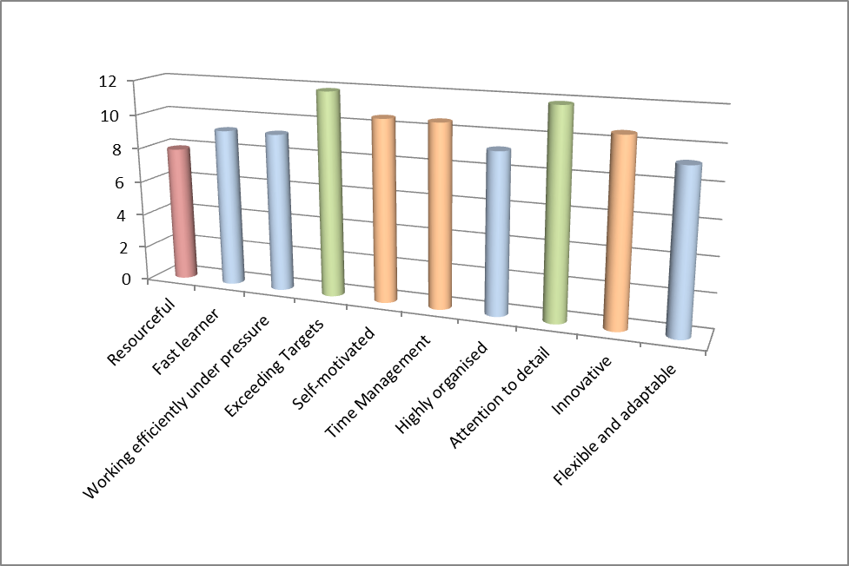

Experience
Feb 16 – Present: FCC Environment (System Rapids)
Rollout Engineer/Onsite Technician:
- 1st/2nd Line support
- Configure and install hardware and software
- Imaging Hard disks using Ghost32 and Clonezilla
- Hardware diagnosis, desktop and laptop repair
- Windows 7 roll out and restoration of user data and profile settings
- Scheduling staff for migrations
- Liaising with Daisy to schedule new installations for users
- Executing warranty for hardware failures with HP
- Updating Inventory regularly for all IT hardware
- Training new staff on the roll out process and weighbridge installations
Sept 15 – Jan 16: RR Donnelley
Data Entry:
- High and accurate data entry skills
- Document preparation
- Maintaining correct customer data

Nov 14 – Jan 15: Peakbound Financial Services, Australia
Customer Service (Temp):
- Liaising with customers with their queries and complaints
- Data entry and retrieving reports using key reporting tools
- Online and telephone banking queries
- Setting up payments such as periodic payments and transfers
Sept 14 – Nov 14: Prime Care Australia
Administration Assistant (Temp):
- Data entry
- Collating and registering files for scanning (using excel)
- Scanning documents, including: Document preparation, Naming documents on new system and Reassemble of files
- Dealing with queries which would include re-engagement with staff members and various support personnel including IT
Feb 13 – Jun 14: Carphone Warehouse Online Solutions
Product and Pricing Assistant:
- Daily product and tariff reports on Excel
- Commercial decision making
- Handset, tariff and gift creations
- Daily product and tar var bulk uploads on Pie Back Office
- Administering of website product range
- Supporting partnership and trading product requests
- Day to day management and monitoring of stock
Oct 10 – Jul 11: Abbey Primary Community School
IT Technician:
- ICT support to staff, students and classrooms
- Repairing laptops/computers
- Installing, updating new hardware and software
- Creating database
- Managing the ICT department
- Daily back up

Education
Degree Gained:
Bachelor of Science (Honours), 2:2 – Sept 2012
De Montfort University, Leicester
- Business Information Technology
A Levels Pass – June 2008
Gateway College, Leicester
- AS Applied ICT
- A2 ICT Double
Achievements
June 2014
An opportunity arose to go to Australia on a working holiday visa. It was a great personal achievement as it increased my confidence levels and made me aware of myself and my boundaries which had not been challenged previously.
References
Available upon request.

