Muhammad Azeem

Software Engineer

Summary
 Bradford, UK
 07588-363-376

 mhd.azeem@hotmail.com

uk.linkedin.com/in/mhdazeem

Nationality : Pakistani, Tier 2 (Work Permit Visa)

Personal Statement: An experienced and result oriented Software Engineer with a flair for innovation and enthusiasm for working with the latest technologies. A strong team player with a focus on delivering results. Have insightful knowledge of Microsoft Visual Studio (2009, 2010, 2012, 2013, 2015), Microsoft SQL Server (2012), Design Patterns, OOP, .Net framework, Web Applications, PHP, Cloud Computing and test automation. Highly flexible in adjusting work pace to meet evolving client needs.

Core Competencies

Software Development / Engineering
Software Life Cycle Management, LCM
Software Change / Configuration Management, SCCM
Project Management
Agile Development / Scrum Master
Build Automation (Hudson CI)
Unit Testing Automation


Certifications & Training:

Fundamentals of Java SE 6 | PHP 5
(September 2014 - Present) | (October 2016 - Present)
Google Cloud Platform Fundamentals | Amazon Web Services Platform Fundamentals
Training (2016) | Training (2016)


Work History

Software Engineer 2015 - Present

Don Electronics (Leeds, UK)

Achievement Highlights:

Introduced agile development technique for new and ongoing projects. Implemented test automation for all the projects and reduced work load by 30%.
Helped in fixing technical issues of a web server which was in development since 2012. Now its fully operational.
Amazon Web Services:

As a passionate advocate of AWS, I developed a Web Server by using AWS Stack (Including EC2, S3, DynamoDB and SES), focussing on high-availability, fault tolerance, and auto-scaling to receive data from multiple GPRS modules and process the data based on multiple checks. Also forward it to different servers using FTP, SMTP and TCP/IP.
Operations:

Solely responsible for maintaining and improving upon Server. Wrote scripts to fully automate application deployment, configuration and server monitoring.

 https://www.visualcv.com/k2rbqzmsxlu

Application Development:

Responsible for designing and developing GUI Software to decode event logs of embedded systems. Heavily involve in writing graphics firmware for embedded system to configure it using LCD display. Wrote C# .NET Serial library for communication between desktop applications with embedded systems. Design and Developed WPF / Windows based applications to configure products using serial port and Modbus communication protocols.
Tools and Technologies

Modbus RTU / TCP, C#, Embedded C, JavaScript, HTML 5, PHP, Python, Amazon Web Services, Data Tables, JQuery, Bootstrap, MySQL , MS Visual Studio (2013), BitBucket, SourceTree, JIRA, TortoiseSVN, Windows 7/10, Linux, PuTTY, WinScp, Microchip Graphics Library, Microchip Graphical Display Designer

Software Development Support Engineer (Industrial Placement) | 2013 - 2014
Service Power (Manchester, UK)

Achievement Highlights:

Implemented new development methodology to improve build system by using BitBucket, SourcTree and automation.
Responsible for the set up and maintenance of the Build System in HUDSON (CI).
Improved the release process of all the products for Windows 7 and Solaris, also added it into the build system and automated all the process using Shell, Batch and Perl scripts.
Implemented new features in the company’s products according to the requirements, tracking down and fixing bugs, exceptions and crashes.
Corrected reported bugs from earlier releases, searched for and corrected anomalies on the ongoing releases.
Routinely worked on various Java technologies such as: Spring framework, Hibernate and JSP in order to fix customer reported bugs and added additional requested features.
Enhanced C# application that computes the fastest route by employing GPS technology. The application is used by the field engineers in order to quickly get to the customer’s site for troubleshooting purposes. Liaised with the overseas development and test teams on regular basis in order to ensure project development and deployment within the scope and required time frame.
Lead QA team to develop functional area test cases and completion of testing in timely manner. Employed Agile Scrum, Zephyr and Kanban techniques for software development and testing within JIRA framework.
Tools and Technologies

C# .Net, C++, Java, JavaScript, HTML, Oracle, MS SQL Server 12, MS Visual Studio (2009, 2012), MyEclipse, BitBucket, SourceTree, JIRA, Windows 7, Unix, Linux, PuTTY, WinScp, Selenium

Self-Initiated Project | 2012 - 2013
Freelance Project Manager Application

Database application to store, retrieve and edit details of the approved freelancers. Used SQL, PL/SQL and 10g Form to develop GUI application.
Summary sheet displayed current and past projects with colour coded representation based on project status.
Application kept record of all the projects assigned to various personnel.

Self-Initiated Project | 2012 - 2013
2D and 3D Drawing Application

C# Windoes application to draw 2D and 3D drawing objects using OOP concepts. Used Drawing and Graphic libraries and created user library for custom shapes.
Utilised two dimensional arrays to store the user input and dimensions of the shapes such as: surface area, volume and perimeter.

https://www.visualcv.com/k2rbqzmsxlu


Skills

Development/ Environment

_{Tools/Techniques} MS Visual Studio, MyEclipse, NetBeans IDE, HUDSON (CI), UML, VMware, Subversion, TortoiseSVN, Dreamweaver8, MATLAB, Axure,

Selenium, WinScp, PuTTY, JIRA, Bitbucket, SourceTree, GIT, CVS,

MPLABX, Ms Office 365, Amazon / Google Cloud Engine, Apache

Server, Selendroid, Modbus RTU / TCP, GPRS, Zigbee, Microchip Graphics Library, Bootstrap, MVC 3.0, Tomcat Server, Nginx, WordPress

Operating Systems

Windows Server, Linux, SUN/Solaris, Windows XP/7/10

Databases

MS SQL Server 12, MySQL, Microsoft LINQ, Oracle 9i / 11g

Languages

Java, JavaScript, JSON, JQuery, AJAX, JSP, SOAP, Cucumber test scripts,

Android, C# / .NET, C++, Embedded C / C, Perl, SQL, PL/SQL, XML,

HTML 5, Batch Scripts, Shell Scripts, CGI Scripting, Python, PHP 5,

Asp.Net 3.5, MVC 3.0


Education

BSc(HONS) Software Engineering | 2011 - 2015
Manchester Metropolitan University

BSc(HONS) Software Engineering

Highly computational and technical degree to enhance the software design and development skills with the ability to develop and deploy professional software and database applications.

https://www.visualcv.com/k2rbqzmsxlu


Portfolio

Screenshots From my Work History
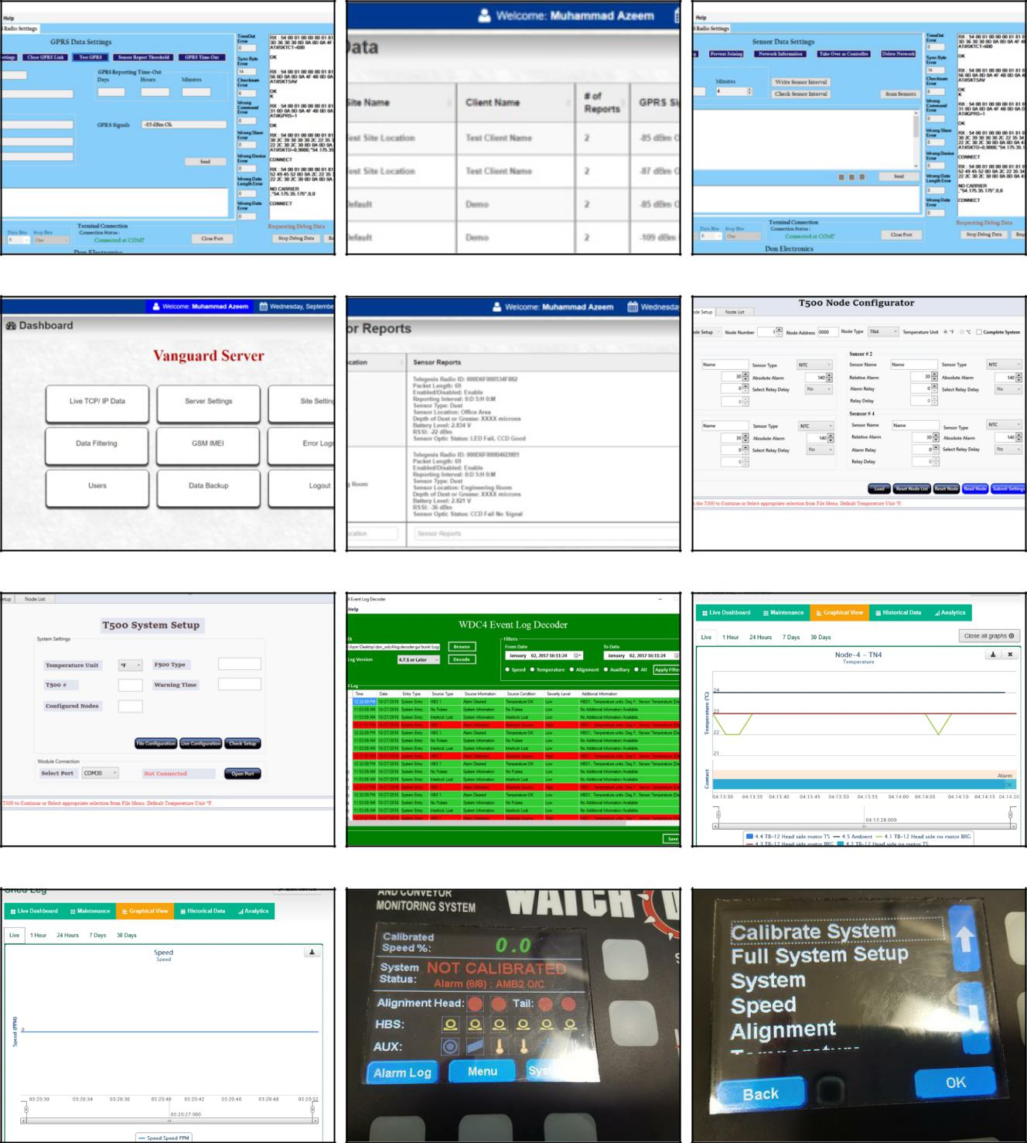

https://www.visualcv.com/k2rbqzmsxlu

