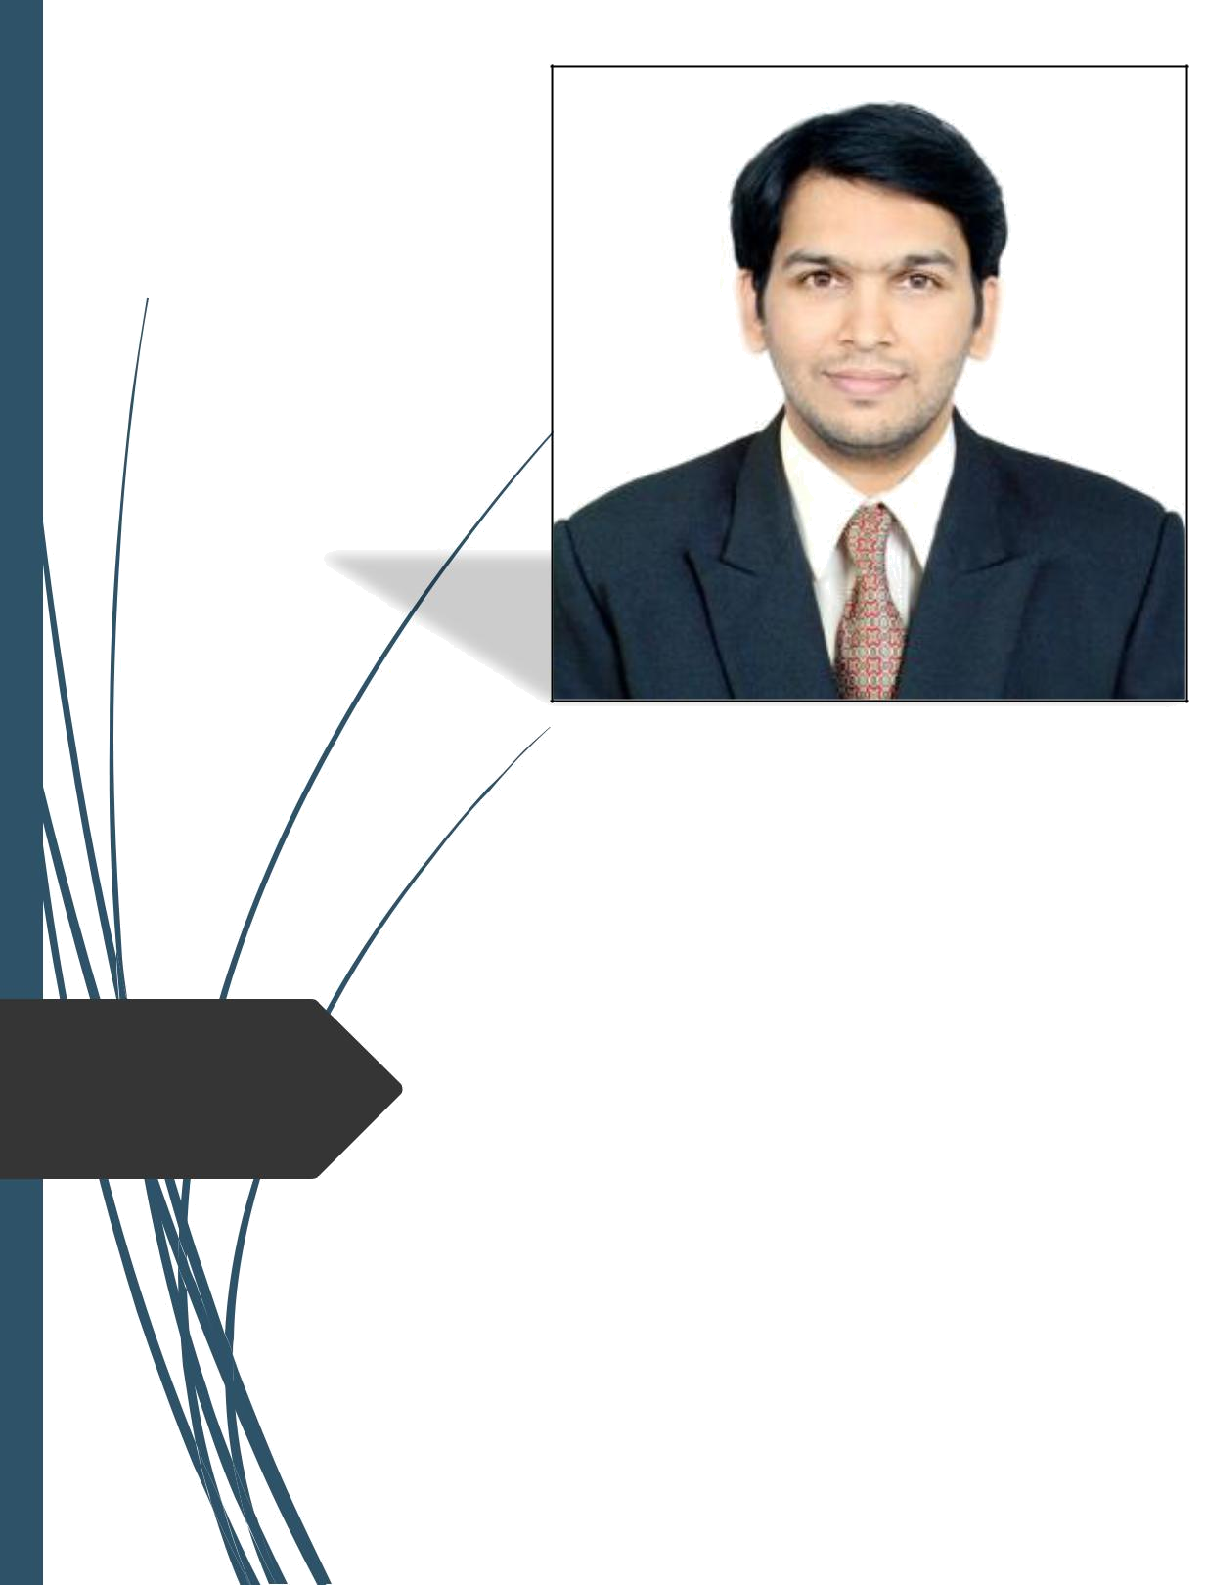
Wundtstrasse 27 Mobile: +49 152 5313 1561

80939 Munich Email: jajupj@gmail.com

Bavaria, GERMANY

Parag Jaju

Functional Safety Consultant

- Masters in Business Administration (MBA) from the Brighton Business School, United Kingdom – batch of 2010/12

- Nearly 88 months professional work experience, comprising of roles involving

  - Expertise Consultancy Services

  - Corporate Sales

  - Embedded Applications Development in the Automotive Industry.

- Bachelors of Engineering (Electronics) – Pune University, India – batch of 2006

- Expertise in:

  - Functional safety consultation for automotive system, hardware and software development

  - Process definition as per ISO26262, HARA, Safety goals, Functional safety and Technical safety concepts, Safety analyses - FMEA, FTA & FMEDA

  - Evaluating safety mechanisms, fault handling techniques, diagnostic methods and testing methodologies for functional safety compliance

  - Performing confirmation reviews and providing assistance on safety audits and assessments.

  - Management of system requirements using IBM Rational DOORS.

- Knowledge on process definition standards like ISO/TS 16949, ASPICE, CMMI, IEC 61508 and 12207

 |  | Organization | Designation | Client | Expected Responsibilities and Deliverables | Tenure |  | Managerial Skills
 |  | Organization | Designation | (Location) | Expected Responsibilities and Deliverables | Tenure |  | Managerial Skills
 |  |  |  |  | Responsible for requirements management in IBM |  | • | Synchronise the
 |  |  |  |  | Rational DOORS. Tasks include writing system |  |  | safety life cycle to the
 |  |  |  | Leading OEM | level requirements at the Technical Safety Concept | OCT 2016 – |  | product development
 |  |  |  | (Germany) | level and narrowing down to the Hardware and | Till Date |  | life cycle.
 |  |  |  |  | Software level safety requirements for High |  |  | Ensure that the
 |  |  |  |  | Voltage Electric Vehicles. |  | • | Ensure that the
 |  |  |  |  |  |  |  | quality of the end
 |  |  |  | Leading OEM | Involved in preparing Item Definition and HARA for | MAY 2014 – |  | product matches the
 |  |  |  | Leading OEM | Involved in preparing Item Definition and HARA for | MAY 2014 – |  | customer
 |  |  |  | (UK) | various applications like Head Up Display, Lane | APR 2015 |  | expectations.
 |  |  |  | (UK) | Keep Assist and Lane Change Merge Aid. | APR 2015 |  | expectations.
 |  |  |  |  |  |  | • | Prepare the safety
 |  |  |  |  |  |  |  | plan and align it with
 |  | KPIT | Functional | Leading OEM | Participated in Confirmation reviews of various | OCT 2013 – |  | the project plan.
 |  | KPIT | Functional | Leading OEM | work products for applications like Air Suspension, | MAY 2014
 |  | Technologies
 |  | Technologies | Safety | (UK) | Climate Seats, and Active Rear Diffuser etc. |  | • | Ensure that the safety
 |  | Ltd. | Safety |  | Climate Seats, and Active Rear Diffuser etc. |  | • | Ensure that the safety
 |  | Ltd. | Consultant |  |  |  |  | work products are
 |  | Pune, India | Consultant |  |  |  |  | work products are
 |  | Pune, India |  |  |  |  |  | technically reviewed
 |  |  |  | Tier 1 | Involved in preparing the functional safety plan | AUG 2013 – |  | and delivered to the
 |  |  |  | Tier 1 | Involved in preparing the functional safety plan | AUG 2013 – |  | project team for
 |  |  |  | Supplier | and identifying the safety work products for Gear | AUG 2013 – |  | project team for
 |  |  |  | Supplier | and identifying the safety work products for Gear | OCT 2013 |  | safety audits and
 |  |  |  | (South Korea) | Shifter Module. | OCT 2013 |  | safety audits and
 |  |  |  | (South Korea) | Shifter Module. |  |  | assessments
 |  |  |  |  |  |  |  | according to plan.
 |  |  |  |  | Imparting training on Functional Safety within the |  |  | according to plan.
 |  |  |  |  | organization and involved in formulating safety | APR 13 – JUL | • | Ensure that all the
 |  |  |  | Internal | culture. | 13 |  | supporting processes
 |  |  |  | Internal |  |  |  | defined for the project
 |  |  |  | (India) | Gap Analysis between ISO 26262 and other | JUN 15 – SEP |  | align with those
 |  |  |  |  | standards like ISO / TS 16949, ASPICE, CMMI, ISO | 2016 |  | described by ISO
 |  |  |  |  | 12207. |  |  | 26262.
 |  |  |  |  | Understanding of the master standard (IEC 61508)

 |  | Organization | Designation | Client | Expected Responsibilities and Deliverables | Tenure |  | Managerial Skills
 |  | Organization | Designation | (Location) | Expected Responsibilities and Deliverables | Tenure |  | Managerial Skills
 |  | TATA |  |  | Deputed at the customer location to deploy and |  | • Utilise my skillset and
 |  | TATA |  |  | Deputed at the customer location to deploy and |  |  | education from the MBA
 |  | Consultancy | Assistant |  | test software on ECU’s for hybrid and expected | AUG 2012 – |  | education from the MBA
 |  | Consultancy | Assistant |  | test software on ECU’s for hybrid and expected | AUG 2012 – |  | course to enhance the
 |  | Services | Systems | OEM (India) | to exhibit dedication and initiative to take up | MAR 2013 |  | course to enhance the
 |  |  |  |  |  |  |  | company deliverables to
 |  | Bangalore, | Analyst |  | added responsibilities and increase the account |  |  | company deliverables to
 |  | Bangalore, | Analyst |  | added responsibilities and increase the account |  |  | the client.
 |  | India |  |  | business. |  |  | the client.
 |  |  |  |  |  | JUL 2010 – | • Developed people and time
 |  |  | Pre-Sales | Internal | Ability to apply innovative ideas and sculpt | JUL 2010 – |  | management skills while
 |  |  | Pre-Sales | Internal | Ability to apply innovative ideas and sculpt | AUG 2010 |  | management skills while
 |  |  | Executive | (India) | project winning proposals for my organization. | AUG 2010 |  | working in this role.
 |  | KPIT Cummins | Functional |  |  |  | • | Responsible for training
 |  | KPIT Cummins | Development |  |  |  | • | Responsible for training
 |  | KPIT Cummins | Development |  | Developed automation scripts to reduce the | MAY 2008 – |  | colleagues on tools like
 |  | Infosystems | and ECU | Leading OEM | Developed automation scripts to reduce the | MAY 2008 – |  | colleagues on tools like
 |  | Infosystems | and ECU | Leading OEM | efforts required to make models developed in | JUN 2010 |  | MATLAB, SIMULINK,
 |  | Limited | testing | (India) | efforts required to make models developed in | JUN 2010 |  | MATLAB, SIMULINK,
 |  | Limited | testing | (India) | MATLAB adhere to MISRA guidelines. |  |  | Stateflow and Targetlink.
 |  | Bangalore/Pun | engineer |  | MATLAB adhere to MISRA guidelines. |  |  | Stateflow and Targetlink.
 |  | e, India
 |  |  |  | Leading |  |  | • | Practical application of
 |  |  |  | Leading | Regressive Unit Testing using Rational Test | FEB 2008 – |  | emulators and simulators
 |  |  | ECU Testing | Aircraft | Regressive Unit Testing using Rational Test | FEB 2008 – |  | emulators and simulators
 |  |  | ECU Testing | Aircraft | Real Time (RTRT) for highly critical (Level A) | APR 2008 |  | and SDLC for safety critical
 |  |  | Engineer | Manufacturer | Real Time (RTRT) for highly critical (Level A) | APR 2008 |  | and SDLC for safety critical
 |  |  |  | (India) | software. |  |  | software.

