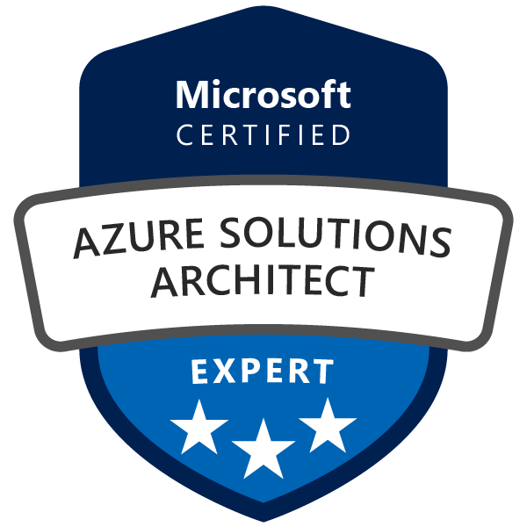

Karupathevan P
Contact no: +44 (0) 7448 655339
Email id: deva43.43@gmail.com
74 Stafford Grove, Shenley Church End, Milton Keynes – MK5 6AZ

Professional Experience

A focused, innovative, and solution driven professional, with more than 14 years of experience and hands-on skill in information technologies; with focus in IT infrastructure technology architecture, presales, design and large-scale system integration
Areas of Expertise

- Cloud Solution Architecture
- IT Infrastructure Solution Architecture
- Cloud Readiness Assessments
- Cloud Transformation Design & Architecture
- IT Transformation Strategy & Design
- IT & Business Consulting
- Presales, Implementation & Support

Work Experience
Solution Architect October 2015 to August 2019
Wipro Technologies / Ensono Technologies
(Moved from Wipro to Ensono as part of the transition. Job role remains same)
- Design and define cloud/hybrid cloud architectural solutions and oversee the implementations
- Design and implement dynamically scalable, highly available, fault tolerant, and reliable application infrastructure on public, private and hybrid cloud platform
- Ensure the technical component of the solution aligns with the client's business goals and current/potential standards
- Develop architecture blueprints and detailed documentation
- Identifying and articulating the technical and business requirements to create winning proposals in conjunction with sales and account team
- Understand financial and operational requirements to help create ROI models that meet the client needs
- Lead the Consulting, Assessment, PoC and implementation engagements of public/hybrid cloud solutions
- Own the solution design integrity throughout the entire lifecycle of the client solution
- Create RFI, RFP solution response and oral presentation
- Create high and low level design documentation
- Define migration strategy to move application/workloads from on-premise to public/hybrid cloud platforms (R-lane patterns – Rehost, Refactor, Replatform, Rearchitect)
- Understand and integrate dependency and tower impact (e.g. application, security, digital, DevOps, Business Continuity, and Disaster Recovery) to public/hybrid cloud migrations
- Engage with customers and implementation teams around solving business and technical problems in the hybrid cloud ecosystem
- Contribute to the development of hybrid cloud standards, best practices and organizational capability
- Provide technical consultancy to managed services
- Co-location services by leveraging Ensono data centre’s

Associate Principal Software Quality Engineer April 2013 to September 2015
EMC
- Responsible for providing solutions for Unix infrastructure in EMC multipath product development/test environment and testing on multiple Unix platforms

Design, installation and configuration of IBM Power 6, Power 7 and Power 8 series hardware

Management of EMC storage arrays such as Clariion, VNX, VNX2, VNX2e, VMAX, VGER, VPLEX and XtremIO

Senior Consultant February 2012 to April 2013
Capgemini

Design and lead the implementation of an infrastructure architecture roadmap based on business requirements and IT strategies

Develop target architecture that helps meet the customers’ business needs strategic objectives
- Responsible for architecture, design, development, implementation, integration, compatibility and customization of the solution
- Provide technical guidance/directions for and take ownership of all relevant projects

Migration of AIX and RHEL environment from client DC to Capgemini DC in Netherlands

Creation of High level design (HLD) and Low level design (LLD) documents

Documenting technical procedures and processes

Provide knowledge transfer to support team and assist them in stabilizing the environment

I.T Analyst September 2010 to February 2012
Tata Consultancy Services (TCS)

Analyze IT Infrastructure Services requirements for customers and design appropriate cost-effective services/solutions

Solutions/Service Design dealing with all components of an IT Infrastructure, Transition & Transformation (Technology & Services)

Lead, organize, schedule and conduct requirement gathering discussions

Evaluate, recommend, architect and implement Services solutions

Build solution documents, effort estimation, pricing, resource planning, risk management and defining project tasks and activities

Technical Solutions Consultant II October 2007 to September 2010
Hewlett Packard (HP)

Providing support for HPUX 11.x and 10.x to enterprise customers in SPR & SEA region

Expertise in LVM, VPAR, IVM, MC-SERVICE GUARD and System administration

Regular follow-up/interaction with customers to ensure that issues are resolved in time

Ensure customer response and SLA is met

Associate Customer Engineer May 2005 to September 2007
HCL Infosystems Ltd

Responsible for Hardware/OS Maintenance and System Administration at location Office serving around 300 Clients

Responsible for sales and service of the HCL make systems, servers and printers

Specialized Skills:

Hardware– Cisco UCS, HP, Dell and IBM Servers (P Series)

Windows Servers – 2003, 2008, 2012 and 2016

Linux – RHEL and SUSE

Unix – HP-UX (11.11, 11.23 and 11.31) and AIX (5.3, 6.2 and 7.1)

Virtualization – VMWare, Hyper-V, IBM PowerVM, HP-UX(nPar, vPar,IVM)

AWS

EC2, Snapshot, Lambda, Cloudwatch, Autoscaling, EBS, S3, VPC, LB, CloudFormation

Azure

VM, VNET, Autoscaling, Load Balancer, Application Gateway, NSG, WebApps, Backup, Blobs, OMS, Application Insights, Azure Site Recovery, ARM

Storage – NAS and SAN (EMC Clariion, VNX, VNX2, VNX2e, VMAX, VPLEX and XtremIO)

Backup – AWS Snapshots, Azure Recovery vault service, Veeam and Tape Library

DevOps Tools such as Terraform, Ansible, Jenkins, Docker and Kubernetes

Scripting – Shell and PowerShell

Cloud (AWS/Azure)
- Professional experience in architecting large-scale distributed applications
- Experience in producing multi-tier, high-availability infrastructure architectures
- Understanding of Hybrid Cloud solutions and experience in integrating public cloud into traditional hosting/delivery models
- Experience with executing quick technical feasibility and proposal development for moving identified workloads to AWS/Azure
- Hands-on experience using compute, virtualisation, networking, storage, backup/archival, containers, databases, monitoring and management tools
- A good understanding and implementation experience of all security features and cloud management platform (CMP) tools
- Hands-on experience in moving IaaS workloads using Re-hosting, Re-platform or Re-factoring migration approach
- Experience in designing for disaster recovery, hybrid cloud storage, backup and archival
- Experience in capacity, performance management and ITIL environments
- Broad project lifecycle experience – especially in Enterprise environments starting from cloud application assessment to migration
- Networking (TCP/IP, DNS, VPNs, Direct Connect, ExpressRoute. routing, switching etc.)
- Security (firewall configuration, IPS/IDS etc.) and other Cloud security controls
- Understanding of common database technologies (e.g. backup/restoration, replication/mirroring)
- Good knowledge of DevOps Tools

AIX

Installation and configuration of P7 and P8 hardware

Configuration of dual VIO server

Logical Partition’s – creation, resource’s allocation to profiles

SEA failover Configuration in VIO server

NPIV setup and configuration to virtualize fibre-channel ports

Installation and configuration of OS using NIM server

HP-UX

Good working experience in production environment with HPUX 11.11, 11.23, 11.31 and 10.20

Installation and configuration of high availability environment using MC Service Guard

Troubleshooting and solving various high availability cluster related problems

Creating and managing HP-UX virtual systems by using vPar and HP integrity virtual machines

Certifications

Microsoft Certified Azure Solutions Architect Expert

AWS certified solutions architect – Associate

Microsoft specialist: Implementing Microsoft Azure Infrastructure Solutions – 70-533

IBM certified system administrator - AIX 7 (000-221)

IBM certified systems expert - High Availability for AIX technical support and administration -v2

Information storage management(ISM) Certification

HP certified system administrator (HP0-091)

