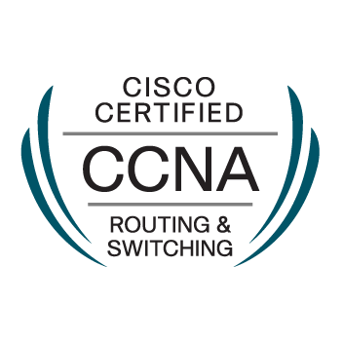

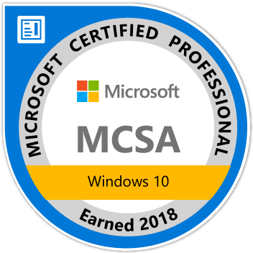

Kanishka Marasinhage MBA, B.sc (Hon)IT, MCPS, MCSA, CCNA.

11,Golden Hill Close ,Preston,PR2 6YX.
Mobile. 07411861956
Kanishka_gayan@yahoo.co.uk

PERSONAL SUMMARY

A confident and reliable IT support engineer with extensive practical experience of working with computers and resolving any support issues that are raised to the service desk. Possessing a proven ability to administer and control the operation, configuration and maintenance of computer based information systems, as well as having an eye for detail and able to multi-task under pressure. An excellent communicator can relate well with people at all levels and has the flexibility of working well as part of a team and on my own.

Now looking to further an already successful career by working for an ambitious and expanding company.

PROFESSIONAL QUALIFICATION

- Microsoft Certified Professional(MCP)
- Microsoft Certified Solutions Associate (MCSA) Windows 10
- Cisco Certified Network Associate Routing and Switching (CCNA Routing and Switching)

KEY SKILLS:

- Microsoft Operating Systems (Windows XP, Windows 7,Windows 10)
- Microsoft Operating Deployment (MDT/WDS/ADK)
- Citrix xenApp and xenDesktop 7.6(Installation,Administration and configuration )
- VMware- ESXI 6.5
- Windows Server 2003/2008/2012 installation & administration
- Active Directory administration
- Experience supporting desktop environments and hardware(DELL/HP)
- Creating and managing backup schedules (VEEAM)
- Troubleshooting and maintaining of network firewalls (WatchGuard Firebox M500 and CISCO ASA), Routers and Switches (CISCO).
- Experience of Routing and Switching Protocols (BGP, OSPF, EIGRP,RIV and IGRP)
- Server Build (Dell PowerEdge R720\740, )

Recent Projects Completed

- IE11 Upgrade Project –Floor Work Support -2016

  - Trade-floor day one support after Upgrade E9 to E11 and IE11 related tickets to work through.

- Geofield Application Upgrade Roll out (New Version) – Floor Work Support 2016

  - Responsible for application support and installation over 1800 Desktop, Laptop and Toughbook

- Geofield Application Roll out – 2015

GeoField is a powerful map-based mobile work management solution that enables your field workers to access and update enterprise data at the point of action. Responsible for application support and installation over 1800 Desktop, Laptop and Toughbook.

- Windows 7 Migration - Floor Work Support – 2014

Responsible for dealing with Windows 7 migration from XP – user profile migration, preserving desktop configuration -eg Application issues, printer drivers and connections for over 2000 user in different location.

Floor support after migrations and windows 7 related tickets to work through

Microsoft Office Suite support.

Imaging of new PC’s, laptop’s and Toughbook.

Liaising confidently with application support and other IT technology teams.

- Data Center Migration Project – 2014

Responsible for Data center equipment relocation, installation new hard ware (CISCO Blade servers).

WORK EXPERIENCE
London Computer Centre 2011 March - Present (Electricity North West /WIPRO Account- Preston)

IT Support Engineer
Responsible for supporting (2nd Line ) Electricity Northwest users at all levels as part of IT infrastructure team. Ensuring that all hardware and software is configured and installed correctly.

Duties:

- Diagnosis of desktop/Laptop, application, networking and infrastructure issues.
- Escalating problems when appropriate to third party suppliers
- Experience of supporting a wide and varied client base.
- Troubleshooting PC’s, laptops and mobile devices (Iphone- Mobile application). Providing 2nd line support to users.
- Administering the IT department’s policies and procedures.
- Maintaining a log of all problems detected and system backups.
- Responsible for maintaining backups (Veem Backup and Replication) and for project work such as new builds(desktop and servers ).
- Working closely with software suppliers to resolve operational issues.
- Responsible for supporting: Windows XP/Vista/Windows 7/Window 10/ Office 2003 and 2007, Windows Server 2003/2008, Active Directory management, Backup products, Anti-Virus products, DNS/DHCP, TCP/IP, Ethernet, wireless router and Firewall Configurations.

United Motors (PLC)-Sri lank 2003-2006
IT Support Technician

Duties:
- Configuration and testing of any new hardware and software.
- Travelling to client sites to help with installs, deployment, and troubleshooting.
- Management of the daily data backup and retrieval scheme.
- Installing and operating Windows desktop and server operating systems.
- TCP/IP networking and hardware maintenance and repair.
- Assistance with training of staff and compiling procedural documentation.
- Assisting the network manager with support requests.
- Ensure computer hardware is safe & complies with health and safety legislation.
- Applying patches in accordance with company procedures

ACADEMIC QUALIFICATIONS

2009-2010 University of Sunderland
Masters in Business Administration (MBA)

2007-2008 British institute of Technology and Ecommerce
Postgraduate Diplomas in Business Administration (level 07)

2001-2004 Sri Lanka Institute of Information Technology (Colombo) SL
B.sc (Hon) Special in Information Technology.

1987-1994 G.C.E O/L (passed)
1994-1998 G.C.E A/L (Passed)

REFERENCES – Available on request

