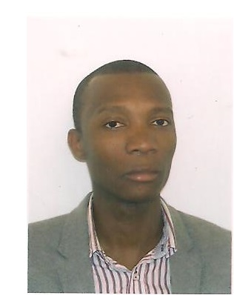

CURRICULUM VITAE

Name Jerciley Da Silva Andre
Address Flat 2 Liberty Point 1A Blackhorse Lane
CR0 6RT Croydon - London

Telephone 07424489376
E-mail andrejorcy@gmail.com
Date of birth 15 February 1985
Nationality Portuguese
Sex Male
Marital status Married

Education/Qualifications
2017- 2020 BA Leadership and Management - Skills for the the Workplace. UWTSD – London Campus
2015 - 2016 Certificate High Education - Skills for the the Workplace. UWTSD – London Campus (Level IV)

2013 – 2014 Masters Degree - Systems Information and Business Technology – IMF Madrid Spain

2006 – 2009 Networks Management and Systems Information – Level IV (EPBJC Lisbon – Portugal)

Employment /Work Experience
06/2011 - 07/2015
IT Technician / Systems Admin - Vodafone Portugal
- Installation and Support of full MS Server 2008/2012 R2 Infrastructure
- Desktop / Laptop Support Windows Operating Systems
- VMware Installation and Creation
- System Center configuration and Administration
- Hardware / Software Support
- Backup / Server monitoring

01/2008 – 05/2011

IT / Systems Support 2nd Line – CGD Bank - Lisbon Portugal
- Installing software and hardware systems, including new equipment, anti-virus programs, CRM programs, BO, BI, SAS, SAP, SQL, ORACLE
- Providing support for all staff either by phone, remote access and site visits
- Maintaining the hardware across company sites via regular onsite visits
- Monitor networking equipment and servers
- Set up equipment for new users
- Cabling and hardware setup at new offices and expansions
- Ensure security and privacy of networks and computer systems

Skills

- VMware
- Active Directory
- ITIL
- IPV4
- IPV6
- DHCP
- DNS
- Telnet
- Firewall
- Wordpress
- Systems Admin
- Windows
- Mac
- Linux
- ADSL
- FTTH
- MPLS
- IPTV

Languages Portuguese: native speaker; English: Listening (very good) Reading (very good) Speaking (good) Writing (good).

Personal Skills and
Competences
Confident, very energetic person, with a genuine smile, who naturally connect with others, and also a very quick learner, with strong organizational ability, skilled at working closely with others in a team environment

Other skills Frequent and Timely
Responsible

Driving license UK Full Category B / Sub Catg B1

References Available upon request

