BHASKER C VENKATRAMAN


EXPERIENCE SUMMARY

A total of 17+ years of experience in IT Industry involved in System Analysis, Design, Application Development and Application Sustenance using C, C++, Linux, Unix Shell Script, Clearcase, GIT under various flavors of Unix (Linux, HP Unix & Sun Solaris), and CISCO IOS Environment.

My strength areas are UNIX, C,C++, shell and networking. I have been working with UNIX environment for most of my experience now and I am well-versed in different distributions of Linux and UNIX. I am very fond of virtualization.

I also have successfully motivated and lead teams of several sizes. I believe in leadership by example and have successfully demonstrated many occasions of good management and team building.

I am also a very strong Dev-ops Engineer.

EDUCATIONAL QUALIFICATION

- Master of Technology in Chemical Engineering from Anna University, 1999

- Masters of Science in Physics from Anna University, 1997

- Brainbench Certified Unix Administrator, 2001

- Training in ICRC - Introduction to Cisco Router Configuration

- Cisco Certified Network Associate (CCNA)

- Building Cisco Multiple Switched Networks (BCMSN - CCNP)

TECHNICAL ENVIRONMENT/ SKILL SETS
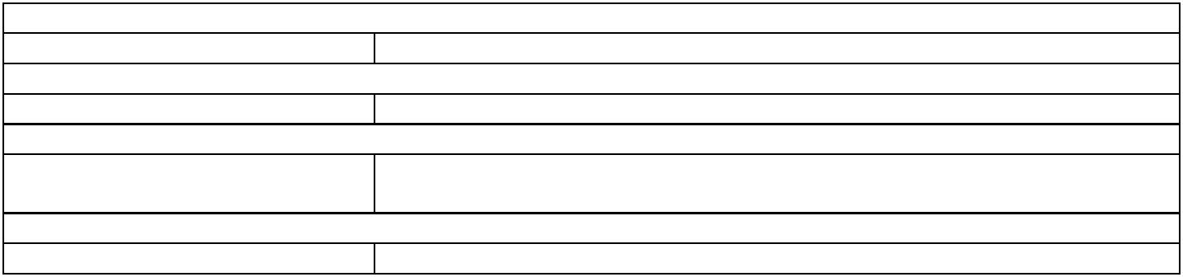
HARDWARE PC, Sparc, CISCO Routers
KEY SKILLS Unix, C, networking, HEADEND, DOCSIS(3.0), virtualization
OPERATING SYSTEM HP Unix, Sun Solaris 5.8, Red Hat Linux, Linux (debian)
LANGUAGES C, C++, Perl, Unix Shell Scripts, perl, Java
TOOLS Clearcase, DDTS, Perforce
NETWORKING TCP/IP, Frame-Relay, MPLS

PROTOCOLS
DATABASE Sybase, Postgres, Mysql, Oracle (Unix platform only)
INTERESTS Linux, programming C(Unix), virtualization
SUMMARY OF ASSIGNMENTS
Key skills put under use and Achievements
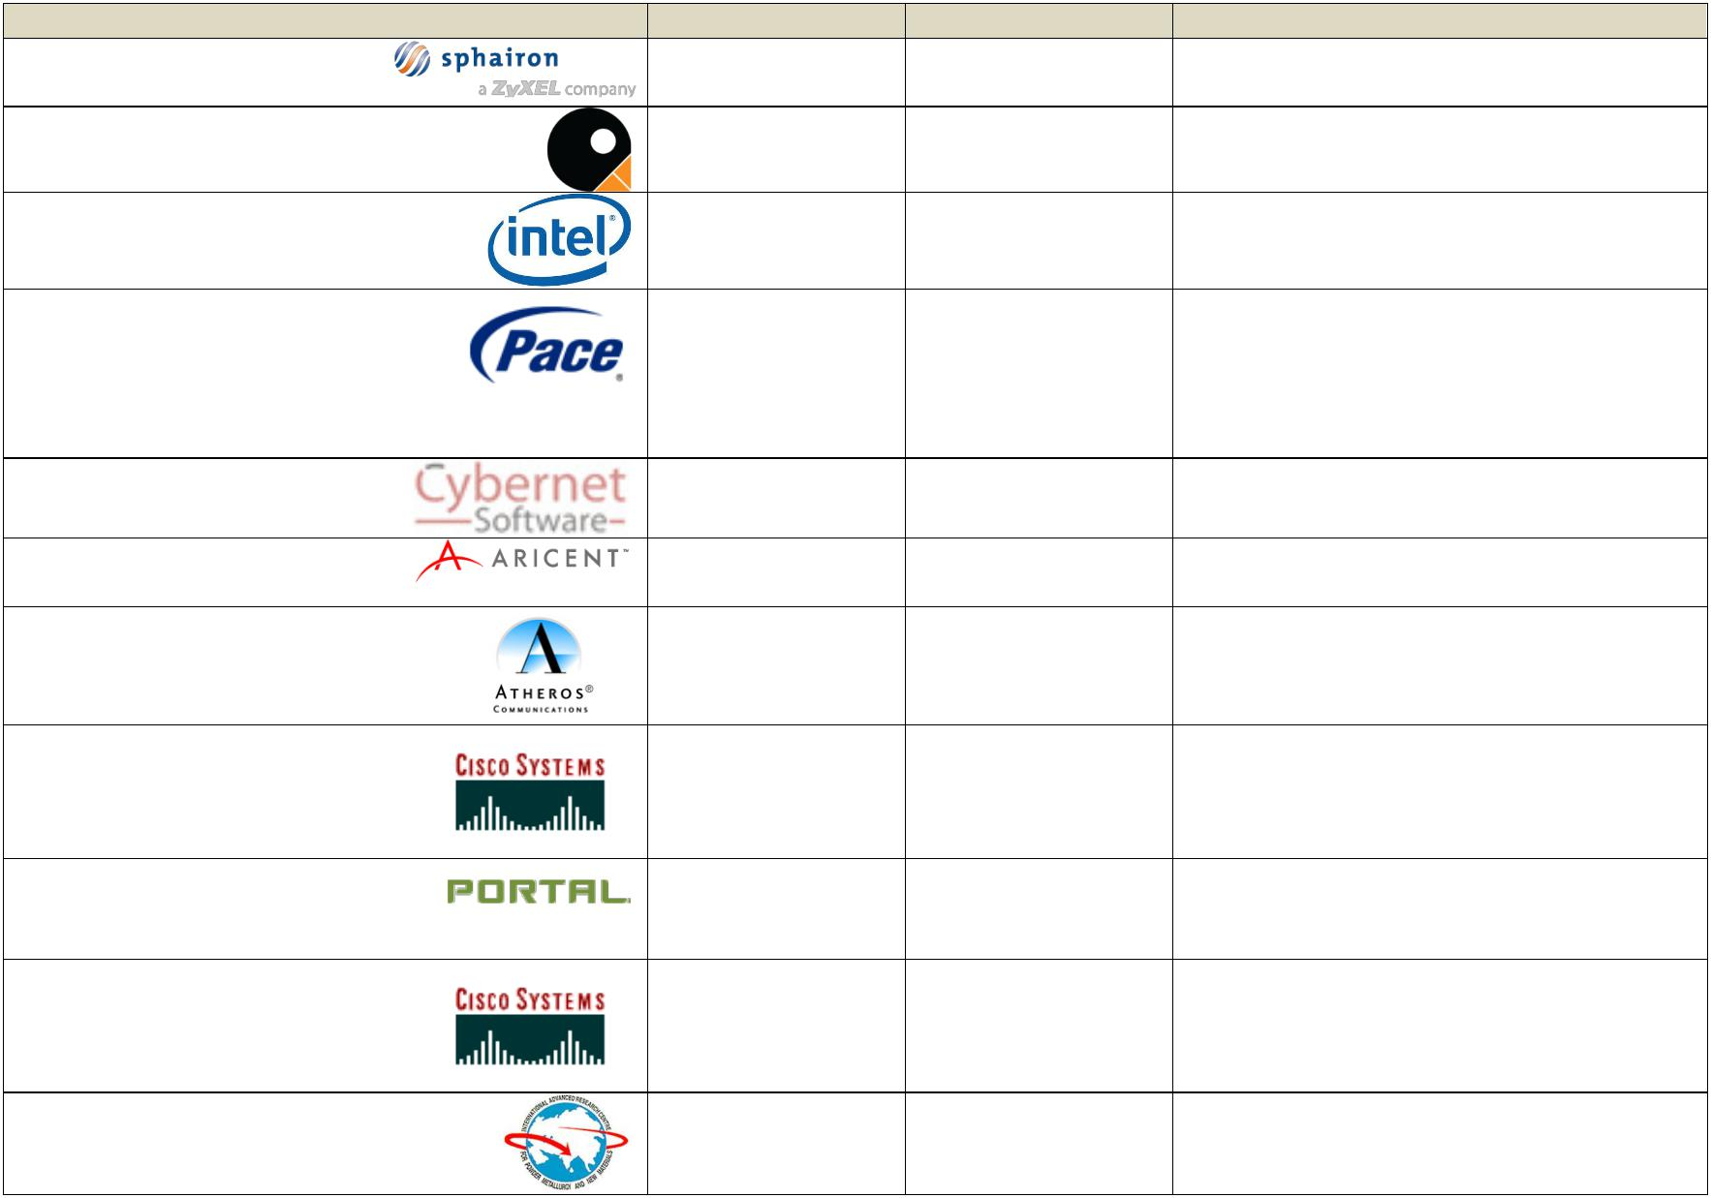

Organisation |  |  |  |  |  |  |  | Role | Duration | Skills, Key achievements*
Sphairon |  |  |  |  |  |  |  | DevOps Engineer | 2016-2017 | DevOps, Build Engineer, DevOps
 |  |  |  |  |  |  |  |  |  | Engineer.
Qruize Technologies |  |  |  |  |  |  |  | Senior Architect | 2015-2016 | C, Java, Cloud (AWS), Android
 |  |  |  |  |  |  |  |  |  | DOCSIS, IPV6,C, Linux, Embedded
Intel Corporation |  |  |  |  |  |  |  | Lead Engineer |  | DOCSIS, IPV6,C, Linux, Embedded
 |  |  |  |  |  |  |  |  | 2014-2015 | systems
 |  |  |  |  |  |  |  |  |  | DOCSIS, Board bring-up, complete
Pace Plc., |  |  |  |  |  |  |  | Individual |  | DOCSIS, Board bring-up, complete
 |  |  |  |  |  |  |  | Contributor |  | product lifecycle, HEADEND, Linux, C,
 |  |  |  |  |  |  |  |  | 2008-2014 | Perl, BUILD ENGINEERING, DevOps,
 |  |  |  |  |  |  |  |  |  | VIRTUALISATION, Project
 |  |  |  |  |  |  |  |  |  | Management
CSS CORPORATION |  |  |  |  |  |  |  | Project Manager |  | VIRTUALISATION, Project
 |  |  |  |  |  |  |  |  | 2008 | Management, Cloud platform
 |  |  |  |  |  |  |  |  |  | Project Management, Lead Engineer, C,
ARICENT Communications |  |  |  |  |  |  |  | Project Manager |  | Project Management, Lead Engineer, C,
 |  |  |  |  |  |  |  |  | 2007 | TCPIP, 3GPP2-ROHC
Atheros Communications |  |  |  |  |  |  |  | Team Leader and |  | Embedded, C, BUILD ENGINEERING,
(Qualcomm) |  |  |  |  |  |  |  | Developer | 2004-2006 | VC++, Linux, Macrovision Install
 |  |  |  |  |  |  |  |  |  | framework, Leadership
 |  |  |  |  |  |  |  |  |  | Linux, BUILD ENGINEERING, C/Unix
CISCO SYSTEMS |  |  |  |  |  |  |  | Project Leader |  | Linux, BUILD ENGINEERING, C/Unix
(TATA ELXSI) |  |  |  |  |  |  |  |  | 2003-2004
 |  |  |  |  |  |  |  |  |  | C++, Perl, Linux, Solaris,
PORTAL INC., |  |  |  |  |  |  |  | Senior Software |  | C++, Perl, Linux, Solaris,
(APAR) |  |  |  |  |  |  |  | Engineer | 2003 | Troubleshooting
[INDIA] |  |  |  |  |  |  |  |  |  | C,C++,Linux, tcl/tk – expect, Test
CISCO SYSTENS |  |  |  |  |  |  |  | Software Engineer, |  | C,C++,Linux, tcl/tk – expect, Test
(HCL TECHNOLOGIES) |  |  |  |  |  |  |  | Developer | 2000-2003 | Automation, BUILD ENGINEERING
[INDIA]
Advance Research Centre |  |  |  |  |  |  |  | Scientist |  | C, Linux
 |  |  |  |  |  |  |  |  | 1999-2000

DETAILED ROLE, TASKS and ASSIGNMENTS
ORGANIZATION: Sphairon GmbH a Zyxel Company(Germany)


Role: DevOps Build Engineer
Position: Embedded Software Engineer
Duration: Jan 2016 - Jul 2016
Duration: Sept 2016 – Nov 2016 (contract extn.)

Duration: Jan 2017 – Apr 2017 (contract extn.)

Notes: Freelance Engineer

Sphairon is one of Europe's leading specialists in the design and manufacture of end-equipment (CPE) and enterprise solutions and adds numerous service providers and telecommunications companies in Germany with innovative and high-quality network and telecommunications solutions. The clientele of Sphairon include the German Telekom, Vodafone, Telefónica, Versatel and Netcologne. Sphairon has pioneered

Projects/Accomplishments:

- Redesign of the complete build system to enable future expansion
- Full support for git based CI system

- Methodologies and scripts in place to automatically deduce changelog and release notes for releases
- Automated test cases (BATS) for complete build-system library.

Environment : Linux (Debian/Ubuntu), Shell (bash), BATS Team Size : 1

Language : shell, Linux, bash

Tools : KVM (kernel virtual machine), Bash

ORGANIZATION: QRUIZE Technologies Pvt Ltd.,(INDIA)


Role: Individual Contributor/Architect
Duration: Jun 2015 – Jan 2016

Qruize is a research-driven technology consulting company with a focus on Cloud, Mobile and Internet of Things. Qruize helps customers crash development times and enhance their go-to-market by using custom built solution frameworks.

Projects/Accomplishments:

Android Application Lead:

- Developed android application along with designing the Content management system

- Managed android module development across team.
C/C++ development lead:

- Developed (design and coding) a complete security based monolithic image manager for embedded systems. Also managed a team to further this C/C++ code.

Environment : Linux (Debian/RHEL ), Android Studio, emacs

Team Size : 5

Language : shell, perl , C, Unix, IPV6, Java

Tools : KVM (kernel virtual machine)

ORGANIZATION: INTEL CORPORATION (United Kingdom)
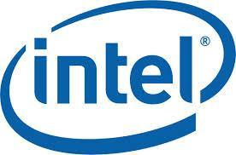

Role: Senior Software Engineer.
Duration: June 2014 – Jan 2015

Intel is one of the world's largest and highest valued semiconductor chip manufacturers. Apart from the specialized desktop processors, Intel also manufactures SoCs which are for specific applications like DOCSIS, wireless etc.,

Projects/Accomplishments:

- DOCSIS engineer/expert

  - Maintained DOCSIS code and also interact with customers to find out issues and gate releases to customers.

  - Fix bugs in the DOCSIS code.
  - Be a point of reference as a domain expert in DOCSIS (3.0)

- HEADEND engineer

  - Setup and maintain ARRIS C4c (32x24) for team usage.

  - Virtualized servers to do the DOCSIS backend tasks required for provisioning CMs

Environment : Linux (Debian/RHEL )

Team Size : 5

Language : shell, perl , C, Unix, IPV6,
Tools : KVM (kernel virtual machine)

Organization: Pace Plc., (United Kingdom)


Role: Individual Contributor
Duration : Nov 2008 – May 2014.

Pace is a market leader in manufacturing set-top-boxes. PVR (personal video
recorder) technology allows viewers to control what they watch on TV - and when they watch it.

Pace’s range of satellite, cable and IPTV products is at the forefront of the global switch to HD

(high definition) television. Most of the major customers use Pace products for their clients.

Projects/Accomplishments:
•
- Distributed Clustered Build system (perl + Linux + makefiles )

This is a build farm totally written and developed in perl which can do multiple parallel builds requested from web interface.

- Distributed test system (integrated with Build Cluster)

Similar to the build system above but can service multiple test requests parallely and maintain availability of test entities (racks/shelves/boxes)
•
- Release Engineering and tracking

- Kerrighed Single-Image Cluster [using]

- Glusterfs cluster distributed file system [using]

- Complete HEADEND (Motorola) management designing and building a new headend from scratch.

The Motorola headend is the centre point of the team and DTV development. The team’s day-to-day activity depends on the HEADEND. I maintain the complete

headend and also troubleshoot networking/NAT. I have done many implementations of HEADEND wide ipv6. Also public servers and their security was under my control.

- DOCSIS 2.X

Know the internals of DOCSIS and how the CM interacts with the CMTS. Conversant with networking internals and registration mechanisms of both IPV4
and IPV6

•

- Complete board bring-up (using provided SDK) and release of sigma 8644

•
dev/prod chip based IP Set-top-box

This project involved bringing-up(with provided SDK) and releasing IP set-top boxes based on Sigma SMP865X (IP set-top-box secure chip processor ). Minor changes to primary and secondary bootloader. Bring up and make a nfs kernel working on the board for development engineers. Key activities are creating busybox based rootfs and nfs loading kernels(for devel), creating NOR and NAND image maps for factory manufacture of boxes.
•

- Factory ramp-up: Taking care of factory issues and yield issues during the product production ramp-up.
•
- VIRTUALISATION: virtualising servers and maintaining them for the team

  - Libvirt
  - KVM (qemu)

- Cross compiling: Involving complete porting of x86 based TR-69 protocol stack on to a MIPS based board and make it work with a backend server.

Environment : Linux (Debian/RHEL )

Team Size : 1

Language : shell, perl , C, Unix, IPV6,
Tools : cvs, bugzilla, KVM (kernel virtual machine), kerrighed

Organization: CSS Corporation(INDIA)

Role: Project Manager
Position: Technical Architect
Duration :Aug 2008 – Nov 2008.

Cybernet Software is a center of R&D for CSS Corporation. CSS' CoE for R&D enables independent software vendors and enterprises find solutions to their technology & business challenges. The CoE possesses highly specialized technology resources, industry leading methodologies & frameworks, and proprietary technology solutions, all of which are leveraged for the benefit of our clients. Through continuous research, design and improvement of development processes and practices, the coe helps clients achieve quality deliverables efficiently. The expertise in technology and process is supplemented with specific vertical domain expertise to customize solutions for each client's unique needs.

Project:

- AWS EC2 usage learning and S3 storage based solution (bucket explorer etc.,)

Environment: Linux
Team Size: 4

Languages :
Organization: Aricent Commications(INDIA)


Role: Project Manager
Position: Engineering Project Manager
Duration :Feb 2007 – Nov 2007.

Aricent is a full-service, full-spectrum communications software company. Aricent is committed to powering communications for all of our clients-the world's leading communications equipment manufacturers, device manufacturers and service providers. No other company offers the depth and breadth of services and products. And no other company delivers such a unique combination of innovation, excellence and results.

Projects:
- RoHC protocol based implementation and coding for a 3GPP2 box.

- In-flight entertainment design and development. Accomplishments:

- On time delivery.

- Setup Bugzilla/cvs and other tools for the team.

- Customer interaction.

- Quality adherence.

Environment: RHEL,
Team Size: 4

Languages : C++

Tools: cvs, bugzilla, ddd/gdb.

Organization: Atheros India (Atheros Communications Inc.,)


Multi-functional Role:
Aug 2004 – Nov 2006.

- Role : Team Leader and Developer

- Device driver programmer

- Manager for IT

- Build and release gating.

Atheros is one of the world leaders in wireless technology mainly concentrating on wireless chip design (please visit www.atheros.com) . There are lots of proprietary products of Atheros which are now taken as standards upon which other products are developed. Some of them to mention are XR, Turbo Mode, Single chip solution etc.,

Accomplishments:

- Implemented PEAP(MSCHAPPV2) authentication using certificates

- Setup Linux and windows build machine

- Maintain single manly the 11n AP code.

- Complete process and maintenance of IT for Chennai Atheros.

Roles and Responsibilities:

- Setup local SCM environment and coordinated product releases.

- Product release sentry.

- SCM facilitator for the team.

- Provide complete technical leadership in establishing Linux development environment and develop and assist Linux development and Linux test process.

- Setup and maintain all the servers and create and maintain the domain in Chennai

- Total build system setup on Linux for daily/nightly builds

- Implementing packet generator on Linux (IOCtl/Linux)

- Maintain/develop 11n based Access-point running Linux

- installer creations using Installschield and NSIS

Environment: RHEL, RH9, SuSE,

Team Size: 7 Languages : C++/C/perl

Tools: Perforce, IAS, Cisco ACS, Cisco AP, Atheros AP, Atheros Wireless cards (cardbus)

Organisation : TATA ELXSI (CISCO SYSTEMS)
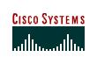

Role : Lead Engineer
Duration : June 2003 – Aug 2004

- Project :VTG: Cisco Emergency Call Responder

- Role: Project Leader

Voice technology group (VTG) aims at providing VOIP solutions for customers. CER is an emergency responder solution to be used in conjunction with Cisco Call Manager

Accomplishments:

- Migrated the complete source code management from VSS to Clearcase

- Migrated code from NT to Linux

Roles and Responsibilities:

- To manage complete SCM for the team

- To plan and implement branching strategies

- Database and Linux migration and Install Framework

- Design of RPM specs and dependencies

- Code migration from NT to Linux and usage of cprefs instead of NT registry

- PAM based authentication module

Environment: Linux (RHEL ADS 2.0), Linux (Debian)

Team Size: 25 (blr)
Languages: C++, Java, Postgres / Sybase

Tools : Source Insight, Source Navigator, bash (cygwin)

• Project :Toyota source extraction and vulnerability identification

- Role: Project Leader

Toyota has developed the embedded sys operating software, which is used to control the Toyota family of vehicles. The code is written and C and there are distinct functions which are used to control various tasks for controlling the vehicle. The project is to identify variables/functions which are vulnerable for re-entrant functions.

Accomplishments:

Developed a script, which can auto-identify those variables and find out possible human errors in such variable identifications.

Roles and Responsibilities:

- Analyzing the vulnerabilities

- Selecting and writing scripts which will auto-find the vulnerabilities

- Inter-team co-ordination (Trivandrum/Bangalore)

Environment: -none-

Team Size: 25 (blr)

Languages: C

Tools : Source Insight, Source Navigator, bash (cygwin)
Organisation: Apar InfoTech (Portal Inc.).

Feb 2003 – June 2003

- Project: Portal Backend sustenance

- Role: Senior Software Engg.

This product is telecom billing software, which is targeted to be mainly used by ISP and Telecom.

Accomplishments:

Roles and Responsibilities:

- To find and fix bugs in the back end which is a distributed computation environment Using RPC and TCP/IP.

- Co-ordinate across globe timings for fixing and understanding some types of bugs.

- Drive development engineers for some enhancements after hearing from customers.

- To support customers with the problems they are facing with the software thereby helping the first level customer support engineers.

- Worked in these modules RADIUS front end Integrate product

Pricing Engine backend.

Environment: Sun Ultra Sparc 10, SunOS 5.6, W2K professional, Linux Team Size: 22 situated at Bangalore.

Languages: C++, Perl (for CGI front end), Unix shell scripting, Java (not worked on this) for some of the backend event processing engine.
Organization: HCL Technologies
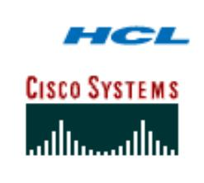

- Dec 2000 – Feb 2003

- Role: Team Member / Developer

Cisco systems is one of the world leaders in Networking products and network management software. My role as a developer and software engineer has been:

- Support AVMT CEMF (Access vision technologies, Cisco element management framework). Tasks involve writhing controllers using the CEMF framework and also design, manage and troubleshoot the component of the huge network management framework.

- Coding in C++ for design change of the newly designed polling engine for NMS

- Maintenance of raw Clearcase tools and wrappers and be an local support for the team in Clearcase

- Create automated build scripts and build error analysis scripts for daily check and integration

- Network tester for ATS EASY (Automated test system – a CISCO in-house tool for automation)

- Using rational purify and code coverage tools and also integrate them into build process.

- Writing scripts for checking performance and scalability of test framework

- Writing to comply with SEI CMM design documentation and keep them up-to-date

- Point of contact for team for both Solaris and Linux system expertise.

- Programming in C and perl for the RME (Resource manager essentials) plugin engines.

- Write and manage tcl/tk-expect scripts for the automation framework testing

- Supporting tech-support engineers with their customer issues with on-time bug fixing and resolution for critical issues.

- Configuring and managing cisco routers using IOS commands

- Web design/project home page for the group I was representing.

- Building testbeds with Cisco routers, access servers etc. and management using TACACS

- Created a test plans and simulated test failure scenarios for stress testing.

- Multi-user single test bed synchronization and maintenance scripts

Environment : Linux (Debian/RHEL ), Solaris

Team Size : 1

Language : shell, perl , C, Unix, C++, Expect, tcl/tk, C++

Tools : cvs, bugzilla, Clearcase, DDTS, ILOG API, AVMT, SNMP

Organization: Advanced Research Centre for Powder Metallurgy and New Materials(INDIA)


- Apr 1999 -Nov 2000.

- Role : Scientist

Advanced Research Centre for Powder Metallurgy and New Materials (ARCI) is an organization coming under department of science and technology Govt. of INDIA. The major work done in the organization is development of support materials for defense applications.

Major Responsibilities:
- Powder metallurgy:
Development of TiB₂ and AlN substrate materials, and research in the development of the same. This includes writing programs for extrapolation and interpolation of experimental data.

- Simulation of compound formation:

Development of program for determining intermediate compound formation and predicting the intermetallic/compound characteristics

- Data interpretation:

Simulation of high pressure and high temperature studies and statistical prediction of compound formation and intermediate compound sampling characteristics for tracking the end result.

Environment: Windows

Team size: 4 Along with the Joint Director who was also involved in the project. Language: Borland C++

Contact Details:
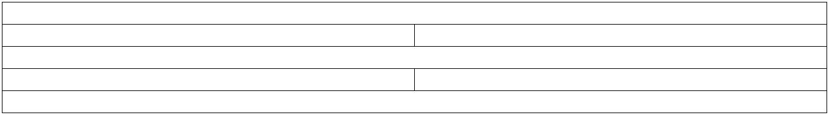

Phone MOBILE : +44 791 555 0458
Skype bhasker.linux
Contact Email: bcvj@unixindia.com
Work Endorsements LinkedIn (bhaskercv)
References Available on request

