
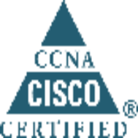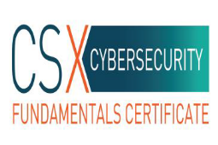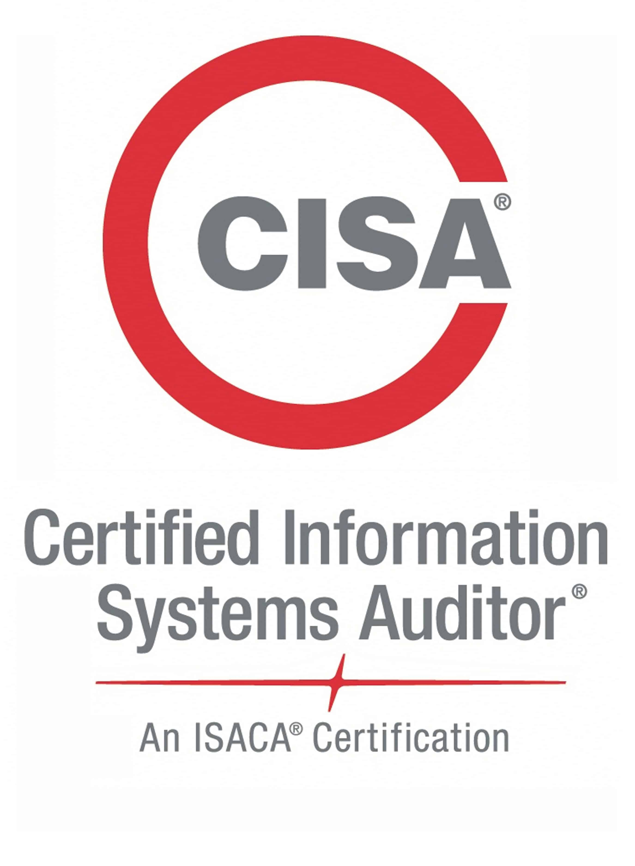
Rakesh Khaitan
+974-33069445
rakeshkhaitan@hotmail.com
https://www.linkedin.com/in/rakesh-khaitan-cisa-isaca-csxf-itil-mcse-ccna-85052213/

CISA , ISACA CSX Cybersecurity , MCSE, CCNA and ITIL Certified NOC & SOC Infrastructure Managed Security Services Engineer

SUMMARY OF QUALIFICATIONS:
IT NOC & SOC Infrastructure Managed Security Services Engineer seeking growth based on experience gained with market leader in Telecom and IT Managed Network Security & Infrastructure Operation and through skills in:

Network Support Operation Network Security
IT Infrastructure Managed Security Services Quality NOC & SOC Operation support
Technical Skills:
- SEIM Tools IBM Qradar (SEIM) ArcSight, Splunk, FireEye etc.
- Firewalls Juniper SRX Firewall, Fortigate, Paulo Alto, F5 (ASM, LTM,
- Ticketing Tools HPSM, CRM, Netrac and BMC Remedy.
- Service Monitoring Tools: HP Monitoring Suite, HPBSM, HP OpenView, Solar winds.
- Cisco: Routers (7200 series), Switches (3550,3750), ASA Firewall
Cisco Wireless Controller and Identity Service Engine (ISE)

EDUCATION:
- Master of Science (M.Sc.), Computer Science in 2005 with 67%.

Certification:
- CISA ( Certified Information System Auditor ) Certification Number: 18151239
- Certified IBM Security QRadar SIEM V7.2.6 Associate Analyst
- ISACA Certified CSXF Cybersecurity Fundamentals Certificate (Certification: 2018-1049581 – CSXF)
- Splunk Core Certified User
- ITIL Foundation.
- Cisco Certified Network Associate (CCNA) Cisco Id: CSCO10834502
- Microsoft Certified System Engineer (MCSE) MCSE Id: 3309616

CAREER EXPERIENCE:
Malomatia Q.S.C. (Doha,Qatar) Dec,2011 – Present
NOC & SOC Engineer L1 (IT Managed Network Security & Infrastructure Operation)

- Monitor client IP space tracking security events with internal application looking for suspicious activity.

- Monitoring and analyzing logs and alerts from a variety of different technologies (IDS/IPS, Firewall, Proxies, Anti-Virus, SIEM, etc…), across multiple platforms.

- Escalating and explaining security incidents.

- Monitor information security alerts though the use of SIEM to respond, triage, and escalate as needed.

- Participate in root cause analysis of critical events for improving preventative and reactive processes.

- Works with senior leadership to tune and maintain the SIEM (Security Information and Event Management) as needed; develop SIEM use cases to enhance monitoring capabilities.

- Proactive monitoring of security and network alerts in HP OpenView, HPBSM, HPArcSight, Splunck, IBM Qradar, Bluecoat Packet shapers and CRM , HPSM tickets and notifying and escalating to respective teams to make sure all alerts and tickets are resolved in defined SLA.

- First level trouble shooting on Cisco switches, cisco and juniper & Fortigate firewall, ASA Firewall, wireless controller, access point, F5 etc. Analyzing of security alert and events on various tool like Sourcefire, F5 and Bluecoat etc and blocking them. Experience with Nessus/Security Center, Wireshark, SIEM tool suite, HP Web Inspect, FireEye and HP ArcSight, Splunk and IBMQradar SEIM tools. Hands on experience in Infoblox and VPN 2FA etc.

- Preparing daily, weekly and Monthly incidents, security events and SLA Reports. Backup management, Data center management like inventory of devices and racks. Managing access to data center.

- Preparing team shift roaster and assignment of task list etc. Coordinating with other team to define
and review standard procedure for NOC & SOC environment as per client requirement. Along with
Supervisory role to manage team shift roaster, Defining NOC, SOC new processes and their standard
Documentation along with continuous process improvement.
- Experience in enhancing the monitoring tools and procedures to increase monitoring productivity and increase business and operation transparency.
- Strong hands-on experience on incident management.
- Experience in monitoring incidents volume, trends, major incidents, and generate daily, weekly, monthly incident reports
- Proven skills in managing a 24 X 7 NOC & SOC team
Avaya Inc. (Bangalore, India) Sep, 2008 – Nov, 2011 (3.2 yrs)
(USA based world’s largest Telecommunication product company)
Converged Network Management Engineer. (Managed Global NOC Operation)

- Proactive monitoring of alarms, creating and resolving tickets for Nortel Customers through OSS Tools like Netrac, Remedy Ticketing, Remedy Netkt, Alert, Remedy, Remedium and Iris etc for Nortel Customers within specified SLA in NOC Environment.

- Notifying and updating the customer on various issue. Resolving the issue remotely, Interacts with internal groups, assisting in the identification of root causes of problems (RCA).

- Handling Cisco routers and switches and Firewalls. EPABX System by NORTEL NETWORKS, Communication Server 1000 M, Communication Server 1000E ,Nortel Range of Voice switch/ACD Option 11c, 61c and 81c Enterprise. Coordinate with carriers like AT&T, Verizon, sprint etc. to resolve carrier related issues.

- Handling enterprise outages effectively and driving towards the resolution. Co-ordination of fault escalations in conjunction with the 1st level engineers providing high-level technical management of high priority or technically complex calls. Sending maintenance & outage notifications to the concerned team within specific time

- Acting as Duty Manager to overall smooth operation of shift and assigning work case to team.

- Monitoring over 99 customers globally with a rich variety of elements

- Working with vendors during circuit outages and getting RMA for Parts replacements and technician dispatch.

IBM Daksh (Bangalore, India) Nov, 2007 – August, 2008
Network Support Engineer
- Configuring Cisco 3550 and 3750 switches, Routers and Cisco PIX 515E Firewall, STP, VTP, VLAN, HSRP, LAN, WAN, Backup of Cisco devices, port Management -Enable and Disable ports on VLANS, Periodic backups of all VLAN Switches, Routers and Firewalls to TFTP Servers.

- Coordinate with counterparts to get small changes done on Firewalls like adding and removing ACLs and IP Addresses for Projects. Bandwidth and Cisco Device monitoring, generating Bandwidth Reports through Solar Winds, Solaris System. Visio design/diagramming skills.

- Monitoring of existing links, coordinating with vendors and WAN Team in case of link down and monitoring of Network Devices in Data Center. Raising tickets through HP Openview, incident management etc.

- Customer service; take ownership and manage all support cases via ticketing systems, provide regular updates to end users/requesters and close tickets within agreed timescales.

Bharti Airtel Limited (Jaipur, India) (On Adecco Payroll) May 2006 – March, 2007
(India’s biggest Telecommunication Company)
DSL Engineer – Network and Broadband Operation

- Administering the network of the company in the assigned territory and imparting technical support.
- Assuring the network’s performance through preventive & emergency maintenance services.
- Ensuring compliance with SLAs for response time and network uptime, for delivery of uninterrupted services to the customers.
- Installing, configuring and maintaining network equipment e.g. Routers & Switches, DSL Modem, Wi-Fi router of D-Link & Cisco, Broadband Connection, VPN and Static IP.
- Interacting with the customers’ technical team to resolve productivity and support related issues.
- Implementing and maintaining the systems and procedures for management of support operations.

PERSONAL INFORMATION:
- Date of Birth 15th August 1980
- Marital Status Married
- Language Known English, Hindi
- Passport detail K1167463 (Expiry: 2021)

Awards and Recognition:
- Awarded certificate of appreciation for Outstanding performance and contribution in IT managed Services Project for two consecutive years in 2014 and 2015.
- Captained school table Tennis team successfully.

Date:
(Rakesh Khaitan)
Place

