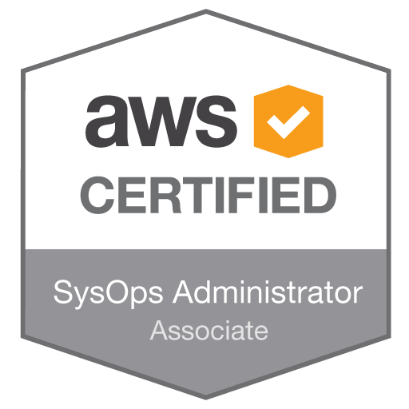
Hemalatha Srinivasan
hemasri.aws@gmail.com
Nationality: British
Mobile: +44 79 88 77 1009

Overview
Certified SAP Application Associate & AWS Solution Architect Professional from an ERP Testing background with deep expertise in managing wide range of Cloud Computing related tools & Technologies.

An effective team player & a quick learner with exceptional planning / execution skills coupled with a systematic approach and adaptability.

Key Skills: AWS Cloud Computing, Architecting in Cloud, SAP & ERP Testing.

Jan 2017 – till date : www.ekaspace.com : AWS Cloud Architect, Central and Eastern Europe

- As an AWS APN Partner in Central and Eastern Europe, providing Cloud expertise to large scale infrastructure, private and public cloud design, build & migration Projects
- Providing expert level knowledge to private and public cloud providers in the Eastern European region
- Designing Cloud Architecture keeping the well architected framework in mind and deploying dynamically scalable, highly available, fault tolerant, and reliable applications on AWS
- Selecting appropriate AWS services to design and deploy an application in line with the AWS best practices
- Migrating complex, multi-tier applications on AWS and performing Well Architected framework Review.
- Designing and deploying enterprise-wide scalable operations on AWS on Well Architected framework guidelines
- Implementing cost control strategies
- Estimating AWS usage costs and identifying operational cost control mechanisms
- Selecting the appropriate AWS service based on compute, data and particularly security requirements
- Providing exceptional technical design and thought leadership to Clients focused on migration to cloud.
- AWS presentations – White board, small and large group presentations
- Mentoring client technical architects in AWS Cloud Computing
- Providing thought leadership regarding AWS design, architecture, Security and integration to clients
- Application discovery, prioritization, and roadmap development for clients keeping cloud security focused.
- Making clients understand the AWS Cloud Adoption Framework
- Performing an effective TCO analysis for potential AWS Clients
- Application discovery, prioritization, and roadmap development for AWS clients
- Running hybrid architecture using metering, chargeback, and show back for AWS clients
- Identifying use cases, reference architectures, and best practices for enterprise deployments
- Providing cloud consulting to make client understand migration strategies, methodologies, and tools used
- Describing AWS use cases and solutions to clients

2013- 2016: Senior Software Tester - InfoTech Business Solutions Ltd, London, UK

- ANOVO the client provided after-sales support solutions for high-tech products – from their sale through to ownership model
- It partnered with operators, manufacturers and retailers and provided a full range of logistics, repair and regeneration solutions.
- help4mymobile is online application for O2 customer to self-service any technical issue faced by customer e.g.: software upgrade, tracking lost phone etc.
- Test case preparation and execution on various mobiles like Samsung SIII, Blackberry, Sony Ericson’s, HTC, Nokia etc.
- Test reports integrated with the various development teams.
- Worked closely with the development team to proactively understand the end solution thereby creating effective Test Cases.
- Managed the Test team of seven testers both functional and technical.

Professional: Academic:
AWS Certified Solution Architect Professional Post Graduate Diploma in in Strategic Carbon Management (UEA, Norwich Bus School)
AWS Certified Solution Architect Associate Diploma in Management Consultancy – (UEA, Norwich Bus School)
AWS Certified Sys Ops Administrator Associate M.Phil. - Master of Philosophy in English Literature - (University of Madras, India)
SAP Certified Application Associate –
(Financial Accounting with ERP 6.0 EHP6)
SAP Certified application Associate –
(Management Accounting (CO) with SAP ERP 6.0 EHP4)
ISTQB – ISEB Certified Tester Foundation Level

