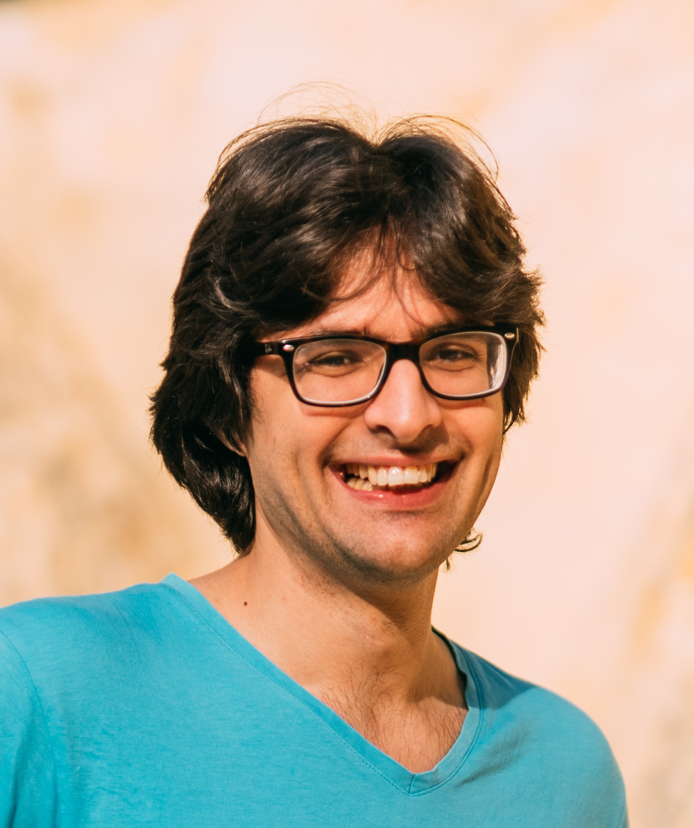
Dávid Gábor Bodor
E-mail: | david.gabor.bodor@gmail.com
Telephone: | +36 30 306 7283
GitHub: | http://www.github.com/dragonfi
LinkedIn: | https://www.linkedin.com/in/david-gabor-bodor
Website: | https://dragonfi.github.io

Language skills
Hungarian: | native language
English: | fluent (speaking, reading, writing)

Work experience
2020-2022: | Software Developer at Ericsson
Developing CI framework and tools mostly in Python, refactoring Erlang code
- Learning Erlang and Groovy within a month, producing production-quality code
- Introducing coverage metrics to already existing code base
2019-2020: | Software Developer at Craftunique
Developing slicer software for 3d printing.
- Extensive use of OpenGL, matrix math and geometry
2019: | Software Development Mentor at Green Fox Academy
Teaching software development to career changers in a boot-camp format
- 1-on-1 mentoring, presenting daily topic to class, improving teaching materials
- Held training for seasoned software developers on Git
2017-2018: | Software Engineer at NNG
Porting automotive navigation software to a wide range of embedded devices (Android, QNX, Linux, Windows CE).
- Writing an audio compatibility layer for a particularly quirky Linux device.
- Holding a 3+ month in-house Python training.
2015-2017: | Software Engineer at Balabit
Developing security application in Python and Scala. The application utilizes machine-learning to find potentially malicious activity in multiple streams of data, such as server and session logs, location data, etc.
- Working closely with data scientists on testing, implementing and optimizing certain algorithms.
2014-2015: | Python Developer as a Freelancer
 | Various small projects done remotely. Mostly in Python.
2012-2014: | Software Engineer at Nokia Solutions and Networks
 | Home Location Register (a mobile telecommunication server) development done mainly in C++, following agile practices like Scrum and Test Driven Development.

Volunteer experience
2015-2018: | Volunteer Mentor at Technológiai Oktatásért Alapítvány
 | Mentoring kids (8-18) as they learn the basics of programming in Skool, Kódgarázs and Kódklub projects.

Education
2009-2012: | Physicist Msc, Science University of Pécs
2006-2009: | Physics Bsc, Science University of Pécs

Skills and competencies
- Test Driven Development, Agile practices
- Linux, UNIX systems
- Python, Scala, Go, Clojure, C, C++
- Elm, JavaScript, HTML5, Django, Flask
- Git

Notable Gigs
2014: | Creating open-source plugins for edx-platform, a learning portal engine written in Django.
2011: | Remote work experience, created website http://www.manna.sk
2010: | Physics tutoring as a student at Science University of Pécs

Additional courses
2015: | edX 16.00x Introduction to Aerospace Engineering: Astronautics and Human Spaceflight
2012: | edX CS188.1x Artificial Intelligence course
2006: | European Computer Driving License
2005: | Computer Software Operator and Web Designer

