General information

Available landsat data

- Landsat 8 Operational Land Imager (OLI): April 2013 to present
- Landsat 7 Enhanced Thematic Mapper Plus (ETM+): July 1999 to present
- Landsat 5 Thematic Mapper (TM): March 1984 to May 2012
- Landsat 4 Thematic Mapper (TM): July 1982 to December 1993
- API for the Landsat data (https://espa.cr.usgs.gov/static/docs/api-readme.html)
- USGS Landsat archive: L1T products are systematically corrected for radiometric, geometric, and terrain distortions
- Preference for Landsat-5 over Landsat-7 for best available pixel analysis (details below, White et al., 2014)

Normalised Burn Ratio (NBR) for LandSat timeseries analysis

Definition of burn severity can be found in this paper (Key & Benson, 2005), advocating for NBR is used for land cover change:
The index we developed is called the Normalized Burn Ratio (NBR). It is similar in construct to another standard index, called the Normalized Difference Vegetation Index (NDVI). The primary difference is that NBR integrates the two Landsat bands that respond most, but in opposite ways to burning. Those were determined to be TM/ETM+ Band 4 and Band 7. The NBR is calculated as follows:
NBR = (R4-R7) / (R4+R7)
where R values are the calculated per pixel “at satellite” reflectance quantities per band, which have been corrected for atmospheric transmittance. Based on experience in generally forested ecosystems of the Western United States, R4 decreases while R7 increases from prefire to postfire TM/ETM+ acquisitions. The change is greatest in magnitude compared to other bands, and the variance within burns is greatest for R7. The combination of those traits appears to provide the best distinction between burned and unburned areas. It also provides an optimum signal, over other Landsat band combinations, for information about variation of burn severity found within the burn.
To isolate burned from unburned areas and to provide a quantitative measure of change, the NBR dataset derived after burning is subtracted from the NBR dataset obtained from before burning, such that:
dNBR = NBRprefire – NBR
postfire This measured change in NBR, delta NBR, or dNBR, is hypothesized to be correlative in magnitude to the environmental change caused by fire.
NBR2 as an alternative to NBR (USGS.gov)
NBR2 modifies the Normalized Burn Ratio (NBR) to highlight water sensitivity in vegetation and may be useful in post-fire recovery studies. NBR2 is calculated as a ratio between the SWIR values, substituting the SWIR1 band for the NIR band used in NBR.

NBR2 = (SWIR1 – SWIR2) / (SWIR1 + SWIR2)
In Landsat 4-7 NBR2 = (Band 5 – Band 7) / (Band 5 + Band 7)
In Landsat 8 NBR2 = (Band 6 – Band 7) / (Band 6 + Band 7)

If I understand correctly they provide rasters with calculated NBR2 (LC8NBR2, LE7NBR2, LT5NBR2, or LT4NBR2), but otherwise the procedure can be done starting from Sentinel 4-5 data (1984).

Pre-processing of Landsat data

A ) Cloud & Shadow:
Fmask is an object-based algorithm designed to identify clouds and cloud shadows, as well as clear land and water pixels, snow, and areas of no data (Zhu and Woodcock 2012). Fmask is run on 30 m aggregated TOA reflectance. Detailed method: https://www.l3harrisgeospatial.com/docs/calculatecloudmaskusingfmask.html
B) Surface reflectance correction:
The Landsat Ecosystem Disturbance Adaptive System (LEDAPS; Schmidt et al. 2013) is used to generate surface reflectance values. LEDAPS produces top-of-atmosphere (TOA) reflectance from Landsat TM and ETM+ digital numbers (DN) and applies atmospheric corrections to generate a surface reflectance product. LEDAPS applies the dark dense vegetation method of Kaufman et al. (1997) to estimate aerosol optical thickness (AOT) directly from the imagery and the AOT is one of the inputs used in the 6S radiative transfer model (Ju et al. 2012). The LEDAPS surface reflectance output includes an AOT map derived from the Landsat TM or ETM+ blue band (Masek et al. 2006), commonly referred to as opacity.
New standard LaSCR instead of LEDAPS?
LaSRC is based on the 6S radiative transfer model and a heritage from the MODIS MCD09 products (Vermote and Kotchenova 2008) as well as the earlier LEDAPS algorithm implemented for Landsat-5 and Landsat-7 (Masek et al. 2006).

Timeseries analysis for Landsat imagery
The process is a stepwise approach, introducing recent methods (pixel based compositing) to achieve the most up to date analysis of landsat information.
Pixel-based image compositing approaches constitute a new para-digm in image processing, emerging as result of the opening of theLandsat archive. Commonto the pixel-based image compositing approaches is the selection of BAP (A) from a set of images subject to multiple criteria. Higher scores are assigned to those pixels with more desirable conditions. Those pixels with the highest scores are included in subsequent composite development. Composite2Change procedure (B) to fill pixel gaps based on temporal trends.
A) Best available pixel analysis (BAP, White et al., 2014)
Four scores were calculated for each pixel. Sensor and DOY score were calculated at the image level (i.e., all pixels within the image receive the same score), whilst the cloud/cloud shadow and opacity scores were unique to each pixel.
- sensor score
In order to give preference to images captured by the Landsat TM (Landsat 5!) sensor and mitigate the impact of spatial gaps associated with Landsat 7 ETM+ SLC-off data, a sensor score is assigned to the pixels in each image acquired after May 31, 2003 as follows: pixels from Landsat TM images were assigned a score of 1; pixels in Landsat ETM+ images were assigned a score of 0.5. Pre-2003, both sensors received a score of 1.
- day of year score
A target DOY of August 1 (Julian day 213) was selected for its likelihood of being within the growing season. The date range for candidate images was further restricted to ±30 days A DOY score was assigned to all pixels in an image as per Griffiths et al. (2013):
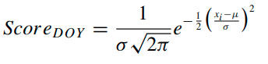

where μ and σ denote the mean and standard deviation respectively of all the image DOYs, and xi is the DOY for the image being assessed. In our processing, μ was forced to our target DOY (August 1 or Julian day 213) and the standard deviation was set to 38 by examining the distribution of DOYs for all candidate images in the two prototype regions. The DOY score is scaled to a value between 0 and 1 by dividing by the maximum score.
- distance to cloud or cloud shadow score
Using the outputs from Fmask, a distance to cloud or cloud shadow score is assigned, whereby pixels identified as clouds or cloud shadows are assigned “no data” value and any pixel located at a distance greater than 50 pixels from an identified cloud or cloud shadow pixel is assigned a score of 1. Pixels that are not identified as clouds or cloud shadows and that are less than 50 pixels away from clouds and cloud shadows are assigned a score between 0 and 1 using Equation (2) as per Griffiths et al. (2013):
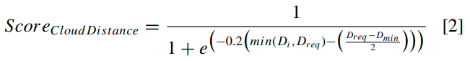

where Di is the pixel’s distance to cloud or cloud shadow, Dreq is the minimum required distance (i.e., 50 pixels), and Dmin is the minimum distance of the given pixel observations (i.e., 0 pixels).

- opacity score
In general, opacity values less than 0.1 are considered clear, opacity values between 0.1 and 0.3 are average, and opacity values greater than 0.3 are considered hazy2 . Since hazy images can confound the generation of quality image composites, an opacity score was calculated using the atmospheric opacity band output by LEDAPS. Pixels with an opacity value < 0.2 were assigned a score of 1 and pixels with an opacity value > 0.3 were labelled as “no data”. Pixels with opacity values ≥ 0.2 and < 0.3 were assigned a score between 0 and 1 using Equation (3).
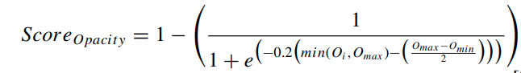

where Oi is the pixel’s opacity value, Omax is the maximum opacity value (i.e., 0.3), and Omin is the minimum opacity value (i.e., 0.2).

Results for BAP study in Canada (J. C. White et al., 2014, p. 201)
Approximately 17% of pixels do not have BAP observations within ± 30 days of our target DOY; however, if the date range is expanded to ± 45 days, then only 4% of pixels have no BAP observations. For the annual image composites in Saskatchewan, 29% of pixels had observations from within ± 30 days of August 1 for all 15 years considered, whilst 74% of pixels have 13 or more years of observations within the target date range. All pixels in Saskatchewan had at least seven years of observations within the target date range (Figure 6a). Approximately 86% of pixels in Saskatchewan have no consecutive years of missing data
When cloud cover exceeds 70%, images are difficult to geometrically correct due to obscured ground control points (White and Wulder 2013).
A master list of all candidate images for the area of interest is compiled, list is used as a look-up table (LUT) to track the source image that is used for each pixel in order to support the development of image composites.

In addition to a day-of-year rule, rules may also constrain observations according to sensor (e.g., preference for Landsat-5 over Landsat-7), distance to cloud and cloud shadows, and atmospheric opacity (to reduce the impact of haze)
Proxy value composites are annual BAP composites where “no data” pixels are populated using a time series of annual BAP composites to determine proxy values. Likewise, pixels with anomalous values—those that exceed a pre-defined range of expectation or which have opacity values indicative of hazy imagery—may also be assigned a proxy value. In essence, the objective of the proxy value composite is to assign the most similar value in time and space to a pixel that either has “no data” or has an anomalous value.

A master list of all candidate images for the area of interest is compiled, list is used as a look-up table (LUT) to track the source image that is used for each pixel in order to support the development of image composites.
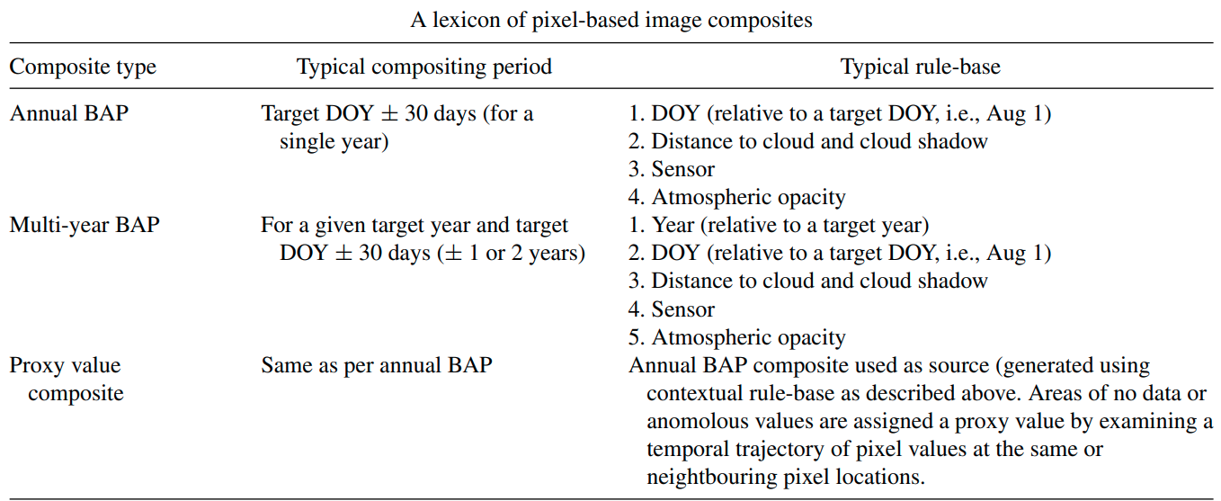

B) Filling gaps in BAP with breakpoint analysis (Hermosilla et al., 2015b) Composite2Change
Characterisation of trends in pixel series. A breakpoint represents a change in the temporal development of a pixel's values through time. Robust identification of breakpoints enablesthe assignment offinal proxy values to pixels with missing observations, as well as enabling change events, and the year in which theevent occurred, to be correctly identified. The breakpoint detection pro-cess is performed over the Normalized Burn Ratio (NBR) (Key & Benson,2006) pixel series, which has been demonstrated as sensitive and con-sistent for the retrieval of disturbance events over forest environments(Kennedy et al., 2010). Breakpoints were detected using a variation of the bottom-upalgorithm proposed by (Keogh et al., 2001). This process is composed of four main steps:
- Initially n−1 segments are created in a pixel series composed of n values
- Cost in terms of root-mean-square error (RMSE) of merging eachpair of adjacent segments is computed
- The pair of segments with the lowest cost is merged
- The cost is recomputed for the new segments, and the process is iterated until certain stopping criteria are fulfilled.
Two stopping criteria are used, which are required prior to calculation: the maximum number of segments and the maximum merging cost allowed. During the iteration process the maximum merging costvalue can be dynamically adapted to enforce the algorithm to meetthe maximum number of segments requirement. The maximum num-ber of segments was set to 5, and the maximum merging cost 0.125.An absolute maximum merging cost was chosen to avoid challenges of defining costs relative to the time series values as discussed by Kennedy et al. (2010).

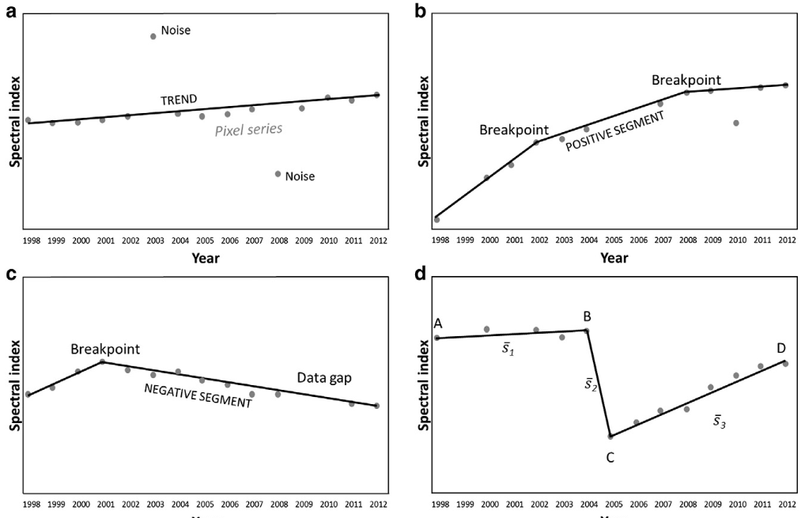

Graphical depiction of trends computed from the pixel-series and their components: (a) monotonic, (b) multiple breakpoints all with positive slopes, (c) single-breakpoint; and (d) multiple-breakpoint (at least one negative trend, adapted from Pflugmacher et al., 2013)
- Once breakpoints (temporal) have been identified us contextual analysis for spatial correlation
The pre-infill process of data gaps may result in spatially discordant disturbance events labeled with an incorrect year for change. If we consider discrete events, such as a wildfire, the information need is to ensure that these change events are allocated to the correct year. It is assumed that if a change event is detected in a year with no or few data gaps, and the previous and subsequent years also have no or few data gaps, then the change event has been labeled with the correct year. We rank the reliability change detection based on data absence where the chances of correctly predicting the year of a change event is inversely related to the number of years of missing data in the pixel's trajectory. Thus, change detection reliability is ranked according to data availability in the years before, during, and after the change event
Detected change events are spatially aggregated into pixel segments based on their date of occurrence and duration (i.e., persistence). Seg-ments missing less than 50% of observations in a given year–before,during and after the change event–are deemed reliable and attributedwith their date of occurrence. Segments that are missing more than 50%of observations in any of the considered years are ranked less reliable.Lower-ranked segments that are spatially-adjacent (eighth-connectedneighborhood) to a higher-ranked segment within ±one year areattributed the year of occurrence of the more reliable neighbor. In addi-tion, during this process, change events that have a size less than theminimum mappingunit (MMU) are removed. The MMU size was deter-mined to support the information needs of Canada National ForestInventory (0.5 ha)
Final infill of data gaps and generation of proxy image composites
Assignment of final proxy values to pixels with no observations. These proxy values are computed using a piecewise linear interpolation from the temporal segments, in which breakpoints and trends have been identified and characterized,as follows
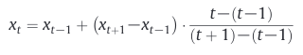

wherextis the proxy value assigned to a pixels with no observation atthe yeart,andxt−1andxt+1are the spectral values in years withobservations before (t−1)andafter(t+1), respectively. Proxy valuesto pixels located in the extremes of the temporal segments are com-puted using linear extrapolation, as indicated:
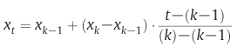

where xk and xk − 1 are the spectral values of the two nearest years, k and k−1, with observations. As result, the proxy value assigned to a data gap is uniquely a function of the spectral values of the temporal segment where the gap is located. Thereby, combining informationfrom the different trend components can be avoided, preserving sothe change events in the temporal series.
Accuracy Assessment and results
To assess the impact of our proxy value assignment process, werandomly selected 0.005% (116,000), pixels (from all cover types) thathad valid pixel observations from each annual composite. We maskedandflagged these pixels as“no data”, thereby generating syntheticgaps, and applied our full protocol as described above.
Overall, our results indicate strong agreement between the assigned proxy values and the reference data (R=0.71–0.91, RMSE = 0.008–0.025). Agreement was stronger for pixel series with no change events (R = 0.73–0.92, RMSE = 0.007–0.024), relative to pixel series with change events (R = 0.63–0.87, RMSE = 0.010–0.029). The generated change metrics, derived via temporal and spatialanalysis of the annual BAP composites, were an important precursor to the generation of valid proxy values,and–importantly–provide valuable information for the further assessment and understanding of land coverand land cover change

Analysis based on BAP (A) and Composte2Change (B) (Hermosilla et al., 2015a)
Set of spectral metrics are computed for selected bandsand indices: average of the spectral values of the objects before thechange event, average and standard deviation after the change event,and range, average and standard deviation of the values of the pixelseries for the spectral bands 3, 4, 5, and 7, and for the indices NBR, and Brightness, Greenness and Wetness components from the TasseledCap (Crist, 1985; Healey, Cohen, Zhiqiang, & Krankina, 2005)

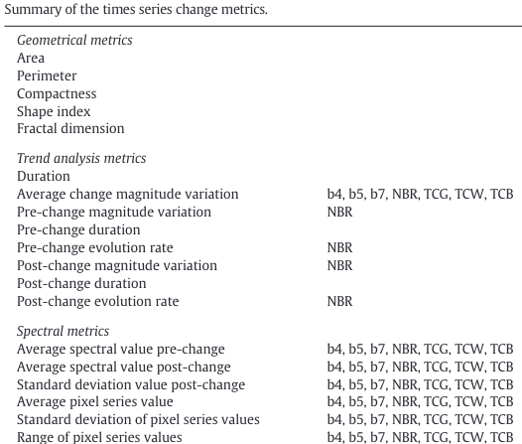
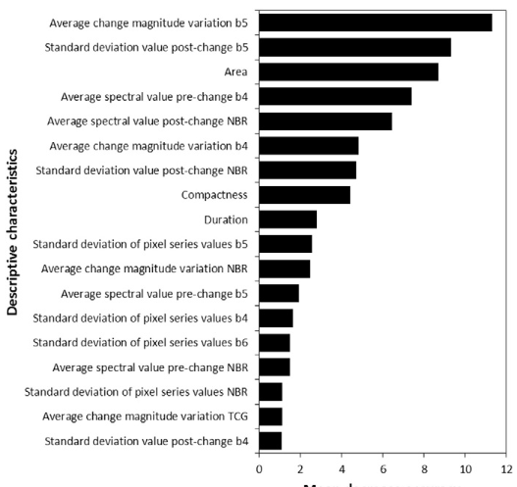

Method for entire Canada (Hermosilla et al., 2016):

The annual image composites were created by considering as candidate images all available Landsat Thematic Mapper (TM) and Enhanced Thematic Mapper Plus (ETM+) images (more than 81,000) from the 1285 scenes (path/rows) of the Landsat Worldwide Referencing System (WRS2) in the USGS archive that covered at least part of the terrestrial area of Canada, had less than 70% cloud cover, and were acquired within a date range defined as 1 August ± 30 days from 1984 to 2012. The date 1 August (Julian day 213) was designated as the central target acquisition date due to its correspondence with the growing season for the majority of Canada’s terrestrial area.

All candidate images were downloaded from the archive as Level-1 Terrain-Corrected (L1T) products. Then we produced atmospherically corrected surface reflectance values for the six Landsat optical bands (bands 1–5, 7) using the Landsat Ecosystem Disturbance Adaptive Processing System (LEDAPS) algorithm.

Clouds, related shadows, and other unwanted atmospheric elements are detected and masked using the Fmask algorithm (has been updated by Zhu and Woodcock (2014) by additionally considering the temporal information in the cloud detection). Fmask outputs were also used to define a water mask, which enabled the exclusion of water bodies from further analysis (Lunetta et al. 2004).

Change detection overall accuracy was 89%. Change attribution overall accuracy was 92%, with higher accuracy for standreplacing wildfire and harvest. Changes were assigned to the correct year with an accuracy of 89%.

Forest regeneration after logging and wildfire (White et al., 2017)
National trends in forest disturbance and recovery by disturbance type (1985–2010)
57.5 Mha of Canada's forests were disturbed by wildfire (71%) and harvest (29%).
First national spatially-explicit map of harvesting in Canada at a 30 m resolution
Greater variability in annual area disturbed by wildfire compared to harvest
Spectral recovery metrics indicate that vegetation returns following disturbance.

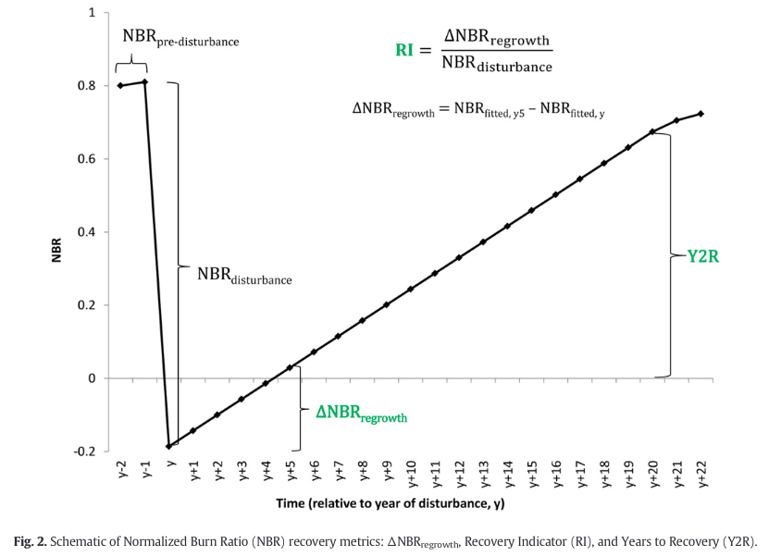

(Bolton et al., 2020)
Landsat time series predictors and information of disturbance eventsfrom 1984 to 2016 were obtained from gap-free Landsat composites,created using the Composite2Change (C2C). Specifically, summer image composites (August1 ± 30 days) were created through a best available pixel (BAP) selection process which accounted for distance to clouds, atmospheric con-tamination, as well as acquisition sensor (seeWhite et al., 2014bfordetails).

Spectral indices (bold performed best):
Tasseled Cap Brightness (TCB), Greenness (TCG),Wetness (TCW), and the normalized burn ratio (NBR) (Crist, 1985; Keyand Benson, 2006, 1999).

Brightness: b1*0.3029+b2*0.2786+b3*0.4733+b4*0.5599+b5*0.508+b6*0.1872
Greenness: b1*(-0.2941)+b2*(-0.243)+b3*(-0.5424)+b4*0.7276+b5*0.0713+b6*(-0.1608)
Wetness: b1*0.1511+b2*0.1973+b3*0.3283+b4*0.3407+b5*(-0.7117)+b6*(-0.4559)

The new Coastal Blue band 1 of the OLI sensor is not used in these transforms. Negative values must be enclosed in parenthesis (https://yceo.yale.edu/tasseled-cap-transform-landsat-8-oli)

Satellite-based time series land cover and change information for mapping forest area (Wulder et al., 2020)

Annual time series of gap-free, surface reflectance composites and the detection, delineation and characterization of annual forest changes Detected forest changes were attributed to a change type (i.e. fire, harvest, road and non-stand-replacing disturbance) following a random forest classification model based on their spectral, geometrical and temporal characteristics (Hermosilla et al., 2015b)

To avoid potential noisy information at boundaries, samples are 45 m away from polygon boundaries.This figure appears in colour in the online version of Forestry. In other words: samples only taken further within the polygon

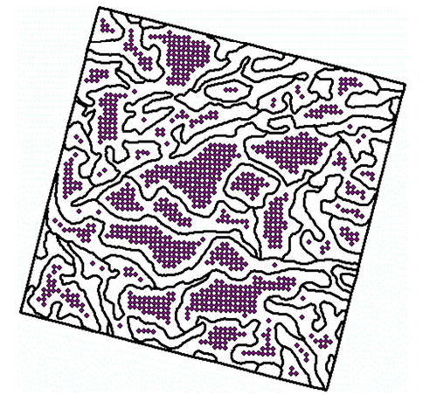

Bolton, D. K., Tompalski, P., Coops, N. C., White, J. C., Wulder, M. A., Hermosilla, T., Queinnec, M., Luther, J. E., van Lier, O. R., Fournier, R. A., Woods, M., Treitz, P. M., van Ewijk, K. Y., Graham, G., & Quist, L. (2020). Optimizing Landsat time series length for regional mapping of lidar-derived forest structure. Remote Sensing of Environment, 239, 111645. https://doi.org/10.1016/j.rse.2020.111645
Hermosilla, T., Wulder, M. A., White, J. C., Coops, N. C., & Hobart, G. W. (2015a). Regional detection, characterization, and attribution of annual forest change from 1984 to 2012 using Landsat-derived time-series metrics. Remote Sensing of Environment, 170, 121–132. https://doi.org/10.1016/j.rse.2015.09.004
Hermosilla, T., Wulder, M. A., White, J. C., Coops, N. C., Hobart, G. W., & Campbell, L. B. (2016). Mass data processing of time series Landsat imagery: Pixels to data products for forest monitoring. International Journal of Digital Earth, 9(11), 1035–1054. https://doi.org/10.1080/17538947.2016.1187673
Hermosilla, T., Wulder, M., White, J., Coops, N., & Hobart, G. (2015b). An integrated Landsat time series protocol for change detection and generation of annual gap-free surface reflectance composites. Remote Sensing of Environment, 158, 220–234. https://doi.org/10.1016/j.rse.2014.11.005
Key, C., & Benson, N. (2005). Landscape Assessment (LA) Sampling and Analysis Methods (p. LA 1-51).
White, J. C., Wulder, M. A., Hobart, G. W., Luther, J. E., Hermosilla, T., Griffiths, P., Coops, N. C., Hall, R. J., Hostert, P., Dyk, A., & Guindon, L. (2014). Pixel-Based Image Compositing for Large-Area Dense Time Series Applications and Science. Canadian Journal of Remote Sensing, 40(3), 192–212. https://doi.org/10.1080/07038992.2014.945827
White, Joanne C., Wulder, M. A., Hermosilla, T., Coops, N. C., & Hobart, G. W. (2017). A nationwide annual characterization of 25years of forest disturbance and recovery for Canada using Landsat time series. Remote Sensing of Environment, 194, 303–321. https://doi.org/10.1016/j.rse.2017.03.035
Wulder, M. A., Hermosilla, T., Stinson, G., Gougeon, F. A., White, J. C., Hill, D. A., & Smiley, B. P. (2020). Satellite-based time series land cover and change information to map forest area consistent with national and international reporting requirements. Forestry: An International Journal of Forest Research, 93(3), 331–343. https://doi.org/10.1093/forestry/cpaa006

