Overview methods

The proof of concept contains 3 datasets (vegetation classification, canopy height model, sentinel-2 derived NDVI).

Our initial test region has been anchored North of Lake Tahoe where we accessed a Sentinel-2 imagery for the 9th of May 18:49 (UTC). Within this imagery we downloaded a subset of the 2014 LiDAR dataset from the national center for airborne laser mapping (NCALM) with 5 - 35 cm (8.93 pts/m²) accuracy from a publicly available source. (OpenTopography, 2014). The dataset provides pre-calculated digital terrain model (DTM), digital surface model (DSM) and derived canopy height model (CHM). In the future we will adopt Scott Conway”s workflows to achieve this from the LiDAR point cloud. Additionally we incorporated a rasterized version of the fire returnal interval departure (FRID 2019) dataset which contains 34 dominant vegetation classes from the CALVEG. All the datasets are projected into California Albers (EPSG:3310) and raster alignment is checked. We then calculate the normalised difference vegetation index (NVDI) from Sentinel-2 bands (NIR & Red, 10 m). For the 1 m² canopy height model we calculate the mean tree height for the extend of the Seninel-2 area. We then use the CHM to train the and using a linear correlation between the mean canopy height and the NDVI values calculated from the Sentinel-2 bands. The upscaling process predicts mean canopy height outside the area of LiDAR availability.

The detailed worfklow to extract, rasterize and align the datasets can be found in the repo (vp-csm/test-LakeTahoe).

We agreed on a 10 m resolution upscaling since the majority of our datasets will be available in this resolution and only a few bands (e.g. Sentinel-2 red edge, shortwave infrared)

The inital model uses a 2014 LiDAR dataset from the national center for airborne laser mapping (NCALM) with 5 - 35 cm accuracy from the Lake Tahoe National Forest. We downloaded the derived Canopy Height model derived from DSM and DTM. T

https://portal.opentopography.org/datasetMetadata?otCollectionID=OT.032017.26910.2

Our final model is expected to use 20+ vegetation indices derived from Sentinel-2 bands, LiDAR derived metrics, Landsat timeseries information

Sentinel-2 data

- Sentinel data offers complete coverage of the area with a 5 day revisit time
- Sentinel-2 derived vegetation indices can be used to to correlate with above-ground forest biomass (AGB, 10-20 m resolution)
- cloud obstructions, coverage since 2015-2016, 2017 datasets have been post-cleaned by ESA, from 2018 onwards clean uploads
- saturation effects for Sentinel-2 and Landsat imagery for forest areas with 150 t / ha

LiDAR

- current LiDAR availability from the opentopo DB, patchwork from multiple years (starting from 2010)
- useful to derive vegetation metrics from point cloud (height, intensity, density, canopy volume)
- some datasets provide canopy height model (CHM), Scott has workflows available to generate, alternative derive own best protocol (Zhao et al., 2016)
- gold standard for AGB estimations,
- for delineating individual trees CHM resolutions > 1 m are required (Van Kane, April meeting)

Vegetation classification

For the initial proof of concept we use a downscaled version of the extensive Classification and Assessment with Landsat of Visible Ecological Groupings database (CALVEG) which summarizes a total of 32 vegetation classes for the entire state. For now the FRID dataset will be used to discriminate forested areas and non-vegetated surfaces (urban, lakes). In a later stage of the model the CALVEG database will serve as another predictor.

- currently using the fire return interval departure dataset (FRID) contains records for historic fires
- EVEG layer is a patchwork from 20+ years of vegetation mapping with careful literature research and field verification (CALVEG)

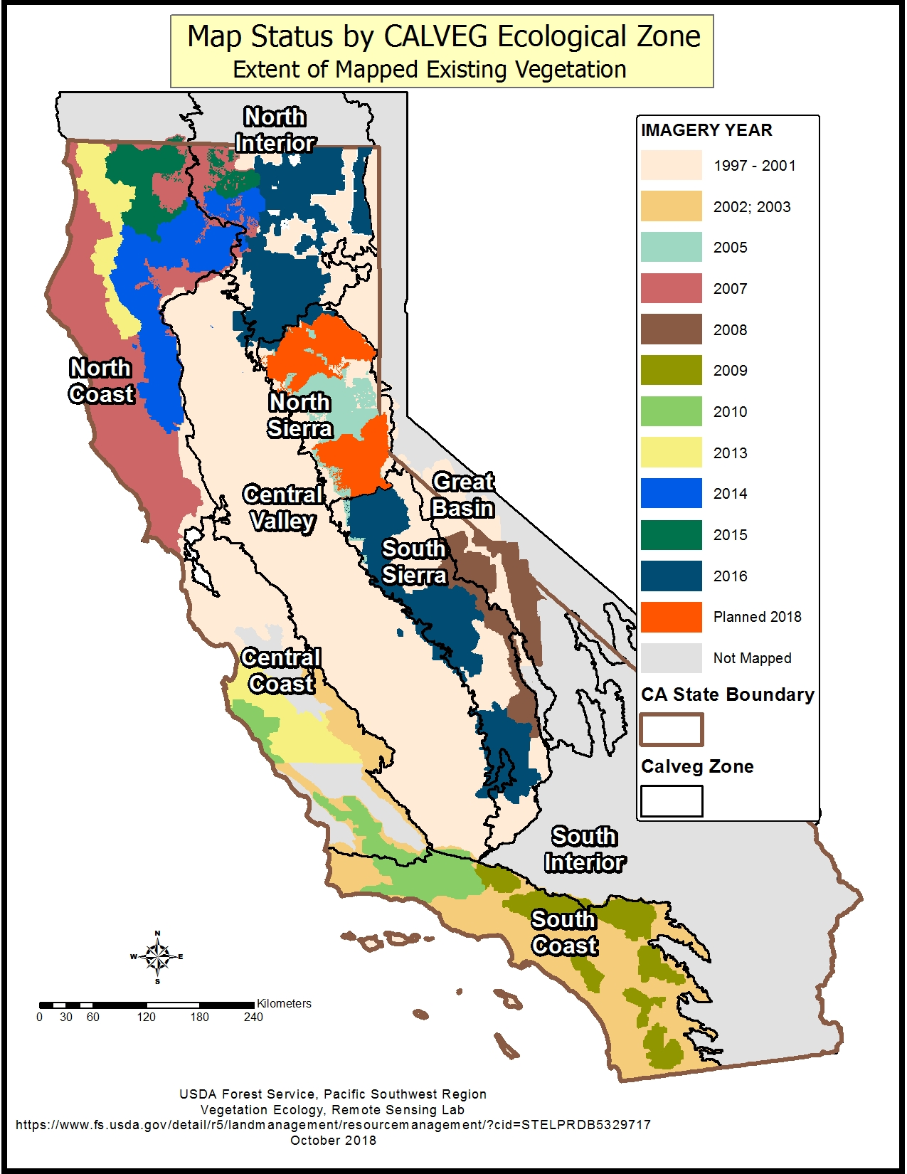

Field data (FIA plots)

The field plots are required in order to indicate the accuracy of our predictions in areas outside of LiDAR avaiability and to verify the accuracy of CHM created. At this stage it is unclear if we receive the exact plot locations within the framework of this project, alternatively we could artificially create gaps in in the LiDAR plots and verify our predications. Apart from the verification of the CHM the field plot could also be a useful reference to indicate vegetation change within the CALVEG database.

- vegetation type, DBH, coarse size classes, date, triangle structure with 4 circular macroplots
- AGB calculations via allometric calculations (Brown et al., 1989; Lehtonen et al., 2004; Wang et al., 2011)
- explore AGB estimates via Fire and Fuels Extension (FFE) of the Forest Vegetation Simulator (FVS) (Rebain 2015, Dixon 2018). Kane used this metholodgy in a recent paper (Hudak et al., 2020)
- problematic will be the training of Sentinel-2 and Landsat pixels with FIA plots since the circular layout does overlap with multiple pixels, plus the location of the three outside macroplots is not georeferenced
- coarse height classes > 8 m make it necessary to infer biomass from DBH and vegetation type

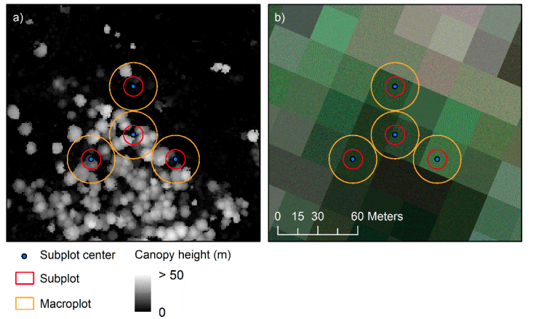

FIA sampling plot layout. a) generated canopy height model from LiDAR and b) landsat 30m
imagery overlay (taken from Hudak et al., 2020)

Landsat data (mainly thematic mapper (TM)

The overall aim for the landsat data is to make use of the temporal resolution of the dataset. Pixel based image compositing constitutes state of the art approach.
By calculating NBR, tasseled wetness XXX

- cleaning from clouds and atmospheric distortion (Fmask, LEDAPS)
- filling gaps with best practice approach to achieve a gap-free Landsat image for every year
  - Best available pixel (BAP, White et al., 2014) selection based on four criteria (sensor selection, day of the year, cloud cover, opacity)
  - Filling gaps in the landsat imagery with a breakpoint detection procedure for temporal trends in individual pixels referred to as Composite2Change (C2C, (Hermosilla et al., 2015). Consecutively the accuracy is verified by a contextual analysis (spatial, surrounding pixels)
- Normalised Burn Ratio (NBR, (Key & Benson, 2005) derived from shortwave infrared bands (SWIR) will serve as an ideal reference indice to assess forest disturbance (Kennedy et al., 2010)
- breakpoint detection in C2C and
- Forest regeneration after logging and wildfire events using NBR (White et al., 2017)

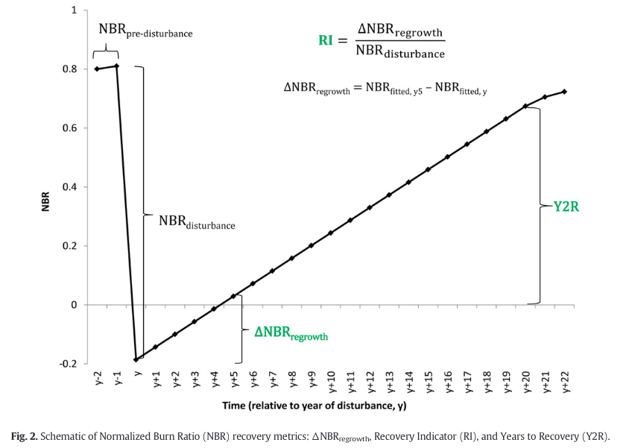

The output will aid us in predicting biomass regeneration of burned areas (30 m). It will allow us to label forest types (from calveg) with their expected timespan to recover to a pre-fire state. This will be an important indicator to estimate the severity of the fire damage and aid us in estimating aboveground biomass where post-fire LiDAR information is unavailable.

https://cloud.sdsc.edu/v1/AUTH_opentopography/www/metadata/2014_TNF_Guo_Metadata.pdf

Upscaling

- Train LiDAR datasets with field plot information and consecutively train Sentinel-2 pixel with LiDAR information. (point-line-polygon approach, Dezhi et al., 2020)
- Machine learning to select vegetation indices, LiDAR metrics, vegetation classification, forest regeneration and timeseries derived info for post-disturbance data
- Random forest has been widely used in biomass estimations (Ghosh and Behera, 2018; Huang et al., 2019; Matasci et al., 2018; Pham and Brabyn, 2017), but we will expore other options to rank prediction power of selected parameters

Water balance metrics refers to “availability of energy and water to support plant growth.” It is based on actual evapotranspiration (AET) and climatic water deficit (CWD) and it provides a climatic signature for each feature. The water balance metric can help in predicting fire and forest structure patterns (Kane et al. 2015)

Adding ref
- Vegetation Simulator (FVS) (Rebain 2015, Dixon 2018)
- (Hurtt et al., 2019)
- (Zhao et al., 2016)

Ghosh and Behera, 2018; Huang et al., 2019; Matasci et al., 2018; Pham and Brabyn, 2017).

Things to consider:

- To avoid noise effect at forest boundaries only samples 45 m within forest polygons (within calveg polygons) are considered (Wulder et al., 2020)
- Evaluate the potential of Landsat to study fire history (FRID dataset potential alternative ?)
- adding climate data to improve forest regeneration prediction by calculate carbon assimilation rate and transpiration (2 m air temperature, dew point, downward solar radiation, precipitation, soil temperature) (Hurtt et al., 2019)
- EcObject layers as additional CHM information being fed into object

Brown, S., Gillespie, A. J. R., & Lugo, A. E. (1989). Biomass Estimation Methods for Tropical Forests with Applications to Forest Inventory Data. Forest Science, 35(4), 881–902. https://doi.org/10.1093/forestscience/35.4.881
Dezhi, W., Wan, B., Liu, J., Su, Y., Guo, Q., Qiu, P., & Wu, X. (2020). Estimating aboveground biomass of the mangrove forests on northeast Hainan Island in China using an upscaling method from field plots, UAV-LiDAR data and Sentinel-2 imagery. International Journal of Applied Earth Observation and Geoinformation, 85, 101986. https://doi.org/10.1016/j.jag.2019.101986
Hermosilla, T., Wulder, M., White, J., Coops, N., & Hobart, G. (2015). An integrated Landsat time series protocol for change detection and generation of annual gap-free surface reflectance composites. Remote Sensing of Environment, 158, 220–234. https://doi.org/10.1016/j.rse.2014.11.005
Hudak, A. T., Fekety, P. A., Kane, V. R., Kennedy, R. E., Filippelli, S. K., Falkowski, M. J., Tinkham, W. T., Smith, A. M. S., Crookston, N. L., Domke, G. M., Corrao, M. V., Bright, B. C., Churchill, D. J., Gould, P. J., McGaughey, R. J., Kane, J. T., & Dong, J. (2020). A carbon monitoring system for mapping regional, annual aboveground biomass across the northwestern USA. Environmental Research Letters, 15(9), 095003. https://doi.org/10.1088/1748-9326/ab93f9
Hurtt, G., Zhao, M., Sahajpal, R., Armstrong, A., Birdsey, R., Campbell, E., Dolan, K., Dubayah, R., Fisk, J. P., Flanagan, S., Huang, C., Huang, W., Johnson, K., Lamb, R., Ma, L., Marks, R., O’Leary, D., O’Neil-Dunne, J., Swatantran, A., & Tang, H. (2019). Beyond MRV: High-resolution forest carbon modeling for climate mitigation planning over Maryland, USA. Environmental Research Letters, 14(4), 045013. https://doi.org/10.1088/1748-9326/ab0bbe
Kennedy, R. E., Yang, Z., & Cohen, W. B. (2010). Detecting trends in forest disturbance and recovery using yearly Landsat time series: 1. LandTrendr — Temporal segmentation algorithms. Remote Sensing of Environment, 114(12), 2897–2910. https://doi.org/10.1016/j.rse.2010.07.008
Key, C., & Benson, N. (2005). Landscape Assessment (LA) Sampling and Analysis Methods (p. LA 1-51).
Lehtonen, A., Mäkipää, R., Heikkinen, J., Sievänen, R., & Liski, J. (2004). Biomass expansion factors (BEFs) for Scots pine, Norway spruce and birch according to stand age for boreal forests. Forest Ecology and Management, 188, 211–224. https://doi.org/10.1016/j.foreco.2003.07.008
OpenTopography. (2014). USFS Tahoe National Forest Lidar. https://portal.opentopography.org/datasetMetadata?otCollectionID=OT.032017.26910.2
Wang, G., Zhang, M., Gertner, G. Z., Oyana, T., McRoberts, R. E., & Ge, H. (2011). Uncertainties of mapping aboveground forest carbon due to plot locations using national forest inventory plot and remotely sensed data. Scandinavian Journal of Forest Research, 26(4), 360–373. https://doi.org/10.1080/02827581.2011.564204
White, J. C., Wulder, M. A., Hobart, G. W., Luther, J. E., Hermosilla, T., Griffiths, P., Coops, N. C., Hall, R. J., Hostert, P., Dyk, A., & Guindon, L. (2014). Pixel-Based Image Compositing for Large-Area Dense Time Series Applications and Science. Canadian Journal of Remote Sensing, 40(3), 192–212. https://doi.org/10.1080/07038992.2014.945827
White, Joanne C., Wulder, M. A., Hermosilla, T., Coops, N. C., & Hobart, G. W. (2017). A nationwide annual characterization of 25years of forest disturbance and recovery for Canada using Landsat time series. Remote Sensing of Environment, 194, 303–321. https://doi.org/10.1016/j.rse.2017.03.035
Wulder, M. A., Hermosilla, T., Stinson, G., Gougeon, F. A., White, J. C., Hill, D. A., & Smiley, B. P. (2020). Satellite-based time series land cover and change information to map forest area consistent with national and international reporting requirements. Forestry: An International Journal of Forest Research, 93(3), 331–343. https://doi.org/10.1093/forestry/cpaa006
Zhao, X., Guo, Q., Su, Y., & Xue, B. (2016). Improved progressive TIN densification filtering algorithm for airborne LiDAR data in forested areas. ISPRS Journal of Photogrammetry and Remote Sensing, 117, 79–91. https://doi.org/10.1016/j.isprsjprs.2016.03.016

