CASTLING

We will learn a special move Castling. This move combines the movement of both King and Rook at the same time. The King moves 2 steps towards the Rook while the Rook jumps over and stands next to the King.
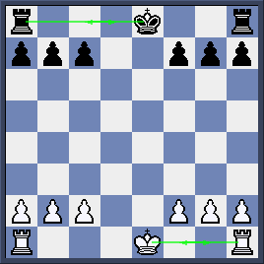

Here is the starting position of King and Rooks.

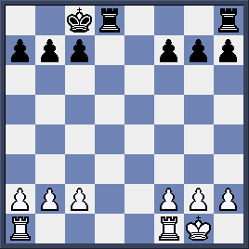
White castled Kingside (or short castling 0-0) while Black castled Queenside (or long castling 0-0-0)
As we see the position after castling, both Kings are well covered by his pawns and Rooks now can link up.

Castling Rules
As a special move, castling requires the following rules:
1. The path between the King and the Rook involved must be clear.

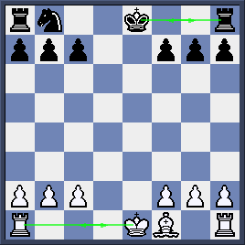

White can only castle Queenside while Black can only castle Kingside.

2.Castling must be the first move of both the King and the Rook involved.

There is only castling move available in this game. That is White’s long castling because his King and Queen’s Rook have not moved yet. His King’s Rook has move to g1 so even the Rook return to original square h1, he cannot castle anyway.
For Black, thing is even worse as his King has already moved so no way he can castle.
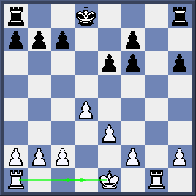

Remember not to move your King in the opening.
3. The King must not be in check at the point of castling. You cannot get out of check by castling.

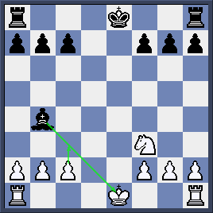

White King is in check so he can castle neither sides. The best move for White is to play c2-c3 to block the check then castle in the following move. Note that moving the King is bad because you will lose the right to castle.

4.The square which the King arrives after castling must be safe.
5. The square which the King crosses during castling must be safe too.

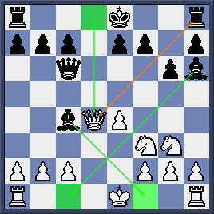

Look at the highlighted squares. Both Black Bishops are controlling crossing square (f1) and arriving square (c1) of White King so he cannot castle any sides.
Meanwhile, Black can castle Kingside as f8 and g8 are safe for black King. He cannot castle Queenside as d8 square is under control of White Queen

