KING
- The King cannot be captured as other pieces.
- The King may not move onto a square that is under the control of an opponent’s piece.
- The King may not capture an opponent’s piece if that piece is protected.

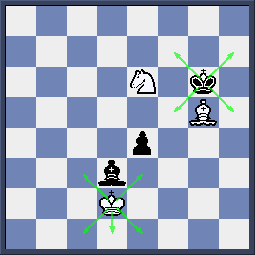

Here White King can neither capture Black Bishop at d3 nor move to squares like c2 and e2 which are controlled by Black Bishop.
Black King meanwhile cannot capture White Bishop at g5 which is protected by White Knight at e6.

He cannot move to f6, g7, h6 squares which is under the control of both White Knight and White Bishop.

- A piece shielding the King from attack along a file, rank or diagonal may not move away at this will expose the King to attack.
Please take a look at those highlighted pieces. Here white Knight at g5, Bishop at d3 and pawn at c2 cannot move away as they are shielding their King on h6-c1 diagonal, d-file and 2nd rank respectively.

At the same time, black Knight at b4, black Queen at d6 and black pawn at c5 cannot move because that means his King will expose to attack. We say that illegal moves.

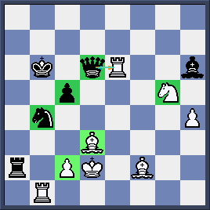

CHECK, DOUBLE CHECK AND CHECKMATE
When the King comes under attack from an opponent’s piece, the King is said to be in check. According to the rules of chess, the player whose King is under check must:
- Move the King to a safe square which is not attacked by opponent’s pieces.
- Capture the checking piece.
- Shield the King from check by placing a piece between the King and the checking piece.
Note: If check is given by either a pawn or a Knight, this defense is not available.

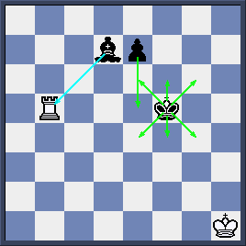

Here Black King is in check and he can move King to safe squares on 6th and 4th rank (e6, f6, g6 or e4, f4, g4) case a)
He also can capture white Rook with his Bishop case b)
Finally, he can block the check with a pawn move to e5 case c)

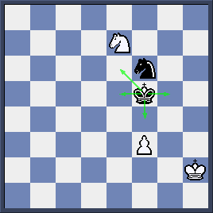
Here black King has no choice but move away from a Knight check. Available squares are e5, e6, f4, g5.

If there are two checking pieces then we have a double check. In that case, we cannot capture nor block the check but move the King to safety.

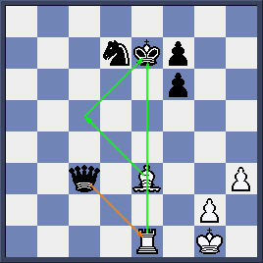
White moves Bishop to c5 to give a double check

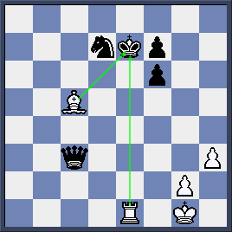
Here Black cannot capture either Rook or Bishop and cannot block the check. Black’s only choice is to move King back to d8 square.

If the King cannot be defended from check by one of the methods given above then it is said to be checkmate and the game is over.

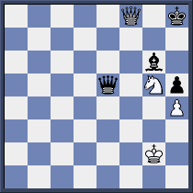
White has just made the move 1.Qf8 with checkmate as Black King has no way to get out of check.

You can deliver checkmate in one move in the following puzzles.

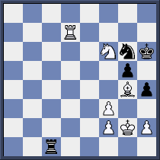
Can you find checkmate in this position for both White and Black?
……………………………………………………………………..
……………………………………………………………………..

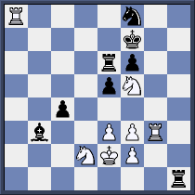
You have got the same task here.
………………………………………………………………………………
…………………………………………………………………………

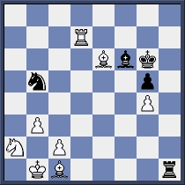

If Black move first he can checkmate White in one move.If it is White’s turn then he needs two moves to mate.Can you do it?
………………………………………………………………………………...
………………………………………………………………………………...

