PAWN

As we all know a pawn is a foot soldier. It moves straight forward and capture diagonally forward. It can be easily stopped if you place a pawn or a piece in front of it.
However, it has a compensating quality: when it reaches the other end of the board, it can change to either Queen, Rook, Knight or Bishop (but not the King). It is called Pawn Promotion.

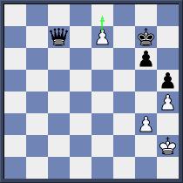

Here White Pawn is going to promote. Would you change it to
- a Queen
- a Knight

The pawn also can capture an opponent piece on the back rank and promote at the same time.
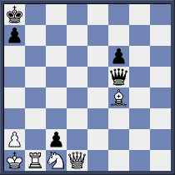

Black Pawn c2 has two options of promotion. It can capture either White Queen or White Rook and promote. What is your choice?

Next we will learn another way to capture for a pawn.It is called en passant
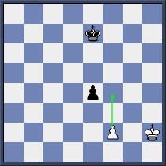

We have got the original position with White’s turn and he plays
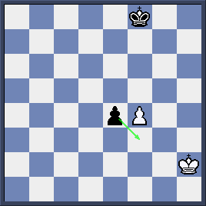

Black can capture with 1…ef3

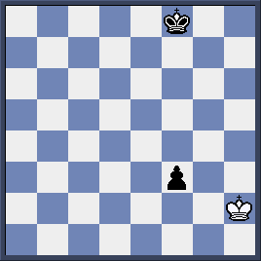

With this special Pawn capture we have to abide by the following rules
- White Pawn is on 5th rank or Black pawn is on 4th rank
- Opposite Pawn plays 2 steps forward
- The capture must be done immediately

