|  |
| --- |
| **NAFAbox “Alim_hat” board test procedure** |

|  |
| --- |
| Abstract :  This document summarizes the specifications of the “Alim_hat” board of NAFAbox, present the tests procedures of these specifications, and expose the results. |

|  |  |  |
| --- | --- | --- |
|  | Date | Signature |
| Prepared by :   * Guitton Thomas | 07/04/2021 |  |
| Approved by : |  |  |

|  |  |  |  |  |
| --- | --- | --- | --- | --- |
| **Modification History** | | | | |
| Ed. | Rev. | Date | Modifications | Visa |
| 1 | 0 |  |  |  |

**Table of Contents**

1 Glossaries 3

2 Document Presentation 3

3 Tests 4

3.1 Test 1: Visual check 4

3.2 Test 2: 12V equipotential 5

3.3 Test 3: VCC equipotential 6

3.4 Test 4: 5V equipotential 7

3.5 Test 5: 3.3V equipotential 8

3.6 Test 6: GND equipotential 9

3.7 Test 7: reverse current protection 10

3.8 Test 8: 5A auto-resettable fuses 11

3.9 Test 9: INA219 communication 12

3.10 Test 10: Full board supply compliance 13

4 Error report 14

4.1 Functionality 14

4.2 CAO/Fabrication 14

# Glossaries

|  |  |  |
| --- | --- | --- |
| PCB  CAO  MOSFET  DC  GND | | Printed Circuit Board  Conception Assisté par Ordinateur (computer assisted conception)  Metal Oxide Semiconductor Field Effect Transistor  Direct Current  Ground |
|  |  | |

# Document Presentation

This document is training for electronic board test of NAFAbox project. It is a summary of the specification of the board, with associated tests to verify these specifications, and expose the result of these tests and concluded that the card is functioning properly or not.

# Tests

## Test 1: Visual check

|  |  |  |
| --- | --- | --- |
| Procedure | Results | Comments |
| Check solder: any pin without solder? No solder bridge? | No solder issues.  => Validated. |  |
| Check components’ polarity. | No polarity issues.  => Validated. |  |
| Check holes: isolation, metallicity, Via. | MK1 and MK4 isolation not respected.  No metallicity issues.  No Via issues.  => Validated. | No impact but corrected on PCB. |

## Test 2: 12V equipotential

|  |  |  |
| --- | --- | --- |
| Procedure | Results | Comments |
| Supply the board with 12V on J1 or J2 connectors.  Check all 12V pins. 12V should be observed. | 12.04V observed for each 12V pins.  => Validated. |  |
| For each jack DC connector (J4, J5, J6 and J7):  Open “ON/OFF” jumper. Check the output voltage of Jack DC connectors. No voltage should be observed. | 0.002V observed for Jack DC V+ pins.  => Validated. |  |
| Close “ON/OFF” jumper. Check the output voltage of Jack DC connectors. 12V should be observed. | 12.04V observed for Jack DC V+ pins.  => Validated. |  |

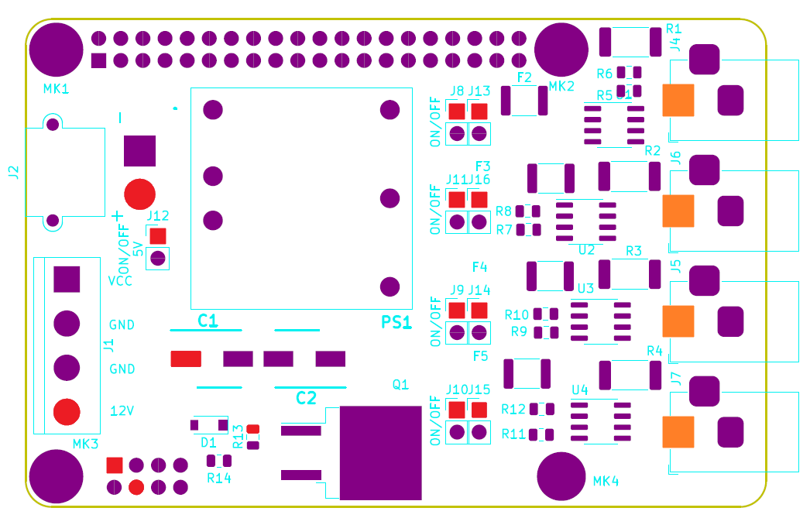

12V and Jack DC V+ pins map

## Test 3: VCC equipotential

|  |  |  |
| --- | --- | --- |
| Procedure | Results | Comments |
| Supply the board with VCC on J1 connector.  Check all VCC pins. VCC voltage should be observed. | VCC was chosen to be 5V.  5.01V observed for each VCC pins.  => Validated. |  |

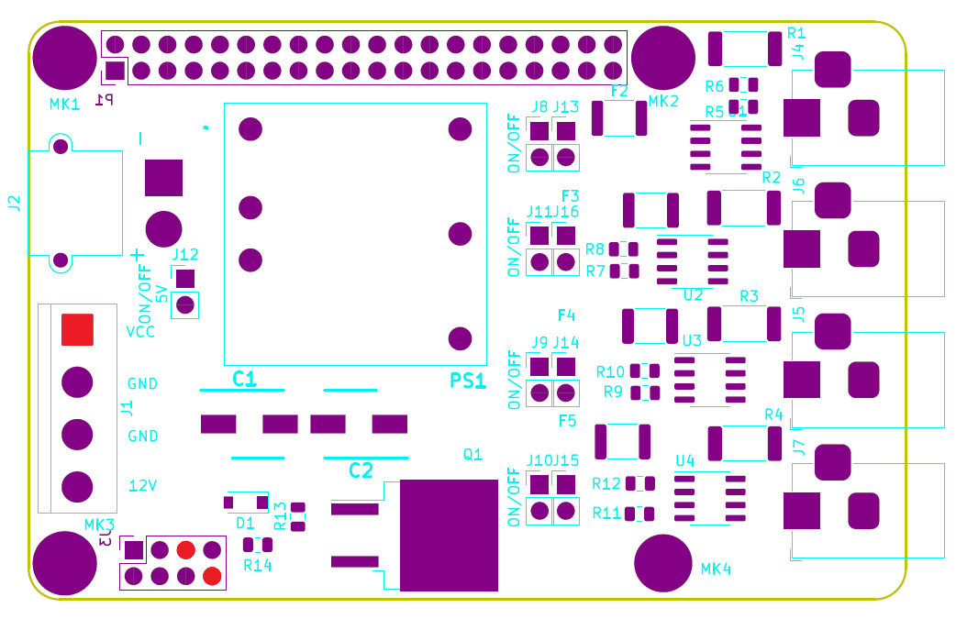

VCC pins map

## Test 4: 5V equipotential

|  |  |  |
| --- | --- | --- |
| Procedure | Results | Comments |
| Supply the board with 12V on J1 or J2 connectors.  Open “ON/OFF 5V” jumper and check all 5V pins. No voltage should be observed. | 0.001V observed for each 5V pins.  => Validated. |  |
| Close “ON/OFF 5V” jumper and check all 5V pins. 5V should be observed. | 5.01V observed for each 5V pins.  => Validated. |  |
| With a heating resistor consuming 1A at 5V, check the behavior of the converter. 5V should be observed. | 4.98V observed for 5V pins of the 40 pins header with 0.853A.  => Validated. | Power losses due to the wiring of the instruments. |
| With a heating resistor consuming 2A at 5V, check the behavior of the converter. 5V should be observed. | 4.95V observed for 5V pins of the 40 pins header with 2.05A.  => Validated. | Power losses due to the wiring of the instruments. (Uses of 3 heat resistor consuming 1A at 5V). |
| With a heating resistor consuming 3A at 5V, check the behavior of the converter. 5V should be observed. | Not tested. | No device consuming 3A at 5V at disposal. |

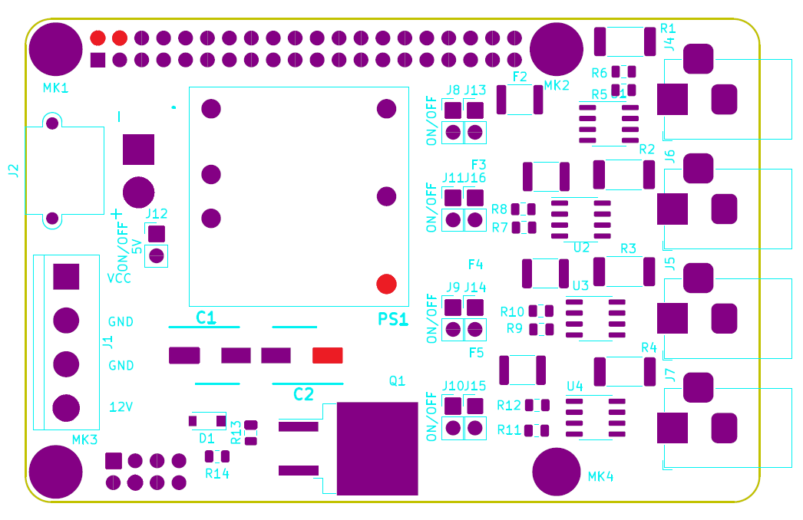

5V pins map

## Test 5: 3.3V equipotential

|  |  |  |
| --- | --- | --- |
| Procedure | Results | Comments |
| Connect the board with the Raspberry pi 4.  Check all 3.3V pins. 3.3V should be observed. | 3.295V observed for each 3.3V pins.  => Validated. |  |

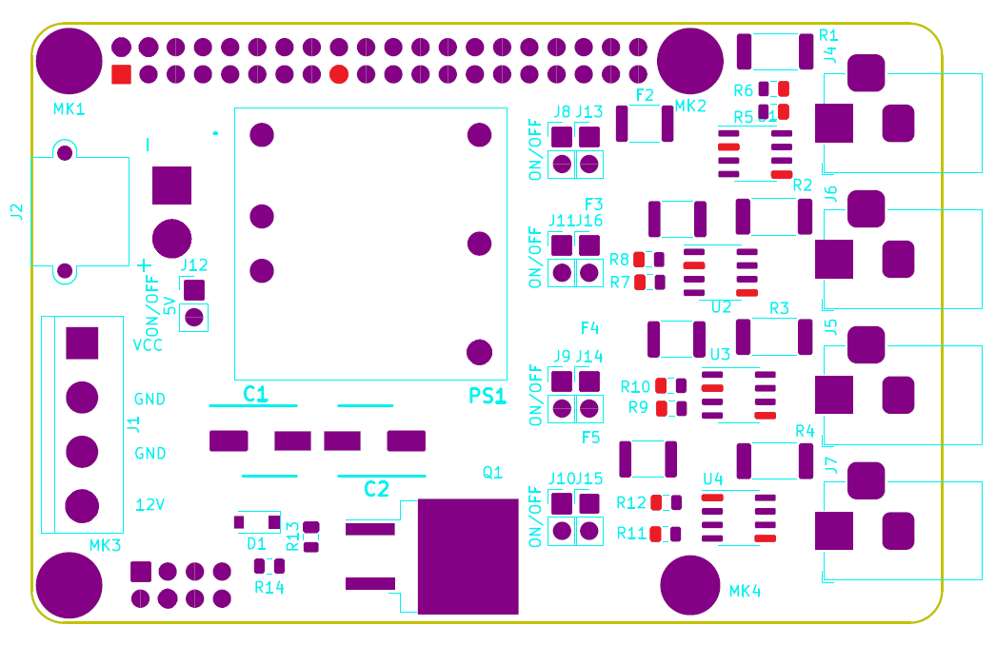

3.3V pins map

## Test 6: GND equipotential

|  |  |  |
| --- | --- | --- |
| Procedure | Results | Comments |
| Connect the board with the Raspberry pi 4.  Check all GND pins. | Continuity ensured between GND pins.  => Validated. |  |

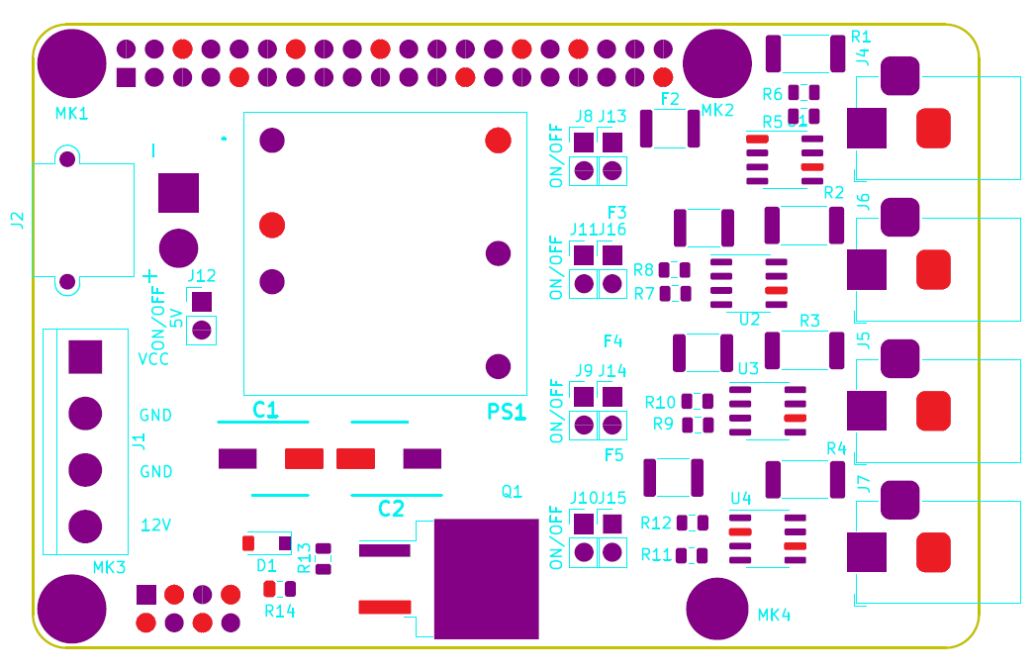

GND pins map

## Test 7: reverse current protection

|  |  |  |
| --- | --- | --- |
| Procedure | Results | Comments |
| Check continuity between MOSFET drain and gnd_no with a multi-meter in test mode. A sound response should be heard. | Sound response heard. Continuity is ensured between MOSFET drain and gnd_no.  => Validated. |  |
| Supply 12V on J1 connector.  A voltage should be observed on Jack DC output. | 12V observed on oscilloscope.  Closed circuit.  => Validated. |  |
| Invert 12V and GND wires for J1 connector.  No voltage should be observed on Jack DC output. | 0V observed on oscilloscope.  Open circuit.  => Validated. |  |
| Repeat for J2 connector for 12V supply. | Same observation as for J1 connector.  => Validated. |  |

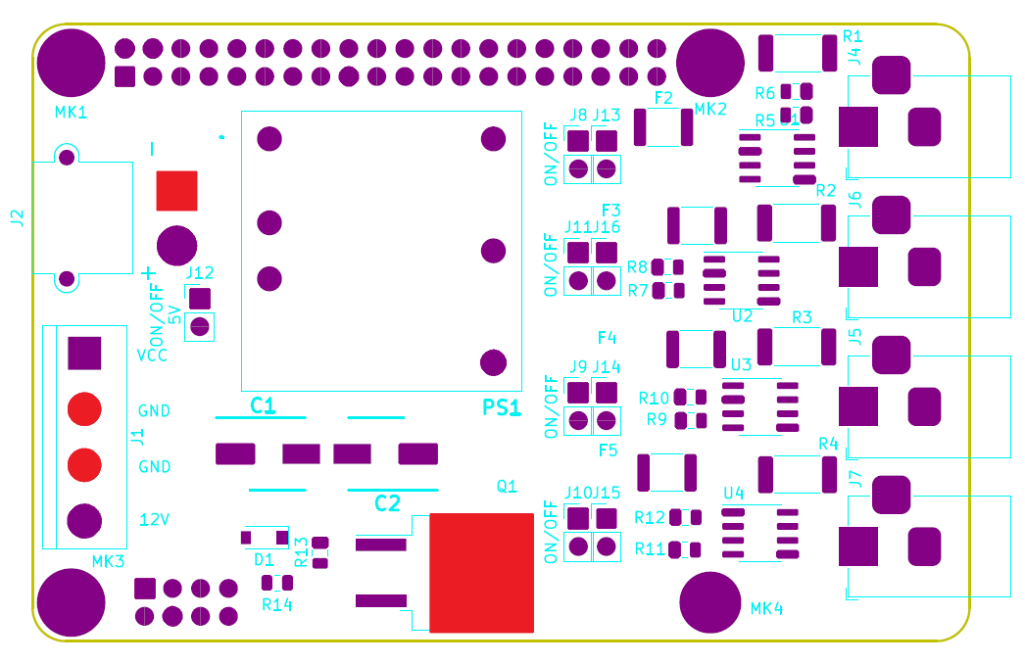

MOSFET drain

gnd_no pins map

## Test 8: 5A auto-resettable fuses

|  |  |  |
| --- | --- | --- |
| Procedure | Results | Comments |
| For each fuse (F2, F3, F4 and F5):  Check continuity between fuse terminals with a multi-meter in test mode. A sound response should be heard. | Sound response heard. Continuity is ensured between fuse terminals.  => Validated. |  |
| Close associated “ON/OFF” jumper and provides 12V/5A to the fuse. Check with the ohmmeter. “0.L” should be observed. | Current drop observed on the supply.  Fuse disarmed.  => Validated. | Because of the speed of rearmament, check current drop on the supply. |
| Wait for fuse to rearm.  Assert continuity between fuse terminals. | Sound response heard. Continuity is ensured between fuse terminals.  => Validated. | The rearmament is quasi instantaneous. |

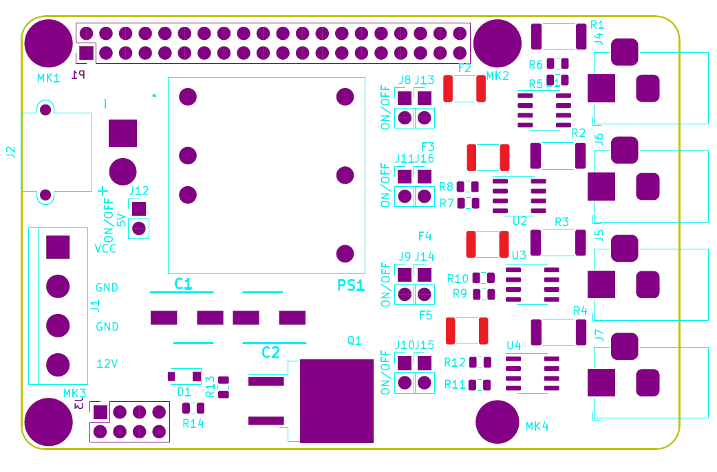

Fuse pins map

## Test 9: INA219 communication

|  |  |  |
| --- | --- | --- |
| Procedure | Results | Comments |
| Connect the board with the Raspberry pi 4.  For each INA219 (U1, U2, U3 and U4):  With a heating resistor consuming 2.5A at 12V connected to the corresponding Jack DC connector, request for current and voltage in I2C. 12V and 2.5A should be returned. | **U1:**  *Test without current:* return 11.86V and 0.001A  *Test with current:* return 11.69V and 2.31A  => Validated.  **U2:**  *Test without current:* return 12.04V and 0.001A  *Test with current:* return 11.69V and 2.18A  => Validated.  **U3:**  *Test without current:* return 12.01V and 0.001A  *Test with current:* return 11.68V and 2.22A  => Validated.  **U4:**  *Test without current:* return 12.01V and 0.001A  *Test with current:* return 11.68V and 2.19A  => Validated. | U1 address : 1000001  U2 address : 1001001  U3 address : 1000011  U4 address : 1000100  slight tension drop. |

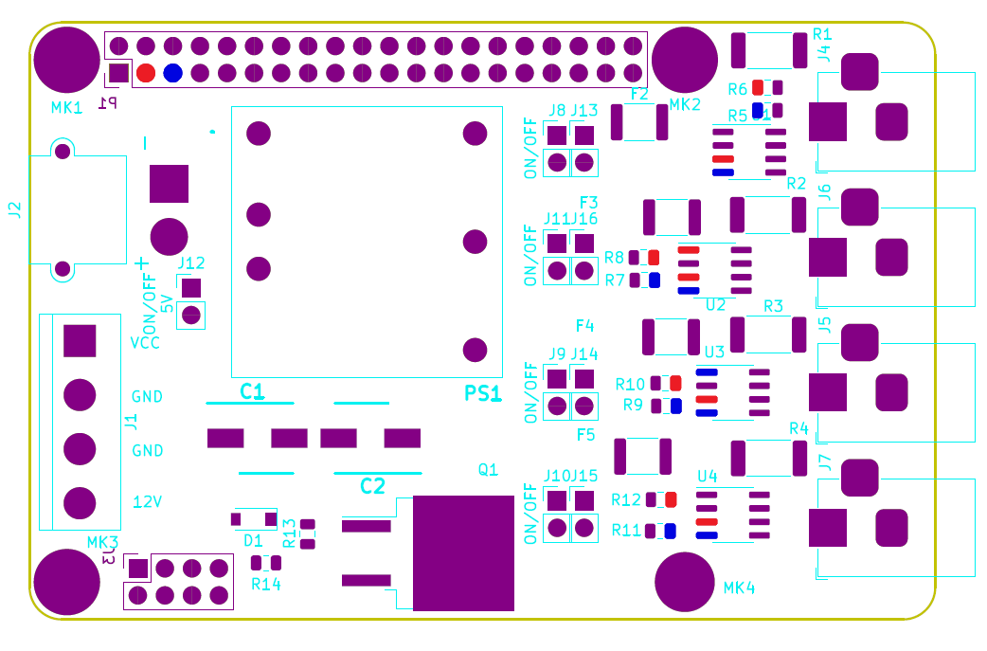

SDA pins and SCL pins map

## Test 10: Full board supply compliance

|  |  |  |
| --- | --- | --- |
| Procedure | Results | Comments |
| Test multiple Jack DC outputs simultaneously.  12V should be observed for each output. | For two Jack DC outputs connected with a heating resistor 12V/2.5A and with a heating resistor 12V/0.6A.  Respectively 11.62V/2A and 11.02V/0.6A observed.  => Validated. |  |
| With all jumper closed, use a voltage supply able to deliver 180W, regulate the voltage to 12V and limit the current to 10A and increase the limit until 15A. No voltage drop should be observed. | Not tested. | No device consuming 10A/15A at 12V at disposal. |

# Error report

## Functionality

* No certitude of proper functioning of the DC to DC converter with 3A (test until ~2A).
* No certitude of proper functioning of the full board supplied with 12V/15A.

## CAO/Fabrication

* Isolation of mounting-hole MK1 must be 1.5 instead of 0. The 5V track preventing the isolation (corrected on PCB).
* Isolation of mounting-hole MK4 must be 1.5 instead of 1.2 (corrected on PCB).
* Inversion of J2 pins (corrected on PCB).