|  |
| --- |
| **NAFAbox “Base_hat” board test procedure** |

|  |
| --- |
| Abstract :  This document summarizes the specifications of the “base_hat” board of NAFAbox, present the tests procedures of these specifications, and expose the results. |

|  |  |  |
| --- | --- | --- |
|  | Date | Signature |
| Prepared by :   * Guitton Thomas | 09/04/2021 |  |
| Approved by : |  |  |

|  |  |  |  |  |
| --- | --- | --- | --- | --- |
| **Modification History** | | | | |
| Ed. | Rev. | Date | Modifications | Visa |
| 1 | 0 |  |  |  |

**Table of Contents**

1 Glossaries 3

2 Document Presentation 3

3 Tests 4

3.1 Test 1: Visual check 4

3.2 Test 2: 5V equipotential 5

3.3 Test 3: 3.3V equipotential 6

3.4 Test 4: GND equipotential 7

3.5 Test 5: CR2032 cell 8

3.6 Test 6: Permanent time base 9

3.7 Test 7: Ventilator 10

4 Error report 11

4.1 Functionality 11

4.2 CAO/Fabrication 11

# Glossaries

|  |  |  |
| --- | --- | --- |
| CAO  GND  PCB  PWM | | Conception Assisté par Ordinateur (computer assisted conception)  Ground  Printed Circuit Board  Pulse Width Modulation |
|  |  | |

# Document Presentation

This document is training for electronic board test of NAFAbox project. It is a summary of the specification of the board, with associated tests to verify these specifications, and expose the result of these tests and concluded that the card is functioning properly or not.

# Tests

## Test 1: Visual check

|  |  |  |
| --- | --- | --- |
| Procedure | Results | Comments |
| Check solder: any pin without solder? No solder bridge? | No solder issues.  => Validated. |  |
| Check components’ polarity. | No polarity issues.  => Validated. |  |
| Check holes: isolation, metallicity, Via. | MK1, MK2, MK3 and MK4 isolation not respected.  No metallicity issues.  No Via issues.  => Validated. | No impact but corrected on PCB. |

## Test 2: 5V equipotential

|  |  |  |
| --- | --- | --- |
| Procedure | Results | Comments |
| Connect the board with the powered “alim_hat” board.  Check all 5V pins. 5V should be observed. | 5V observed for 40 pins header. 4.99V observed for ventilator.  => Validated. |  |

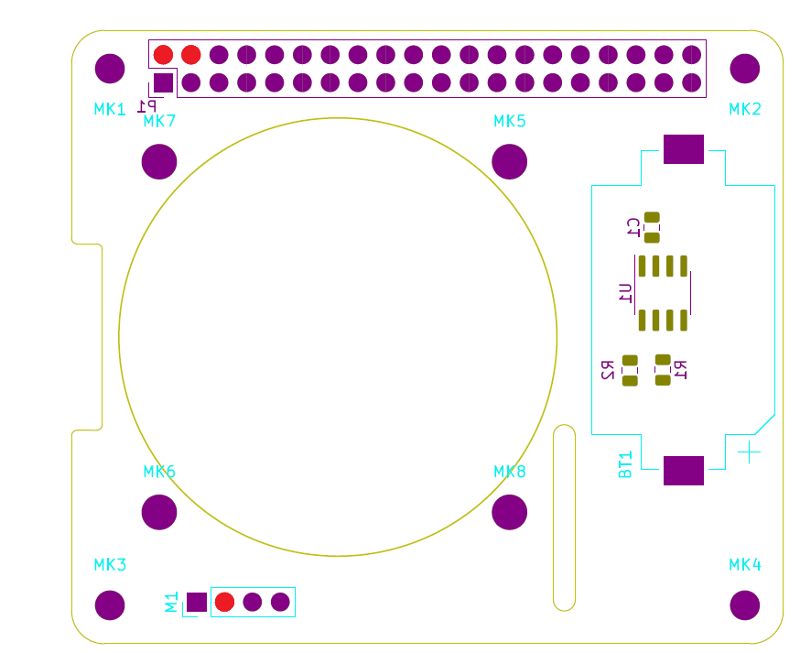

5V pins map

## Test 3: 3.3V equipotential

|  |  |  |
| --- | --- | --- |
| Procedure | Results | Comments |
| Connect the board with the Raspberry pi 4.  Check all 3.3V pins. 3.3V should be observed. | 3.297V observed for each 3.3V pins.  => Validated. |  |

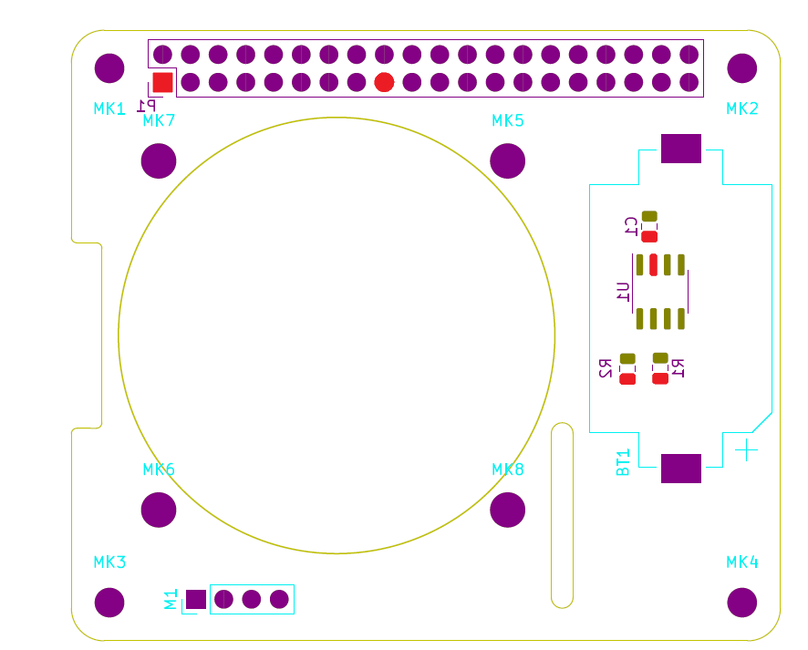

3.3V pins map

## Test 4: GND equipotential

|  |  |  |
| --- | --- | --- |
| Procedure | Results | Comments |
| Connect the board with the Raspberry pi 4.  Check all GND pins. | Continuity ensured between GND pins.  => Validated. |  |

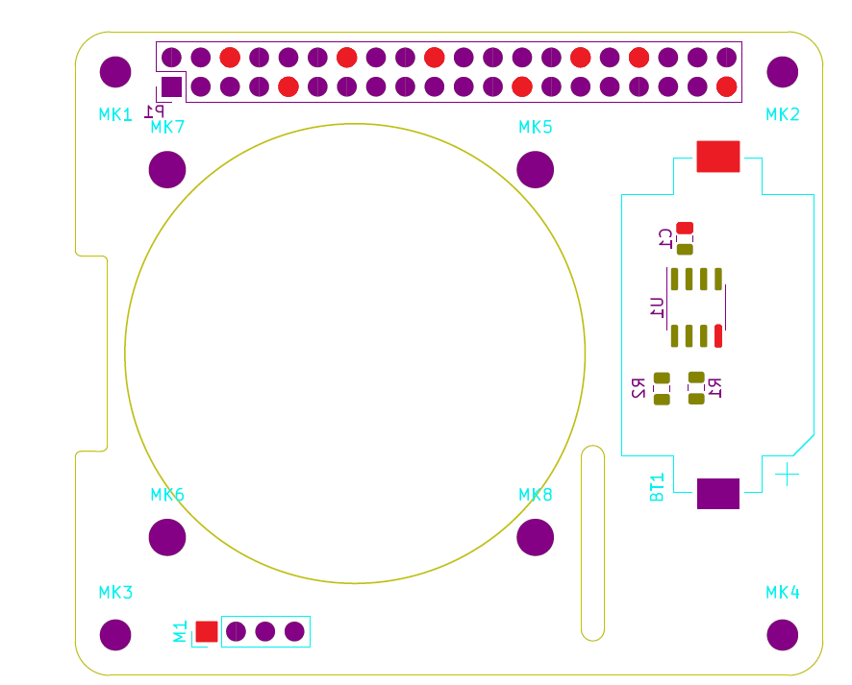

GND pins map

## Test 5: CR2032 cell

|  |  |  |
| --- | --- | --- |
| Procedure | Results | Comments |
| Check 3V pin of the battery. 3V should be observed. | 3.004V observed with a multi-meter.  The cell is charged.  => Validated. |  |

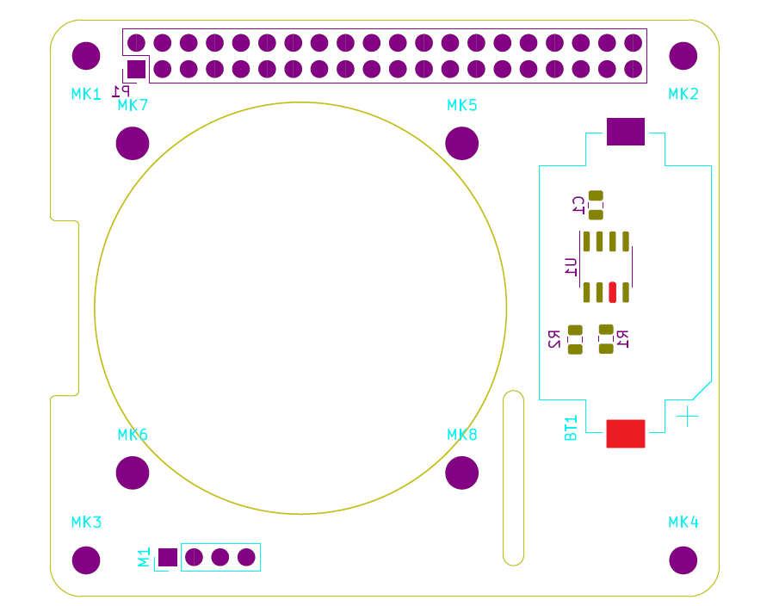

3V pins map

## Test 6: Permanent time base

|  |  |  |
| --- | --- | --- |
| Procedure | Results | Comments |
| Supply with 3.3V from Raspberry pi 4.  Request for date and time.  Wait 5 minutes.  Request for date and time.  Check date and time provided. | Proper date and time after 5 minutes.  => Validated. | U1 address : 1101001 |
| Disconnect the Raspberry pi 4 supply (cell supply takes over).  Wait 5 minutes.  Request for date and time.  Check date and time provided. | Proper date and time after 5 minutes.  => Validated. |  |

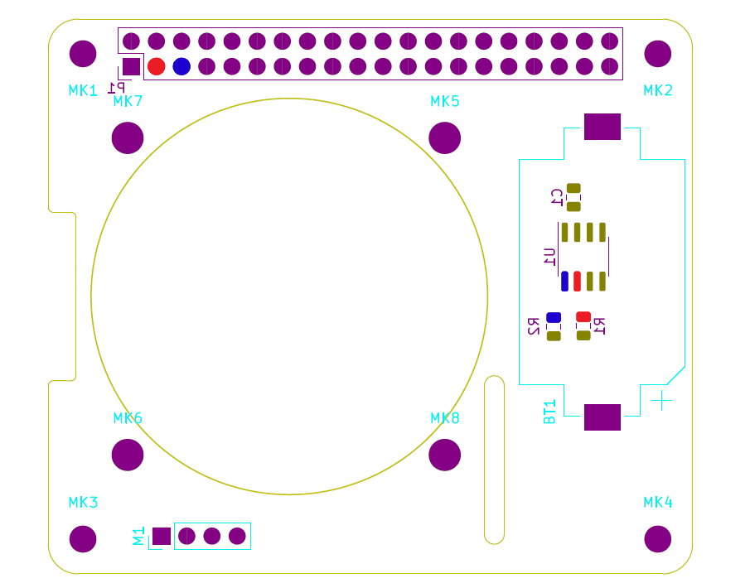

SDA pins and SCL pins map

## Test 7: Ventilator

|  |  |  |
| --- | --- | --- |
| Procedure | Results | Comments |
| Connect the board with the Raspberry pi 4.  With a PWM ratio of 0.  Check ventilator’s rotation. No movement should be observed. | No rotation observed.  => Validated. | GPIO12 (PWM).  Without command on GPIO12, the ventilator functioning at max speed. $0<PWM<1023$ . |
| Increase the PWM until ventilator’s rotation start. | Rotation start at PWM = 60.  Rotation stop under PWM = 40.  => Validated. | $${PWM}_{start}=60$$ $${PWM}_{mini}=40$$ |
| Increase the PWM.  The rotor should accelerate. | Acceleration observed when PWM increase.  => Validated. |  |

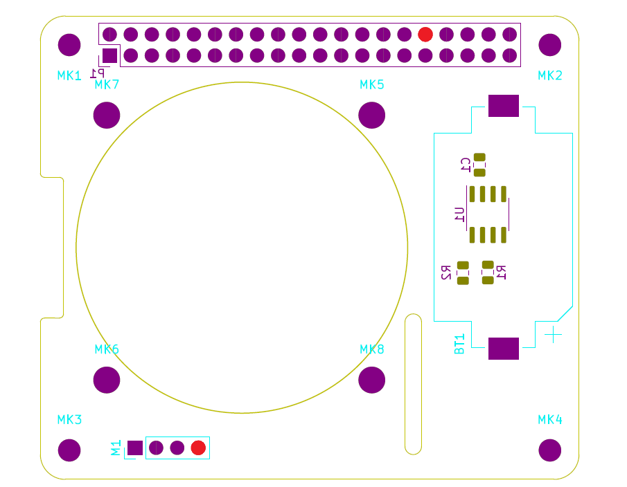

PWM pins map

# Error report

## Functionality

* No functionality error.

## CAO/Fabrication

* Ventilator’s 3D model is mounted upside down on PCB.
* Missing isolation on MK1, MK2, MK3 and MK4 mounting holes (corrected on PCB).