|  |
| --- |
| **NAFAbox “Relais_hat” board test procedure** |

|  |
| --- |
| Abstract :  This document summarizes the specifications of the “Relais_hat” board of NAFAbox, present the tests procedures of these specifications, and expose the results. |

|  |  |  |
| --- | --- | --- |
|  | Date | Signature |
| Prepared by :   * Guitton Thomas | 13/04/2021 |  |
| Approved by : |  |  |

|  |  |  |  |  |
| --- | --- | --- | --- | --- |
| **Modification History** | | | | |
| Ed. | Rev. | Date | Modifications | Visa |
| 1 | 0 |  |  |  |

**Table of Contents**

1 Glossaries 3

2 Document Presentation 3

3 Tests 4

3.1 Test 1: Visual check 4

3.2 Test 2: 12V equipotential 5

3.3 Test 3: VCC equipotential 6

3.4 Test 4: 5V equipotential 7

3.5 Test 5: 3.3V equipotential 8

3.6 Test 6: GND equipotential 9

3.7 Test 7: MOSFETs 10

3.8 Test 8: Motor driver 12

4 Error report 14

4.1 Functionality 14

4.2 CAO/Fabrication 14

# Glossaries

|  |  |  |
| --- | --- | --- |
| CAO  GND  LED  MOSFET | | Conception Assisté par Ordinateur (computer assisted conception)  Ground  Light-Emitting Diode  Metal Oxide Semiconductor Field Effect Transistor |
|  |  | |

# Document Presentation

This document is training for electronic board test of NAFAbox project. It is a summary of the specification of the board, with associated tests to verify these specifications, and expose the result of these tests and concluded that the card is functioning properly or not.

# Tests

## Test 1: Visual check

|  |  |  |
| --- | --- | --- |
| Procedure | Results | Comments |
| Check solder: any pin without solder? No solder bridge? | No solder issues.  => Validated. |  |
| Check components’ polarity. | No polarity issues.  => Validated. |  |
| Check holes: isolation, metallicity, Via. | No isolation issues.  No metallicity issues.  No Via issues.  => Validated. |  |

## Test 2: 12V equipotential

|  |  |  |
| --- | --- | --- |
| Procedure | Results | Comments |
| Connect the board with the powered “alim_hat” board.  Check all 12V pins. 12V should be observed. | 12.06V observed for each 12V pins.  => Validated. |  |

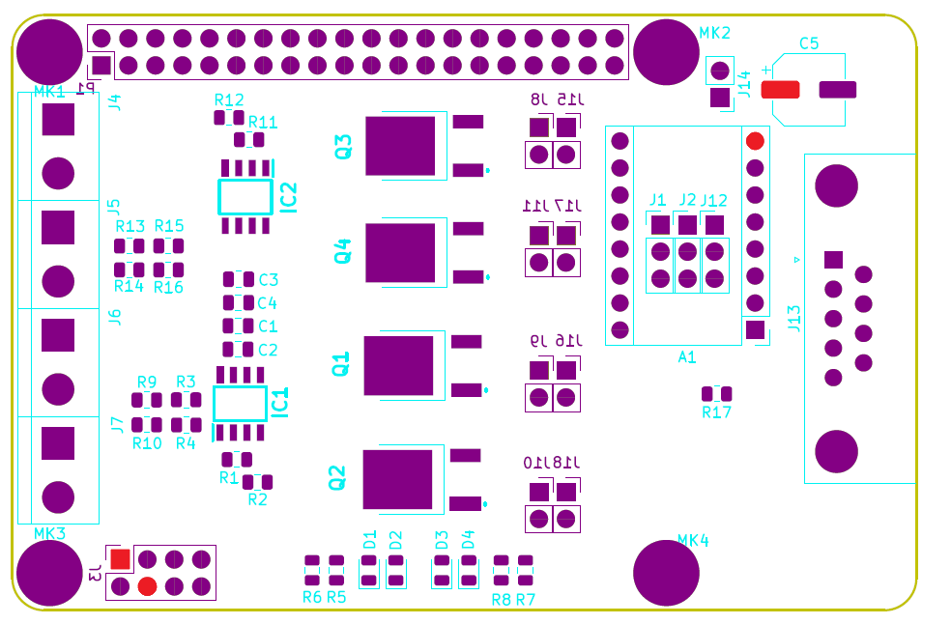

12V pins map

## Test 3: VCC equipotential

|  |  |  |
| --- | --- | --- |
| Procedure | Results | Comments |
| Connect the board with the powered “alim_hat” board.  Check all VCC pins. VCC voltage should be observed. | VCC was chosen to be 5V.  5.01V observed for each VCC pins.  => Validated. |  |

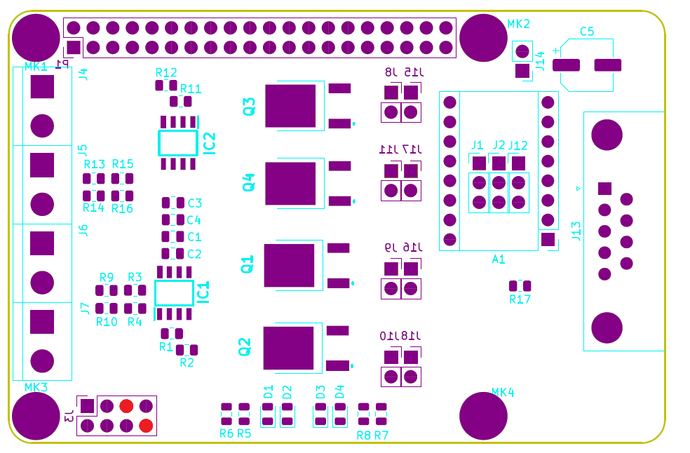

VCC pins map

## Test 4: 5V equipotential

|  |  |  |
| --- | --- | --- |
| Procedure | Results | Comments |
| Connect the board with the powered “alim_hat” board.  Check all 5V pins. 5V should be observed. | 5.01V observed for each 5V pins.  => Validated. |  |

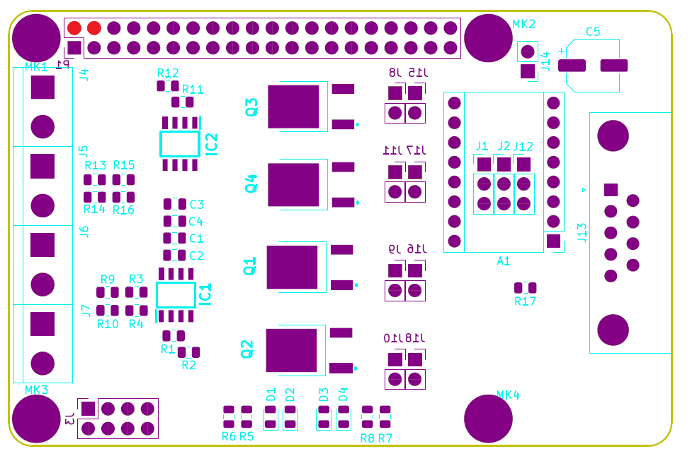

5V pins map

## Test 5: 3.3V equipotential

|  |  |  |
| --- | --- | --- |
| Procedure | Results | Comments |
| Connect the board with the Raspberry pi 4.  Check all 3.3V pins. 3.3V should be observed. | 3.297V observed for each 3.3V pins.  => Validated. |  |

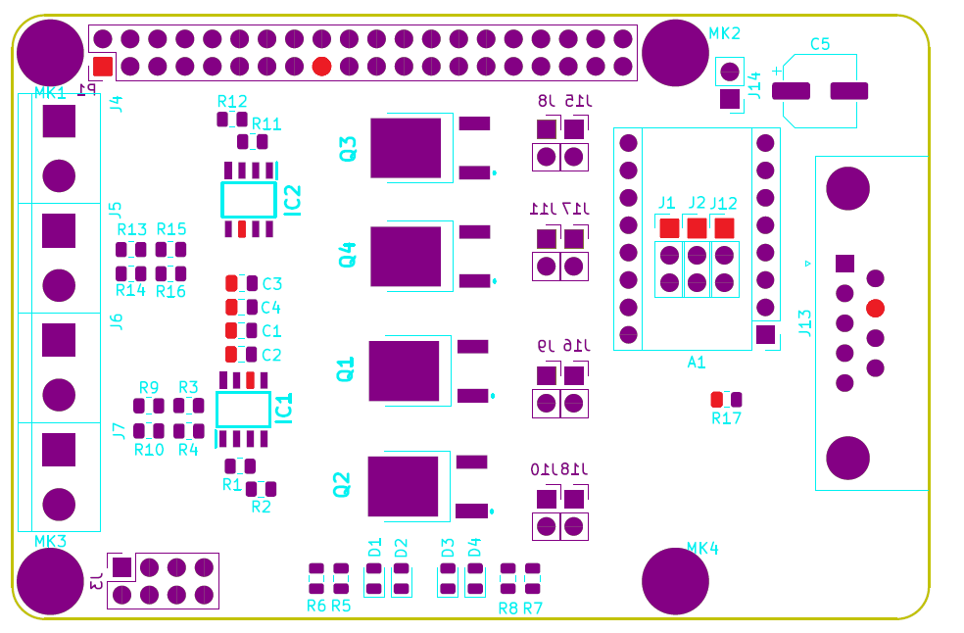

3.3V pins map

## Test 6: GND equipotential

|  |  |  |
| --- | --- | --- |
| Procedure | Results | Comments |
| Connect the board with the Raspberry pi 4.  Close J14 jumper.  Check all GND pins. | Continuity ensured between GND pins.  Continuity ensured between GND_Rpi pins.  Continuity ensured between GND pins and GND_Rpi pins with J14 jumper Closed.  => Validated. |  |

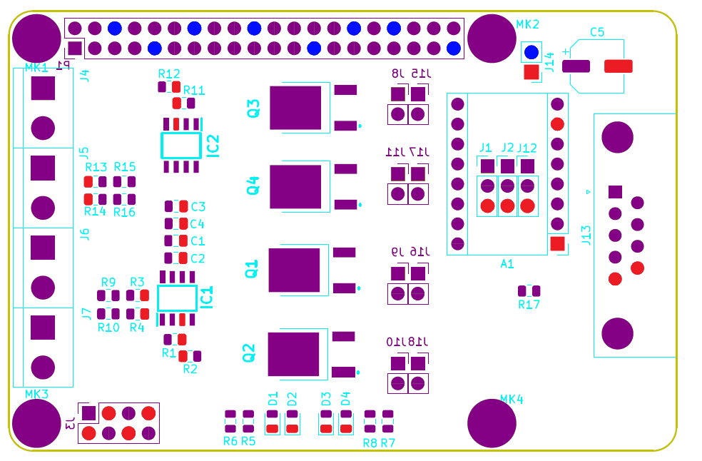

GND pins and GND_Rpi pins map

## Test 7: MOSFETs

|  |  |  |
| --- | --- | --- |
| Procedure | Results | Comments |
| Connect the board with the Raspberry pi 4.  For each MOSFET (Q1, Q2, Q3 and Q4):  Check continuity between MOSFET and associated Connector. | *Continuity 1st test:* contradiction. Three MOSFETs are in passing mode (not supposed to be in) and after double check only Q3 still in passing mode (changing mode not commanded → contradiction).  => Redo the test later with another multi-meter.  *Continuity 2nd test:* confirmation.  Continuity ensured for Q1, Q2 and Q4.  Q3 MOSFET is in passing mode.  => Not validated.  *Continuity 3rd test:* validation.  Continuity ensured for Q1, Q2, Q3 and Q4.  Q3 MOSFET is in blocking mode.  => Ensure right functioning with the other tests. | Conn J4 associated with Q3.  Conn J5 associated with Q4.  Conn J6 associated with Q1.  Conn J7 associated with Q2.  Q3 MOSFET is faulty.  Return to normal for all MOSFETs. |
| With the MOSFET into blocking mode, supply 12V on drain pins. Check voltage on source pins.  No voltage should be observed. | 0V observed for each source pins of each MOSFET.  => Validated. |  |
| Command the MOSFET into passing mode with the associated GPIO. 12V should be observed on source pins. | 2V observed for each source pins of each MOSFET.  => Not validated. Look at “Error report” for explanations. | GPIO22 control Q1 MOSFET.  GPIO23 control Q2 MOSFET.  GPIO17 control Q3 MOSFET.  GPIO18 control Q4 MOSFET. |
| When MOSFET is in passing mode, the associated LED should be turned on. | LEDs turned on when commands are activated.  => Validated. | LED D1 associated with Q3.  LED D2 associated with Q4.  LED D3 associated with Q1.  LED D4 associated with Q2.  LEDs do not inform that the MOSFET is in passing mode but inform that the command to passing mode is active. |

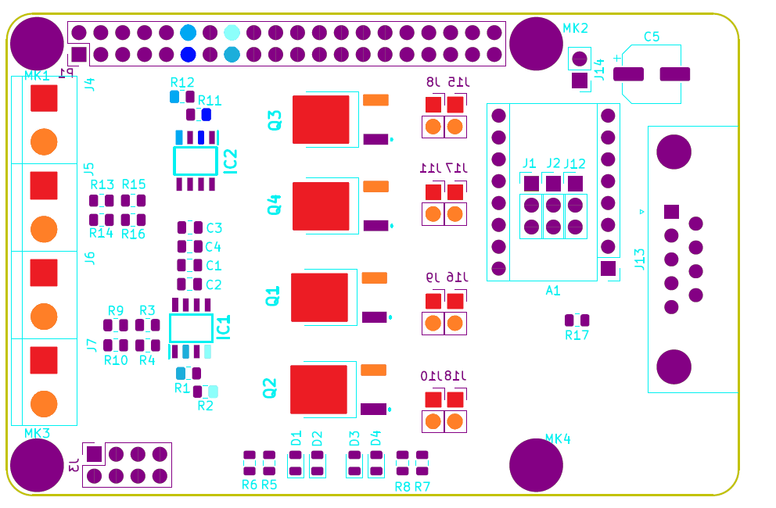

MOSFET drain

MOSFET drain

MOSFET drain

MOSFET drain

GPIO 17, GPIO 18, GPIO 22, GPIO 23, MOSFET drain and MOSFET source pins map

## Test 8: Motor driver

|  |  |  |
| --- | --- | --- |
| Procedure | Results | Comments |
| Connect the board with the Raspberry pi 4.  Open J1, J2 and J12 jumpers. No voltage should be observed respectively on pins A1-PAD10, A1-Pad11 and A1-Pad12. | -0.001V observed for each A1-Pad pins.  => Validated. |  |
| Close J1, J2 and J12 jumpers with 3.3V. 3.3V should be observed respectively on pins A1-PAD10, A1-Pad11 and A1-Pad12. | 3.297V observed for each A1-Pad pins.  => Validated. |  |
| Close J1, J2 and J12 jumpers with GND. continuity should be ensured between pins A1-PAD10, A1-Pad11 and A1-Pad12 and GND. | Continuity ensured between each A1-Pad pins and GND pins.  => Validated. |  |

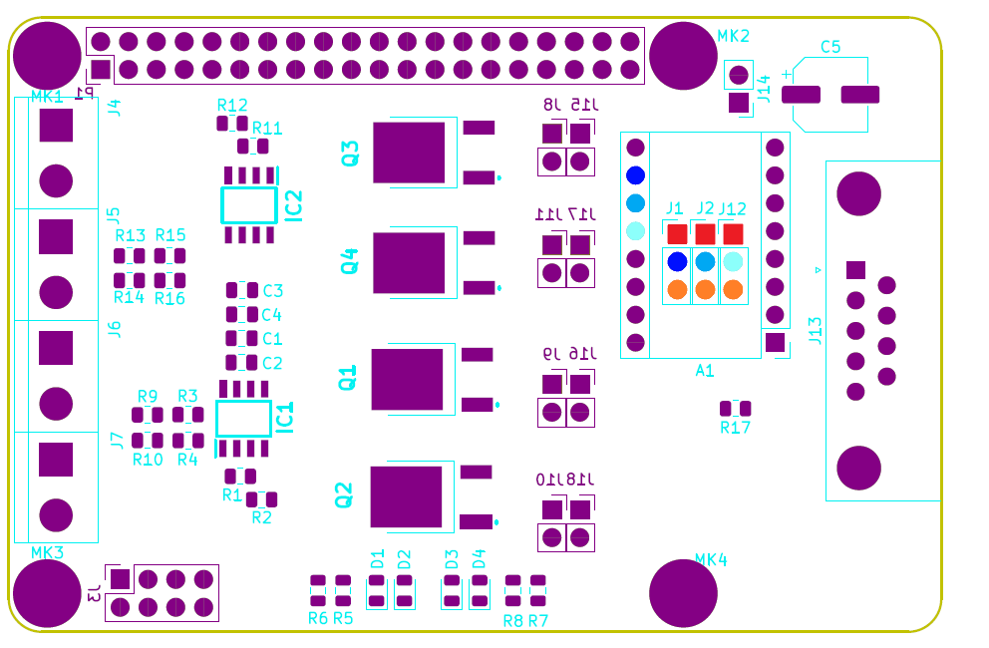

A1-Pad10, A1-Pad11, A1-Pad12, 3.3V and GND pins map

|  |  |  |
| --- | --- | --- |
| Procedure | Results | Comments |
| Connect the board with the Raspberry pi 4.  Check continuity of GPIO24 pins.  A sound response should be heard. | Sound response heard. Continuity ensured between GPIO24 pins.  => Validated. |  |
| Check continuity of GPIO25 pins.  A sound response should be heard. | Sound response heard. Continuity ensured between GPIO25 pins.  => Validated. |  |
| Check continuity of GPIO27 pins.  A sound response should be heard. | Sound response heard. Continuity ensured between GPIO27 pins.  => Validated. |  |

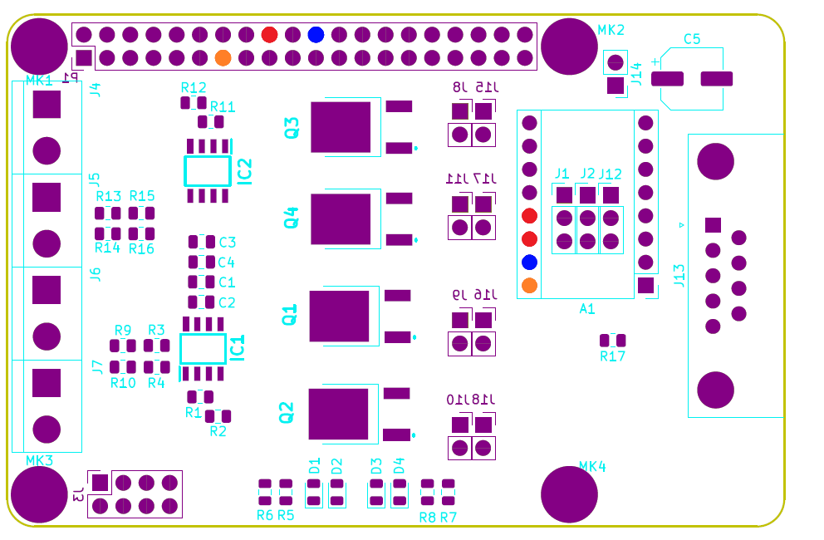

GPIO 24, GPIO 25 and GPIO 27 pins map

# Error report

## Functionality

* MOSFETs mode (n-canal MOSFETs, initially in blocking mode) could be corrupted when voltage is not apply. If any doubt with continuity tests, double check with voltage application on drain pins or source pins. No voltage should be observed on complementary pins (drain/source or source/drain).
* MOSFETs passing mode do not respect the specifications. The gate commander UCC27324D is supply with 3.3V but operate properly at minimum 4V considering its datasheet. However UCC27324D operate with 3.3V without impact. The error concerns the conception of MOSFET logic with “alim_hat” board. Here we cut off 12V when GND should have been cut off. A modification of “alim_hat” board should resolve this error.

## CAO/Fabrication

* Diode labels are not corresponding to the associated MOSFET (corrected on PCB).
* Connector labels are not corresponding to the associated MOSFET.