|  |
| --- |
| **NAFAbox “Res_hat” board test procedure** |

|  |
| --- |
| Abstract :  This document summarizes the specifications of the “Res_hat” board of NAFAbox, present the tests procedures of these specifications, and expose the results. |

|  |  |  |
| --- | --- | --- |
|  | Date | Signature |
| Prepared by :   * Guitton Thomas | 13/04/2021 |  |
| Approved by : |  |  |

|  |  |  |  |  |
| --- | --- | --- | --- | --- |
| **Modification History** | | | | |
| Ed. | Rev. | Date | Modifications | Visa |
| 1 | 0 |  |  |  |

**Table of Contents**

1 Glossaries 3

2 Document Presentation 3

3 Tests 4

3.1 Test 1: Visual check 4

3.2 Test 2: 12V equipotential 5

3.3 Test 3: VCC equipotential 6

3.4 Test 4: V_RES equipotential 7

3.5 Test 5: 5V equipotential 8

3.6 Test 6: 3.3V equipotential 9

3.7 Test 7: GND equipotential 10

3.8 Test 8: UART communication 11

3.9 Test 9: MOSFETs FDD844L-F085 13

3.10 Test 10: USB resistor 15

3.11 Test 11: RCA resistor 15

3.12 Test 12: BME280 board communication 16

3.13 Test 13: INA219 communication 17

3.14 Test 14: D18B20 sensors communication 18

4 Error report 19

4.1 Functionality 19

4.2 CAO/Fabrication 19

# Glossaries

|  |  |  |
| --- | --- | --- |
| CAO  GND  MOSFET  PCB  PCBA | | Conception Assisté par Ordinateur (computer assisted conception)  Ground  Metal Oxide Semiconductor Field Effect Transistor  Printed Circuit Board  Printed Circuit Board Assembly |
|  |  | |

# Document Presentation

This document is training for electronic board test of NAFAbox project. It is a summary of the specification of the board, with associated tests to verify these specifications, and expose the result of these tests and concluded that the card is functioning properly or not.

# Tests

## Test 1: Visual check

|  |  |  |
| --- | --- | --- |
| Procedure | Results | Comments |
| Check solder: any pin without solder? No solder bridge? | Missing solder on 5 pins of the 40 pins header.  Non-compliant welding.  => Validated. | No impacts since the 5 GPIOs are not used (our case).  No impact, potential bridge between GND and isolation. |
| Check components’ polarity. | No polarity issues.  => Validated. |  |
| Check holes: isolation, metallicity, Via. | No isolation issues.  No metallicity issues.  No Via issues.  H5 mounting hole (BME280 board’s fixation) too small.  => Validated. | Modified on PCB. No big impact since connector 01x06 ensure fixation. |

## Test 2: 12V equipotential

|  |  |  |
| --- | --- | --- |
| Procedure | Results | Comments |
| Connect the board with the powered “alim_hat” board.  Check all 12V pins. 12V should be observed. | 12.04V observed for each 12V pins.  => Validated. |  |

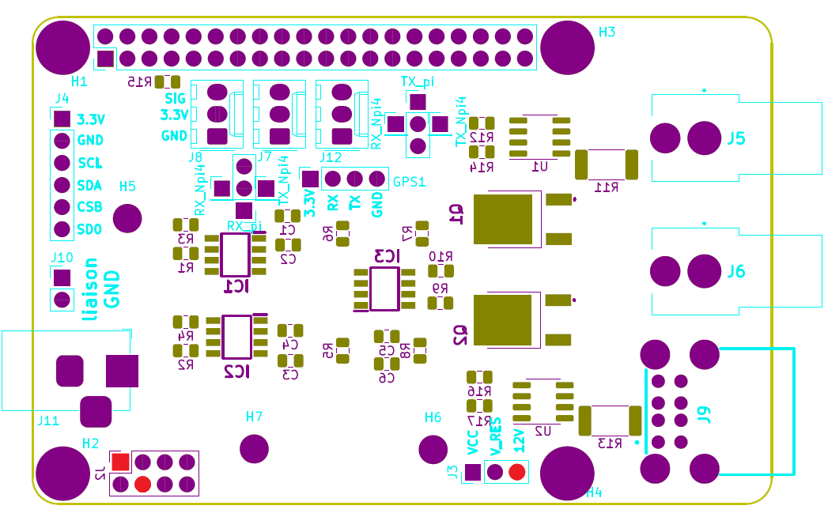

12V pins map

## Test 3: VCC equipotential

|  |  |  |
| --- | --- | --- |
| Procedure | Results | Comments |
| Supply the board with VCC on J11 connector.  Check all VCC pins. VCC voltage should be observed. | VCC was chosen to be 5V.  5.01V observed for each VCC pins.  => Validated. |  |

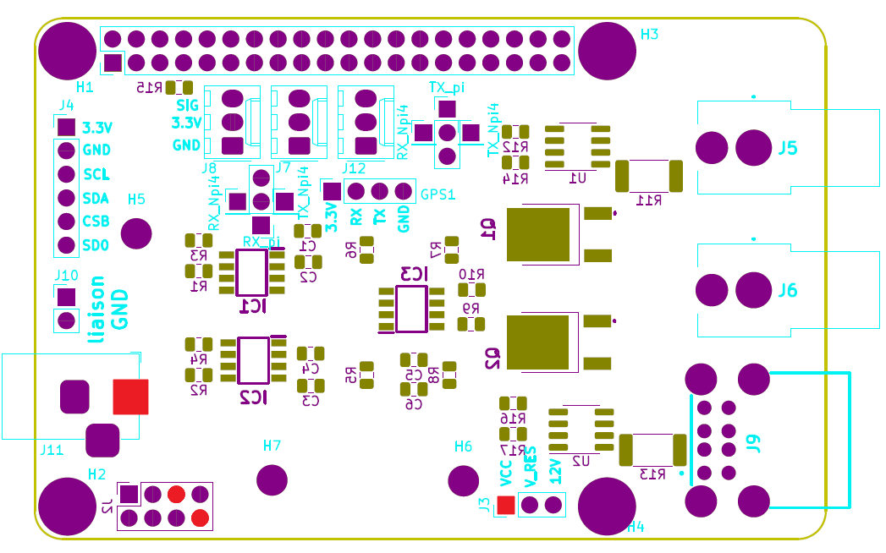

VCC pins map

## Test 4: V_RES equipotential

|  |  |  |
| --- | --- | --- |
| Procedure | Results | Comments |
| Open J3 jumper.  No voltage should be observed on V_RES pins. | 0.0004V observed for V_RES pins.  => Validated. |  |
| Connect the board with the powered “alim_hat” board.  Close J3 jumper with 12V.  12V should be observed on V_RES pins. | 12.04V observed for each V_RES pins.  => Validated. |  |
| Supply the board with VCC on J11 connector.  Close J3 jumper with VCC.  VCC voltage should be observed on V_RES pins. | VCC was chosen to be 5V.  5.01V observed for each V_RES pins.  => Validated. |  |

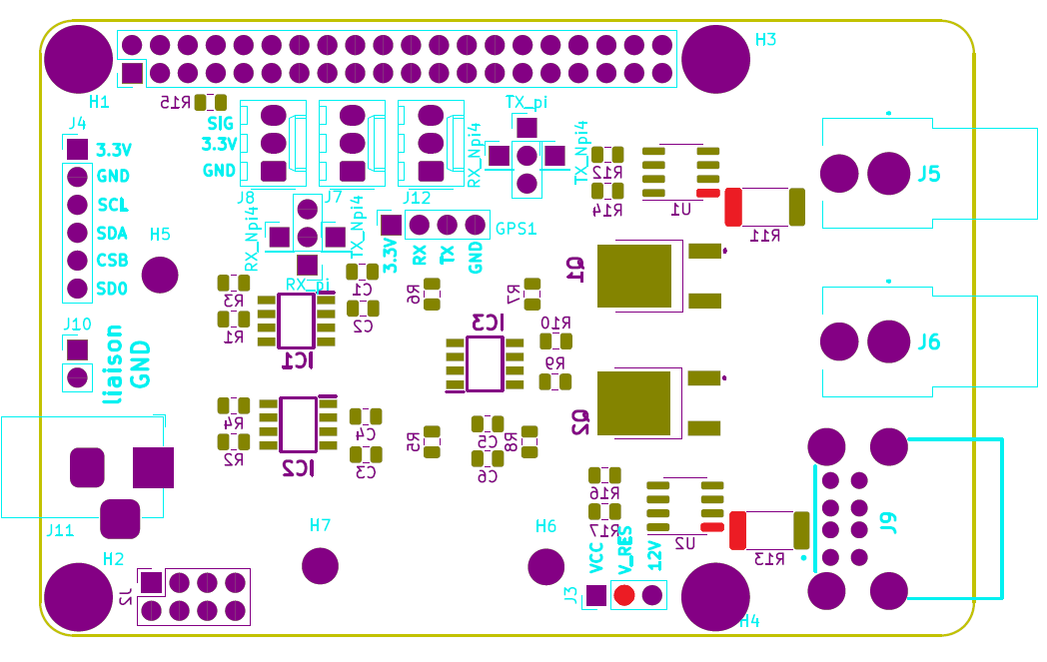

V_RES pins map

## Test 5: 5V equipotential

|  |  |  |
| --- | --- | --- |
| Procedure | Results | Comments |
| Connect the board with the powered “alim_hat” board.  Check all 5V pins. 5V should be observed. | 5.01V observed for each 5V pins.  => Validated. |  |

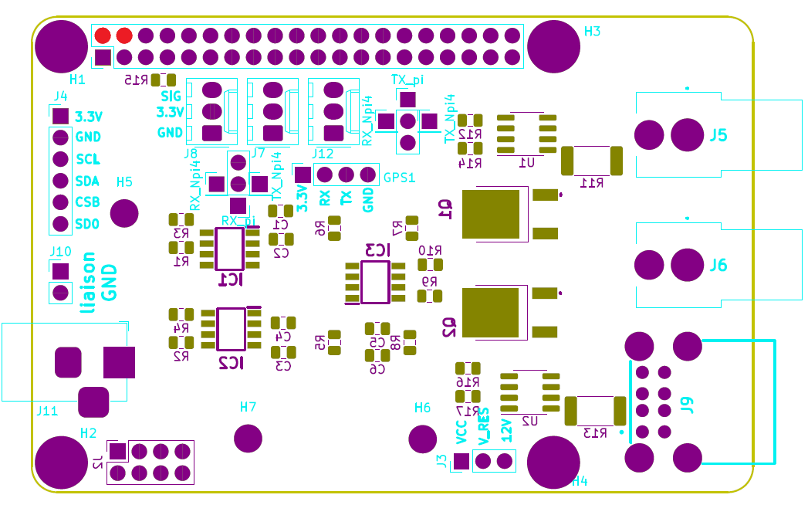

5V pins map

## Test 6: 3.3V equipotential

|  |  |  |
| --- | --- | --- |
| Procedure | Results | Comments |
| Connect the board with the Raspberry pi 4.  Check all 3.3V pins. 3.3V should be observed. | 3.288V observed for each 3.3V pins.  => Validated. |  |

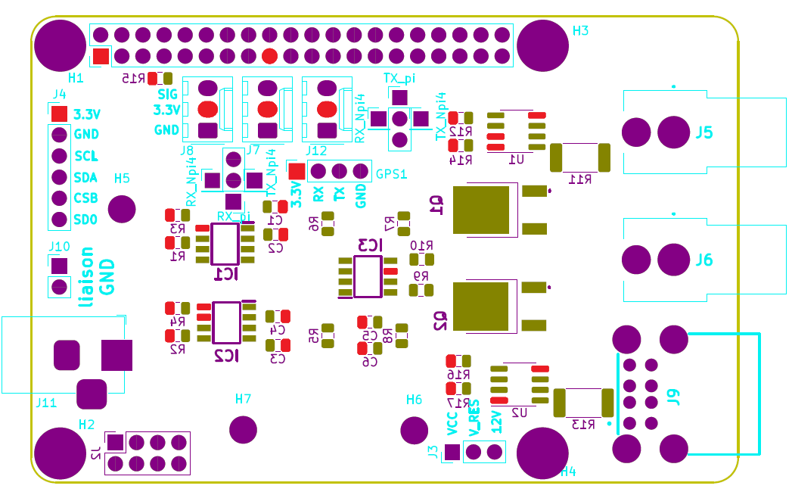

3.3V pins map

## Test 7: GND equipotential

|  |  |  |
| --- | --- | --- |
| Procedure | Results | Comments |
| Connect the board with the Raspberry pi 4.  Close “liaison GND” jumper.  Check all GND pins. | Continuity ensured between GND pins.  Continuity ensured between GND_Rpi pins.  Continuity ensured between GND pins and GND_Rpi pins with “Liaison GND” jumper Closed.  => Validated. |  |

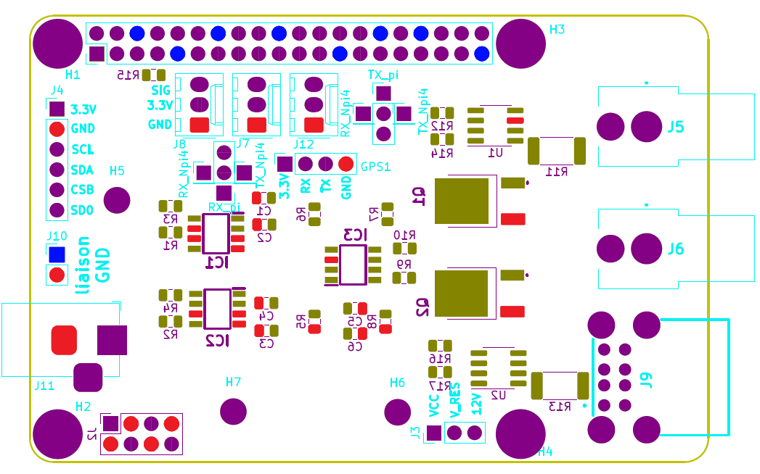

GND pins and GND_Rpi pins map

## Test 8: UART communication

|  |  |  |
| --- | --- | --- |
| Procedure | Results | Comments |
| Connect the board with the Raspberry pi 4.  Open both UART cross jumpers.  Check continuity for this configuration.  No sound response should be heard. | No sound response heard.  => Validated. |  |
| Close both UART cross jumpers with the configuration: RX_pi/RX and TX_pi/TX.  Check continuity for this configuration.  A sound response should be heard. | Sound response heard. Continuity is ensured between RX_pi/RX and TX_pi/TX.  => Validated. | Two continuity must be checked (RX_pi/RX and TX_pi/TX). |
| Close both UART cross jumpers with the configuration: TX_pi/RX and RX_pi/TX.  Check continuity for this configuration.  A sound response should be heard. | Sound response heard. Continuity is ensured between TX_pi/RX and RX_pi/TX.  => Validated. | Two continuity must be checked (TX_pi/RX and RX_pi/TX). |
| Close both UART cross jumpers with the configuration: RX_Npi4/RX and TX_Npi4/TX.  Check continuity for this configuration.  A sound response should be heard. | Sound response heard. Continuity is ensured between RX_Npi4/RX and TX_Npi4/TX.  => Validated. | Two continuity must be checked (RX_Npi4/RX and TX_Npi4/TX). |
| Close both UART cross jumpers with the configuration: TX_Npi4/RX and RX_Npi4/TX.  Check continuity for this configuration.  A sound response should be heard. | Sound response heard. Continuity is ensured between TX_Npi4/RX and RX_Npi4/TX.  => Validated. | Two continuity must be checked (TX_Npi4/RX and RX_Npi4/TX). |
| With one of these configurations, establish a communication.  Communications should be observed between GPS and Raspberry pi 4. | No communication establish with GPS.  => Not validated. |  |

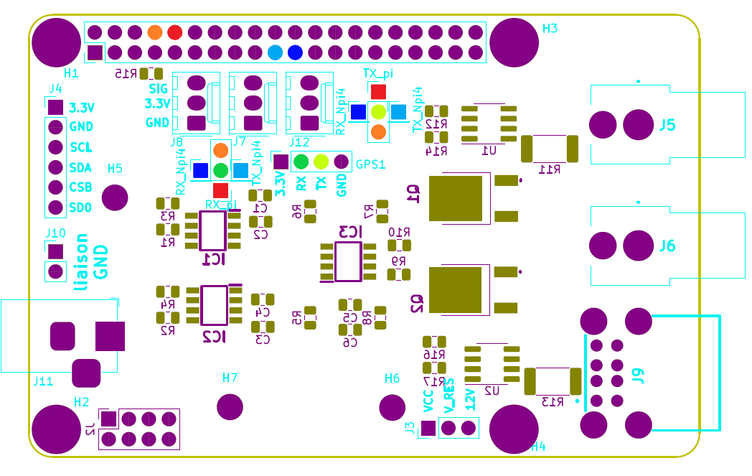

RX, TX, RX_pi, TX_pi, RX_Npi4 and TX_Npi4 pins map

## Test 9: MOSFETs FDD844L-F085

|  |  |  |
| --- | --- | --- |
| Procedure | Results | Comments |
| For each MOSFET (Q1 and Q2):  Check continuity between MOSFET source pin and MOSFET drain pin.  No sound response should be heard. | No sound response heard.  MOSFETs are in blocking mode.  => Validated. | IC1 command PWM for Q1.  IC2 command PWM for Q2.  IC1 address : 0101000  IC2 address : 0101010 |
| Connect the board with the Raspberry pi 4.  Supply V_RES = 5V.  With a PWM ratio of 25%.  Check the current through the MOSFET. A > 0A should be observed. | 0.36A observed through Q1 MOSFET.  0.35A observed through Q2 MOSFET.  => Validated. |  |
| With a PWM ratio of 50%.  Check the current through the MOSFET. = A > A should be observed. | 0.83A observed through Q1 MOSFET.  0.81A observed through Q2 MOSFET.  => Validated. |  |
| With a PWM ratio of 75%.  Check the current through the MOSFET. = A > A should be observed. | 1.29A observed through Q1 MOSFET.  1.27A observed through Q2 MOSFET.  => Validated. |  |
| With a PWM ratio of 100%.  Check the current through the MOSFET. = A > A should be observed. | 1.87A observed through Q1 MOSFET.  1.84A observed through Q2 MOSFET.  => Validated. | must be the current request by the heating resistor, in our case.  A current loss is observed (cables junction is one of the factors).  The operating logic is respected, current increase through the MOSFET when PWM increase. |

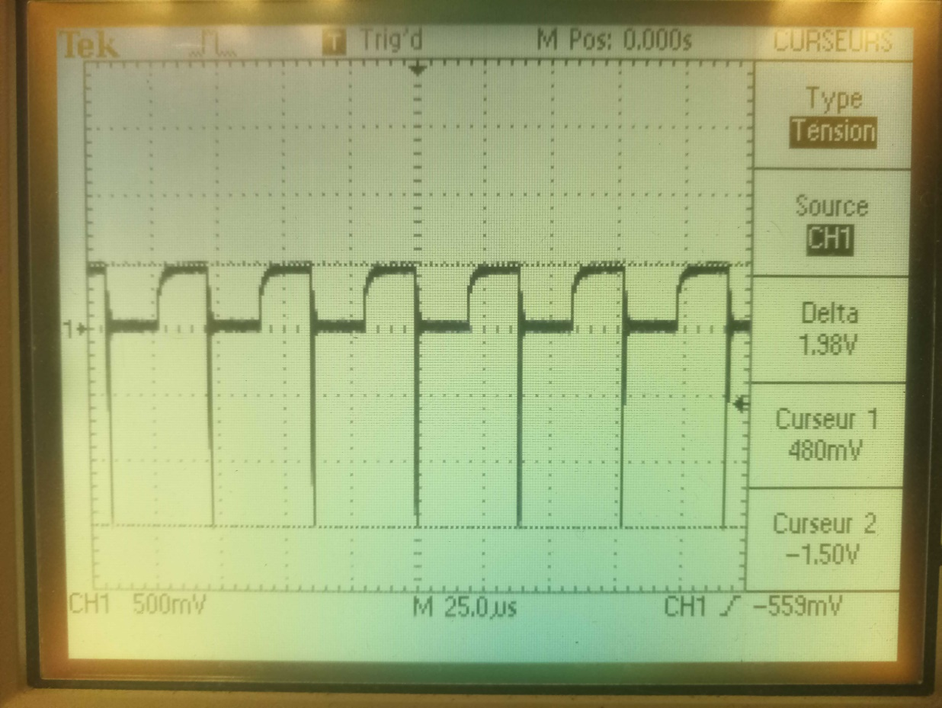

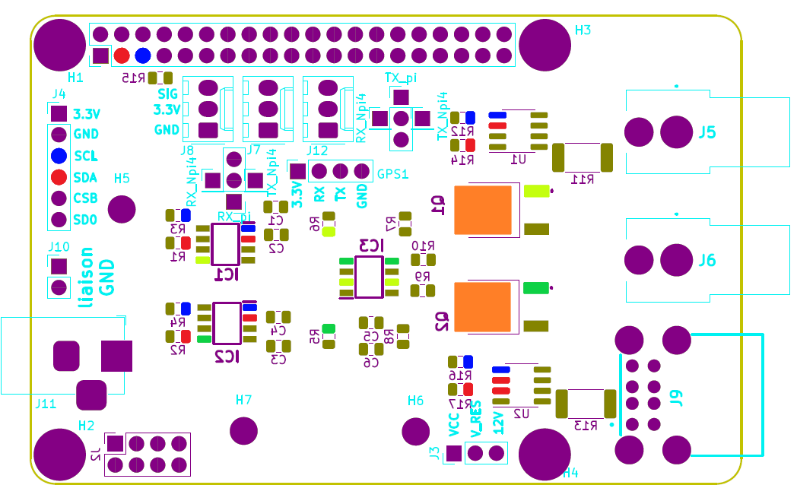

MOSFET drain

MOSFET drain

SDA, SCL, PWM1, PWM2 pins map

## Test 10: USB resistor

|  |  |  |
| --- | --- | --- |
| Procedure | Results | Comments |
| Connect the board with the Raspberry pi 4.  Connect a heating resistor to USB connector.  For each PWM signal tested with MOSFETs, check the current through the USB connector. Current should be identical to the MOSFETs ones. | Same current than MOSFETs one observed for USB.  => Validated. |  |

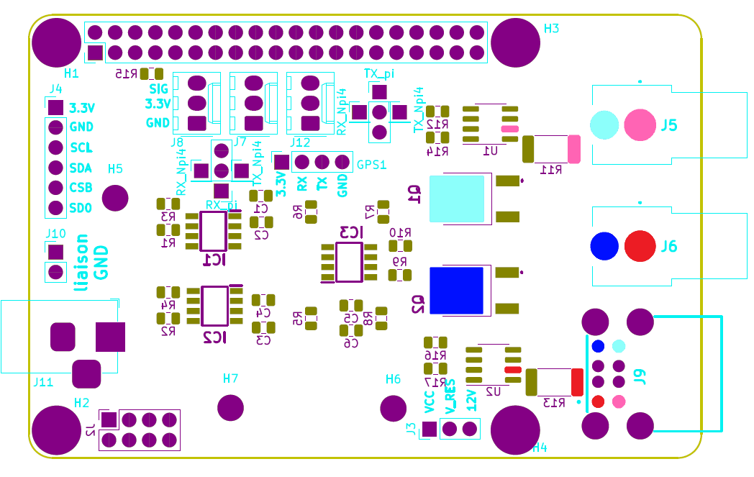

V+ pins, V- pins and V+ pins and V- pins map

## Test 11: RCA resistor

|  |  |  |
| --- | --- | --- |
| Procedure | Results | Comments |
| Check continuity between RCA and USB pins.  A sound response should be heard. | Sound response heard. Continuity is ensured between RCA and USB.  => Validated. | RCA and USB are equivalent. Because continuity is ensured, USB test results cover RCA test results.  Continuity observed between V+ pins and V+ pins, no impact. |

## Test 12: BME280 board communication

|  |  |  |
| --- | --- | --- |
| Procedure | Results | Comments |
| Connect the board with the Raspberry pi 4.  Request for local temperature, and humidity with I2C.  Local temperature in °C and humidity in % and the calculated dew point should be returned. | Communication establish with BME280 board.  Return 24.08°C, 20.98% humidity and dew point = 0.366.  Consistent values.  => Validated. | BME280 address : 1110110 |

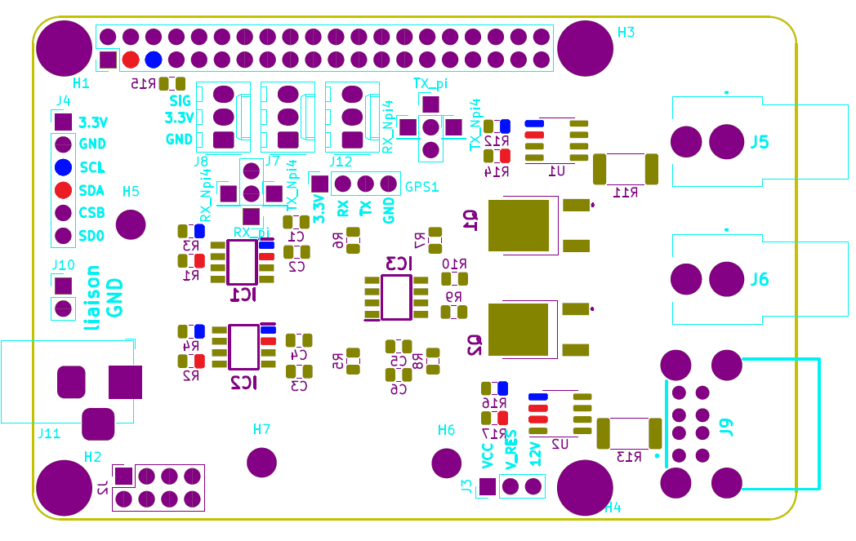

SDA pins and SCL pins map

## Test 13: INA219 communication

|  |  |  |
| --- | --- | --- |
| Procedure | Results | Comments |
| Connect the board with the Raspberry pi 4.  For each INA219 (U1 and U2):  With a heating resistor connected to the USB connector, request for current and voltage in I2C.  V_RES and the heating resistor current should be returned. | INA219 in short circuit since voltage inversion have been applied and ESD chocks have been introduced.  Tests cannot be performed.  => Not validated. | U1 address : 1000101  U2 address : 1000110  INA219 initially not in short circuit. Manipulation error had create the short circuit. |



SDA pins and SCL pins map

## Test 14: D18B20 sensors communication

|  |  |  |
| --- | --- | --- |
| Procedure | Results | Comments |
| Connect the board with the Raspberry pi 4.  Request for resistor temperature.  A temperature in °C should be returned. | 1-wire detected. Multiple sensors with different address identified.  23°C return for room temperature and 31°C return for hand temperature.  => Validated. |  |

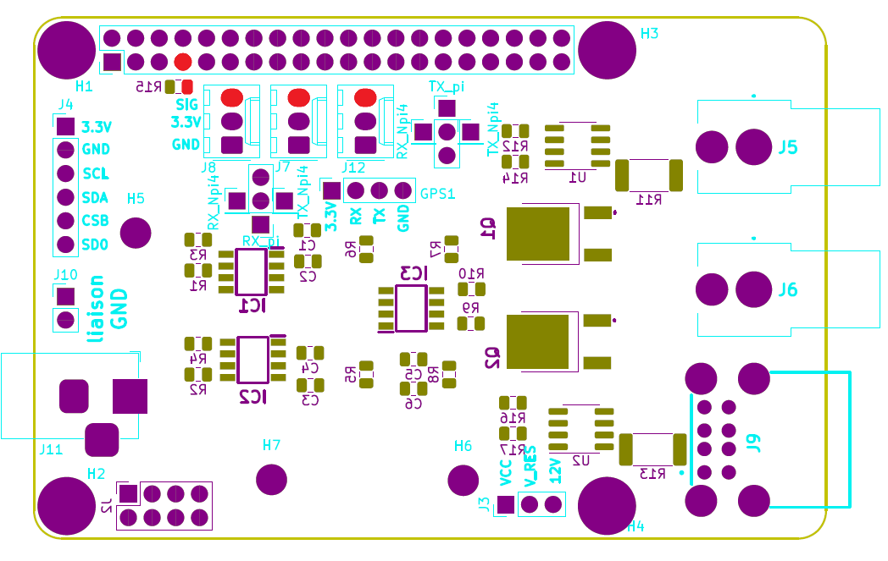

1-Wire pins map

# Error report

## Functionality

* No communication with GPS board.
* INA219 in short circuit since voltage inversion have been applied and ESD chocks have been introduced.

## CAO/Fabrication

* Missing labels for IC1, IC2, IC3, Q1 and Q2 on PCBA (corrected on PCB).
* Fixation hole of BME280 board too small on PCBA (corrected on PCB).
* TX_pi label on cross jumper is not corresponding to associate pins on PCBA (corrected on PCB).