Supporting Information
Acid-Catalyzed Reactions of Epoxides on Atmospheric Nanoparticle Growth
Wen Xu, Mario Gomez-Hernandez, Jeremiah Secrest, Song Guo, Annie. L. Zhang, Renyi Zhang*
¹Department of Chemistry and ²Department of Atmospheric Sciences, Texas A&M University, College Station, TX, USA
*Corresponding author: Renyi Zhang: Renyi-zhang@tamu.edu. Fax: +979-862-4466
Experimental Methods
As depicted in Figure S1, sulfuric acid nanoparticles were produced either using a TSI atomizer or by homogeneous binary nucleation.¹ The freshly generated nanoparticles with a broad size spectrum were subsequently charged by a ²¹⁰Po radioactive source. Charged particles were size selected by a n-DMA and the resulting monodispersed nanoparticles were passed through a stainless steel reaction tube with an inner diameter of about 1.0 inch. The residence time for the mondispersed nanoparticles in the reaction tube was estimated to be about 3 s, with a flow rate of about 3000 sccm. Epoxide vapors were added upstream of the reaction tube to be mixed with nanoparticles. Sulfuric acid nanoparticles after epoxides exposure were passed into a second n-DMA, where size changes of sulfuric acid nanoparticles before and after epoxides exposure were detected.
Sulfuric acid nanoparticles exposed to epoxides were introduced into an electrostatic particle precipitator. As 6 kV was applied to a precipitator, nanoparticles were collected on a platinum filament that was protected by a sheath flow of 400 sccm. After a collection time of about 10 minutes, the filament was pushed into the ID-CIMS evaporation port and a small AC voltage was applied to the filament to evaporate nanoparticles by heating. Hydronium was used as the reagent ion in all ID-CIMS measurements. ID-CIMS spectra were recorded in a range from 60 to 450 amu.
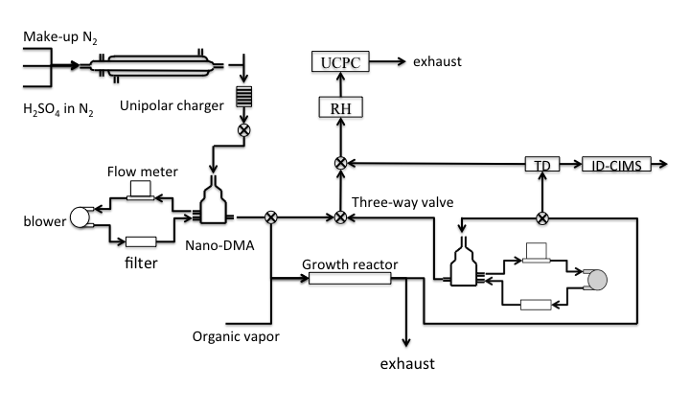
Figure S1. The experimental setup for measurements of the growth factor and chemical analysis using nano-TDMA and TD-ID-CIMS.
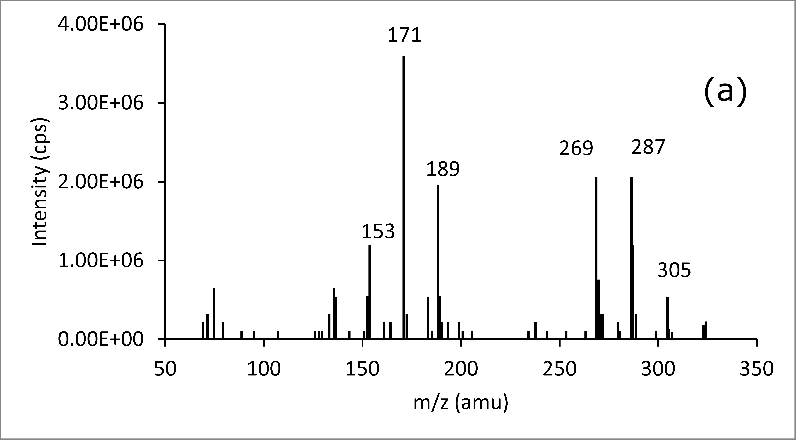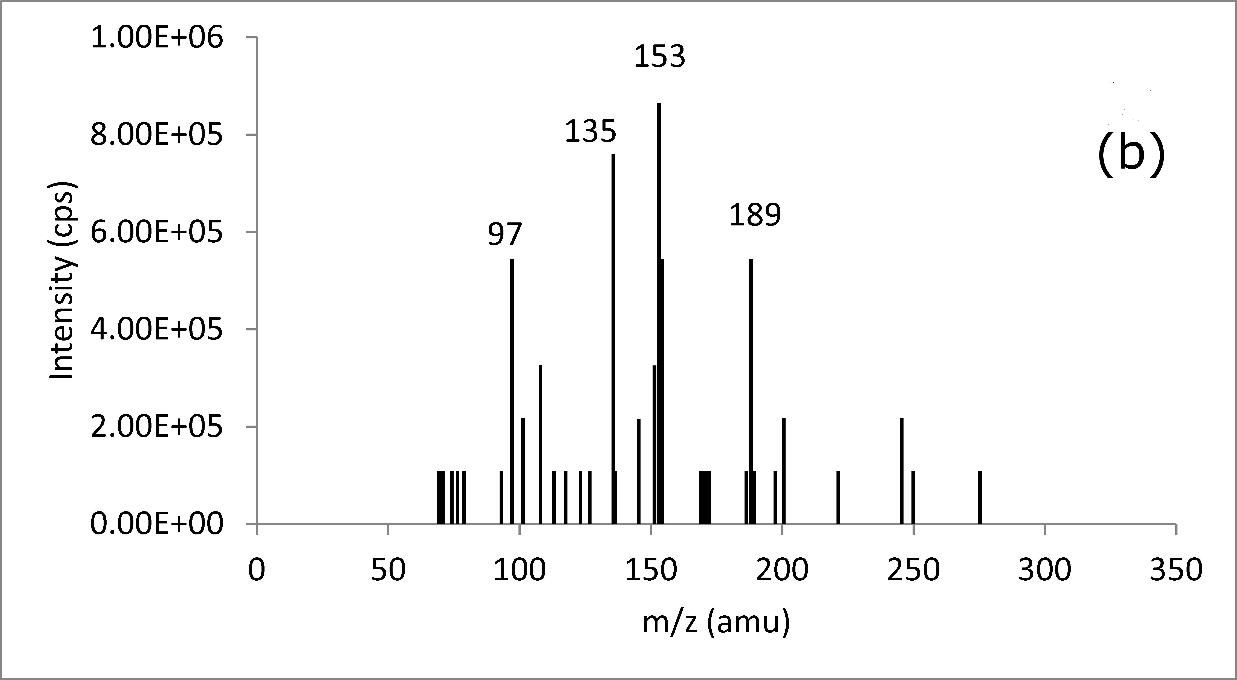
Figure S2. The heterogeneous reaction of α-pinene oxide on sulfuric acid nanoparticles of 40 nm. (a) and (b) correspond to TD-ID-CIMS spectra of 40 nm sulfuric acid nanoparticles after exposure to α-pinene oxide vapor at 5 and 20% RH, respectively.
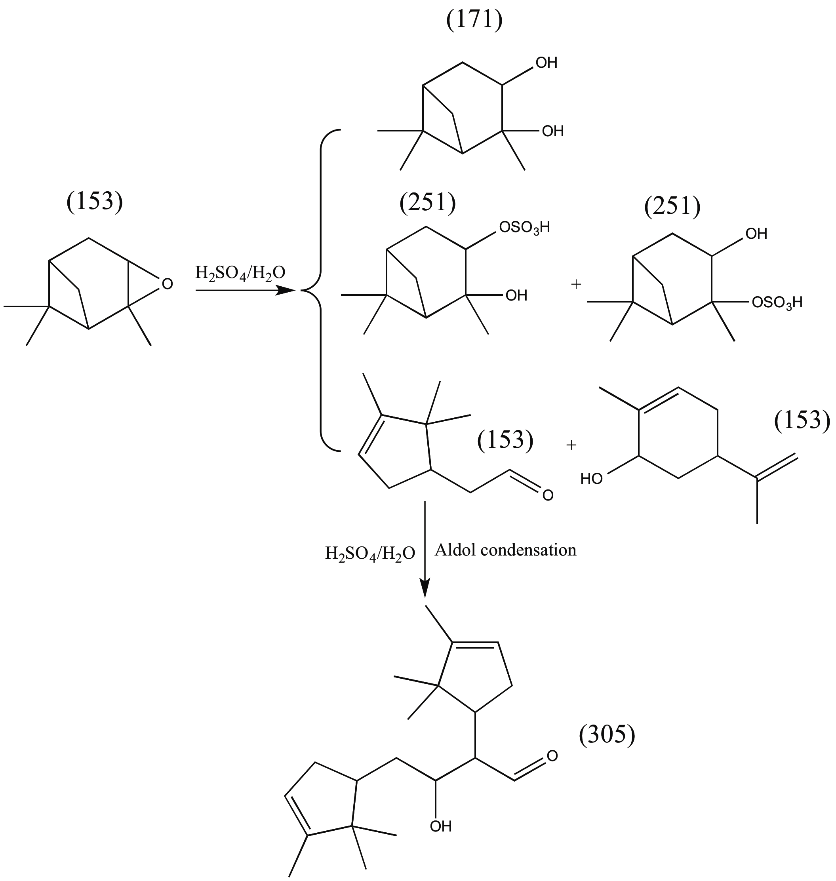
Scheme S1. The heterogeneous reaction mechanism of α-pinene oxide on sulfuric acid nanoparticles of 40 nm.
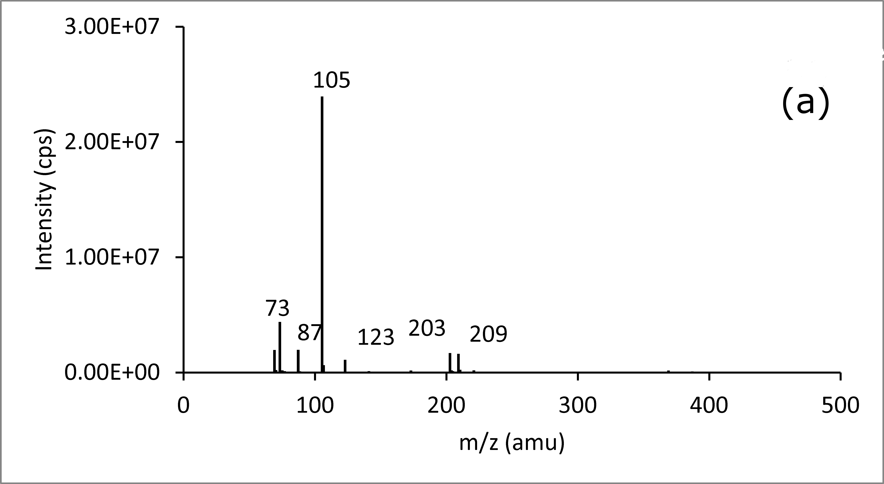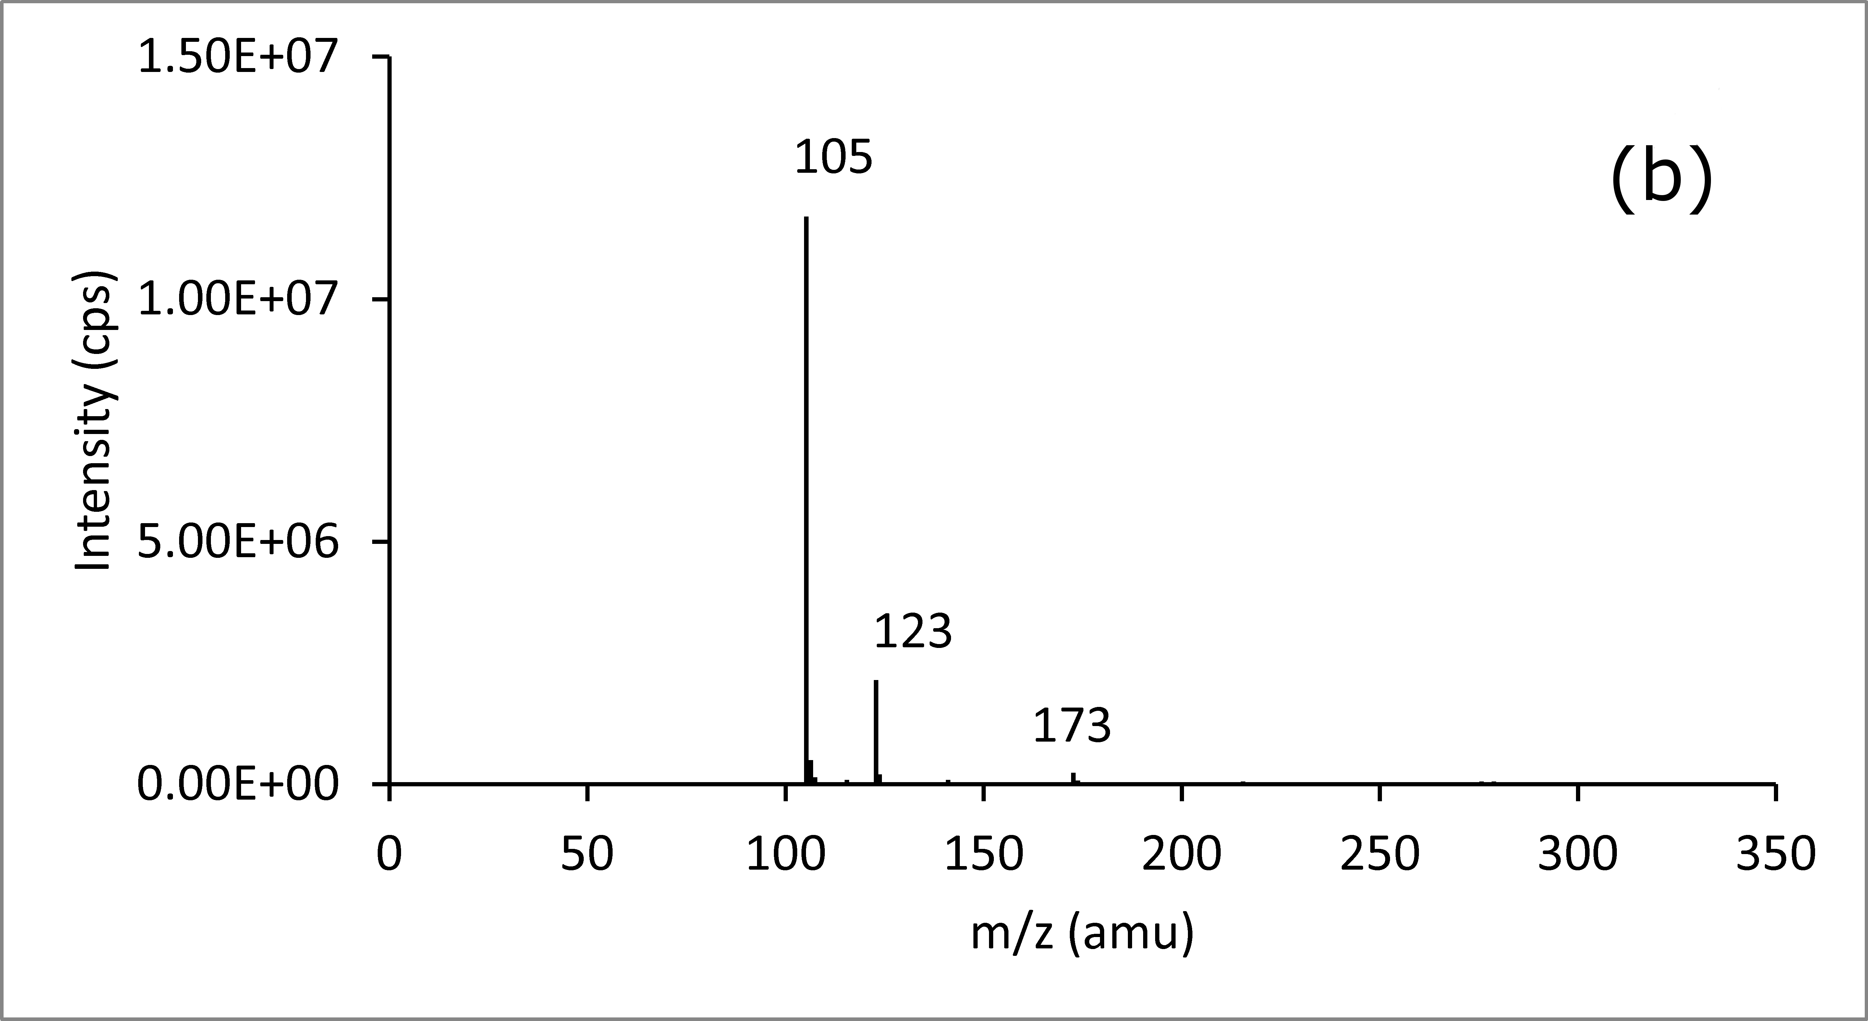
Figure S3. The heterogeneous reaction of butadiene diepoxides on sulfuric acid nanoparticles of 40 nm. (a) and (b) correspond to TD-ID-CIMS spectra of 40 nm sulfuric acid nanoparticles after exposure to butadiene diepoxides at 4 and 32% RH, respectively.
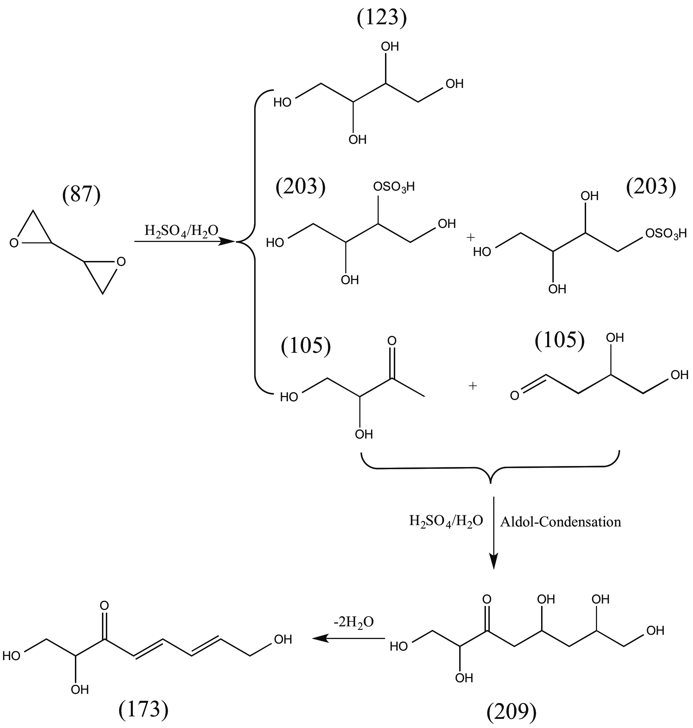
Scheme S2. The heterogeneous reaction mechanism of butadiene diepoxides on sulfuric acid nanoparticles of 40 nm.
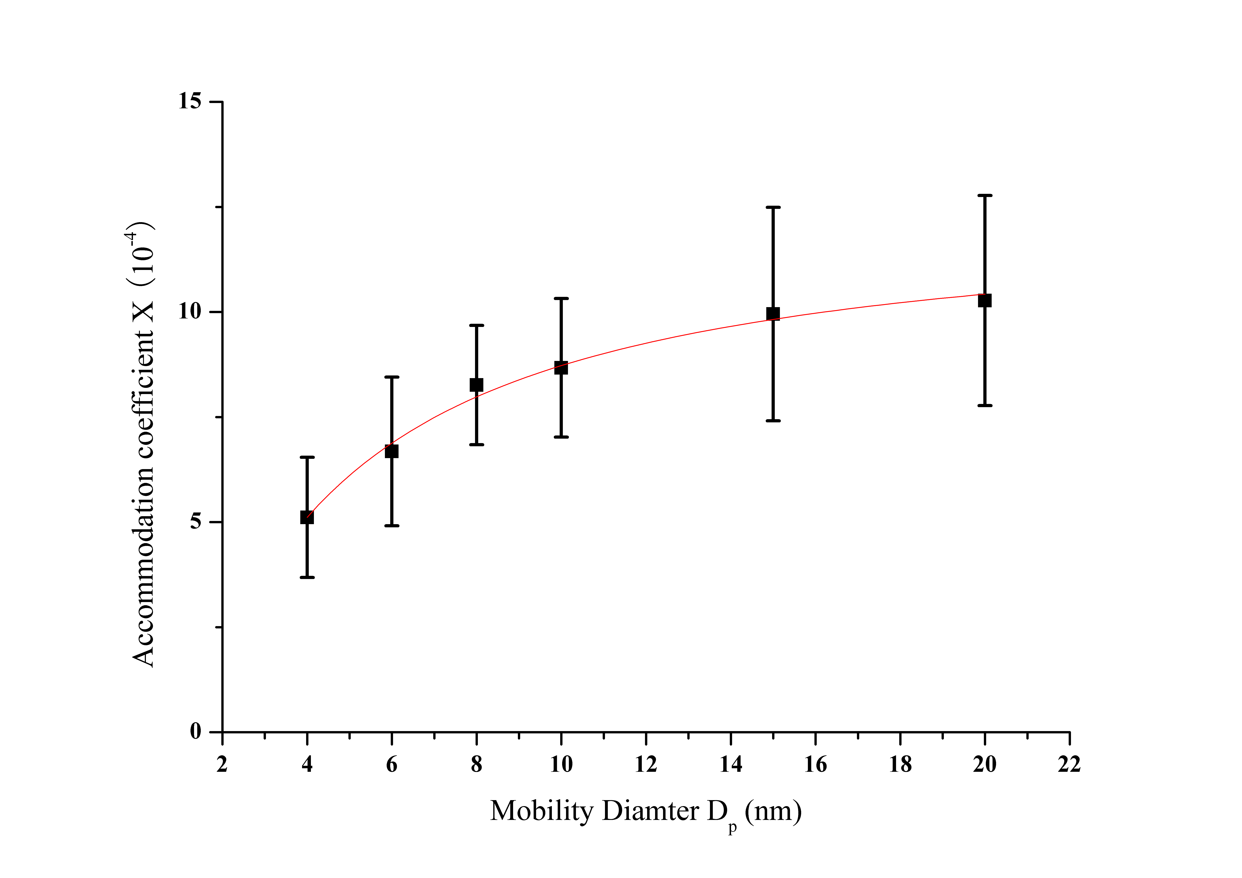
Figure S4. Size-dependent accommodation coefficients for isoprene oxide on sulfuric acid nanoparticle surface at 43% RH. The fitted line is obtained using the Kelvin equation.

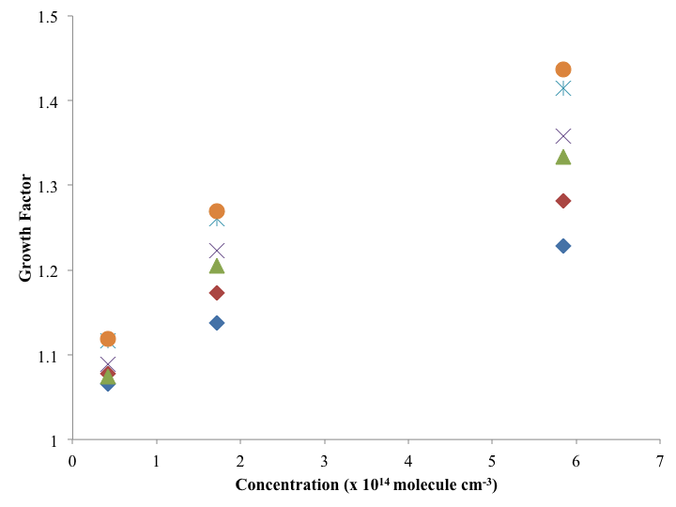
Figure S5. Growth factors as a function of the isoprene oxide concentrations at 43% RH for different sizes. The symbols from the bottom to top correspond to 4, 6, 8, 10, 15, and 20 nm particles.
Table S1. Assignments of the major peaks in the mass spectra collected using TD-ID-CIMS.
Mass spectrum number | Peak position (m/e) | Structures ([M∙H]⁺)
Isoprene oxide  (a) and (b) | 103 | 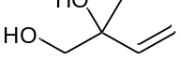
Isoprene oxide  (a) and (b) | 169 | 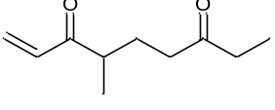
Isoprene oxide  (a) and (b) | 85 | 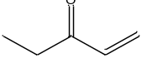
Isoprene oxide  (a) and (b) | 337 | 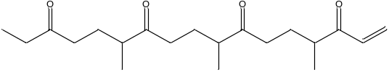
Isoprene oxide  (a) and (b) | 421 | 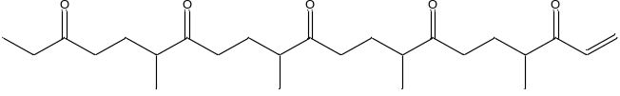
α-pinene oxideª  (c) and (d) | 171 | 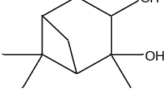
α-pinene oxideª  (c) and (d) | 269 | 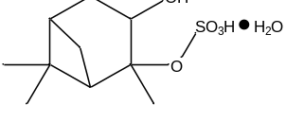 or 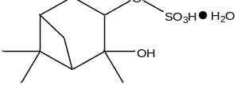
α-pinene oxideª  (c) and (d) | 153 | 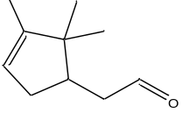 or 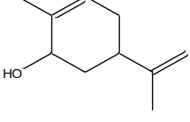
α-pinene oxideª  (c) and (d) | 189 | 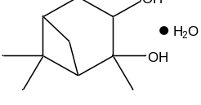
Butadiene diepoxide  (e) and (f) | 105 | 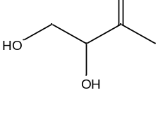 or 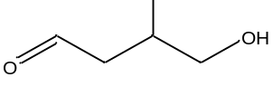
Butadiene diepoxide  (e) and (f) | 123 | 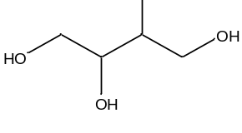
Butadiene diepoxide  (e) and (f) | 203 | 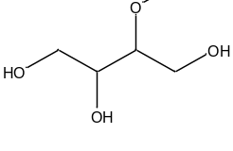 or 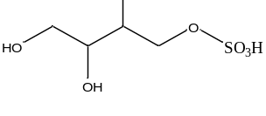
Butadiene diepoxide  (e) and (f) | 209^{b} | 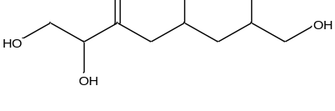
Butadiene diepoxide  (e) and (f) | 173^{b} | 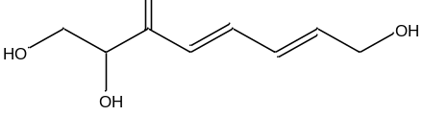

- Possible structures taken from Iinuma et al.^{6a}
- Only one possible structure is presented.
Table S2. Size-dependent accommodation coefficients α for isoprene oxide on sulfuric acid nanoparticle surface at 43% RH. The fitted parameters α∞ (accommodation coefficient for the planar surface) and d_{σ} (characteristic diameter for the Kelvin effect) are also presented.
Size | 4 nm | 6 nm | 8 nm | 10 nm | 15 nm | 20 nm
Accommodation coefficient α (×10⁻⁴) | 5.11 (1.43) | 6.68(1.77) | 8.26 (1.42) | 8.67(1.65) | 9.95 (2.54) | 10.27 (2.50)
Fitted parameters
α∞ (×10⁻⁴) | 12.46 (0.26)
d_{σ} (nm) | 3.56 (0.18)
Size dependent growth rates and accommodation coefficients calculation
Since the largest particle is 20 nm in our experiments, which is much smaller than 100 nm, the kinetic regime growth mechanism is applicable.² The molar flux of epoxides (J_{k}) to the nanoparticle surface is expressed as,
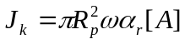 (1)
where R_{p} is the nanoparticle radius, ω is the thermal kinetic speed, α_{r} is the size dependent uptake coefficient, and [A] is the concentration of epoxides. Therefore, the growth rate of the nanoparticles can be derived from the mass conservation law,
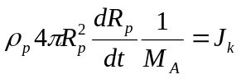 (2)
where ρ_{p} is the density of the nanoparticle, and M_{A} is the molecular mass of condensing species. By solving the above differential equation using the initial condition R_{p0} at 0, the time and concentration dependence of the growth factor is obtained.
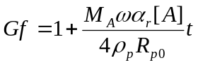 (3)
From equation (3), the growth factor is linearly dependent on the exposure time and the concentration of the condensing vapor. Fitting the growth factors versus concentration curve via the equation (3), the growth rates for sulfuric acid nanoparticles of various sizes in the unit time (s) and epoxides concentration are obtained. The thermal kinetic speed (ω) at 298.15 K is 274.13 m s⁻¹ for isoprene oxide. The molecular mass of isoprene oxide (M_{A}) is 84 g mol⁻¹. Assuming 1 g cm⁻³ for the density of the nanoparticle, the size dependent uptake coefficients (α_{r}) is obtained from the size dependent growth rates.
Planar surface accommodation coefficient and Kelvin effect characteristic length calculation
From the size dependent uptake coefficients, the uptake coefficient for planar surface (α∞) and the Kelvin effect characteristic diameter (d_{σ})³ is extracted via nonlinear curve fitting using the following equation (see Figure S4).
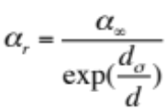 (4)
Reference

(1) Wang, L.; Xu, W.; Khalizov, A.; Zheng, J.; Qiu, C.; Zhang, R. J. Phys. Chem. A 2011, 115, 8940.
(2) Seinfeld, J. H.; Pandis, S. N. Atmospheric Chemistry and Physics - From Air Pollution to Climate Change; 2nd ed.; John Wiley & Sons, 2006.
(3) Lewis, E. R. J. Aerosol Sci. 2006, 37, 1605.

