First i found rows in MySQL database that I needed and created view

**CREATE** **VIEW** timesheet **as**

**SELECT** i.project, i.employee,

**DATE_FORMAT**(i.`date`, "%m/%d/%Y") **AS** "datum",

TIMEDIFF(i.`end`,starttime) **AS** "razlika",

i.task **as** "task",

**CONCAT**(e.vorname,' ',e.name) **AS** "ime",

**CONCAT** (p.mark, ' ', p.name) **AS** "projekt"

**FROM** hrm_internal_hour i

**JOIN** hrm_employees e

**ON** i.employee=e.id

**JOIN** project_list p

**ON** i.project = p.id

After that I created table

**CREATE** **TABLE** timesheets **AS**

**SELECT**

project,employee,datum,razlika,task,ime,projekt

**FROM** sac.timesheet;

Let see what we have now

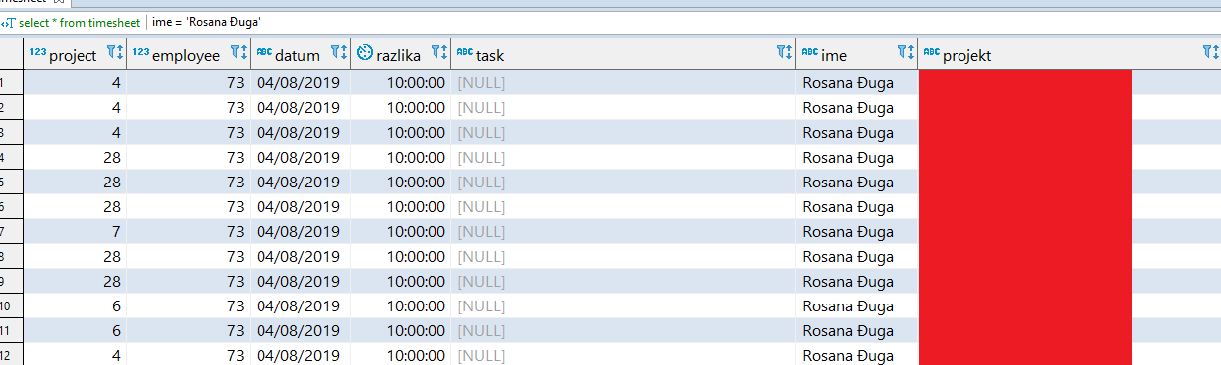

And some project like 123456 Project or some other project

After that we go to Postgres database for Odoo

All the timesheets are stored as records in default table account_analytic_line

**select** * **from** public.account_analytic_line

to see how the insert should look like and example of it

**INSERT** **INTO** public.account_analytic_line(create_uid, user_id,account_id,company_id, write_uid,amount,unit_amount,**date**,create_date,write_date, partner_id,**name**,product_uom_id,amount_currency,is_timesheet) **VALUES**(1,39,258, 1, 1, 0,'9.45','02/04/2019','02/04/2019','02/04/2019',40,'/', 5, 0, **true**);

ETL makes the input we can import in Postgres.

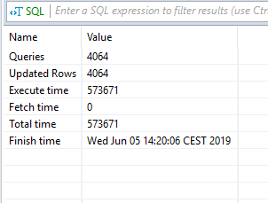

This is parto of code for import

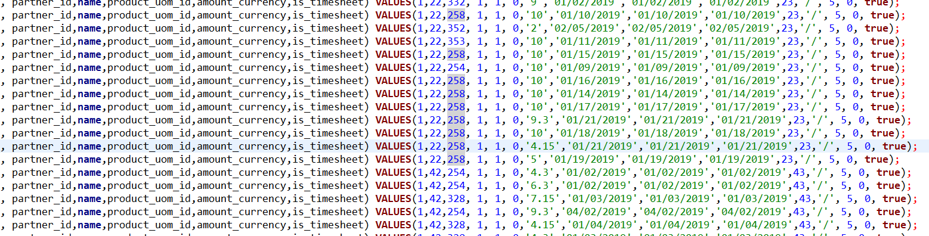

And import after that

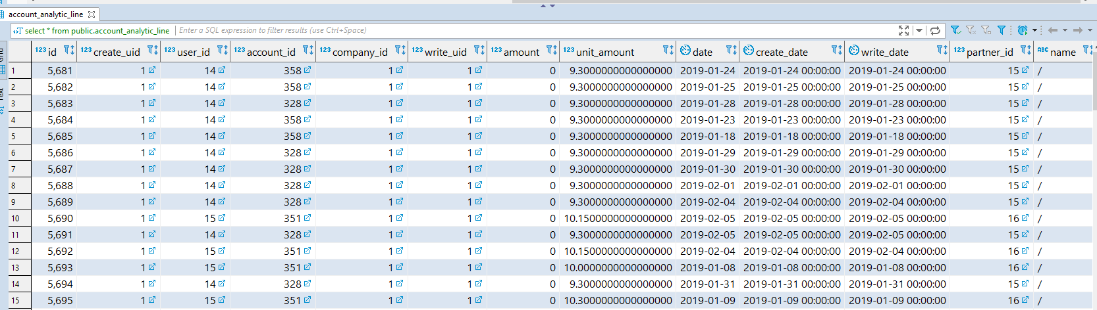

On Odoo Timesheet and Activities we get something like this

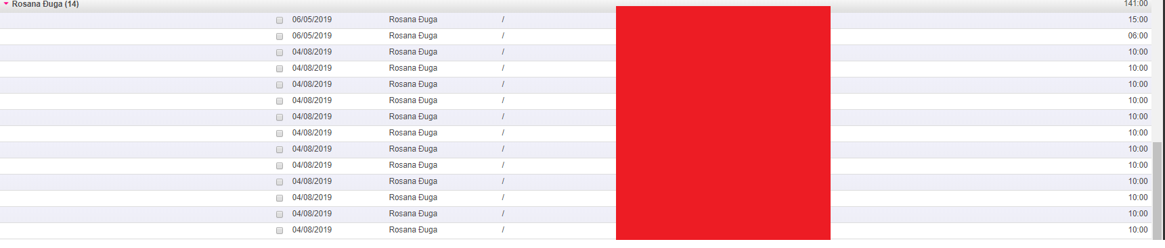

Red are the projects Im working on so it irrelevant, let say it writes 123456 Project