Table of Contents
Document Version 2
1. Purpose 3
1.1. Intended Audience 3
1.2. Intended Use 3
1.3. Scope 3
1.4. Definitions and Acronyms 3
2. Overall System Description 4
2.1. Use Case Diagrams 4
2.2. System Architecture 5
2.3. Functional Requirements 6
2.3.1. Function xxxx 6
2.3.2. Function yyyy 7
2.3.3. Function zzzz 7
3.1. Non-Functional Requirements 8
3.1.1. Non-Functional Requirement xxxx 8
4. Software Architecture 9
4.1. Static Software Architecture 9

Document Version
No | Update | Name | Date | Version
1. | Initial version |  |  | 1.0

Purpose

Intended Audience
This SRS document describes the System Requirements and Software Design for an IoT Coffee maker and the target audience are System and Software Engineers working on the development of this project.

Intended Use
The SRS defines the overall System Architecture and Requirements as well as the Software Architecture and Design. This document is also contains the definition of the System Requirements which shall be used as the input for System Test cases and Software Unit Test cases.

Scope

Definitions and Acronyms

Acronym | Description
IR | Infra Red
LED | Light Emitting Diode
NFC | Near Field Communication
SW | Software
HW | Hardware

Overall System Description

Use Case Diagrams

Add Use Case diagrams here ..

System Architecture

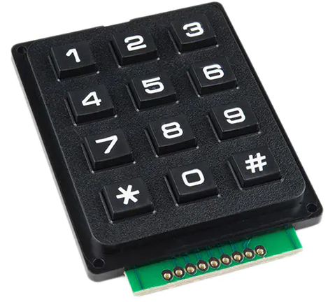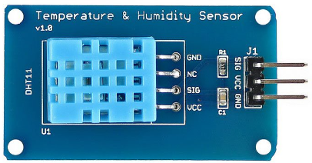
DC Motor
Servo Motor
Heater
Water Temperature Sensor
SPI_ADC_CH01
LCD
I2C
Raspberry Pi Development Board
Water Temperature Sensor

Functional Requirements

Function xxxx

Add short description here …

REQ_ID | Requirement
REQ-xx
REQ-xx
REQ-xx

Function yyyy

Add short description here …

REQ_ID | Requirement
REQ-xx

Function zzzz
- Add short description here …

REQ_ID | Requirement
REQ-xx

Non-Functional Requirements

Non-Functional Requirement xxxx

Add short description here …

REQ_ID | Requirement
REQ-xx
REQ-xx

Software Architecture

Static Software Architecture

The Software Architecture defines the various Software Components that are developed to realize the implementation of the system requirements.
PowerMgt
HMI
Application Layer
Hardware Abstraction Layer (HAL)
ADC
USonic
NFC
Servo
RainSens
BlackCoffee
HotWater

