BRITTNEY WALLING – CMST 386 – PROJECT 2

Client and Topic

My final website project will be a website dedicated to my artwork. I’ve always loved art and drawing, and I draw a lot of characters ranging from personal original characters, to fanart of official characters. I draw Dungeons and Dragons characters, animal characters, etc. My final project will be showcasing that as an online portfolio.

Development Process and Engagement

I am creating this website for myself. I will dedicate time researching other artist portfolio websites to see what information is needed, how they go about organizing their work, prioritizing what to put on the front page display. I will research artists that inspire me to use as references and for ideas. I will use ideas from similar artists to conduct a reasonable commission set up. Since I draw the style artwork that I like, it will be easy for me to come up with an interface and design that will appeal to similar people looking for similar artwork to my own.

Testing

I will test the website myself, and have some other artist friends look over the website and give their own feedback on the layout, design, and information provided. I plan to include the following pages:

Home - The main homepage provides a small snapshot of my artwork and a brief description of what I do.

About - A page about the artist; myself.

Commissions - A page displaying commission information, fees, etc.

Order - A page with a submission box to request artwork commissions, including contact information in case the order form isn’t working properly.

Gallery - A page with various pieces of artwork I’ve completed, sorted into different categories:

Original Artwork

Character Artwork

Reviews - A page featuring comments and reviews on my artwork will be beneficial, that way new visitors can see any credibility I have.

Shows and Conventions - A page dedicated to listing any shows or conventions around the country I will be attending to sell my work.

Links - A page so, if I’m not the kind of artist someone is looking for, people can find other similar artists who might suit their request better.

I will test the website on the following

browsers: Chrome, Edge, Firefox.

Description

The purpose of the website and business is to get my art and craft more well known and shared. If I wish to turn my hobby into a source of income, I need a website to help me with that goal. Since my craft is art, I plan on developing everything from the layout to the logo myself. I will research my style of art and see what the general audience is, then plan my design based on that. Color schemes, layout, etc will depend on the audience. I will update my website at least once weekly, updating and adding any new artwork or projects I have created to the portfolio for potential commissioners to see.

Growth and Maintenance

I will check on the website weekly to see it’s reach and growth, and modify my advertising and design based on that, to potentially bring in more hits. I also will update things such as commission prices and website design based on other comparable artists and their websites, to try and make mine appealing and draw people in.

Organization

The standard page layout will remain uniform among all of the pages, featuring a header, a topnav, a main body and a footer.

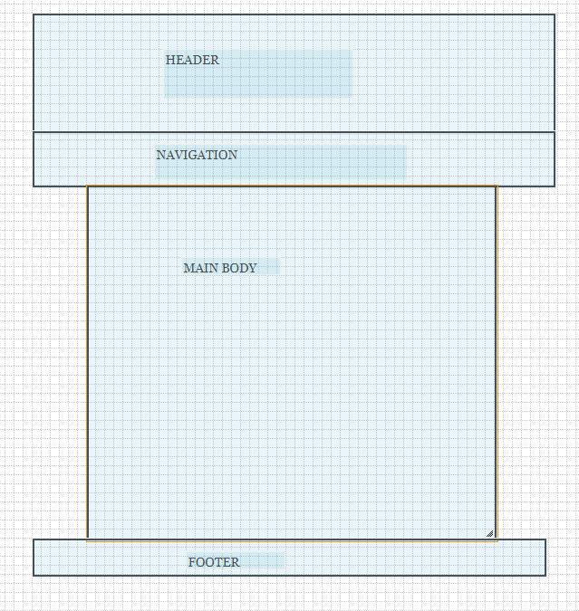

The only pages that will deviate from this design will be pages like the gallery, which will feature a side nav bar to link visitors to the different subpages of the gallery.

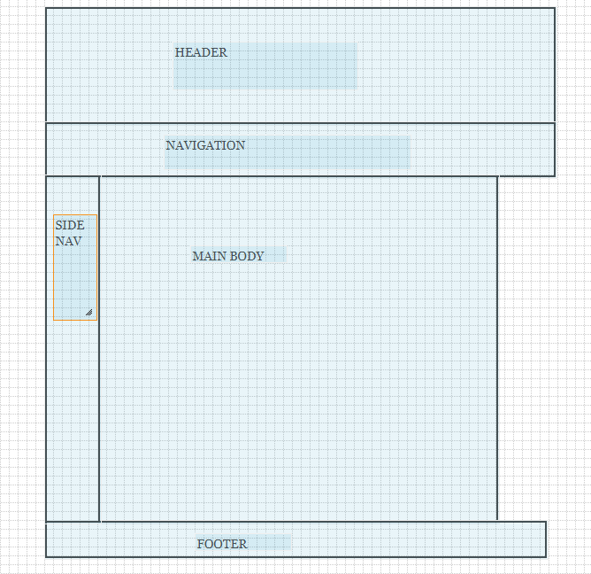

The flow of the website will go as followed:

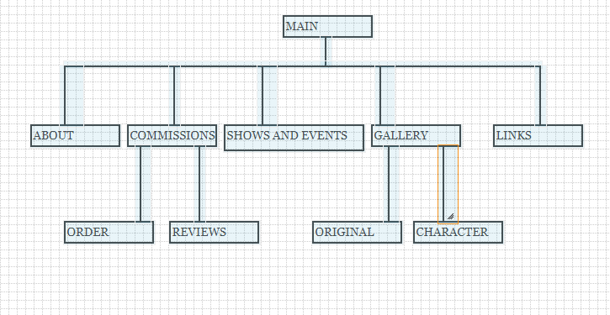

With certain pages such as different styles of art and ordering information and reviews being listed underneath other pages. This will reduce clutter in the topnav and will allow for easier navigation by keeping like pages together.

Marketing

I will market using social media such as Facebook, Tumblr, Instagram, Twitter. I will also post my work on groups on various websites that may help my reach and audience. I will use creative terms and keywords to help my reach in terms of search engines, and I will come up with unique terms and ‘hash tags’ for things like Tumblr and Instagram search algorithms.

Security

I don’t plan on there being any e-commerce or password protected data on the website, all payments will be handled through my paypal account, and the only thing the site will be primarily used for is to show off my work, act as a portfolio and give potential commissioners the access to contact me and request a piece of work.

Web Hosting

I will use the domain name ‘DragonTamer707Art’ for my website, there are many domain addresses that are available using this name. My social media accounts all use ‘DragonTamer707’ or ‘DragonTamerSeven’ as a display name, and I use this name online for many different accounts, including my email address, so it feels like the most appropriate name to take for my website. In terms of a web host, I will require something that can host a large quantity of files without compromising quality, to keep my artwork shown at the best resolution I can. The website will mostly run using html and css coding, and won't require any additional technologies aside from a submission box for commission requests.