Union Hall Compliance Management - Run Processing Documentation
Audience: Business Stakeholders, Process Improvement Teams
Document Version: 1.0
Last Updated: 2026-07-17

Table of Contents
- Executive Overview
- Process Flow Diagram
- Data Inputs & Preparation
- Run Execution Process
- Compliance Engine Logic
- Report Generation
- Key Metrics & Definitions
- Process Workflow Details
- Data Quality & Validation
- Process Improvement Considerations

Executive Overview

What is a "Run"?
A Run is a compliance evaluation cycle that processes hiring data to determine contractor compliance status against union hall dispatch and hire management regulations. Each run:
- Processes all hires that occurred during a specific review period
- Evaluates compliance based on the hiring mode (2To1 or 3To1)
- Generates detailed reports on contractor hiring practices
- Provides recommendations for corrective actions (dispatch requirements)

Run Lifecycle Overview
Document Upload
↓
Hire Data Import (CSV) + Contractor Snapshots (CSV)
↓
Create Run Instance
↓
Load Historical Baseline (Previous Run)
↓
Process Hires Chronologically
↓
Apply Compliance Rules
↓
Generate Reports
↓
Export Results (Excel)

Why Runs Matter
- Regulatory Compliance: Ensures contractors follow union hall dispatch policies
- Fair Competition: Prevents unfair hiring practices
- Data-Driven Decisions: Provides objective metrics for compliance status
- Historical Tracking: Maintains audit trail of compliance over time

Process Flow Diagram

High-Level Data Flow
External Data Sources (HR Systems, Excel Files)
↓
┌───────────────────────────────┐
│ IMPORT PHASE │
├───────────────────────────────┤
│ • Hire Data CSV Import │
│ • Contractor Snapshot Import │
│ • Data Validation │
└───────┬───────────────────────┘
↓
┌───────────────────────────────┐
│ RUN SETUP PHASE │
├───────────────────────────────┤
│ • Create Run Instance │
│ • Select Mode (2To1 / 3To1) │
│ • Set Review Date │
│ • Retrieve Previous Run State │
└───────┬───────────────────────┘
↓
┌───────────────────────────────┐
│ PROCESSING PHASE │
├───────────────────────────────┤
│ • Identify Contractors │
│ • Load Historical State │
│ • Process Hires (Ordered) │
│ • Apply Compliance Rules │
│ • Calculate Metrics │
└───────┬───────────────────────┘
↓
┌───────────────────────────────┐
│ REPORT GENERATION PHASE │
├───────────────────────────────┤
│ • Create Detail Records │
│ • Create Summary Records │
│ • Attach Contractor Metadata │
└───────┬───────────────────────┘
↓
┌───────────────────────────────┐
│ OUTPUT PHASE │
├───────────────────────────────┤
│ • Export Excel Report │
│ • Save to Database │
│ • Generate Audit Trail │
└───────────────────────────────┘

Data Inputs & Preparation

1. Hire Data Import

Source
- CSV file extracted from HR/HRIS systems
- Contains all new hiring activity records

Required Fields
Field | Type | Purpose | Notes
Employer ID | Text | Identify the hiring employer | Links to contractor
Contractor Name | Text | Contractor organization name | For reporting
Member Name | Text | Individual worker hired | Key person record
IA Number | Integer | Unique member identifier | Union membership
Start Date | Date | Hire effective date | Critical for chronological ordering
Hire Type | Text | "Dispatch" or "Direct" | Determines compliance logic
Is Reviewed | Boolean | Data validation flag | Filter for cleaned data
Is Excluded | Boolean | Exclusion flag | Special circumstances
End Date | Date (optional) | Hire termination date | Duration calculation
Contractor ID | Integer | Numeric contractor ID | Database key
Is Inactive | Boolean | Record status | Filter for active records
Reviewed Date | Date | Review cycle date | Groups hires into runs
Excluded Compliance Rules | Text (optional) | Reason for exclusion | Audit trail
Created By / Created On | Text, Date | Audit trail | Who imported and when

Data Validation Rules
- All required fields must be populated
- Start Date must be valid and not in future
- Hire Type must be either "Dispatch" or "Direct"
- IA Number must be positive integer
- Contractor ID must exist in contractor master data

Processing Logic
- Inactive Records: Filtered out (only active hires processed)
- Excluded Records: Skipped from compliance calculations
- Duplicates: Handled by Created On timestamp

2. Contractor Snapshot Import

Source
- CSV file with contractor organizational metadata
- Captures company profile at point in time

Required Fields
Field | Type | Purpose | Notes
Contractor ID | Text | Unique contractor identifier | Padded to 6 digits
Contractor Name | Text | Official company name | For reporting
Last WED Reported | Date | Prior week-ending date reported | Historical reference
Snapshot WED | Date | Current week-ending date | Report date reference
Company Type | Text | Contractor classification | Strategic grouping
Last Hire Date | Date | Most recent hire | Activity indicator
Journeypersons | Integer | Total journeyperson count | Scale metric
Is Inactive | Boolean | Business status | Filter for active contractors

Data Standardization
- Contractor IDs padded to 6 characters with leading zeros
- Dates normalized to consistent format
- Company Type categorized for analysis

3. Relationship Between Imports
- Hire Data contains transaction-level hiring records
- Contractor Snapshots provide organizational context
- Joined via Contractor ID for enriched reporting
- Contractor Snapshots may be updated weekly; hire data is transaction-based

Run Execution Process

Phase 1: Run Initialization
Step 1a: Create Run Record
- Insert new record into CMP_Runs table
- Record captures:
  - Reviewed Date: The cutoff date for hire inclusion
  - Report Date: Auto-set to current date
  - Mode ID: Links to 2To1 or 3To1 mode
  - Run Number: Sequential counter within mode

Step 1b: Identify Baseline (Previous Run)
- Query for most recent run with ReviewedDate < current ReviewedDate
- This becomes the "seed" for contractor compliance state
- If no prior run exists, all contractors start from clean state (Compliant, DirectCount=0)

Phase 2: Contractor Discovery
Step 2: Build Contractor List
- Identifies all unique contractors that:
  - Have new hires in current review period (CMP_HireData), OR
  - Had activity in prior run (CMP_Reports)
- Excludes contractors on blacklist (CMP_ContractorBlacklist with DeletedOn = NULL)
- Result: Set of contractors to process
Query Logic:
Get a DISTINCT list of contractors where:
- Has hires with ReviewedDate >= current_reviewed_date AND not blacklisted
OR
- In previous run's reports AND not blacklisted

Phase 3: Per-Contractor Processing Loop
For each contractor identified:

Step 3a: Load Historical State
If previous run exists:
- Query contractor's final state from prior run's report:
  - Compliance Status: "Compliant" or "Noncompliant"
  - Direct Count: Number of direct hires in prior state
  - Dispatch Needed: Remaining dispatch requirements
  - Next Hire Dispatch: Whether next hire must be dispatch

Step 3b: Initialize Compliance State
- Create in-memory state object with:
  - Starting compliance status (from seed or "Compliant")
  - Direct count (from seed or 0)
  - Dispatch needed (from seed or 0)
  - Next hire dispatch flag

Step 3c: Fetch and Sort Hires
Retrieve all hires for contractor in current review period:
GET all hires for the specified contractorid where the reviewed date is the selected reviewed, order by (in order):
1) HireTypeOrder (Dispatch=0, Direct=1),
2) StartDate, (Account for late hire data)
3) ReviewedDate,
4) IANumber
Ordering Importance:
- Dispatch hires processed FIRST (even if same start date)
- Then chronological by start date
- Ensures correct compliance state transitions

Step 3d: Process Each Hire (In Order)
For each hire, apply compliance rules:
FOR each hire in chronological order:
Apply hire to current state
Record state snapshot after this hire
Insert into CMP_ReportDetails
Details Recorded per Hire:
- All hire information (member, hire type, dates)
- Current compliance status after processing
- Current metrics (direct count, dispatch needed)
- Review date and list position

Phase 4: Generate Summary Reports
For each contractor:

Step 4a: Final State Summary
- Extract final compliance state after processing all hires
- Retrieve contractor snapshot data for enrichment
Data enrichment:
Get the most recent Contractor Snapshot data [LastWedReported, SnapshotWed, and CompanyType] for a specified employer id and the SnapshotWed <= the specified reviewedDate

Step 4b: Insert Summary Report
Create one record per contractor in CMP_Reports with Snapshot data:
- RunId, EmployerId, ContractorId, ContractorName,
ComplianceStatus, DispatchNeeded, NextHireDispatch, DirectCount,
LastWedReported, SnapshotWed, CompanyType

Compliance Engine Logic

Core Algorithm: State Machine
The compliance system maintains a state for each contractor consisting of:
State = {
compliance: 'C' (Compliant) | 'N' (Noncompliant),
directCount: number, // Consecutive direct hires
dispatchNeeded: number, // Outstanding dispatch requirements
nextHireDispatch: 'Y' | 'N' // Must next hire be dispatch?
}

Compliance Rules by Mode

2To1 Mode (allowedDirect = 2)
- After 2 direct hires: Still compliant
- On 3rd direct hire: Becomes Noncompliant, dispatchNeeded = 1
- Additional direct hires: dispatchNeeded increments
Requirement: For every 1 dispatch hire, up to 2 direct hires are allowed.

3To1 Mode (allowedDirect = 3)
- After 3 direct hires: Still compliant
- On 4th direct hire: Becomes Noncompliant, dispatchNeeded = 1
- Additional direct hires: dispatchNeeded increments
Requirement: For every 1 dispatch hire, up to 3 direct hires are allowed.

State Transition Rules

Rule 1: Processing a DIRECT Hire
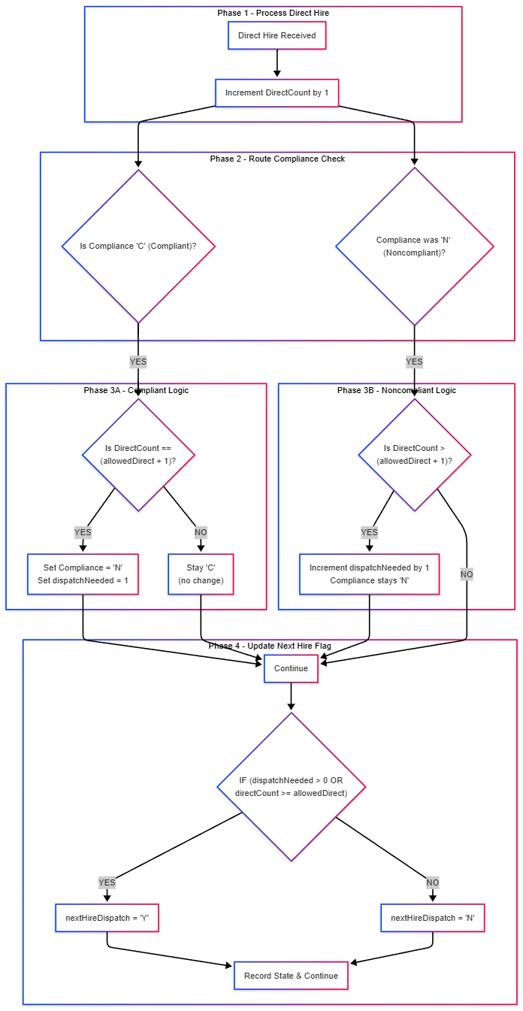
Example (2To1 Mode):
- Start: compliance=C, directCount=0, dispatchNeeded=0
- Direct hire 1: compliance=C, directCount=1, dispatchNeeded=0
- Direct hire 2: compliance=C, directCount=2, dispatchNeeded=0
- Direct hire 3: compliance=N, directCount=3, dispatchNeeded=1 ← Violation triggered
- Direct hire 4: compliance=N, directCount=4, dispatchNeeded=2

Rule 2: Processing a DISPATCH Hire
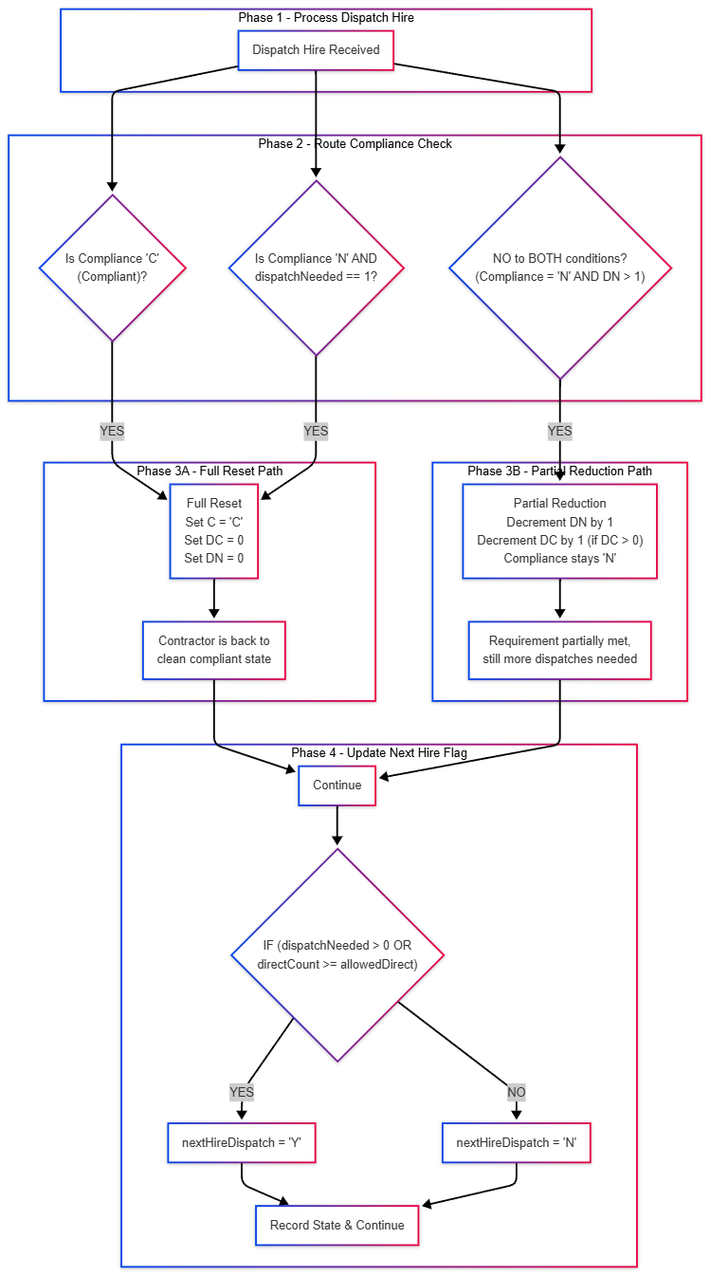

Example (2To1 Mode - Remediation):
- Start: compliance=N, directCount=3, dispatchNeeded=1
- Dispatch hire 1: compliance=C, directCount=0, dispatchNeeded=0 ← Reset to compliant
- Direct hire 1: compliance=C, directCount=1, dispatchNeeded=0

Rule 3: Update Next Hire Dispatch Flag
After each hire, recalculate:
IF dispatchNeeded > 0 OR directCount >= allowedDirect:
nextHireDispatch = 'Y'
ELSE:
nextHireDispatch = 'N'
Business Meaning:
- 'Y' = The NEXT hire must be dispatch to maintain compliance
- 'N' = The next hire can be either dispatch or direct

State Initialization: Seed from Previous Run
If a previous run exists:
- Contractor state CARRIES FORWARD from prior run's final state
- This enables compliance tracking across reporting cycles
- Dispatch requirements must be met before returning to compliant status
Example (Continuing from prior run):
- Prior Run End: compliance=N, directCount=4, dispatchNeeded=2
- New Run Start: Same state (to carry forward the requirement)
- Process dispatch hire: compliance=N, directCount=3, dispatchNeeded=1
- Process 2nd dispatch: compliance=C, directCount=0, dispatchNeeded=0 ← Requirement satisfied

Report Generation

Two-Level Reporting Structure

1. Detail Records (CMP_ReportDetails)
Granularity: Per hire
Purpose: Audit trail and detailed compliance tracking
Fields:
RunId - Which run created this detail
EmployerId - Contractor employer identifier
ContractorId - Contractor numeric ID
ContractorName - Organization name (from hire data)
MemberName - Worker name
IANumber - Union member ID
StartDate - Hire date
HireType - "Dispatch" or "Direct"
ComplianceStatus - Compliance state AFTER this hire
DirectCount - Direct count AFTER this hire
DispatchNeeded - Dispatch requirement AFTER this hire
NextHireDispatch - Next hire requirement (Y/N) AFTER this hire
ReviewedDate - Review cycle date
ListPosition - Position at dispatch (if applicable)
Why Detail Records?
- Enables drill-down analysis
- Audit trail for investigation
- Identifies exactly which hire caused violation
- Historical comparison across runs

2. Summary Records (CMP_Reports)
Granularity: Per contractor per run
Purpose: Executive summary and current status
Fields:
RunId - Which run
EmployerId - Contractor employer ID
ContractorId - Contractor numeric ID
ContractorName - Organization name
ComplianceStatus - Final compliance status (Compliant/Noncompliant)
DirectCount - Final direct count
DispatchNeeded - Remaining dispatch requirement
NextHireDispatch - Next hire requirement (Y/N)
LastWedReported - Prior reporting date (from snapshot)
SnapshotWed - Current week-end date (from snapshot)
CompanyType - Contractor classification (from snapshot)
Enrichment with Snapshot Data:
- LastWedReported, SnapshotWed, CompanyType linked from Contractor Snapshot
- Provides organizational context without joining
- Enables reporting on company type trends

Excel Export: Four-Tab Workbook

Tab 1: "Detail"
- All detail records for this run (CMP_ReportDetails)
- Sortable/filterable by contractor, compliance, hire type
- Use for detailed investigation

Tab 2: "Report"
- Summary records for this run (CMP_Reports)
- One row per contractor
- Use for compliance dashboard and trending

Tab 3: "Last 4"
- Last 4 hires per contractor (from CMP_HireData)
- Snapshot of recent hiring pattern
- Contextual information for compliance discussion

Tab 4: "Recent Hire"
- All hires in the current review period matching this run's date
- Raw transaction data for verification
- Links back to source HR data

Date Formatting & Data Quality
- All date columns formatted as text in Excel to prevent date reinterpretation
- Ensures data integrity when Excel file is manipulated
- Maintains referential integrity with source systems

Key Metrics & Definitions

Compliance Status
Status | Meaning | Trigger | Action
Compliant | Contractor following all regulations | Direct count ≤ allowedDirect OR all required dispatches completed | Continue monitoring
Noncompliant | Violation detected | Direct count > allowedDirect | Dispatch requirement issued

Direct Count
Definition: Number of consecutive direct (non-dispatch) hires in current compliance cycle.
Reset Triggers:
- Dispatch hire that satisfies the requirement
- Completion of compliance cycle
- Manual adjustment by compliance officer
Business Meaning:
- Tracks unmet compliance requirement
- Higher count = greater urgency for dispatch hire

Dispatch Needed
Definition: Number of outstanding dispatch hires required to restore compliance.
Calculation:
- Increases by 1 for each direct hire beyond allowedDirect
- Decreases by 1 for each dispatch hire (when noncompliant)
- Returns to 0 when compliance restored
Business Meaning:
- Concrete action item for contractor
- Used to prioritize enforcement

Next Hire Dispatch
Definition: Flag indicating whether next hire must be dispatch.
Values:
- Y = Next hire MUST be dispatch
- N = Next hire can be dispatch or direct
Conditions for 'Y':
- dispatchNeeded > 0 (outstanding requirement), OR
- directCount >= allowedDirect (at threshold)
Business Meaning:
- Early warning of compliance pressure
- Used in proactive outreach

Mode (2To1 vs 3To1)
2To1 Mode:
- Allows 2 direct hires per 1 dispatch
- Stricter compliance requirement
- Used for certain contractor classifications
3To1 Mode:
- Allows 3 direct hires per 1 dispatch
- More flexible compliance requirement
- Used for other contractor classifications

Process Workflow Details

Transaction Processing

1. Transaction Wrapping
All database operations wrapped in SQL transaction:
- Enables atomic commit/rollback
- Prevents partial data states
- Supports dry-run mode (rollback all changes)

2. Dry-Run Mode
Optional flag for validation without writes:
node cmp-run.js --reviewedDate 2025-12-01 --mode 2To1 --dryRun
- Executes all processing logic
- Does NOT insert to database
- Useful for testing and validation
- Returns success/error messages

3. Commit Strategy
After all contractors processed:
- If successful: COMMIT transaction (all data written)
- If error: ROLLBACK transaction (all data discarded)
- Maintains data consistency

Contractor Filtering: Blacklist Exclusion
Two-stage exclusion to prevent excluded contractors from being reported:
Stage 1 - Hiring Data:
SELECT contractors
FROM CMP_HireData h
LEFT JOIN CMP_ContractorBlacklist b
ON h.EmployerId = b.EmployerID
AND b.DeletedOn IS NOT NULL
WHERE b.Id IS NULL -- Exclude blacklisted
Stage 2 - Prior Run Data:
SELECT contractors
FROM CMP_Reports r
LEFT JOIN CMP_ContractorBlacklist b
ON r.EmployerId = b.EmployerID
AND b.DeletedOn IS NULL
WHERE b.Id IS NULL -- Exclude blacklisted
Business Logic:
- DeletedOn IS NOT NULL = Blacklist record deleted (contractor active)
- DeletedOn IS NULL = Blacklist record active (contractor excluded)
- Supports reversible exclusions

Contractor State Seeding

Scenario 1: First Run (No Prior Run)
IF prevRunId IS NULL:
state = {
compliance: 'C', // Start compliant
directCount: 0,
dispatchNeeded: 0,
nextHireDispatch: 'N'
}

Scenario 2: Contractor Active in Prior Run
IF contractor has report in prevRun:
state = {
compliance: priorReport.ComplianceStatus,
directCount: priorReport.DirectCount,
dispatchNeeded: priorReport.DispatchNeeded,
nextHireDispatch: priorReport.NextHireDispatch
}

Scenario 3: Contractor New in Current Run
IF contractor in CMP_HireData but not in prevRun:
state = {
compliance: 'C',
directCount: 0,
dispatchNeeded: 0,
nextHireDispatch: 'N'
}

Mode Configuration
Modes stored in CMP_Modes table:
Mode Name | Mode Value | Allowable Direct | Dispatch Ratio
2To1 | 2 | 2 | 1 dispatch per 2 direct
3To1 | 3 | 3 | 1 dispatch per 3 direct
Flexibility Note: Algorithm is mode-agnostic. Additional modes can be added by:
- Inserting new row in CMP_Modes
- Selecting new mode when creating run
- allowedDirect parameter auto-populates from mode_value

Data Quality & Validation

Import-Time Validation

Hire Data Validation
✓ Employer ID populated
✓ Contractor ID is positive integer
✓ Member Name populated
✓ Start Date is valid date and not in future
✓ Hire Type is "Dispatch" or "Direct"
✓ IA Number is valid integer
✓ Is Reviewed = true (filtered only reviewed data)
✓ Is Excluded = false or null (active records only)
✗ Fails: Create error record, increment failCount
✓ Passes: Insert into CMP_ReviewedHires

Contractor Snapshot Validation
✓ Contractor ID populated and valid
✓ Contractor Name populated
✓ Snapshot WED is valid date
✓ Last Hire Date is valid date (if provided)
✓ Journeypersons is non-negative integer
✗ Fails: Create error record, increment failCount
✓ Passes: Insert into CMP_ContractorSnapshot
Import Result Summary:
{
successCount: number, // Records successfully imported
failCount: number, // Records with validation errors
errors: [ // List of specific errors
"Row 5: IA Number is required",
"Row 12: Start Date must not be in future",
...
]
}

Run-Time Data Quality Checks
Check | Condition | Action
Null ContractorId | Contractor missing | Skip contractor
Missing Previous Run | Cannot establish baseline | Start with clean state
Hires out of order | System orders hires | Documented in logs
Blacklist changes | During run execution | Exclude contractor

Audit Trail
Every run maintains audit trail:
CMP_Runs:
- ReportDate: When report generated
- ReviewedDate: What period included
- ModeId: What mode used

CMP_ReportDetails:
- RunId: Which run
- ReviewedDate: Confirms period
- Each hire snapshot captured

CMP_Reports:
- RunId: Which run
- Final state recorded

Process Improvement Considerations

Potential Pain Points & Optimization Opportunities

1. Data Import Timing
Current State:
- Hire data and contractor snapshots imported as separate operations
- Manual CSV preparation from HR systems
Improvement Opportunities:
- Automated daily feed from HR systems
- Real-time or near-real-time imports
- Reduce manual data entry errors
- Enable more frequent compliance runs

2. Blacklist Management
Current State:
- Blacklist records maintained with DeletedOn flag
- Checked during run execution
Improvement Opportunities:
- Dashboard UI for blacklist management
- Automation trigger for known violation types
- Appeal/review process workflow
- Historical blacklist tracking

3. Compliance State Carryover
Current State:
- State carries forward from prior run
- Enables persistent tracking across cycles
Improvement Opportunities:
- Configurable reset cycles (e.g., monthly compliance reset)
- Exception handling for long-term remediation
- State anomaly detection (unexpected transitions)

4. Reporting & Insights
Current State:
- Excel exports with four tabs
- Summary at contractor level
Improvement Opportunities:
- Dashboard with compliance trends
- Predictive analytics for violation risk
- Company type-based benchmarking
- Historical compliance scoring
- Contractor hotspot identification

5. Manual Corrections
Current State:
- No mechanism to override computed compliance
Improvement Opportunities:
- Compliance officer manual override with audit trail
- Exception notes linked to specific hires
- Dispute/appeal workflow
- Dry-run validation before override

6. Run Scheduling & Automation
Current State:
- Manual trigger for each run
- Ad-hoc scheduling
Improvement Opportunities:
- Scheduled run execution (daily, weekly, monthly)
- Automated report distribution
- Failure notifications
- Performance monitoring

7. Mode-Specific Rules
Current State:
- 2To1 and 3To1 modes supported
- Rule applied uniformly within mode
Improvement Opportunities:
- Contractor-specific mode assignments
- Graduated requirements based on company size
- Seasonal adjustment factors
- Escalation paths for chronic violations

8. Performance Optimization
Current State:
- Sequential processing per contractor
- SQL queries executed in transaction
Improvement Opportunities:
- Batch processing optimization for large datasets
- Caching of contractor snapshots
- Index optimization on key queries
- Parallel processing of independent contractors

9. Data Governance
Current State:
- Hire data marked as Is_Reviewed and Is_Excluded
- Manual data quality responsibility
Improvement Opportunities:
- Data quality scoring per import
- Automated duplicate detection
- Source data validation before import
- Compliance with data retention policies

10. Stakeholder Communication
Current State:
- Excel exports for analysis
- Manual distribution
Improvement Opportunities:
- Automated compliance alerts to contractors
- Public dashboard for transparency
- Regulatory reporting automation
- Metrics briefings for leadership

Glossary of Terms
Term | Definition
Contractor | Union hall employer hiring workers
Direct Hire | Worker hired directly by contractor (not through dispatch)
Dispatch Hire | Worker hired through union dispatch system
Compliance Cycle | Period of time between compliance evaluations (typically weekly)
Run | Single execution of compliance evaluation for all contractors
Reviewed Date | The cutoff date for hire inclusion in a run
Mode | Compliance strictness setting (2To1 or 3To1)
State Seeding | Initialize current run with prior run's compliance status
Dispatch Needed | Outstanding requirement for dispatch hires to restore compliance
Next Hire Dispatch | Flag indicating if next hire must be dispatch (Y/N)
Noncompliant | Contractor not following dispatch requirements
Snapshot | Corporate metadata captured at point in time (WED, company type, etc.)

Appendix: System Components

Services Layer
Service | Responsibility
RunService | Orchestrates run creation, execution, reporting
HireDataService | Manages hire data import and retrieval
ContractorSnapshotService | Manages contractor metadata
ReportService | Manages report generation and updates
ComplianceEngine | Core compliance state machine logic
BlacklistService | Manages contractor exclusions

Repository Layer (Data Access)
All data operations abstracted through repository pattern for consistency:
- HireDataRepository
- ContractorSnapshotRepository
- RunRepository
- ReportRepository
- ReportDetailRepository
- BlacklistRepository

Database Tables
Table | Purpose
CMP_Runs | Master records for each compliance run
CMP_ReportDetails | Per-hire detail records
CMP_Reports | Per-contractor summary records
CMP_HireData | View of active reviewed hires
CMP_ReviewedHires | Source table for hire data
CMP_Modes | Configuration of compliance modes
CMP_ContractorSnapshot | Contractor metadata by date
CMP_ContractorBlacklist | Exclusion list management

Document Control
Version | Date | Changes
1.0 | 2026-07-17 | Initial documentation

Contact & Questions
For clarifications on this documentation, contact:
- System Owner: [Product Owner Name]
- Technical Lead: [Technical Lead Name]
- Data Governance: [Data Steward Name]

END OF DOCUMENTATION

